**EXERCISE-1**

**SOFTWARE ENGINEERING FUNDAMENTALS**

**Need For Software Engineering**

The story of the building of the ship vasa from 1628 august in history.

This story deals with development. It involves the five phases of Software Engineering.

**Observations from the story:**

* Objectives not clear to the king or team.
* Hendrick had less clarity regarding requirements.
* Requirements changed in the middle.
* Attrition in team and information gap.
* No time for testing.
* Ship sank and the project failed.
* It highlights the need for a systematic approach to a project.

**An engineering approach to software development:**

* Vision of the project and outcomes.
* Clarity on requirements.
* Analysis and design.
* Development of the code.
* Testing.
* Implement Maintain and Deployment.

We need an engineering approach for software development that approach is known as **Software Engineering** as a term emerged.

**Software Engineering Concepts**

**Software Crises:**

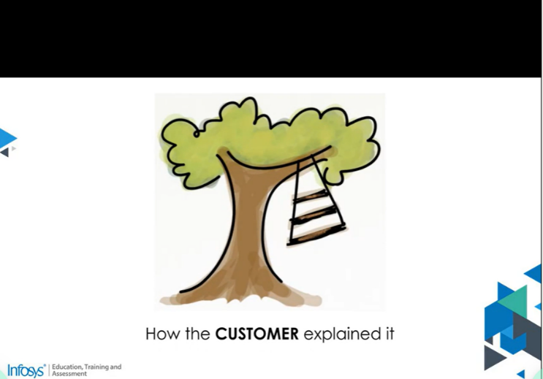

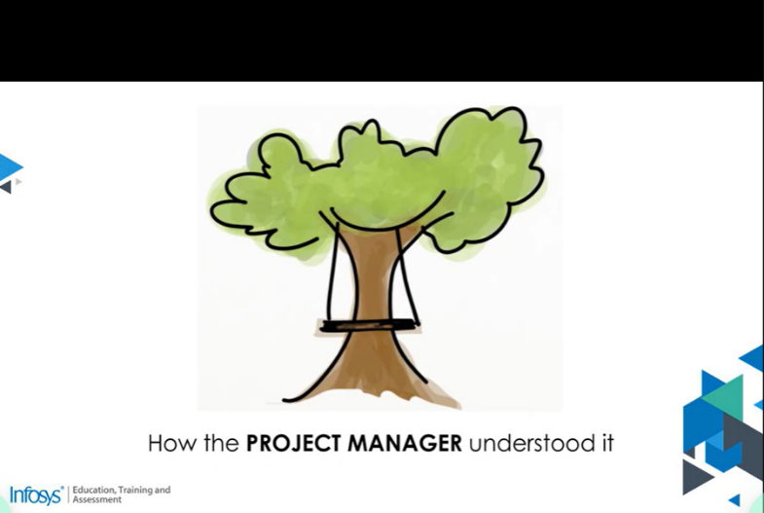

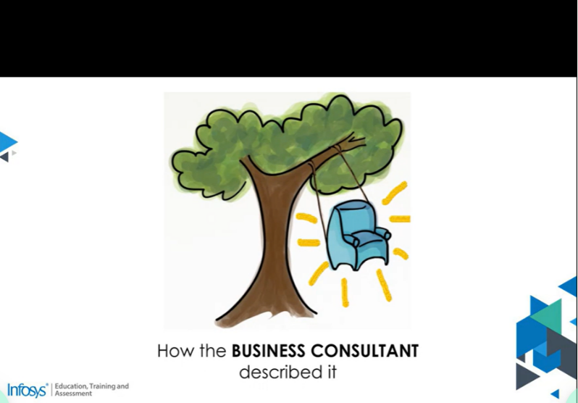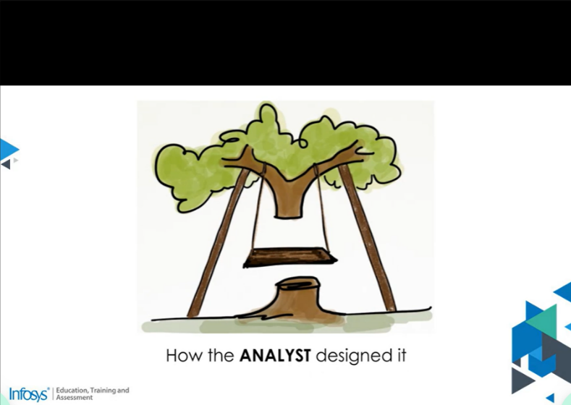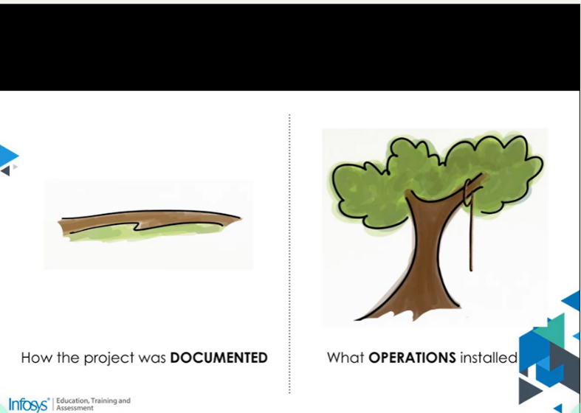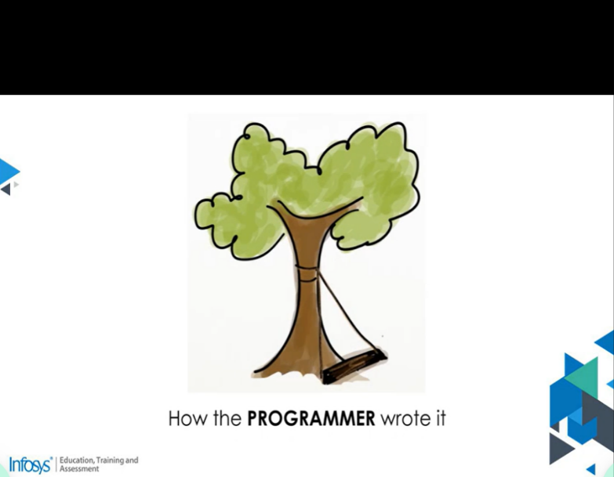

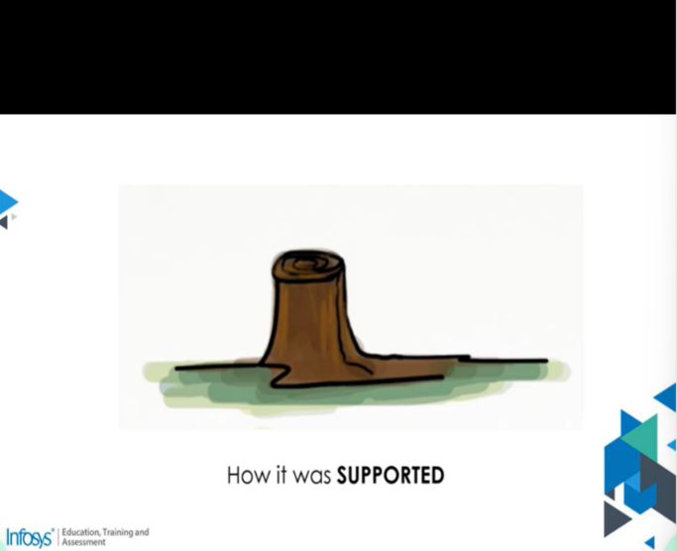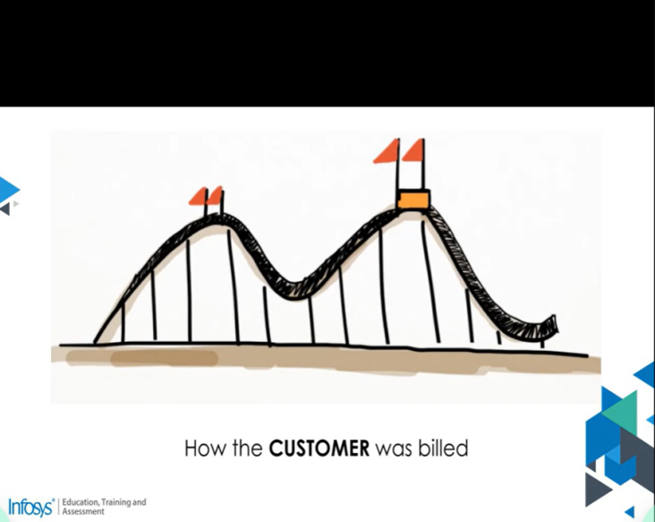

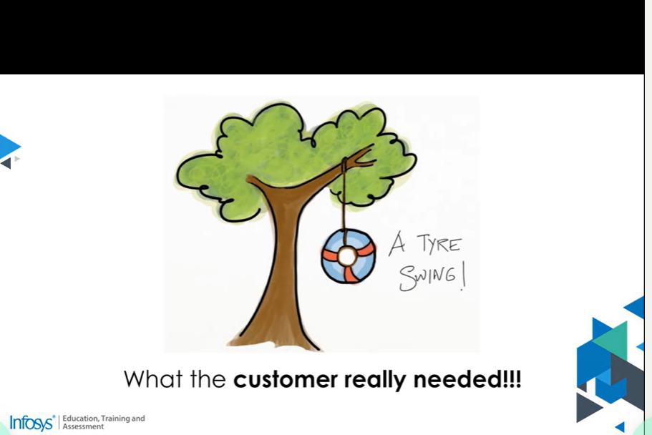

**The above diagrams represent Software Crisis.**

**Software crises include:**

* Time and Cost Slippage.
* Failure at Customer’s Site.
* Untraceable errors after delivery.
* Difficulty in Maintenance.
* Information leaks when multiple stakeholders are at play.

Many stakeholders come into play.

Customers, Requirement folks, Design Team, Def Team, and so on….

Freed books refer to accidental complexity when there are multiple stakeholders and too many modules to be developed, complexity seems ill.

Standardization of Software Development activities helps resolve the Software crisis.

Software Engineering is the term was coined at a NATO Sponsored conference in 1968.

The Definition given by IEEE the standard glossary of software engineering terminology is as follows.

**IEEE Definition:**

“Software Engineering is the application of a systematic, disciplined, quantifiable approach of the development, operation and maintenance of software; i.e., the application of engineering to software.”

**SYSTEMATIC**: systematic means a process is involved.

**DISCIPLINED:** being disciplined provides a predictable output.

**QUANTIFIABLE:** means there are metrics and measures.

**SOFTWARE ENGINEERING**

**Life Cycle Phases:**

* **Requirements Phase:** as the name suggests stakeholders suggest requirements of the software that is to be developed. The aim is to capture the details through interviews, discussions, questionnaires, workshops, etc.
* **Design Phase:** The design phase is the high-level design of software and system to deliver each requirement. The design is discussed with the stakeholder’s risks are discussed and team capabilities are looked at as well. Constraints are also taught off.
* **Coding Phase: a** coding or built or construction phase. This is about bringing the design to reality by coding. Developers start coding and unit testing the modules according to the design.
* **Testing Phase:** this stage is about verifying how the software behaves as per the functionality desired. The defects if any are fixed by the developers and are tested once again.
* **Deployment Phase:** Deployment or Implementation. Here the software is fully tested and high-priority issues are removed and deployed to the customers.
* **Maintenance Phase:** Once a version is released, the support team does maintenance activities to check for any post-production issues.

The life cycle activities apply to any approach of software development, business demands the development of defect-free software, predictable output, adherence to budget and timelines, and development with a diverse team which is why Software Engineering is required.

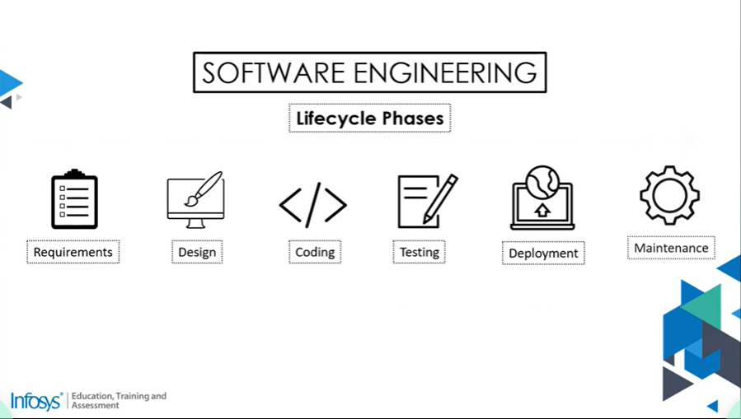

**SOFTWARE ENGINNERING MODELS:**

Definition of Software Lifecycle Model:

Software Lifecycle Model is a conceptual framework that describes activities in a project end to end.

They are several models in Software Engineering. They are

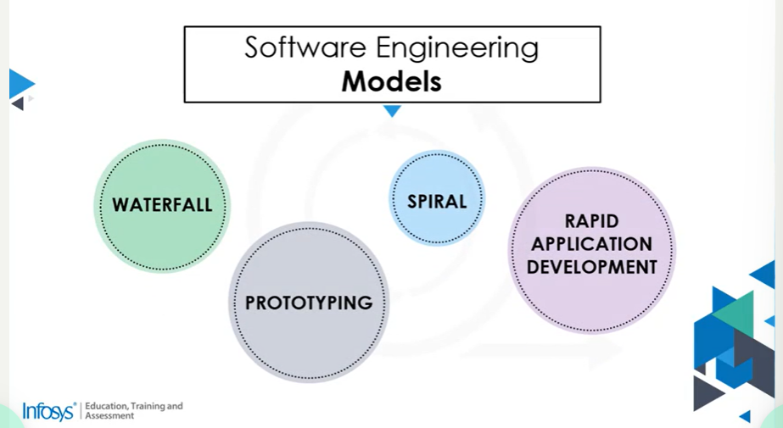

* Waterfall Model
* Prototyping Model
* Spiral Model
* Rapid Application Model



Learning with the Picture:

The customer has provided you with all the requirements and assured you that they won’t be further changed in the requirement they expect deliverable from you at the stage of development.

You carried out a similar project earlier and you showed that the project could be executed systematically.

Now what are your observations here are

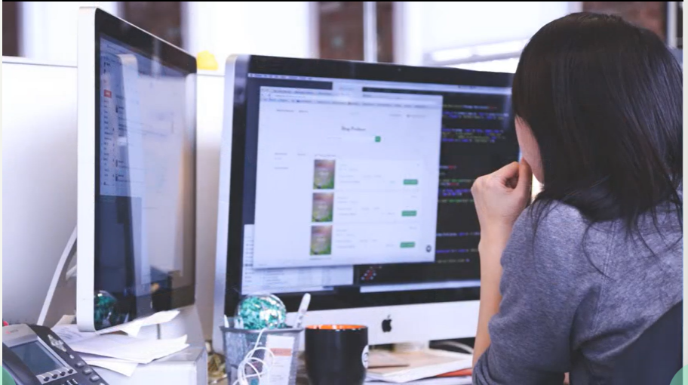

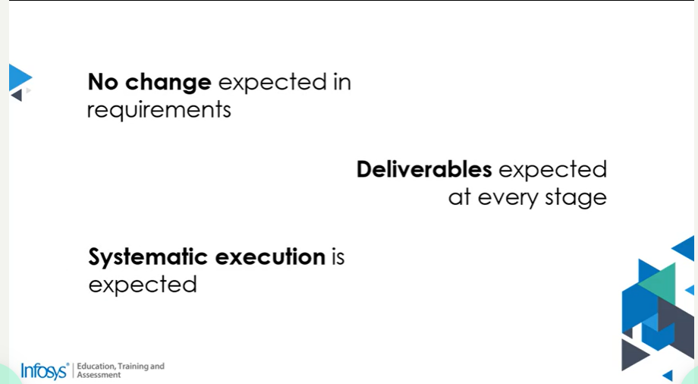

No change is expected in requirements.

Deliverables are expected at every stage.

Systematic execution is expected.

Waterfall Model is very useful in project development scenarios with traits you just observe.

Here the phases in the Waterfall Model are:

Requirement Gathering

Analysis

Construction

Testing

Deployment

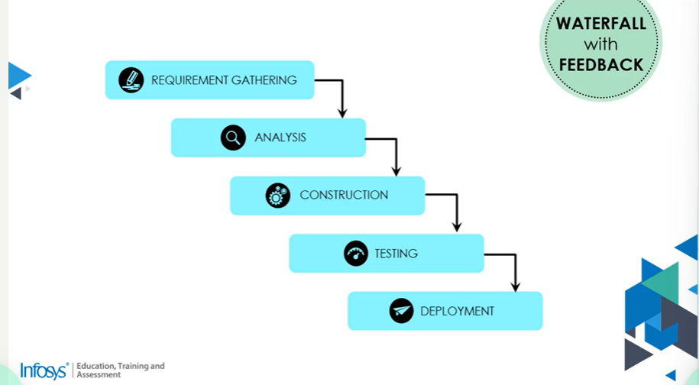

Development Lifecycle. There is a sequential execution of one following the other with deliverables expected at the end of every phase, since requirements are pretty much Atticus and predefined the phases can be executed one after the other.

There is a variation to this in all the Waterfall models with feedback where it is possible were go back to the previous phase or feedback.

Let’s move on to the next scenario



The customer wants to start developing the software for remote control electronic toys, and cannot share all the requirements of the product but has provided you with the initial set of requirements. The customers want a demo of how the product would look and feel and have mentioned that they could provide the rest of the requirements after that.

What is the nature of this use case?

A complete set of requirements is not available, so you need to

Start Development with initial requirements, and

Feel of the product expected through demos

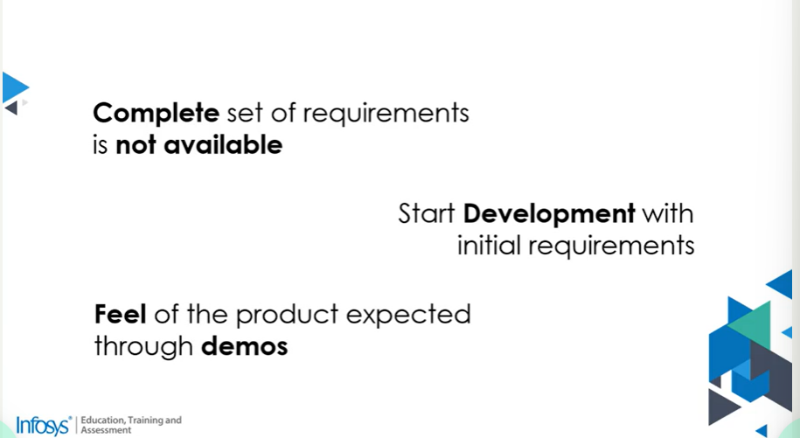

The prototyping Model is best suited for this use case

It involves

Building a working replication of the system

The prototype could be used as-if or with refinements

The throw-away version is a PROOF OF CONCEPT(POC)

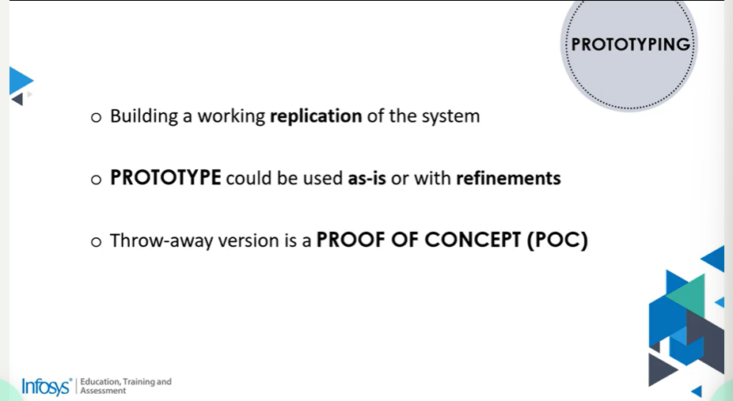

This strategy involves building in increments that are working and demonstrable.

The next scenario

The customer and the Development Team

Picture:

Foresee many risks at each stage of Software Development.

At each stage of Software Development, they are alternatives, and make the right decisions you and the customer have to make the right decisions.

You and the customer have to make the right decision that the project does not have a fixed budget.

**12 Principles of Agile:**

* Our highest priority is to satisfy the customer **through early and continuous** delivery of valuable software**.**
* Welcome **changing requirements**, even late in development. Agile processes harness change for the customer’s **competitive advantage**.
* Deliver **working software** frequently, from a couple of weeks to a couple of months, with a preference for a **shorter timescale**.
* Business people and developers must work **together daily** throughout the project.
* The most **efficient** and **effective** method of conveying information to and within a development team is **face-to-face conversation**.
* Built projects around **motivated individuals**. Give them the environment and support they need and **trust them** to get the job done.
* **Working** software is the primary measure of **progress**.
* The agile process promotes **sustainable** development. The sponsors, developers, and users should be able to maintain a constant pace **indefinitely**.
* Continuous attention to **technical** excellence and **good design** enhances ability.
* The best architectures, requirements, and designs emerge from **self-organizing** teams.
* At regular intervals, the team **reflects** on how to become more **effective**, then tunes and **adjusts** its behavior accordingly.
* **Simplicity** – the art of maximizing the amount of **work not done** – is essential.

Are metrics tracked in the Agile approach?

In traditional approaches, they have a quiet chance to prove a chance.

In Agile it is about failing fast and in Metrics that let us know defects early, we can measure improvement in these techniques.

How do we produce **EMERGENT** software?

Technical or engineering practices come to the rescue. Proven design patterns and engineering practices lead to emergent design.

What is the role of a **CUSTOMER** in collaborative working?

The Business team must work closely with Dev teams to provide a guarantee of requirements and decisions of requirements share the vision of the project and negotiate on the estimation of the site of requirements and schedules and also review the working version and provide early feedback and so on.

Agile is a **PEOPLE-CENTRIC** approach.

Collective Ownership – the team that works together and performs together.

What is the **MANAGER’S** role in agile?

Delegation of control and accountability, not tasks. Teams are collectively responsible for how they perform the tasks.

The Manager plays the role of a facilitator provides a conducive environment and trusts the team to get work done by themselves.

The Manager plays the role of a **servant-leadership**.

Customer collaboration over contract negotiation – no signoffs?

Signoff may not be possible because the scope cannot be fixed because of changes in needs and requirements in projects so the idea here is to ensure the scope is a variable in the contracts.

Should **CHANGES** be expected anytime, anywhere?

Agile does not mean it is anytime and anywhere leading to a very chaotic situation, definitely not. Changes are frequently sought and integrated.

Is there no need for **planning** in agile?

It’s not, in agile there is frequent planning for changes in fact and there are no fixed plans, there is just enough planning we need and we don’t spend a lot of time on planning for requirements that are about to change.

No rigid plans but **planning changes** frequently.

How is the Agile approach different from the traditional one?

Agile recommends working in short titrations and planning in detail for them this ensures that we have scope for newer requirements frequently and plan just enough for the **Line Of Sight(LOS)**.

Does Agile mean NO process?

**“LAGOM”** = just enough

The context of agile means just enough processes.

In the traditional approach if the process was centroid then everything else would work fine and bring in preventively.

Agile strikes a good balance it means no process to too many processes.

What is **WORKING SOFTWARE**?

Traditional models like waterfalls always had all or none to production concept i.e., releasing in a very big lot.

**It is the first time for the Management for :**

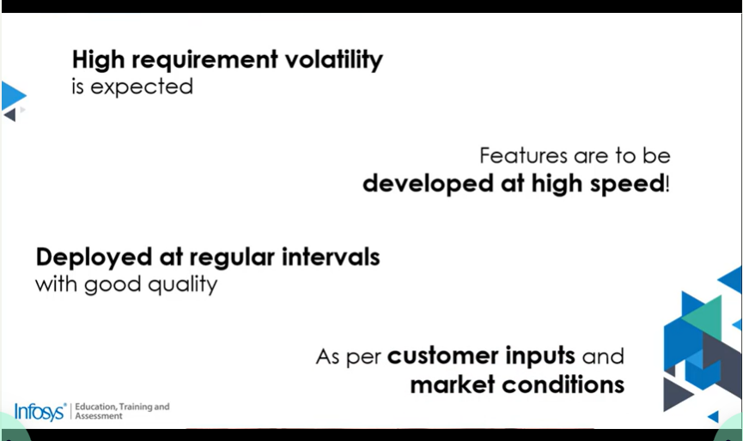

**The new set of Team members will be recruited as :**

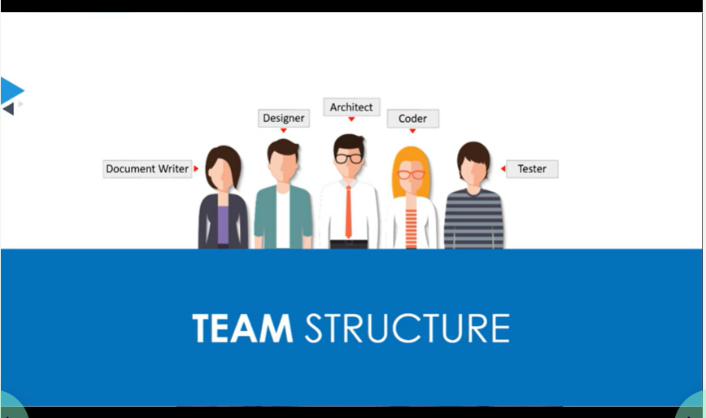

Since there are early and frequent releases Maintenance and support would come much earlier so support forces have been required and there are novice coders also required

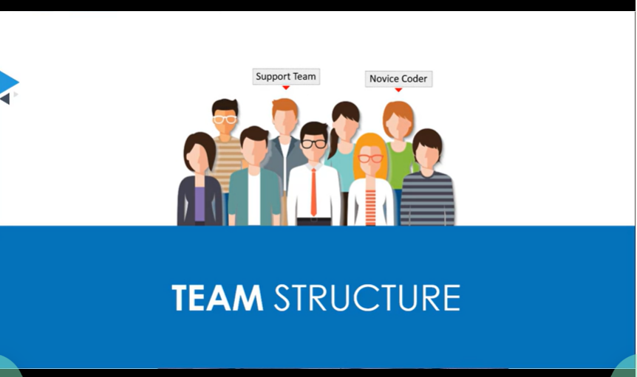

The management is clear in using the agile approach and contemplating the approach and practices

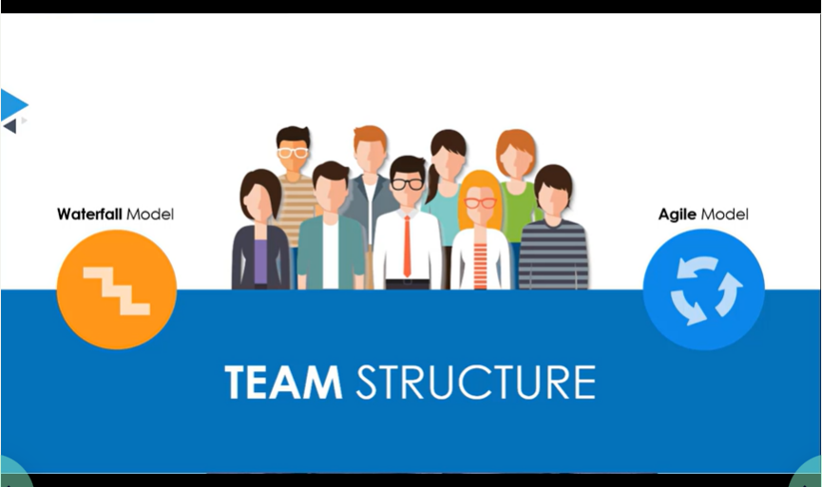

**Observations from the Scenario:**

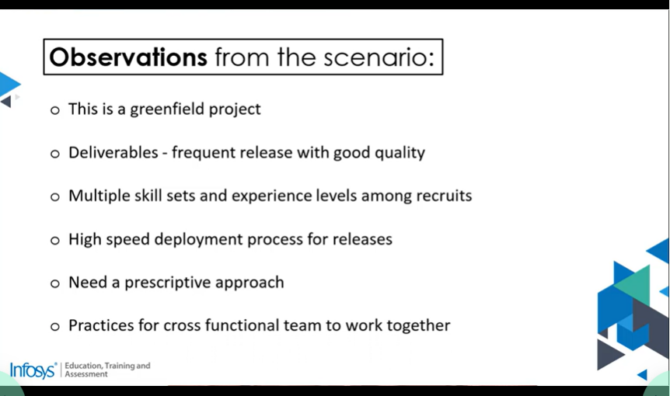

**Agile Adoption**

**Traditional Vs Agile-Part1**

**Introduction:**

The adoption of Agile practices has become a norm today, companies have seen the benefit at project level and are keen on extending it to areas other than software development with the roles leading to Enterprise eternity.

In this lesson we’ll compare traditional approach and the agile approach on various parameters and gain an understanding on the changes that are required and possibly some learning that has to be done in the way of working.

**Requirements and associated contract related aspects:**

**Traditional approaches** expect to get the complete picture of the requirements before software construction with a signoff from the customer. Since software is about the code that can be changed and that business conditions are dynamic requirement volatility is a given. A lot of times the plan and schedules can give a very rosy picture till the end and the real issues emerge after the software is deployed therefore software is bound to change and adapting to changes efficiently is the key to Agile approach.

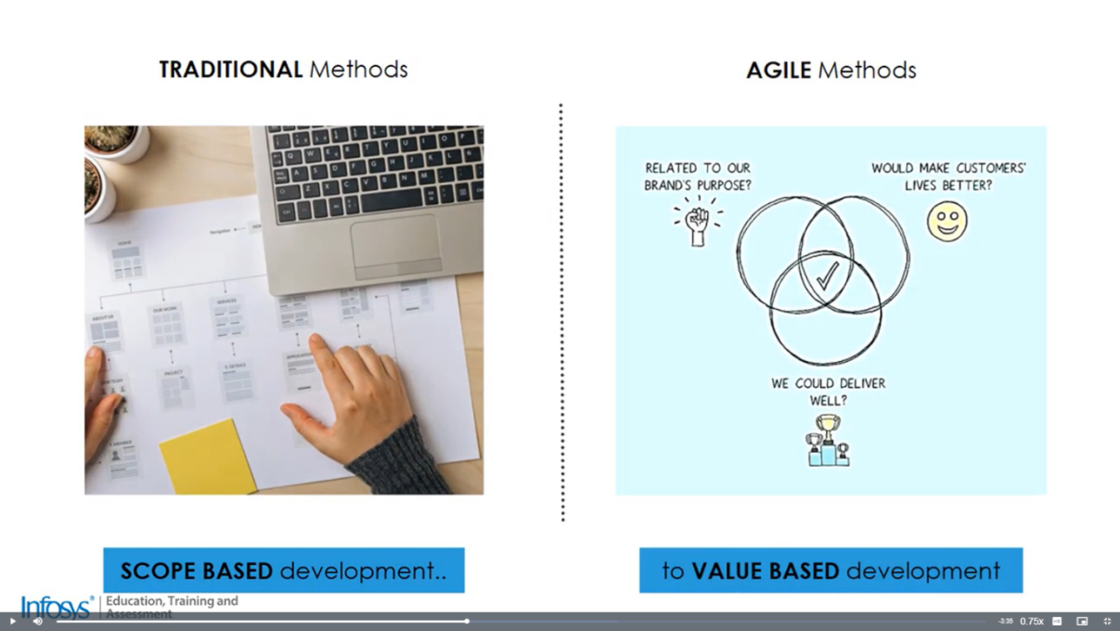

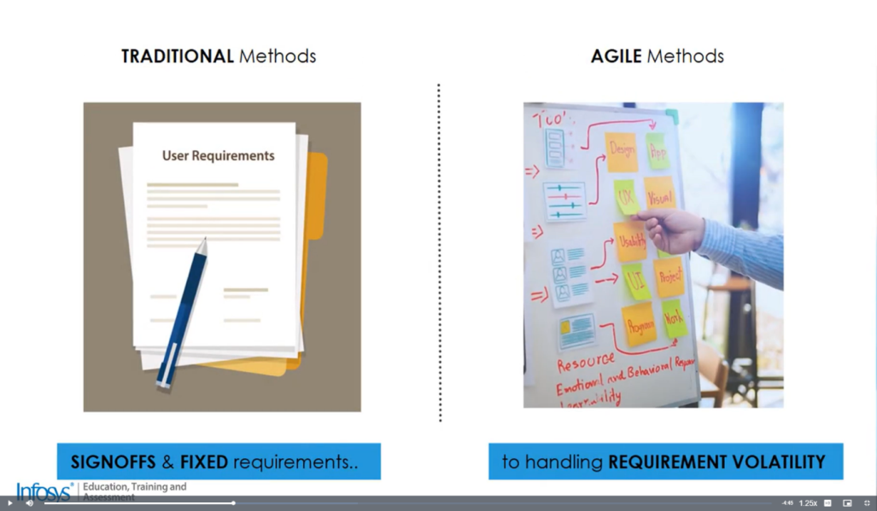

Traditional approaches with scope based development:

* Contracts play major role.
* Software has to be built and deployed as per signed-off requirements.
* Scope is fixed for development.

Agile Methods with value based development:

* Scope cannot be fixed.
* Focus on valuable software delivery to customers.

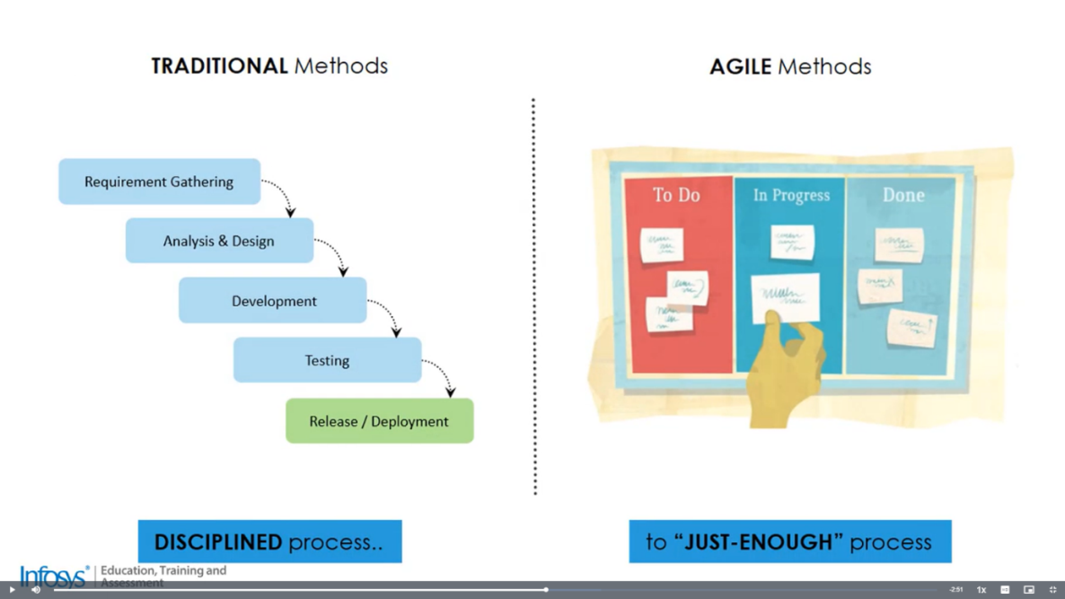

Traditional Methods with disciplined process:

* Plan-driven methods.
* Focus on predictability.
* Disparate teams in various stages.
* Testing done altogether.

But this approach did not work well with the dynamic work conditions and volatile requirements.

Agile Approach with just-enough process:

* Ensure value collaboration.
* Adaptive to change
* People-oriented with aiding processes.
* Frequently reviewed to make corrections.

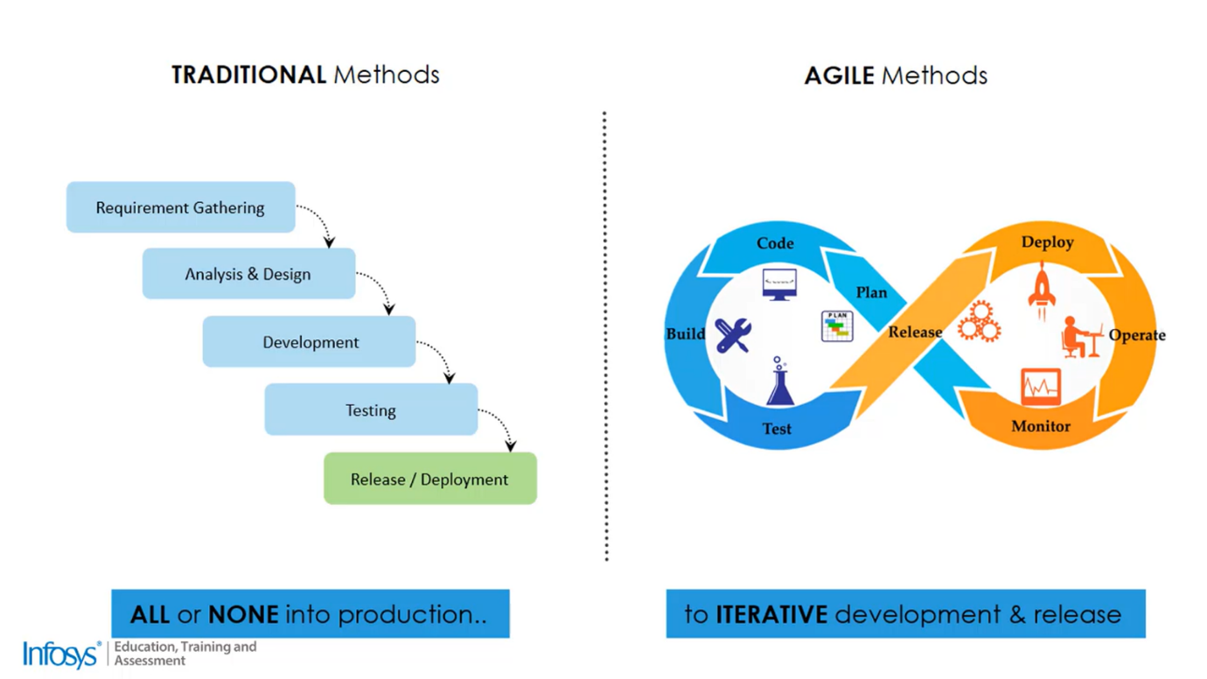

Agile Methods with Iterative development:

* Working versions in iterations
* Less functionality but accurate
* Plan-to-production cycle time in weeks.
* Early feedback and mid-path corrections are possible.

**Traditional Vs Agile-Part 2**

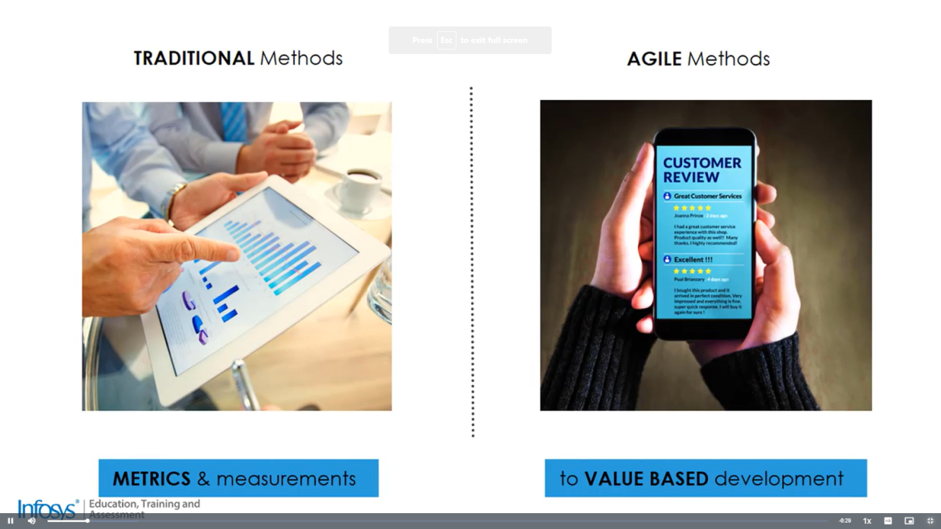

The focus of traditional approach is to declare success of project based on metric measure say on time the project is within budget projects are considered successful. However in the Agile approach to software development it is about whether the software was valuable to customer and whether it gave them a competitive edge in the market.

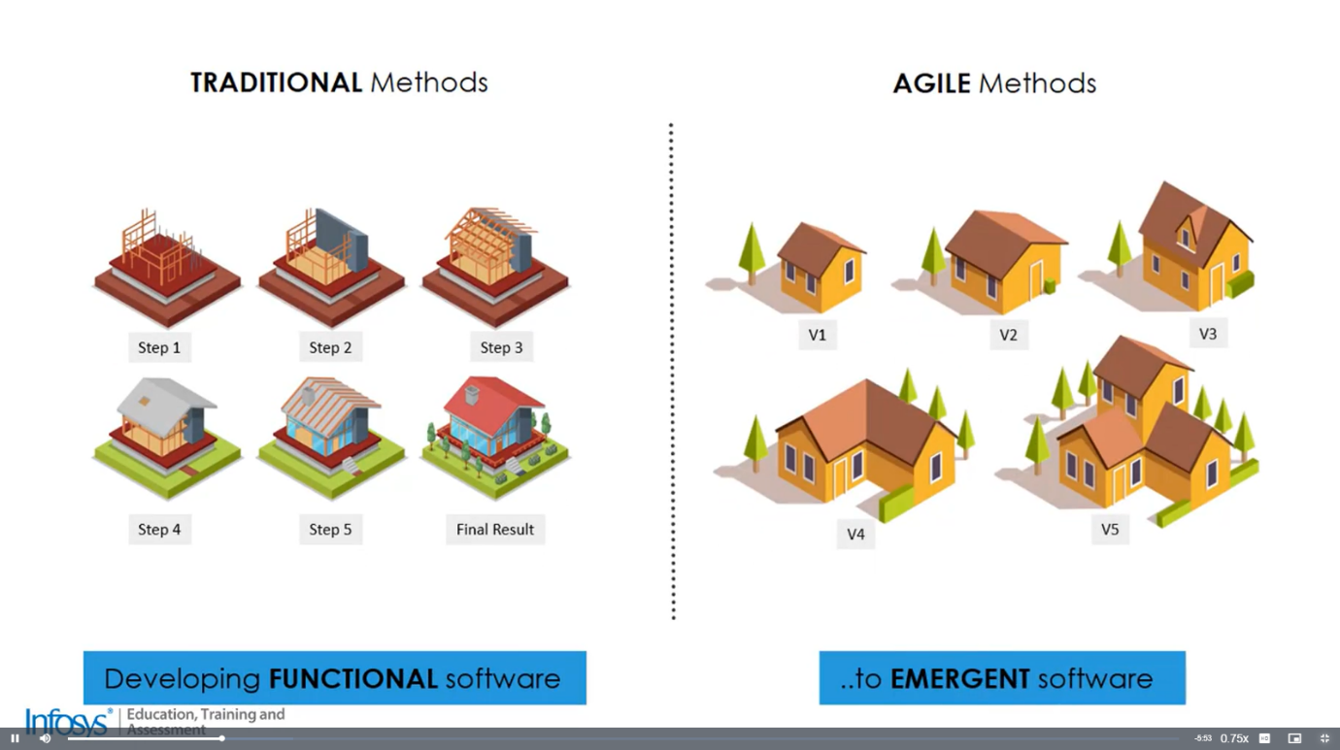

In Traditional method for functional software the focus is on getting the functionality working as per the specifications mentioned by the customer.

While in Agile software development since changes are expected the design and coding is emergent in nature and adapt to changes with ease. Continuous integration, testing and deployment is also expected.

This cause for more focus on:

* Emergent design
* Quality coding Principles
* Continuous integration, testing and deployment through automation.

The traditional software does not focus on quality.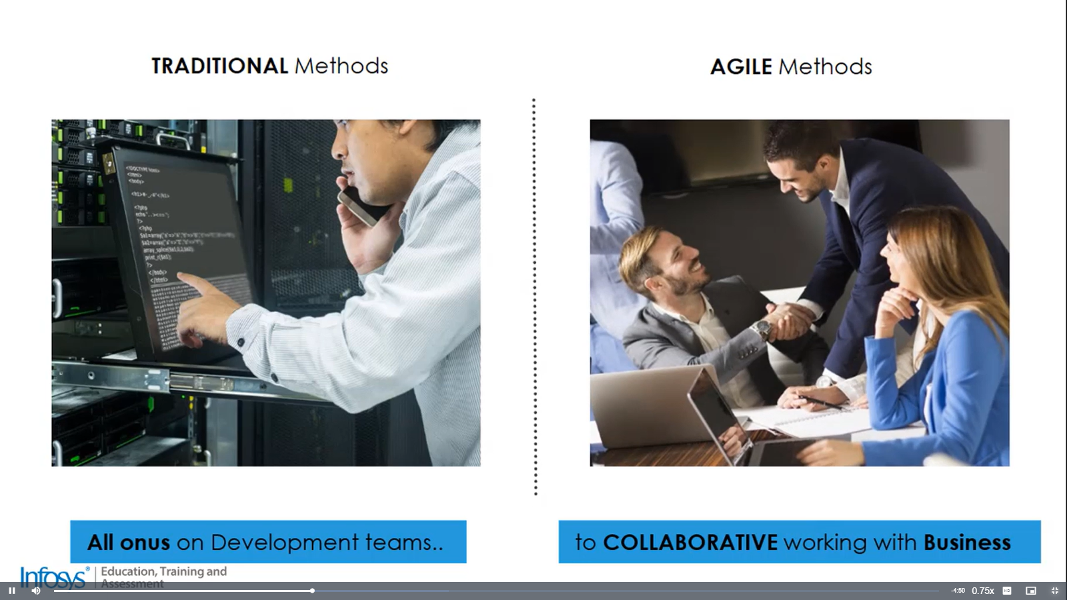

Agile Methods promote better collaboration with business:

* Business team collaboration with Dev to clarify requirements, review, and take decisions.
* Planning for changes and rules.
* Better visibility and transparency.
* Dev team have “Fail-Fast Approach”.

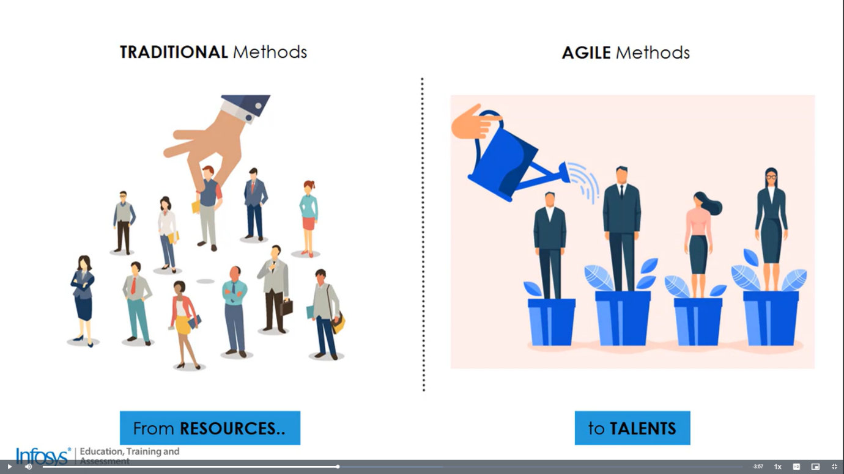

Agile approach to software development believes that it is people oriented that is people oriented.

In traditional approach to software development it believes that it people are being counted from resources to talent.

In the agile approach a lot depends on the team right from estimation to collaboration.

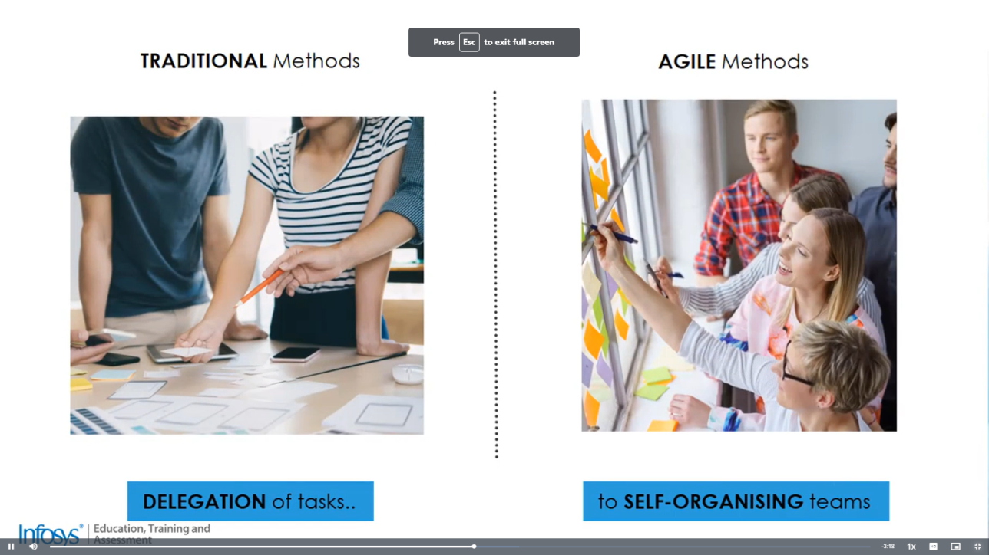

Agile Method promote Self-Organisation

* Dev team members decide:

1.What to do

2.Hom much to commit

3.How to do

* Senior members play roles of facilitators.
* Innovation of processes.

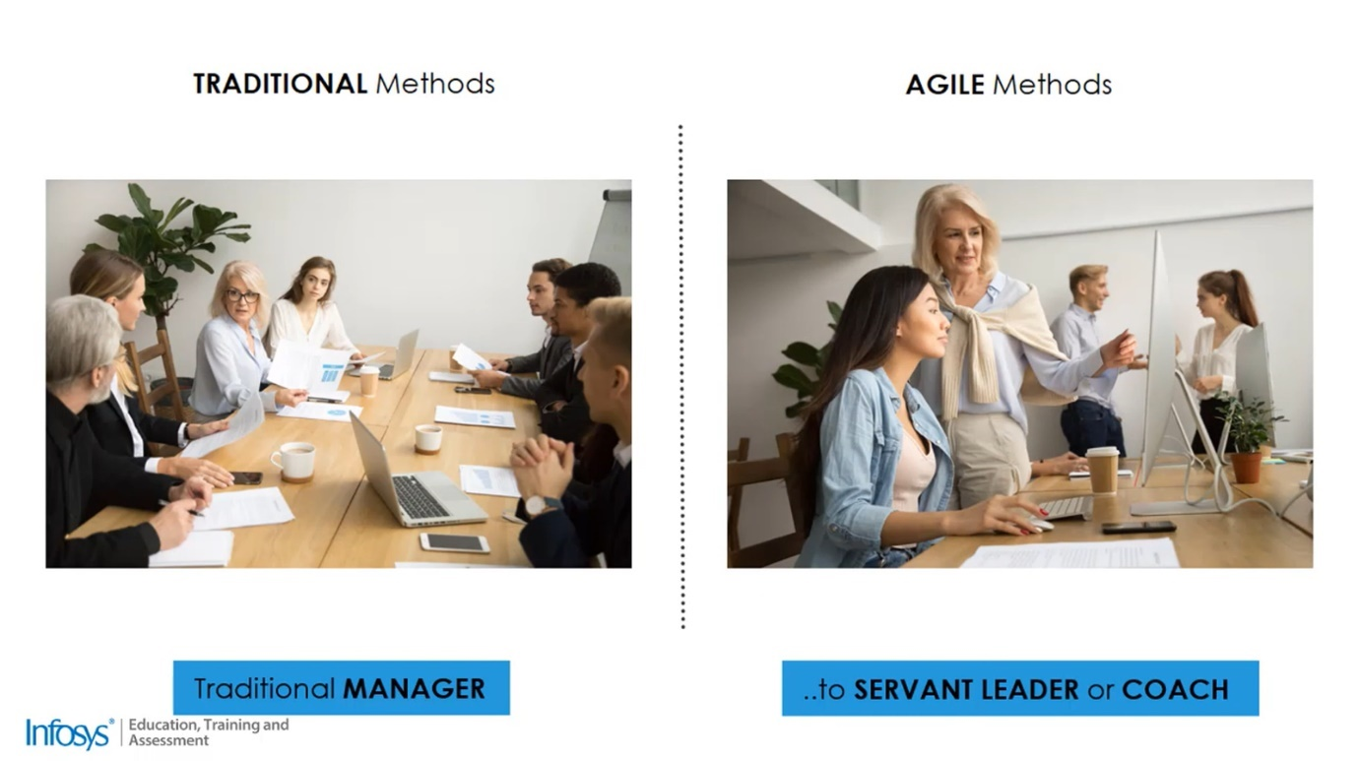

Agile Methods to promote Servant Leadership:

* Manage team by removing impediments.
* Mentor and coach on agile practices.
* Take up the leadership when needed to protect the team.
* Leadership commitment and communication of vision
* Decentralized rather than command-and-control management.
* 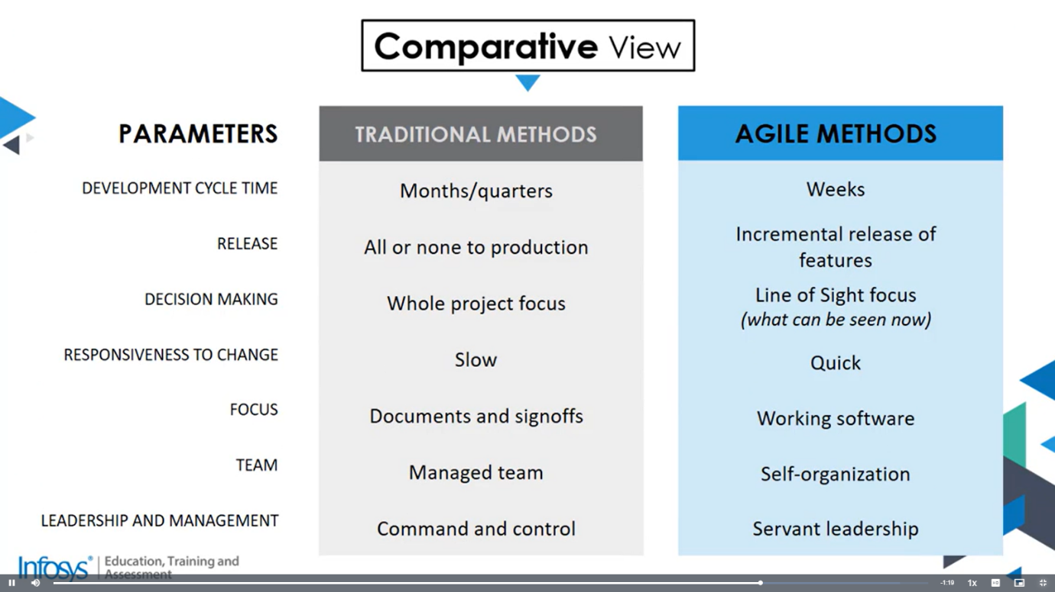

**Agile Flavors:**

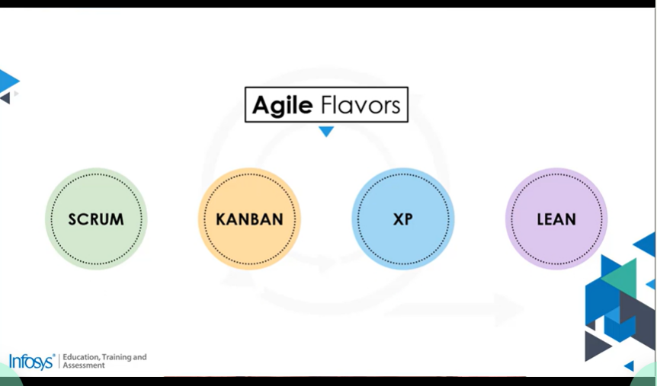

We can map these methods and see how agility can be increased.

**It is recommended by Scrum**

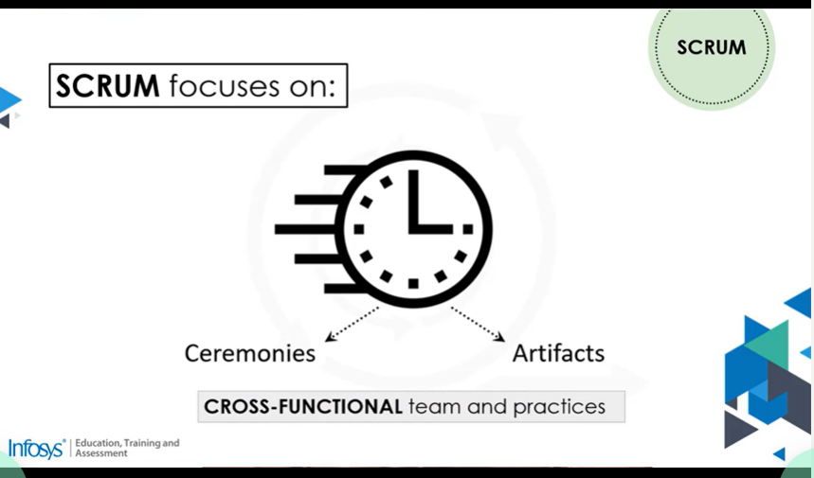

Maintenance and support would come in early and the task will be at halk at each other so an approach that can support these practices also would be needed.

KANBAN

Kanban would come to rescue us here

It is based on 6 practices

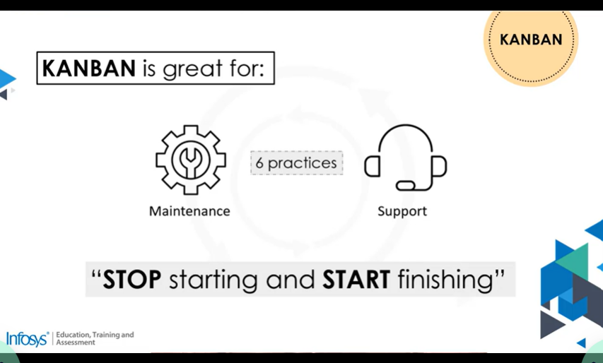

**There needs to be**

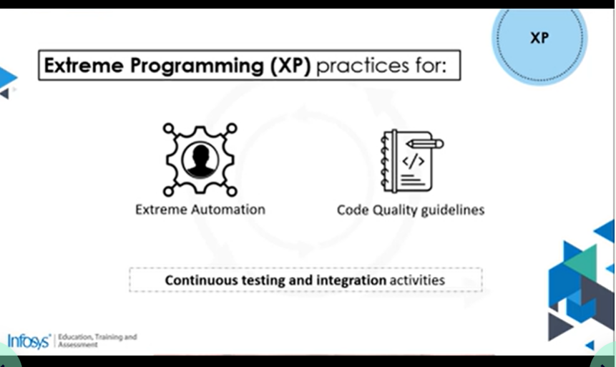

**LEAN:**

Lean practices help in :

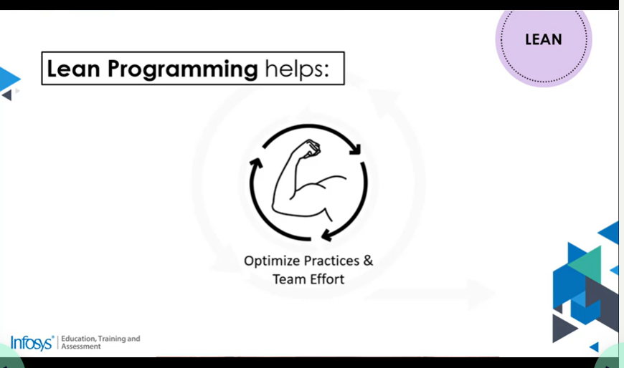

**Agile Flavors:**

What is the relationship between Agile, Scrum, Kanban, and Lean?

In the manifesto of agile development, we see the 4 values and 12 principles.

Methods like Scrum, Kanban, XP, and Lean come under the Agile Umbrella.

**Exercise 2**

**Get a working knowledge of using extreme automation through XP programming practices of test first development, refactoring and automating test case writing.**

**Agile Methodologies**

Agile methodologies in software development help deliver value or products faster, with better quality, and an ability to respond to change. They are implemented in the development and testing phases of software development for an enhanced successful development experience. They also illustrate the process of planning and meeting for an effective communication across the development team. Extreme Programming explores the methodology intended to improve software quality and responsiveness to changing software requirements.

**Extreme Programming Concepts**

When it comes to Agile software development, one of the fairly common implemented frameworks is Extreme Programming or XP. The purpose of Agile software development is to provide a means to develop software efficiently and elicit feedback as quickly as possible. The XP is probably the most direct of all the Agile frameworks because it lays out all the appropriate engineering practices quite well. Like most agile software development frameworks, XP is specifically designed to excel in three main areas.

* Quality improvements
* Process improvements
* Customer satisfaction improvements

*Advantages:*

* Focuses on key activities.
* Cost and time efficiencies.
* Reduces risk
* Uncomplicated
* Transparent
* Iterative testing
* Focuses on customer needs
* Ensures that there's an equal accountability throughout the team.

*Extreme Programming Roles:*

* Customer / Stakeholder: The customer is largely responsible for communicating the requirements and desired priorities. They can also provide constraints like budget. In other words, the customer tells the team what the software should do.
* Tracker: The tracker role is optional. The point of this role is to log certain Agile metrics about how the team is doing.
* Developer: The developer consumes the customer requirements and generates the solution in priority order. So, if the customer tells the team what the software should do, then the developers figure out how, and that's key.
* Coach:The coach gives guidance and support to the team. The coach shows how the process works and what to do and what to avoid, and it's not just the developers that get trained, it's the customers too.

*Extreme Programming Practices:*

* It's important that activities are done as a team, the whole team. It's not a team lead that designs things and everyone else works on it. The whole team needs to do that, have a say, and then agree.
* Ideally, the team sits together physically, too. In this age of virtual teams, that's still achievable with online communication tools.
* The main idea is that the team is in constant communication versus silos, and the team should be constantly working together to share information, guidance, and methodologies
* Work should be energized.
* One of the aspects of XP is to often implement pair programming.
* XP organizes work by creating stories. Stories are the work items that the customer's help define and that the developers work on.
* The way XP works is to have cycles and this is referred to as sprints or iterations. The smallest they should be is weekly and the longest is monthly.
* XP also encourages adding some small low-level items in the backlog.
* The ten-minute build practice requires the team to make sure that the software can compile and be tested within a ten-minute window which actually leads to another practice.
* Code should be continuously built each time it's committed to the repository.
* XP also prefers a test-first programming strategy. This doesn't always have to be the case but it can drastically improve the quality if done right.
* XP practice demands an incremental design.

**Extreme Programming use case**

* XP is good if all the activities that are going to be done are performed throughout the **development phase**. In XP all the work is done during development, and that means that the direction can change as needed without having to completely reset the project.
* XP is also a good tool when builds and deployments are **iterative**, and that means that a very simple version of the software can be released and continuously improved. There's an initial version that only does the bare minimum required to get feedback. Then you start iteratively improving the software by adding features or fixing issues. XP allows you to change direction on the fly, and because of that strategy XP has built-in resilience.
* In XP you can adjust the strategy on the fly, and that iterative nature also means that each new release is actually very small, so there's less chance of huge bugs and failures. So, between those things an XP managed project is actually way more **resilient** to problems, and if you have a project that's not fully understood or it's a bit more nebulous, XP allows you to get started with that minimum information and build up knowledge as you go.
* XP enables the **ability to make changes** on the fly pretty well. So that you can start a project with a simple statement like we need alerting on our data. There are certain things that you know immediately from that statement so you can get started on development while getting more detail on the requirements.

 XP has four phases that have to go through, they are

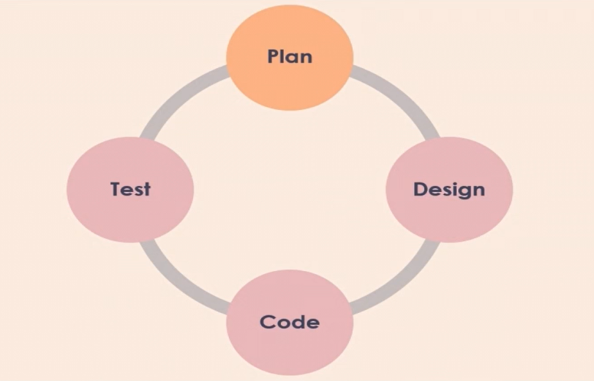

* Planning: The purpose of this planning session is to get a good breakdown of development tasks and an estimate of effort. If the development team can't do that, then they need to ask the right questions to the customer to make sure that everyone has the same shared understanding. The output of the planning phase is a shared understanding of the work that needs to be done.
* Designing: During the design phase, the development team figures out how to do what the customer wants. Sometimes the design phase can be satisfied by a simple conversation between the team. If there's a fairly well-understood mechanism for achieving what the customer wants, the team can simply agree to implement that pattern, and the design phase is complete. The output of the design phase is a design for achieving the requirement that the entire team agrees to.
* Coding: When coding starts the team should have a very good idea of what they're going to do and how they're going to do it. The coding phase can still include lots of investigation, tweaking, and just generally figuring things out. The output of the code phase is then naturally a completed, compiled, usable output that can be executed by whomever or whatever actually needed to use it.
* Testing: During the testing phase sufficient tests should be created, usually automated tests, to validate that the code is functioning as it should. The output of the testing phase is confidence that the requirement has been coded correctly.
* Feedback: Technically there's another phase in XP, and that's Feedback. One way to get feedback is through customer acceptance tests and other is to get the feedbacks from stakeholders like the project manager. The feedback can be on changes or misused cases. So, getting the stakeholders feedback is just as important as getting the customer feedback.

**Planning Game Practice**

One of the features of XP is its planning process known as the XP planning game. The planning game starts with

* Organizing a meeting with the development team, customer, and stakeholders. It’s typically run at the beginning of the project, and then at some logical cadence after that. Some teams run it every sprint and some run it less frequently. The purpose is to make sure everyone's on the same page.
* The purpose of the planning game is to of course plan, and that plan helps to make sure that everyone's on the same page by having an improved design, and that helps to make sure that the team delivers quality.
* Another thing that the game does is it helps to promote effective project management. Even though the development team doesn't really concern itself with project management per se, the business does.
* The XP planning game breaks down into two parts, release planning and iteration planning.

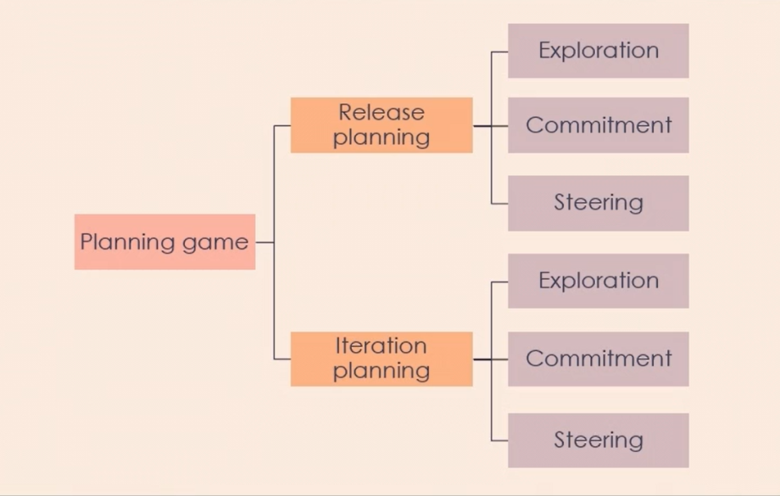

The first part of the planning game is Release Planning. This part of the game includes the customer and developers. The aim of this part of the planning game is to come up with a plan and even a schedule for the releases that the software is going to have.

The first Phase of the Release Planning is Exploration. This phase asks and answers the question, what software are we going to produce? Now, this doesn't have to be a fully-featured piece of software either. It can be a version that includes basic features that everyone agrees will satisfy some base requirements of the customer.

Next is the Commitment Phase, this phase is where the development team agrees to include certain functionality in a particular release. In other words, they commit to producing a release that includes the features the customer and developers discussed and agreed upon. Now that commitment ideally also includes a release date, and this can be a target release date. The collective group has discussed and agreed-upon what the release will include and how that will be done, and the team has a good idea of effort, and so estimates can be made, so the team collectively agrees to a targeted release date.

The last phase is the Steering Phase. In this phase, the team can discuss adding requirements to the software in this or later releases, and this is done by having the team review the existing plan and see if there's room for improvement.

The next part of the XP planning game is the Iteration Plan. The iteration planning breaks down into the same phases as the release planning.  An iteration is a constant and repeating period of time in which work is completed. In Agile, we often refer to an iteration as a sprint.

The first phase in the Iteration Planning is the Exploration Phase. In this phase, the development team will start to create and refine user story requirements. The team considers the stories from a technical point of view and starts breaking down the work. In fact, the team specifically works to break down the customer's requirements from the stories that were created into tasks. Then the team creates task cards. Now, a task represents an item of work that a single developer would perform within a single iteration. They're typically small and only about one thing. From a requirements perspective, all of those tasks need to be completed for the requirement to be production-ready. But from a development perspective, these tasks are distinct units of work that could each be taken on by different developers.

Next comes the Commitment Phase. In this phase, the development team, armed with the tasks that they've created, will self-organize and assign tasks to each other. The development team is handed work and they decide amongst themselves how best to divvy out the work. As a part of the assignment process, the team also determines the durations for the work. Developers only work a certain number of hours so the work needs to fit within those hours and ideally be equally divided amongst the team members, and this is sometimes referred to as capacity planning.

Last is the Steering Phase. In this phase, the development team completes the tasks in the iteration and then sits down to review how the iteration went. This process is sometimes referred to as the sprint review and sprint retrospective. The team uses the opportunity to validate the overall design of the software and make sure that the software is working as it should.

Then the design is evaluated against where the plan suggests it's going. Now, all of that is reviewed and the team decides if any adjustments need to be made. Now this can include some simple refactoring, but it can also include a total change in direction for the software as a whole. Simple changes can be fed back into the iteration planning, but anything significant that could affect the releases should be fed back into the release planning.

**Pair Programming Introduction**

Pair Programming Characteristics

* Two programmers
* Shared workstation
* Regular role switching

Pair Programming Benefits

* Increases quality of code
* Grows collective team knowledge
* Enables skills transfer to more inexperienced developers
* Reduces coordination efforts
* Improves coding resiliency

Pair Programming Disadvantages

* Requires active engagement by both participants
* Potential cost increase
* Requires good communication
* Requires good relationship between participants

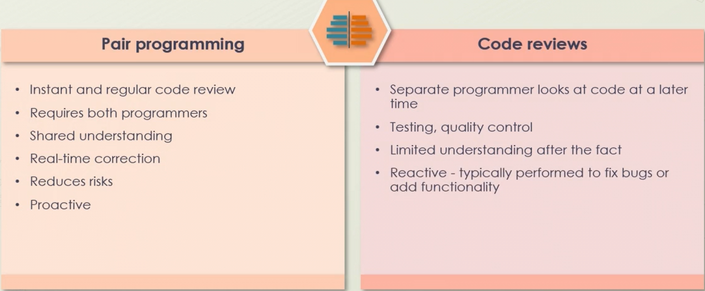

Pair Programming is an instant and actually quite verbose code review. Pair Programming naturally requires both programmers to be involved. So that means that the code review has two sets of eyes right from the get-go. Pair Programming also results in a shared understanding of the code that was written and why it was written that way, and because Pair Programming is being coded in real-time, corrections that would normally happen as a result of a code review also happen in real-time.

Pair Programming reduces risks that can come of code reviews. Consider that the Pair Programming scenario requires a shared understanding. Well, with a code review, someone writes the code and then someone else comes in after and reviews it. That shared understanding isn't necessarily there. So there's a risk that the code review doesn't catch something that it should or flag something that it shouldn't, and of course, Pair Programming is reviewing code in real-time. So the resolution prompt is actually proactive.

Now with code reviews on the other hand, a separate programmer looks at code at a later time, and that can sometimes be an advantage, because they aren't biased in their review, and code reviews are really good for testing the code in making sure that it's meeting the quality standards of the company. Now one disadvantage of code reviews compared to Pair Programming, is that there's limited understanding of what was done simply because they weren't involved. Sometimes that's a good thing, but other times it can make it difficult to understand why certain things were done, and of course, code reviews are reactive, the code was written and submitted. So the reviewer is seeing code that's already been completed, and then flagging things for repair.

**Effectiveness of pair programming**

* Can be advantageous if used correctly
* Requires understanding different styles and how they each work
* Different scenarios require different styles of pair programming
* Six common styles of pair programming

In fact, there are six common styles of Pair Programming, unstructured pairing, driver navigator, backseat navigator, tour guide, ping pong pairing, and distributed pairing.

**Unstructured Pairing**

The first Pair Programming strategy to talk about is called Unstructured Pairing.

Essentially, unstructured pairing is an approach that includes a lot of trial and error. The developers work together to continuously refine the technique as needed. Even if something works the developers may still choose to refine it to make it better.

The very first thing that you need to do with the unstructured pairing, is simply work towards making the thing work, and then, you can refactor it to make it right.

**Driver-Navigator**

This strategy involves two developers working together, where one is driving the work and the actual code base, and the other is navigating the requirements and how best to solve the problem holistically, and they can switch between each other as well.

Now the driver is focused primarily on the **tactics** of the work. The driver will be concerned with the mechanics of the code itself, and generally, the driver is the one actually writing the code. Meanwhile, the navigator is focused primarily on the **strategy** of the work.

The driver might focus on how to actually implement that capability and make it work. Meanwhile, the navigator might also consider the consumers of the API and how they would interact with the new feature. So, the driver will focus on making it work, while the navigator will focus on making it right.

**Backseat Navigator**

The backseat navigator approach is very similar to the driver navigator approach.

With the backseat navigator style, the driver still has a primary focus on the tactical aspect of the work to be done.The driver will still be concerned with the mechanical implementation of the solution in the actual codebase.

Now,the navigator is still focused on the big picture strategy of the solution in general. But the big difference between the driver navigator style is that in the backseat navigator, the navigator can actually wear the driver hat too.

So that means that the navigator has both a tactical and a strategic focus. Now you'll generally find that developers can't help but get involved in code.

**Ping-Pong Pairing**

With the ping-pong strategy, one developer creates a test for desired capability, and this test will fail, but that's on purpose.The developer is creating a test that must be satisfied before the code can be considered valid.

Then, the second developer sets to work on creating the necessary capabilities that result in that test passing, and once the test passes, the developers switch role.

So, the second developer will now write a failing test for a new capability, and the first developer will work to making that test pass.

This strategy works really well, when both the developers involved are experts. It can be done with a novice, but the novice will likely need guidance.

**Distributed Pairing**

With the distributed style, the programmers are actually in geographically different locations and conduct Pair Programming tasks using collaboration software.

**Test-Driven Development**

Test-driven development, or TDD, is a methodology used to help greatly improve the quality of the software being built. The idea with TDD is that you create the test that prove that the software is working before you create the actual software.

If all the tests pass, it means that the software is meeting the quality bar that you've set for it. TDD will be very difficult to achieve.

Now TDD can be broken down to three tightly interwoven elements.

* **Design.**
* **Coding**.
* **Testing** (the key piece)

**TTD Benefits:**

* Helps you build early bug notification capabilities
* Increased design efficiencies
* Provides refactor confidence
* Enables collaboration
* Reduces debugging and development time

**TTD Levels:**

1.Acceptance TTD’s

2. Developer TTD’s

**Comparing of testing approaches:**

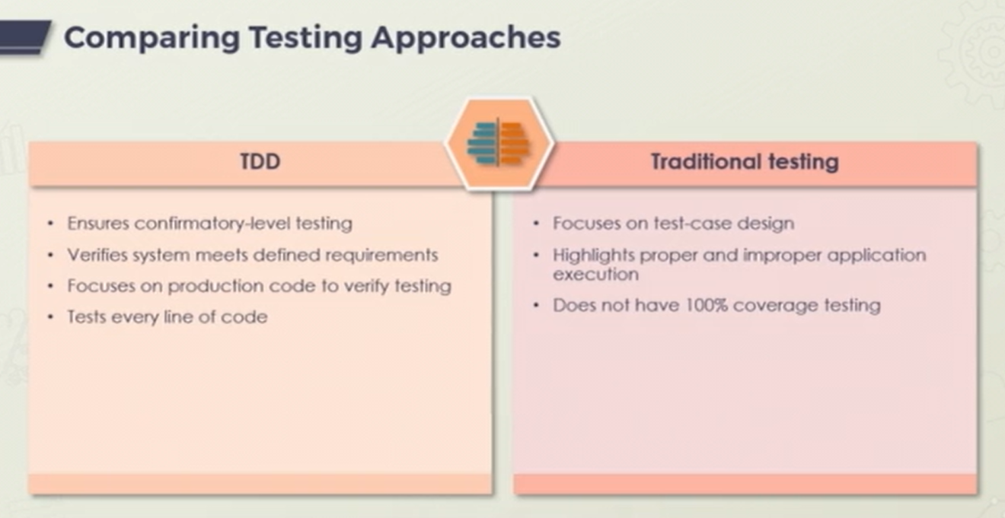

**TTD Considerations:**

* Not foolproof
* Slower process
* Requires full team collaboration
* Requires test maintenance

**TTD’s Development Best Practices:**

* No production code until failing unit test
* No extraneous unit test code
* No extraneous production codes

**TTD Life Cycle**

One of the main goals of TDD is to make sure that the code is as efficient as possible.

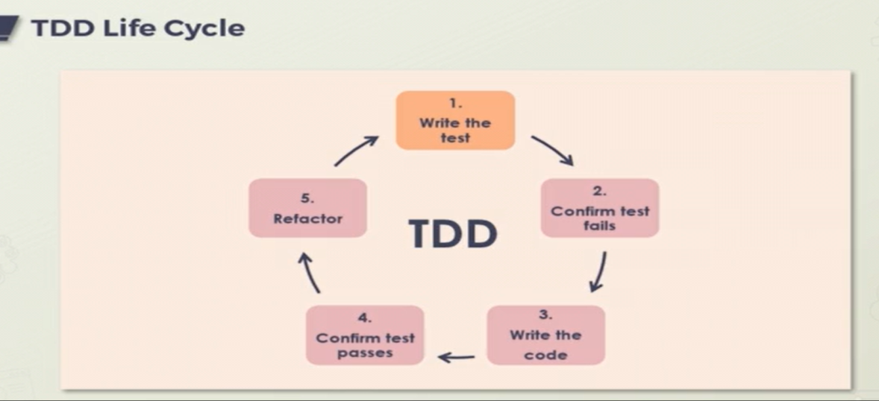

The first thing that's done after we have a design, of course, is to write the tests. With TDD, development is driven by tests.

So naturally, the first thing we want to do is **write tests**. Importantly though, the tests are as succinct as possible. They test a very specific feature and they don't have a lot of cruft. Point is that if the test passes, you can be satisfied with whatever release that would come with it.

The next step in the TDD life cycle is that the tests you write must all fail, that's right.

You have requirements and then you create tests that confirm whether those requirements have been met. But of course, they haven't been met yet.

The simple concept of TDD is to write and correct the failed tests before writing new code. This helps to avoid duplication of code as we write a small amount of code at a time in order to pass tests.

**Customer Role in Extreme Programming**

In the extreme programming paradigm, the customer role is extremely important.

In fact, the customer role is so important that they must always be available. As a role, the customer is the one that has all of the information.

The development team can always figure out how to make things, but it's the customer that tells us what needs to be done, and critically, why it needs to be done.

Ideally, the customer is so involved that they're actually considered to be part of the development team.

**Extreme Programming Values and the customer:**

The customer obviously won't be doing any actual development, but they engage quite heavily in the process. So, that could be stand up meetings, backlog refinements, reviews, or just ad hoc meetings to discuss strategies, designs, and ask questions in general. If the customer isn't available to answer questions like that, then the development team is stuck.

The XP also prefers a test-first programming strategy. This doesn't always have to be the case but it can drastically improve the quality if done right, and finally, like all Agile methodologies, XP practice demands an incremental design.

**Extreme Programming Principles:**

* Rapid feedback
* Assume simplicity
* Incremental change
* Embrace change
* Quality work

**Extreme Programming Practices:**

* Whole team
* Sit together
* Informative workspace
* Energized work
* Pair programming
* Stories
* Weekly and quarterly cycles
* Slack
* Ten-minute build
* Continuous integration
* Test-first programming
* Incremental design

**Source control management Tools:**

Source control management or SCM, and the various associated tools that go with it, is probably the single most important thing you can implement in your development practice.

SCM can be used to track work, track code, and just manage your source altogether.

The main thing is that it can help you with version control.

SCM -The process of using tools and track code and maintain code change history.

One of the main benefits of Source Control is that it lets you maintain a single source of truth.

**Source Control Benefits:**

* Maintains single source
* Facilitates collaboration
* Accelerates velocity

**SCM Best Practices:**

* Select the most appropriate system for your needs.
* Store your code directly in the system
* Always pull latest versions of code.
* Ensure you commit code often, including details.
* Make use of branches for parallel work.

**Common Source Control Management Tools:**

* Git
* Perforce Helix Core
* Subversion
* ClearCase
* Team Foundation Server
* Mercurial

**Source Control Tools**

1. We're going to use our browser and head over to GitHub.
2. We're going to create a brand-new repository. To do that, let's click on the Create repository button in the left-hand side of the screen.

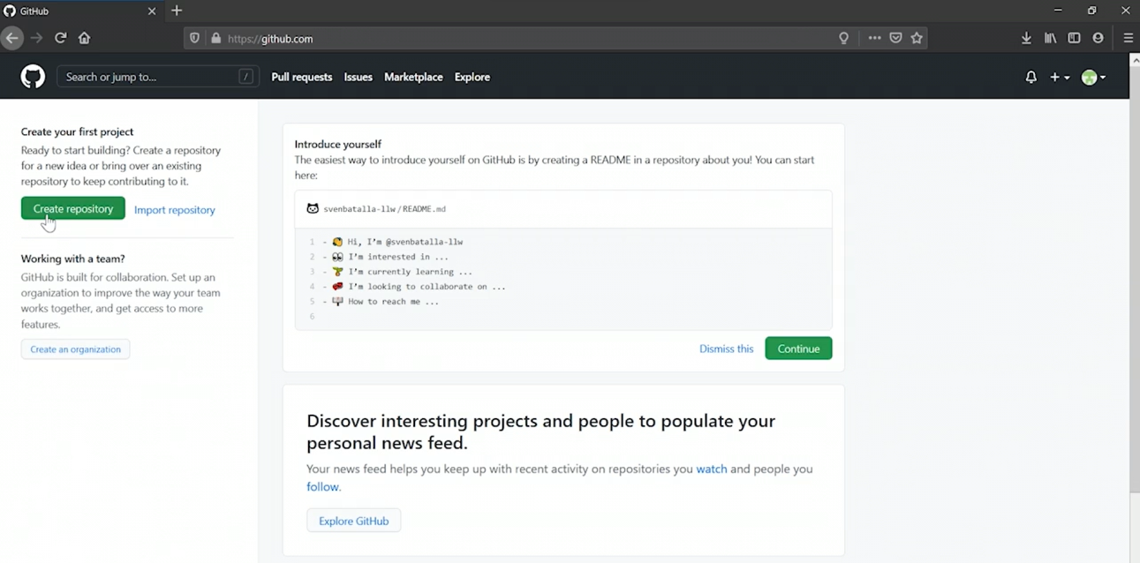

1. Now that takes us to a screen where we can give our repository a name and set some other criteria.
2. Name the repo as repo02. Now we can choose if the repo will be Public or Private.

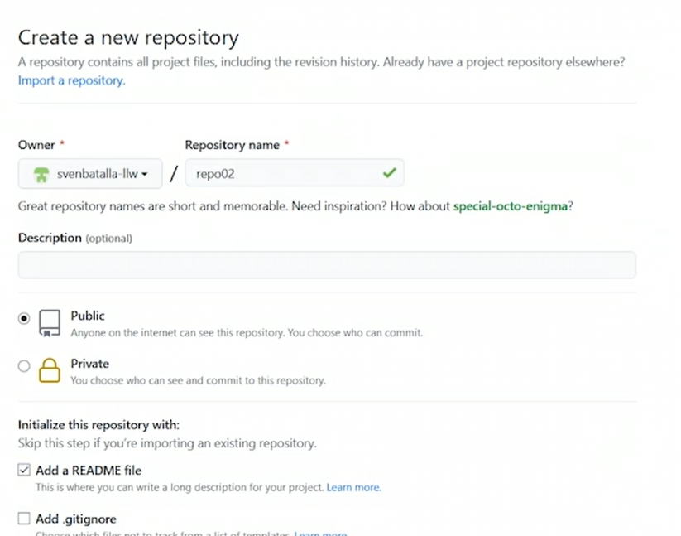

1. Choose to initialize my repo with a readme file. Now we can scroll to the bottom of the page and Click the Create repository button.

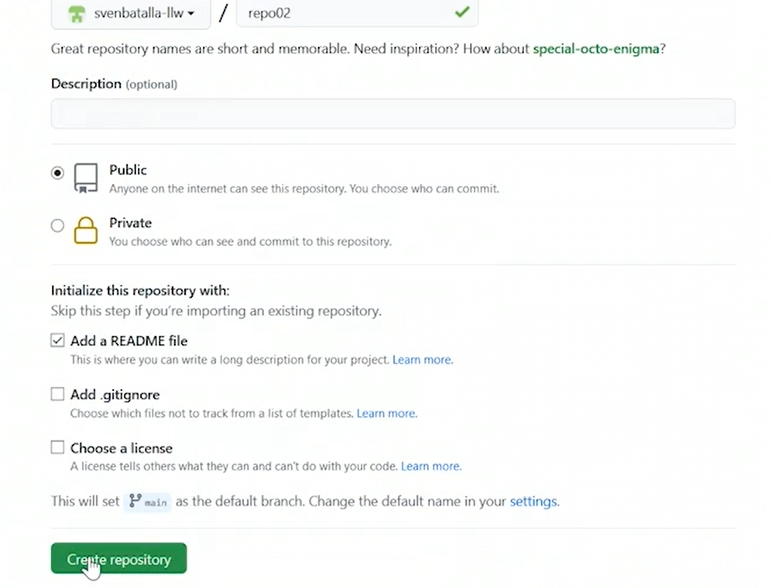

1. Now the main branch is the root branch. Open GitHub Desktop.
2. We will clone the repository from the internet because the repo is in GitHub.
3. So, click on the Cloner repository from the Internet button. Now, this pops up a dialog that allows us to clone a repo. Now you'll see right in the middle of the screen that repo2 now appears in the list.
4. Click on it and now we can set a local path. So, click Clone at the bottom of the dialog. Now at this point, the repository has been cloned to the local system.

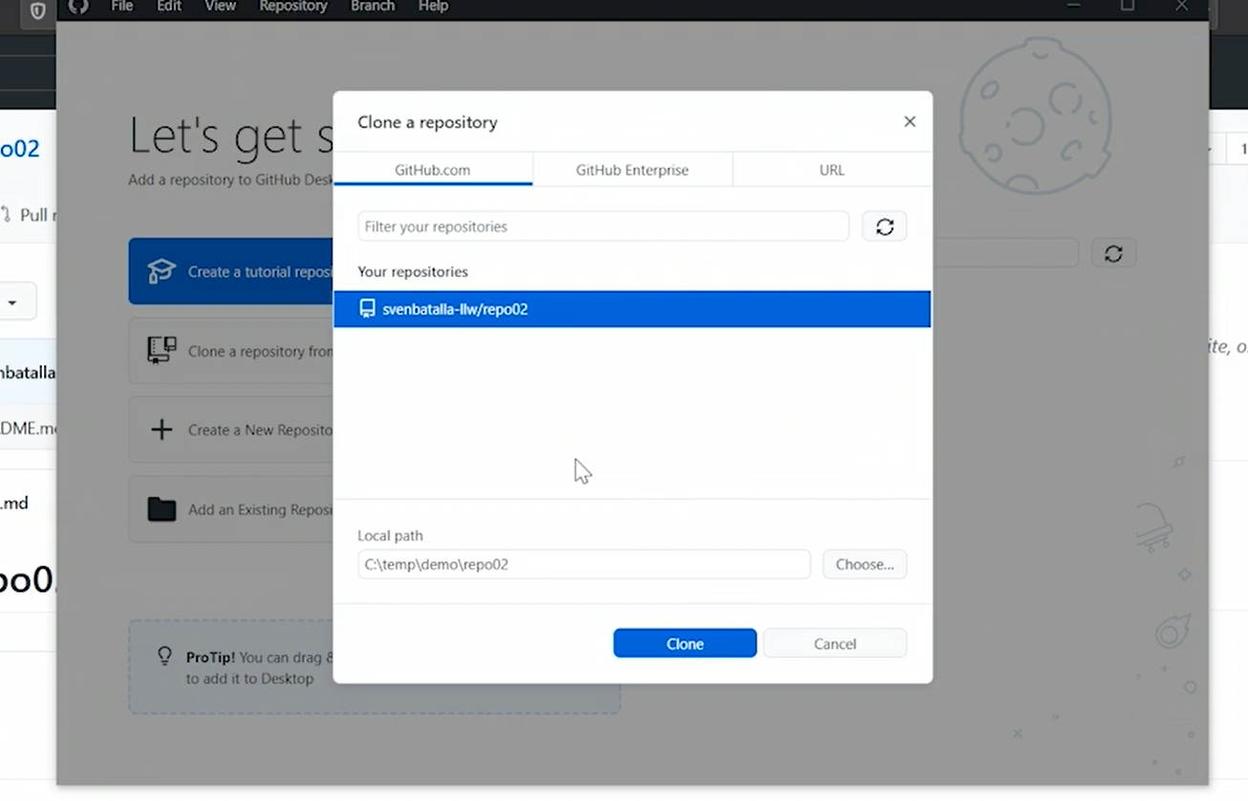

1. Click on the Current branch pull down at the top of the screen. Now this lists all the branches in the repo and notice that we only have the main branch here. Click on the New branch button.
2. Name the branch task-123/initial-skeleton.

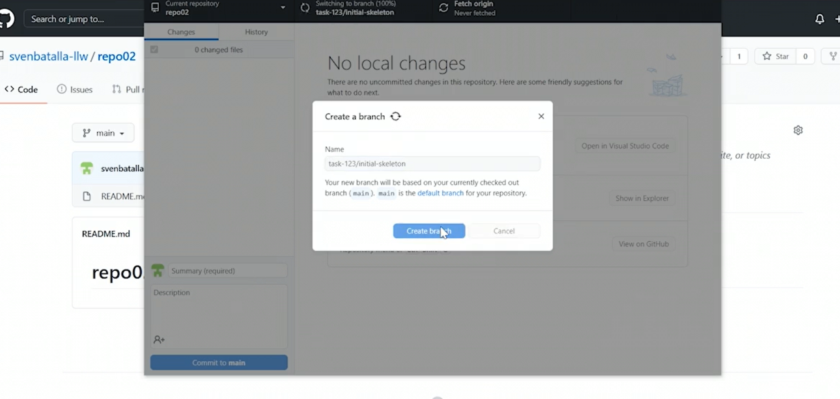

1. Click on the Create branch button. Now notice that there's now a published branch button on the screen and that's because this branch is actually local to my computer and not visible to anyone else.
2. Now click on the 1 branch button in the toolbar. Notice that there's only one branch listed here and GitHub. Now let's go back to Git desktop and click that Publish branch button. Now let's go back to GitHub and refresh that page. Now we see the branches, we're ready to write some code.
3. So in Git desktop application, Click on the Open in Visual Studio Code button, and that will open Visual Studio code inside my local repo folder. Now use the terminal to create a console application project.
4. Click on View, Terminal, and type dotnet new console, and hit Enter. So now we can see in the terminal that Hello World! was output.
5. Click on the little branch icon on the left side of the window.

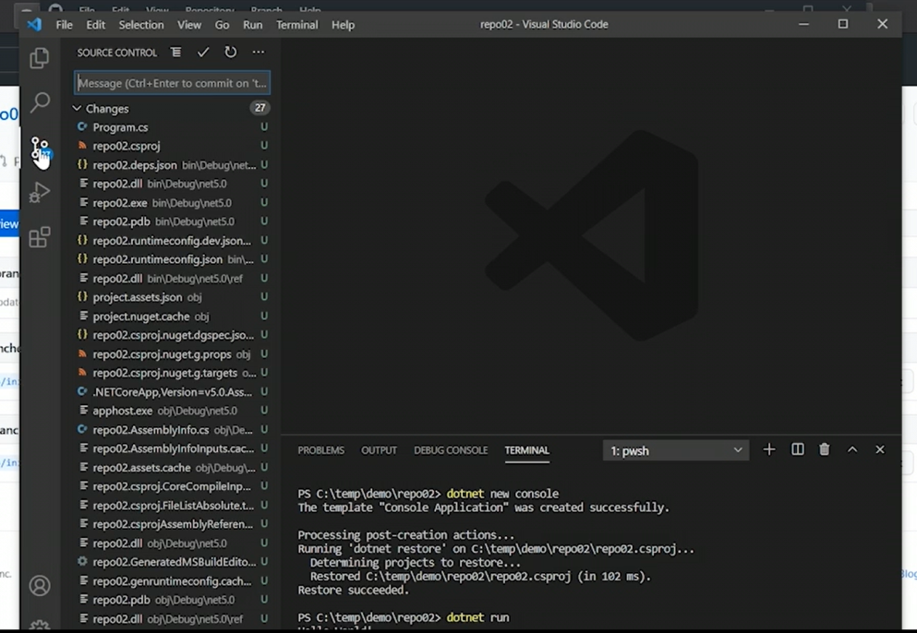

1. Go back to the file list and click to Add a new file by clicking on the New file button above the file list. Now call the file.gitignore. Now this is a special file that tells git, which files or folders that it should ignore when committing files to the repository.
2. In this file, list some of the folders that we don't want to include in our repo mainly, we don't want that bin and obj folder.

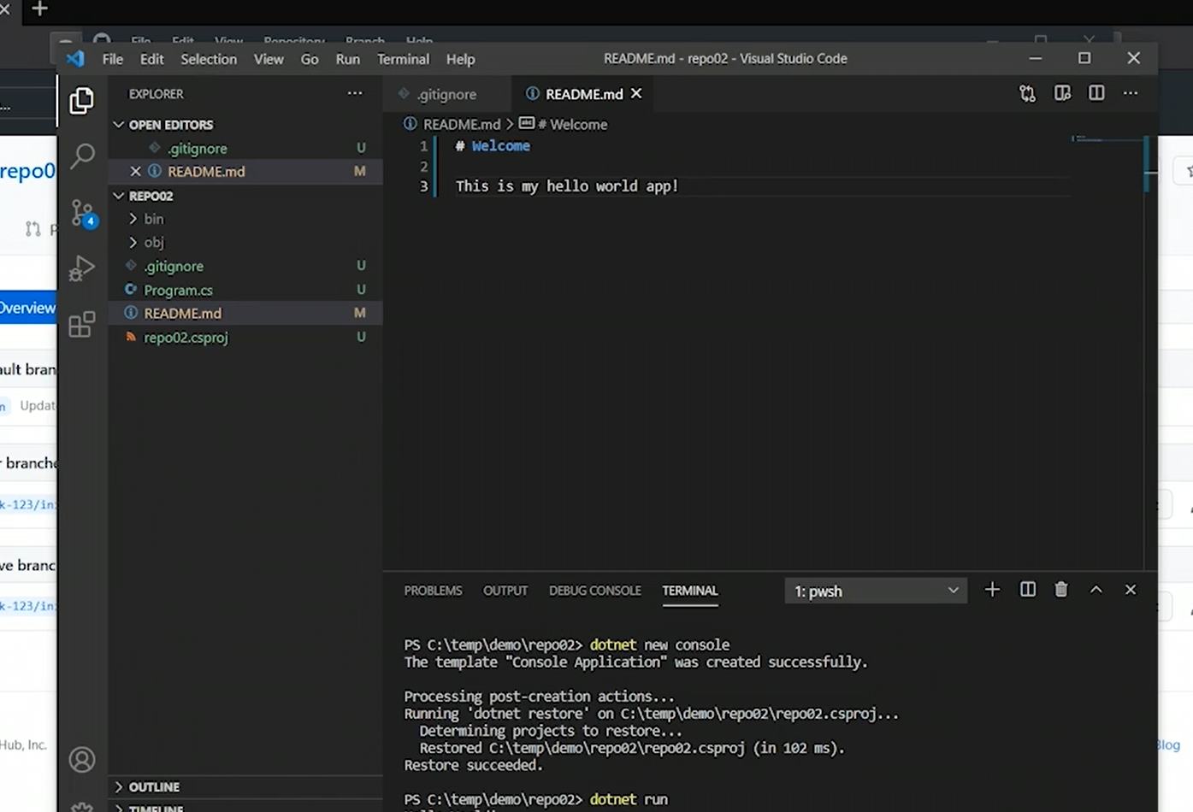

1. So, type those out on two separate lines bin, obj and now we can save the file, and look, now it only lists three files that need to be sent to the repo.
2. Click on the Readme page. Change the text to # Welcome, and then on the next two lines type This is my hello world app! and then click Save.
3. At the bottom of the screen, let's type a message about what we did here in the summary text field. Now we can click on the Commit button below the text fields. Now let's go back to GitHub. Click on our branch, to look at it. Notice that our files aren't there.
4. Well, that's because the files were committed to our local repo on our computer, not the central repo. So, to do that we need to push our changes to the central repo.
5. So let's head back to our desktop app and notice that we're presented with a button called Push origin in the middle of the screen. That will push our changes to GitHub. So click on it.

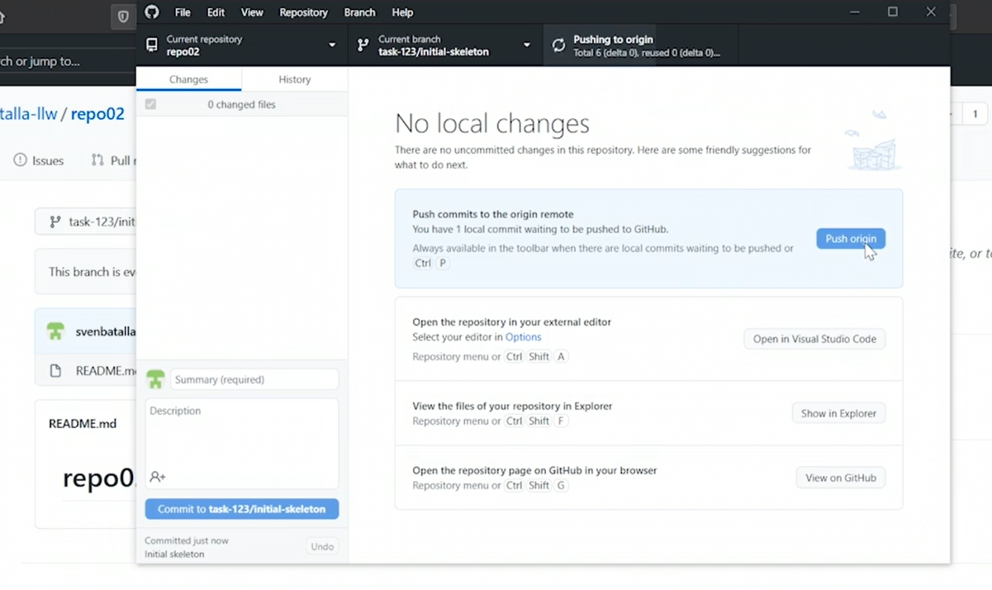

1. Now the last thing that needs to happen is we need to get our changes into the main branch, that's where production code is. So to do that, you need to pull the code into the main branch. To do that, you need to create a pull request.
2. Now notice that GitHub is all helpful and has shown us a Compare & pull request button at the top of the screen. So click on it. Now at the very top of the page, GitHub is showing us that the intent of this pull request is that we're attempting to merge the code to the main branch, that's correct.
3. In GitHub give name to our pull request and give it a description, and leave the defaults,
4. And notice on the right-hand side of the screen that we can choose specific people that we want to review the code or specifically, assign to the approval process.
5. So click on the Create pull request button at the bottom of the screen. Now in the pull request, we can review the code before actually merging it to the main branch.

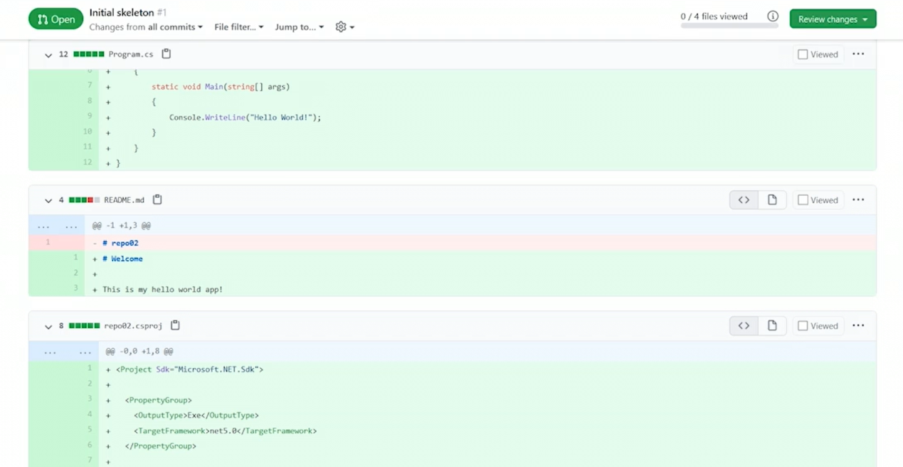

1. So, click on the Conversation tab.
2. Now scroll down a bit and click on the Merge pull request button. Now GitHub asks us to be doubly sure and confirm the merge. By clicking on the Confirm merge button, the code is now merged with the main branch and the pull request is done.

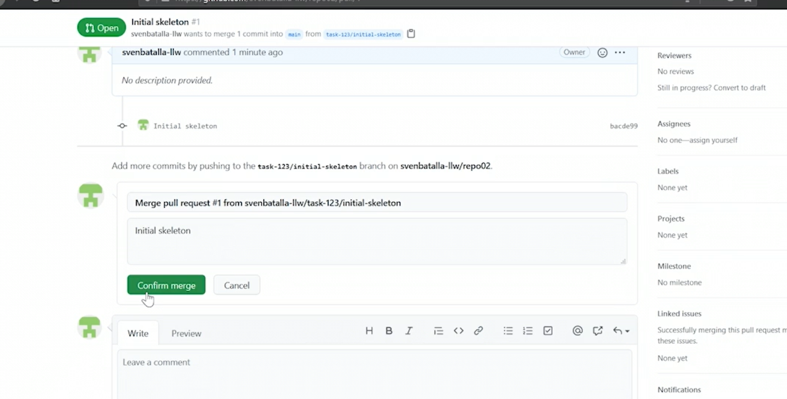

**Continuous Integration**

* Continuous Integration or CI is a natural and logical progression of source control management and agile processes like XP.
* CI is the process by which code is automatically retrieved from the code repository, and compiled, tested, and packaged every time a commit is made.
* CI will help prevent developers from stepping on each other while they're coding, and if there's code overlap, CI will call that out pretty quickly. But one of the main benefits of CI, particularly when coupled with continuous deployment or CD, is that it helps to eliminate integration issues.

**Benefits of CI:**

* Rapid time to market
* Faster development life cycles
* Increased quality
* Increased code stability
* Better risk mitigation
* Increased flexibility
* Efficient on-boarding

**Risks in CI:**

* Costs for maintaining and managing
* Requires established guidelines before use
* Lack of expertise
* Requires full test coverage
* May misguide team focus

**Best Practices in CI:**

* Frequently commit code
* Categorize developer tests
* Use a dedicated machine
* Integrate continuous feedback
* Stage your builds

**Continuous Integration in Action:**

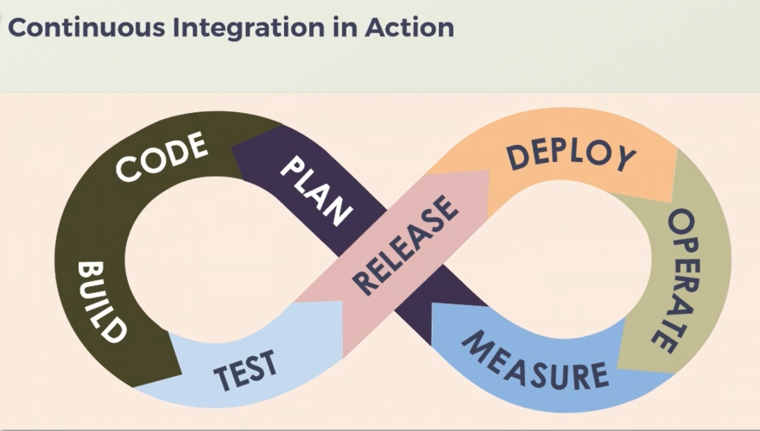

**Using Continuous Integration Tools**

1. Head over to our GitHub repository in our browser.
2. Click on the Actions tab.
3. Scroll down and find the .NET workflow.
4. Click on the Set up this workflow button. So now GitHub has created a new YML file that represents the actions that need to be performed to compile our .NET application.

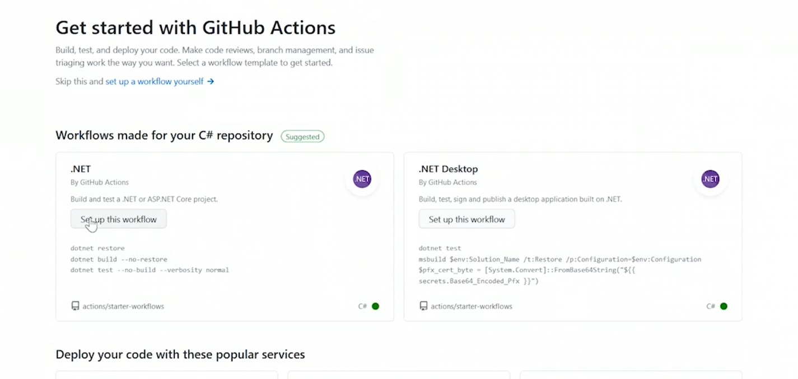

1. At the top of the file, we can see a section called on. Here, the file specifically says that it will be triggered on the main branch, and that's perfect.
2. Click on the Commit new file button at the bottom of the pop-up. So now the file is complete.

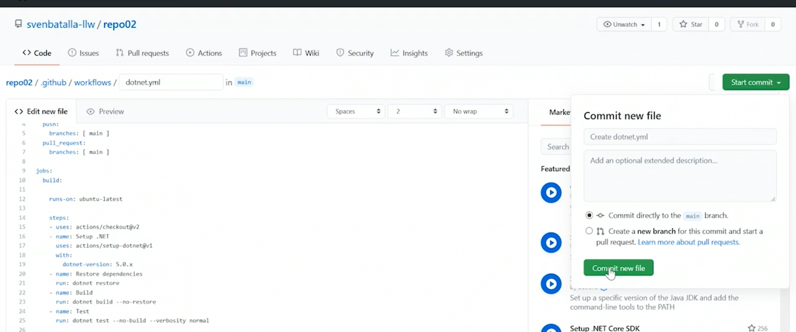

1. Well, if it worked properly, it should actually trigger the action it's described. Click on the Actions tab at the top of the page again. We can see a list of workflows and check it out, our workflow is running, so let's let it finish.
2. Now that our workflow is done, click on it. So now we see that the workflow is triggered when code was pushed to the main branch. We see the workflow was a success, and we see that the workflow included a job action.

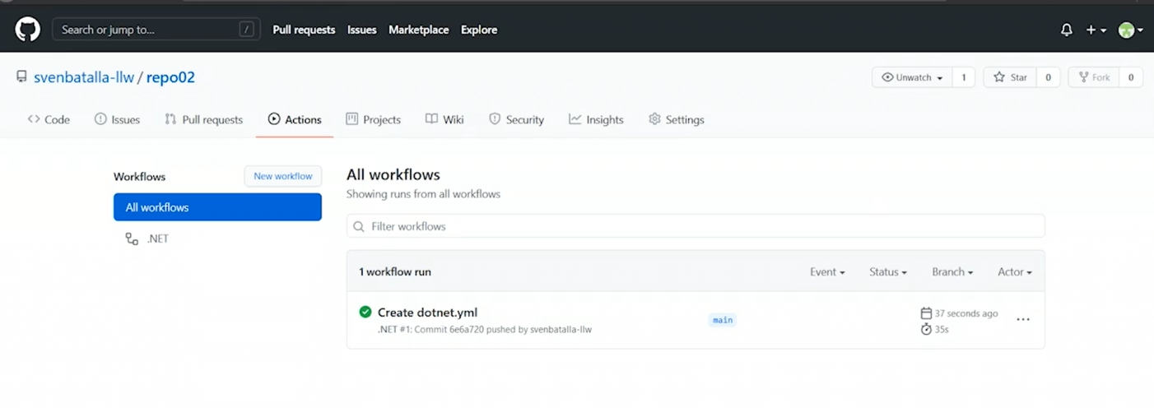

1. Click on the build job.We know this is a console app so we can cheat here. So add a step that outputs the Hello World text to our build output.
2. So go back to our code. Now click on the workflows folder, and click on the dotnet.yml file, and then click the little pencil icon to edit the file. Now scroll down to the bottom of the file.
3. Now add another step. We can do that by moving down to the next line and typing - name: See output. Make sure the text aligns with the other steps.
4. On the line below that type run: dotnet run, and again, make sure that aligns with the other run steps. Now commit the file by clicking on the Start commit button in the top right again.
5. Now give some text to this particular commit and type Added output step, and commit the change by clicking on the Commit change button.
6. Now head over to the actions and click on the running workflow. If we expand the See output section, we'll see our text from our app.

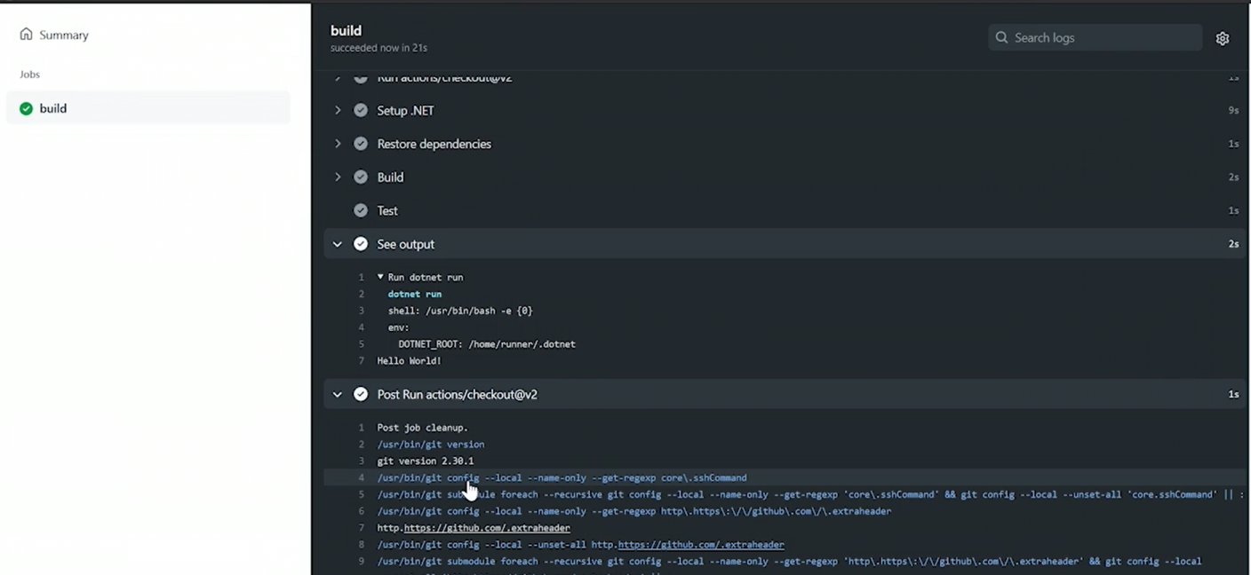

1. Go back to the code tab and click on the Program.cs file, and click on the pencil to edit it.
2. Nowjust change the code a little bit,remove the semicolon at the end of line 9. Now, this is bad code, this won't compile now.

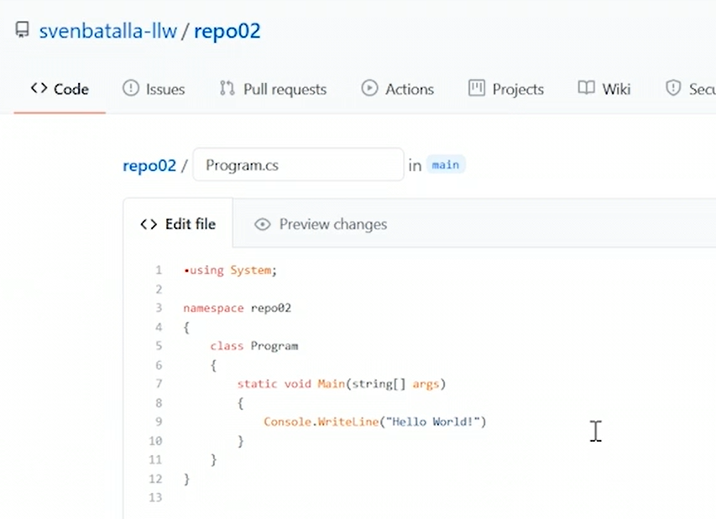

1. Scroll to the bottom of the page and commit this file.
2. Now head over to list of workflows, and watch the build. Now we see the workflow failed, so click on it, and we see our build job failed, because the semicolon was expected.

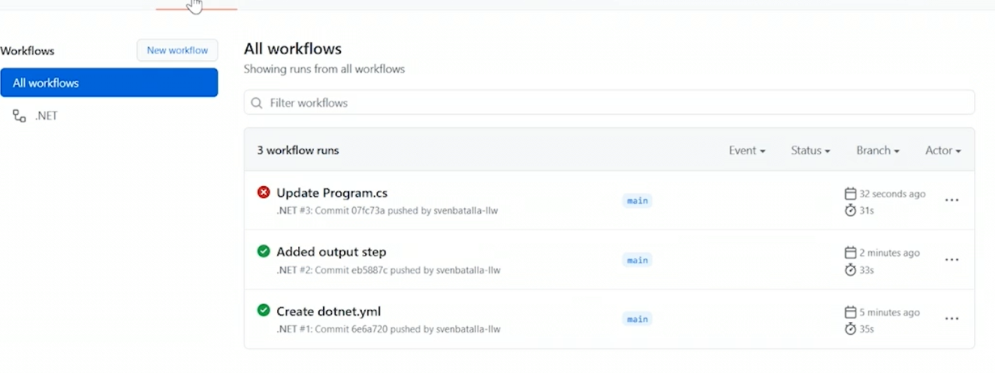

1. Go back to the Code, and click on the Program.cs file again, and the pencil to edit, and now restore the semicolon, and now scroll to the bottom of the page and commit the file, and add the text Fixed missing semicolon.

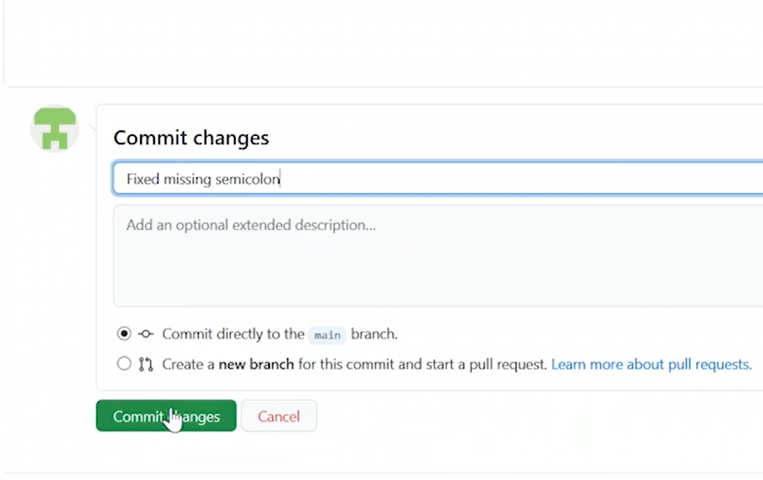

1. Now go back to our workflow and watch again. Success, so that's how you create CI in GitHub. You can see that you can create as many steps as you want to do all sorts of things. You can also have it trigger automatically whenever changes are made to your code.

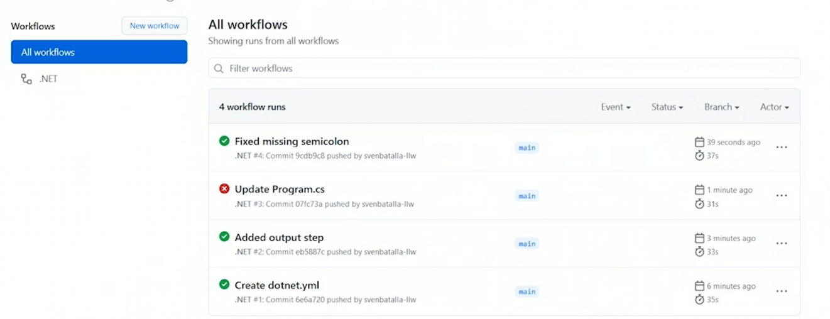

**Coding Standard Practice and Benefits**

* If everyone writes code the same way with the same patterns, formats and methodologies every single time, the likelihood that your team will produce consistent results is greatly increased.
* Coding standards also drastically improve the manageability of your code.
* Well, having code standards will naturally reduce the rates of failure.
* Suddenly, all your code will behave the same way when it comes down to handling errors. Standards also dictate all kinds of things that can simplify debugging.
* This can also include how to structure methods so that they're easier to read or apply breakpoints. It can also include how and where to put logging statements.
* Then because of the guidance in the code standards and an adherence to those standards across the board, development time will be optimized.
* There are just some things that you don't have to figure out how to do because the standards will tell you how to do it, and one more benefit of coding standards is to help control costs.

**Coding Standard Benefits**

* Reduced rates of failure
* Simplified debugging
* Development time optimization
* Cost controls

**Coding Standard Categories**

* Now Coding Standards have many Categories. One of those categories is that the standard is mandatory.
* When the corporate coding standards document says do not suppress exceptions, that's a mandatory rule. So if code is written that suppresses an exception, then it would fail a code review and not be allowed to be merged into the main production code branch. But not all coding standards are mandatory.
* Some coding standards are categorized as guidelines.
* Now, recommendations in a coding standard aren't mandatory either, but they're pretty close. The idea with a recommendation is that it should be followed at all times, unless there's an exceptional reason to do it.

**Standard Elements in Coding:**

* Format
* Code structure
* Naming convention
* Error handling
* Comments

**Coding Standard Best Practices:**

* Understand the purpose
* Consider your industry
* Comply with rules and follow recommendations
* Describe intent
* Update carefully
* Consider open vs. closed
* Prioritize rules
* Plan for deviations
* Educate others

**Collective Code Ownership**

* One thing that often gets forgotten by development teams is that it's the team that produces a quality product, not an individual, and that's hugely important, it means that there's a collective ownership of the product and its code.
* If the product is good it's because the team did a good job. If the product has issues it's a team that's accountable to resolving the problem.
* At the end of the day what that means is that every team member is equally responsible for the product, and that's a good thing, it means that other departments, managers, customers, and stakeholders in general, are going to look to the team to solve a problem.
* If someone is away or doesn't know how to do something that's not an impediment. The whole team is responsible and accountable.
* But one of the best things about collective ownership is that it eliminates critical knowledge silos. The last thing you want in a development team is siloed knowledge.
* If we eliminate siloed knowledge, then what we're actually doing is we're promoting collective learning. The whole team benefits from learning about things.

**Knowledge Sharing**

* Eliminates critical knowledge silos
* Promotes collective learning

**Code Excellence:**

* Increased quality
* Style efficiency

**Removes Dependencies on Individuals:**

* Eliminates the risk of the 'lottery effect'
* Promotes collective responsibilities

**Greater Learning Scope:**

* Continuous learning
* Shorter learning time

**Collective Ownership Disadvantages:**

* No individual ownership
* May hinder motivation
* Relies on team expertise
* Not suited for specializedfunctions

**Code Refactoring:**

* Refactoring is the action of editing code without making any actual changes to its overall function.
* Refactoring means that you can completely rewrite the internals of a method, but the function would remain the same.

**Code Efficiency**: There are many reasons to refractor code, and one of the most common reasons is to increase code efficiency.

**Bug Prevention**: Another reason to refactor is to help prevent bugs in the future.

For example, one thing my teams do on a regular basis is simply evergreening. That helps to avoid code rot. The idea is that periodically we open the code, update to the latest versions of various libraries and frameworks and fix any breaking changes, retest the code and commit the work back.

**Increase Maintainability**: If you don't maintain it and keep it updated, it will eventually break down and it will be much harder to fix than if you'd just done maintenance on it throughout its time.

* If we're optimizing the code and making it more reliable or more robust, then clearly the maintainability is increased.
* In fact, there are several different refactoring techniques. For example, red/green refactoring is a simple little process. The idea is to stop, red, get approval, green, and then refactor.

**Abstraction:** Refactoring by abstraction is mostly used when there's a bunch of refactoring to do.

* Abstraction involves using inheritance models and extraction. The idea is to reduce duplication in the code.

**Simplification of code**: Another refactoring method is simplifying

* Like the name implies, the idea here is to simply take the code that exists and make it simpler. Reduce the lines of code make it easier to read, extract logical blocks into testable methods and so on.

**Preparatory Refactoring:** The idea with preparatory refactoring is that while you're working on code, you may run across aspects of the code base that should be fixed. So you can make changes and resolve the problems while you're looking at that particular module.

**Moving Features Between Objects:** In this scenario, an object has gotten larger and more cumbersome. So we create additional objects and we move features between those objects.

* Once the code is re-factored it's critically important that you test it.
* Ideally, your code is decoupled and abstracted, so that you can test your code query without having to have an actual database connection.

**Refactoring in Agile Software Development:**

* In Agile, refactoring helps improve the overall consistency of the software produced.
* Refactoring also helps to increase time efficiency. By making certain parts of the code better more robust or extensible additional features or just fixing bugs is a much easier task to perform.
* **Restructuring**: One of the very first refactors that you'll do is focused on restructuring. You've got to work towards making the code more manageable and work towards standards.
* **Code duplication** :An easy place to start is to reduce the code duplication.
* **Resize Classes and Methods**: Another thing you'll do in the restructure, refractor is resize classes and methods. Those giant classes or lengthy methods can be reduced into smaller methods.
* Quite often your refactoring is about making the code more efficient, easier to read and easier to manage, and you'll find that duplication is often a contributor to the problem.
* So if you find duplicate code, one of the best things you can do is extract it somewhere else.
* For example,  Imagine you had a method that established a connection to a database. Then in another method, you do the exact same thing because that method needs a connection too.
* You can extract the connection code to its own method, and then just call that connection method from the original methods.
* That means that if there's ever a bug in the connection logic, you only have to fix it in that one place rather than all the duplicate places.
* Well, if the code is overly complex, one of the most critical things that you can do in refactoring is simply to simplify.

## The Problem

## Older code with duplication

## Updates by many developers over years

## Multiple variations for similar products

## Difficult to understand

## Starting to experience unintended side effects with new updates

**Small Releases**

* One of the tenants of Agile development methodologies, particularly with XP, is focusing on small releases.
* Each release doesn't have to be large. Each release has one objective, to elicit feedback. The smaller the release, the quicker the feedback.
* For example, Let's see you wanted a website where you can sell shoes.
* Well, the first release might be a simple little webpage that says coming soon with a picture of a shoe on it.
* The next release might have the ability to browse shoes, and the next release after that could allow you call someone to place an order for a shoe.
* Then you can add searching capabilities and then you can add e-commerce.
* Then you can add profiles, so users can save preferences, and then finally you can add AI to predict the type of shoes certain people are likely to prefer, and on and on it would go like that.
* Each release is incremental.
* Each release only has one objective, to elicit feedback, and the smaller and more succinct a release is, the quicker the feedback is, and that feedback can come from the customer or it can come from other stakeholders altogether.
* This is so counterintuitive to most business people, though.
* So you can see that with a small release, I have very little code that was changed and so my risk is totally insignificant, and finally, small releases help you build adaptability into your process.
* But you can't just start making smaller releases, you have to prepare for that. You need to plan for how your iterations are going to occur.
* Basically, you can agree to a frequency of something like once every two weeks there's going to be a release. So whatever work we finish in that time is going to be released.
* **CICD:** Another strategy is CICD, the idea here is that every code commit is a release.
* This could be meaningless to the customer, but these are micro releases and virtually impervious to huge system malfunctions if you have appropriate automated tests.
* **Plan your iterations:** Another thing to keep in mind when you plan your releases is to plan your iterations.
* Lots of companies map their releases to their iterations, sometimes called **sprints**.
* The idea in those cases is to make sure that the contents of the iteration, maps to some particular customer value.
* Generally, when we say small release, we mean that there really should be a maximum of two weeks between iterations.
* Every release should be production quality.
* By taking the feedback we get from other features that we built to that point, we can create and deploy new features more and more efficiently

**System Metaphor:**

* One common strategy with XP or really any software development methodology is to use system metaphors.
* A system metaphor is a strategy where you can change standard project architecture names to easily understood non-technical terms or phrases.
* This gets everyone on the same page quickly and allows ideas to flow with fewer hurdles.
* For example, imagine that you have a bunch of modules that are responsible for collecting data, normalizing it, and then submitting that data for storage.
* Each of those modules will be composed of various resources like executables, logs, APIs, and so on.
* It's much easier for everyone to understand if each of these modules has a name like Salesforce collector.
* It means that when you're talking to salespeople, customers, or non-technical people at any rate, everyone can be on the same page about what we're talking about without having to get technical at all.
* **Generativity:** Another goal of using system metaphors is what's called generativity.
* The concept here is that by bringing the understanding to a common level, ideas can be shared without having to have low-level technical understandings.
* System metaphors also strive to create a **shared vocabulary**.
* Finally, and critically, system metaphors help everyone to understand the fundamentals about the system architecture.
* **Disadvantages:** One is that if you're not careful it may break some cultural protocols.
* **Break cultural protocols:** Sometimes the names or descriptions we give things can be insensitive or politically incorrect even though it means that we all know exactly what we're talking about
* **Technical Conflict**: Sometimes a metaphor can create technical conflict.
* If we're talking about things at a super high level, then the abstraction from the technical could result in teams building things that aren't exactly what's required.
* **Bad Designs:**  Metaphors can potentially lead to implementing bad designs.
* So you have to be really careful about noting the difference between the metaphor and the true technical design.
* A good system metaphor should be created to give clear and concise design guidance.
* These metaphors should not be handled by a single person. This is a collaborative tool.

**System Metaphor Goals**

* Common vision
* Generativity
* Shared vocabulary

**System Metaphor Advantages:**

* Enables model comprehension
* Enables easier system understanding
* Expands range

**Applying the 40-hour Work Week**

* Agile processes require developers to work no more than 40 hours per week, or at least not work overtime more than two weeks in a row.
* By asking people to work a regular work week and not beyond, you'll find that your team members work better. That’s because people naturally work best when they're well-rested.
* So with a 40-hour work week, people can commit their work and context switch to other tasks or even away from work entirely without too much trouble, especially if that means that they don't have to come back to the same problem
* Now, having our teams limit themselves to a 40-hour work week has lots of benefits-
* One is **creativity** and when a developer doesn't crunch for 100 hours in a week, they have time to reset and re-energize.
* Now another benefit can be **cross-training**.
* If time is going to be limited, teams are more incentivized to train each other on the solutions being implemented, and one more benefit is an interesting one, **problem exposure.**
* The reputation of the company is what should be used to drive velocity, in other words, the business is not saying you must deliver X in Y amount of time.
* It is actually saying we need you to be consistent and predictable because we're making commitments based on this.
* Frequency of releases should be consistent, predictable and reasonable, and of course, there needs to be room for improvement.
* Retrospectives and customer feedback alike can be used to continuously improve the process.
* Ultimately, our objective is to improve not only the health of our team but also the product and the business as a whole.

**EXERCISE-3**

**Software Engineering Concepts you must know before doing this course**

* Phases of software development life cycle (SDLC)
* Values and principles of Agile software development

**Awareness of the following concepts are required–**

* Version control
* Programming Java web applications
* Unit testing, code coverage and build
* Quality assurance testing(QA)
* Deployment and release to production
* Maintenance and support of applications

# Instances of DevOps adoption in projects and its impact

Here is the impact of the adoption in some of the projects in the IT industry:

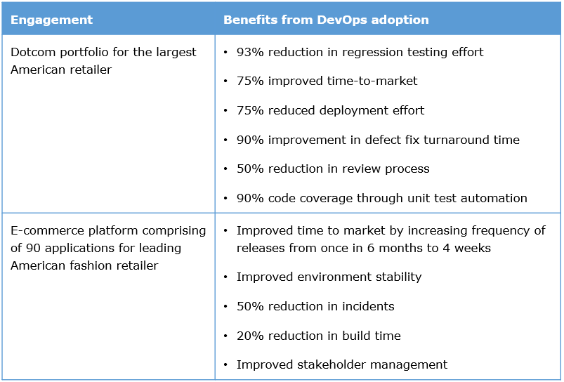

# A case study

Let us take this learning journey of DevOps through the transformation of the "Pura Vida" IT team(fictitious), a 30-year-old, pioneer international Jewellery store with the main office based out of Costa Rica and offices in 5 countries. Their IT group develops features and manages the internal systems (Vendor, Sales, reporting, purchase). "Pura Vida" has seen a dip in sales in the last one year due to competitors launching online sales and using technology to woo the customers. The IT group had also promised delivery of a new feature viz. "Pura Vida Money" to its customers. This is also delayed.

**Action taken by IT group**

* Adopted Scrum to enhance Agility of feature development and launched their online selling application in less than 2 months’ time
* Used some static code analyzer tools and build scripts which were triggered by the team manually. The technology stack used for the application development was Java

These actions did not alleviate the problems but added more. The issues and the impact is shown in the table below.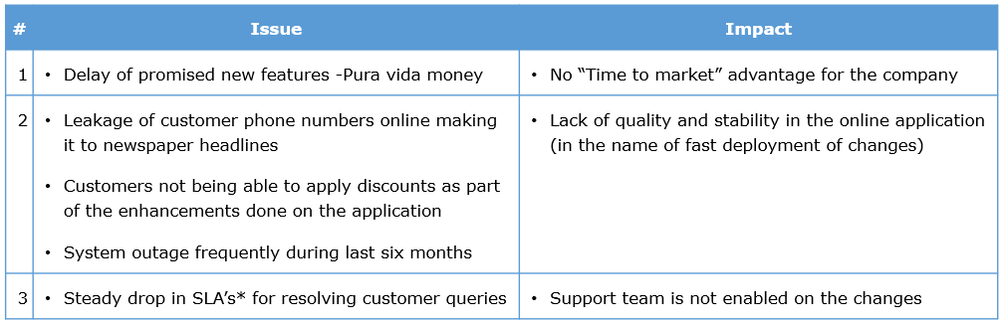

*-  Service level agreements

**Inferences**

* Adoption of Agility is not giving the “quick time to market” advantage (Issue 1 in table)
* Faster deployments are done (ex. Launch of the online application) but quality, testing, stability & reliability are compromised (Issue 2,3 in table)
* The tooling decision has not led to any speed nor quality(Issues 1 and 3)

The IT team invites a DevOps and Lean coach who proposes the adoption of DevOps to alleviate these issues. To do that, let us revisit the values and principles of Agile software development, engineering practices suggested by XP (Extreme Programming). Let us then join the dots and see how these XP and DevOps practices can help us attain, sustain and accelerate the pace of Agility.

**FUNDAMENTALS OF DEVOPS:Definitions**

**dual State of DevOps report**: The term DevOps refers to the transformation that the IT experiences when cross-functional teams develop and deliver software across the full spectrum of IT systems. From software architecture and design to system administration and production support, the term DevOps refersa style of it system

DevOps refersa style of itsystem.From software architecture and design to system administration and production support, the term DevOps refers to a style of IT management and implementation that places an emphasis on automation and iterative delivery of software, while also empowering developers to manage portions of the software delivery process that were previously inaccessible due to specialization within IT

* **Agile Admin**: DevOps is a cross-disciplinary community of practice dedicated to the study of building, evolving and operating rapidly-changing resilient systems at scale
* **Gene Kim**: The emerging professional movement that advocates a collaborative working relationship between Development and IT Operations, resulting in the fast flow of planned work (i.e., high deploy rates), while simultaneously increasing the reliability, stability, resilience and security of the production environment
* **Gartner**: Underpinning DevOps is the philosophy found in the Agile Manifesto, which emphasizes people (and culture) and seeks to improve collaboration between operations and development teams. DevOps implementers also attempt to better utilize technology—especially automation tools that can leverage an increasingly programmable and dynamic infrastructure from a life cycle perspective
* **WhatIs.com**: DevOps is a philosophy or cultural approach that promotes better communication between the two teams as more elements of operations become programmable
* **Wikipedia**: DevOps (a blend of "development" and "operations") is a software development method that stresses communication, collaboration and integration between software developers and Information Technology(IT) professionals. DevOps is a response to the interdependence of software development and IT operations

**DevOps**

* involves a collaborative working of the Development, testing, infrastructure, operations teams together with a unified process, metrics and goals
* is driven by automation
* maturity is measured by speed, frequency,stability and quality of releases

**DevOps is NOT**

* just a conglomeration of tools and their synchronization
* just having Jenkins tool for orchestration of some build activities

With parts of the IT Value Stream, being managed by different stakeholder groups / vendors, each bound by their own set of KPIs / Contracts – one cannot just rely on tools to drive collaboration. People & process dimensions are also critical.

The DevOps adoption requires focus on the People, Process and Technology aspects. The sample roadmap is provided here for your referen

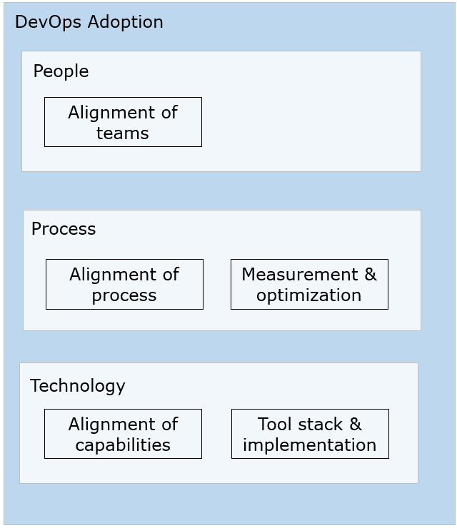

The  coach employed at “Pura Vida” suggests starting with the technology aspects.Let us look at the actions required for DevOps adoption from a technology perspective first.

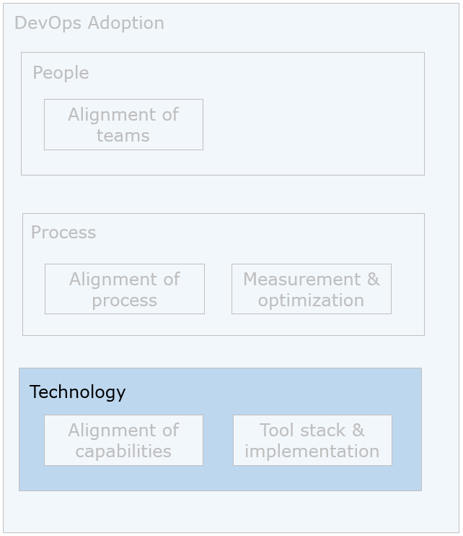

**Technology challenges in "Pura Vida"**

* Lack of automation in the software development lifecycle and hence loss of quality due to error prone repeatability of steps (ex. Tests)
* Defects generated due to inconsistent environments for testing and deployment
* Delays in testing due to infrastructure unavailability
* Brittle point-to-point integration between modules

The DevOps and Lean coach suggests the identification of capabilities to setup an automated development and delivery pipeline. The teams are asked to identify the tools to alleviate these challenges. Let us look at the capabilities to be built in and the popular tools stacks.

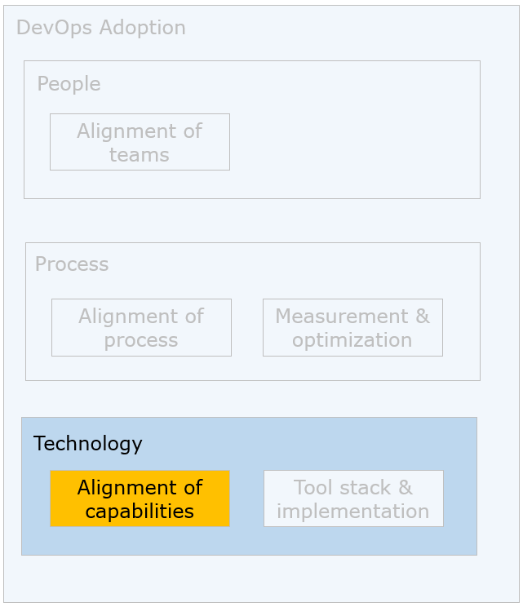

The capabilities to be aligned are shown in the figure below.

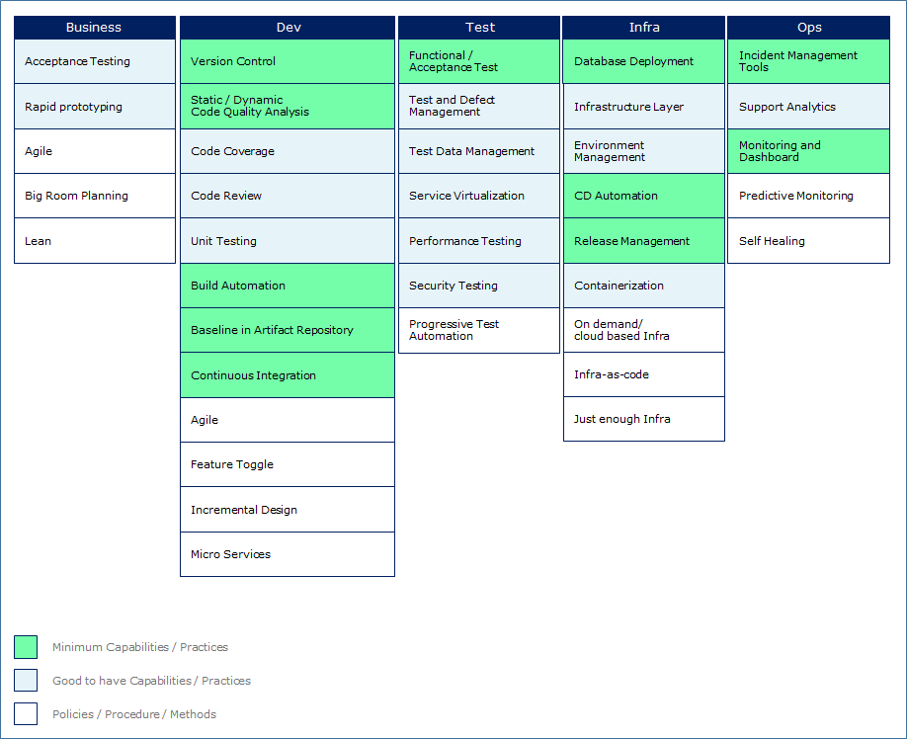

This is crucial because DevOps is a set of capabilities, across the IT Value Stream (PLAN – BUILD – RUN), which enhances Throughput, Quality & Business Value

Now that the capabilities are understood, let us look at how to use tools to actionize the capabilities in the team.

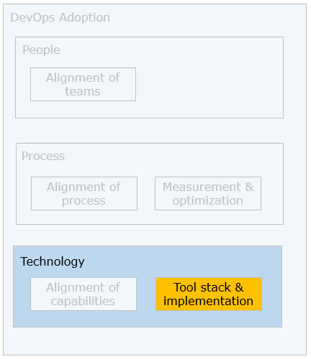

The aim of choosing the tool stack is to build an automated pipeline using tools for performing the various software development, testing, deployment and release activities. This helps in creating rapid, reliable and repeated releases of working software with low risk and minimal manual overhead. Here are the principles to be considered while choosing tools.

# Principles to be considered

* Repeatability : The automated pipeline needs to be executed frequently and multiple times with consistency
* Reliability : The automated pipeline should ensure reliable software
* End to end automation : The activities from coding to release should be automated
* 100% source control : All the artifacts involved in the pipeline need to be version controlled (ex. Source code, automated test cases, reports, binaries etc.)
* Auto build quality : Pipeline should have quality auto-built by way of gating conditions
* Done is released : Pipeline should ensure that “done-ness” as per the definition of done is only released to production
* Continuous feedback : Tools provide continuous feedback by way of reports
* Customer appetite for tooling : The availability of budget from customer, existing tools and alliances, technology used in the project, feasibility of automation

Note: Gating conditions represent the criterion to be met by the build cycle activity in order to move to the next activity. For example, the source code should meet quality rules in order to move towards unit testing stage. These conditions can be configured in and by various tools. They ensure only quality code gets integrated.

The DevOps and Lean coach now provide a snapshot of the tools that are available for the various activities as shown in the figure below:

​​​​​​​The tools stacks are evolving and there are many vendors in this area.

# **Practical tips**

* Tooling is a consulting exercise.

The DevOps and Lean coach suggests using the Java and open source stack for the system development at "Pura Vida" for the reasons mentioned below.

# Reasons

* The tools involved in this stack are primarily open source, free and powerful
* The project is an application development project using Java stack
* Quick availability of these tools and no overhead of maintenance of licenses

The team is advised to get the OSS (Open Source Software) compliance for the open source tools prior to the installation. OSS compliance refers to the compliance in terms of using approved and supported source code. There should be a policy and process to check the usage, purchase (as all open source software is not free), management and compliance(some can be used for training but payment is required if used commercially).Tools like Black Duck help in checking OSS compliance.

He explains the various activities and tooling in this stack to the entire team.

# Continuous integration – Activities involved

Let us revisit the steps in continuous integration

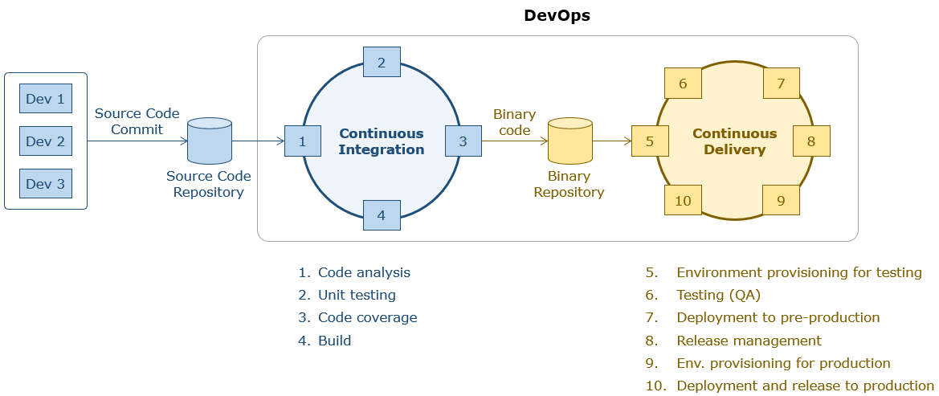

The development team commits the source code and automated test cases to the version control system. The continuous integration tool is scheduled to run at a specific frequency (best practice is to run daily).It polls the version control system (specific repository where the code is committed) for changes and triggers the various tools which can be used to automate the build cycle activities. The CI moves to next stage only if the previous stage meets the gating conditions set. These are explained below:

1. The CI tool invokes the static code analysis tool. This checks the quality of code against the set rules.
2. The CI tool then invokes the automated unit test cases. Only if they pass or as per the gating criteria set, the next stage is invoked.
3. In order to check if the unit test cases cover the code, the code coverage tool is invoked next by the CI tool.
4. The CI tool then invokes the build script for building the executable file. At the end of the integration, the binary file is baselined into a binary repository.
5. The continuous integration tool may trigger the environment provisioning tool which provides provisions and configures the test environments (functional, performance testing etc).
6. The CI tool then triggers deployment automation tool to deploy the application into the provisioned environment and executes the automated QA test cases and if the gating conditions are met for the execution of the tests moves to the next stage.
7. The CI tool then invokes tools to provision the pre-production deployment environment.The deployment tool deploys the working version of the software to the pre-prod environment configured and runs all the automated acceptance tests.
8. If the acceptance tests pass, steps 7 and 8 are repeated for production environment and the software is deployed automatically after going through release management process.
9. The workflow and approval mechanisms are configured using and in release management tools. The changes done get reflected in production environment i.e. release to production.

Note: If the deployment process is also automated seamlessly, then it is called continuous deployment.

# Continuous integration – Tools involved

Let us take a look at the features and functionality of the tools involved in the Java stack for Continuous Integration.

​​​​​​​​

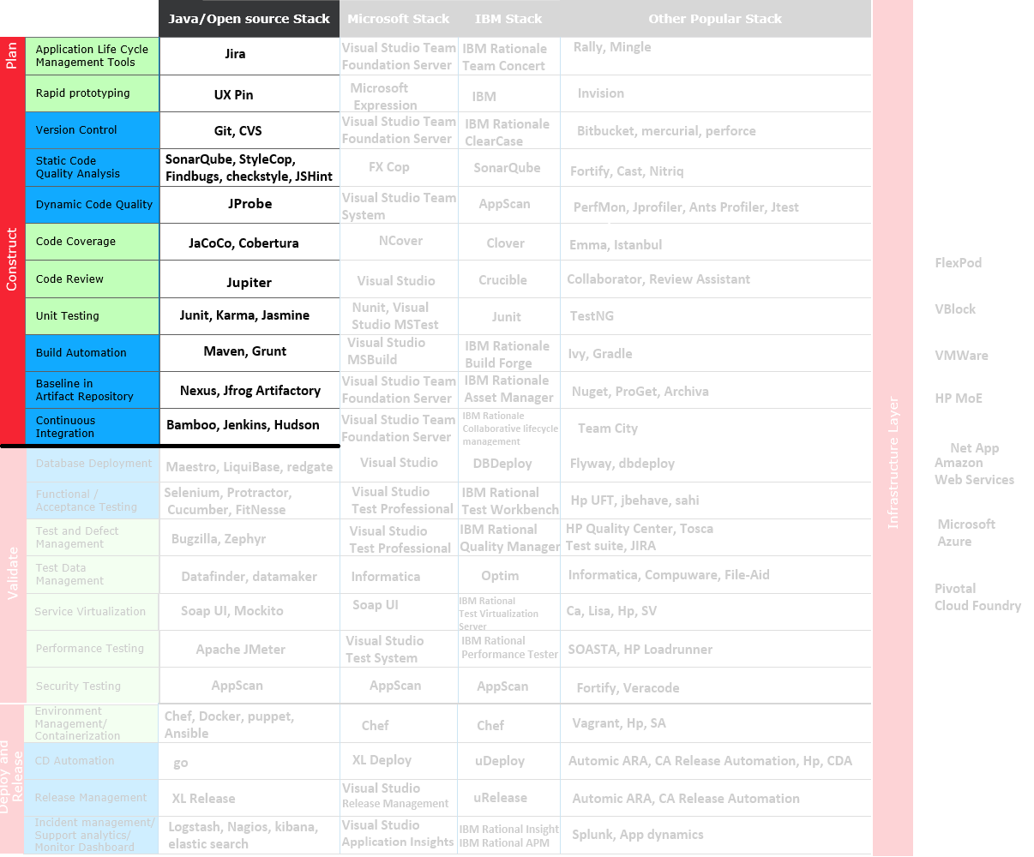

Now that the tool aspects have been finalized, the coach mentions the importance of moving towards the right team structure for implementing DevOps.

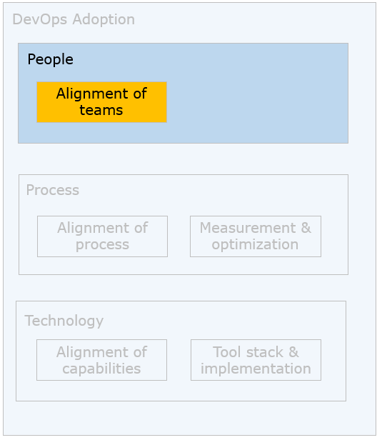

# People challenges in "Pura Vida"

* The Dev,QA and Ops teams are separate
* Conflict in goals
  + Dev Team goals : Adapt to rapid changes and their implementation
  + QA Team goals: Write and execute test cases
  + Ops team goals: achieving stability & reliability
* Little collaboration between Dev, QA and Ops team and no shared responsibility
* Ops team not sensitized on the requirements and urgency of deployments
* Decision making is central and is not autonomous
* Geographically distributed teams

The DevOps & Lean coach now elaborate the people models available and what parameters are to be considered for choosing them.

Agile software development has broken down some of the isolation between requirements, analysis, development and testing teams. The objective of DevOps is to remove the silos between development (including testing) and operations teams and bring about collaboration between the teams.

However, since there are separate teams and also the fact the team may have niche skills rather than skills across the software development lifecycle, there could a phased approach to creating a pure DevOps team. Here are some of the possible team structures.

Note:

Traditional speed: Refers to organizations where there are big business systems and how IT has been running till Agile methods came in.

High speed IT: : When businesses became IT centric with dynamic changes and digitization of businesses happened, organizations had to change levers and adopt agility in projects.

# Team structure m**odel 1: Separate dev and Ops teams**

# C:\Users\admin\Downloads\Peopleaspectsimage11654607003456.png

Key issue: Lack of collaboration between the teams as they are in silos.

However, it may not be possible to merge the teams, so the key is to improve the collaboration through common interventions.

**Salient Features**

* Development and operations are separate (may apply to QA teams also)
* Interventions planned at regular intervals with no overhead processes
* Teams keep separate backlogs but take each other’s stories in their backlogs
* Ops team gets knowledge about upcoming features, major design changes, possible impact on production
* Dev team understands what causes outages/ defects better, improves Dev processes to reduce impact (e.g. specific logging, perf testing for a cycle)
* Dev team improves dev processes over time by understanding Ops defects/outages better

# **Team structure model 2: One team with Ops extension**

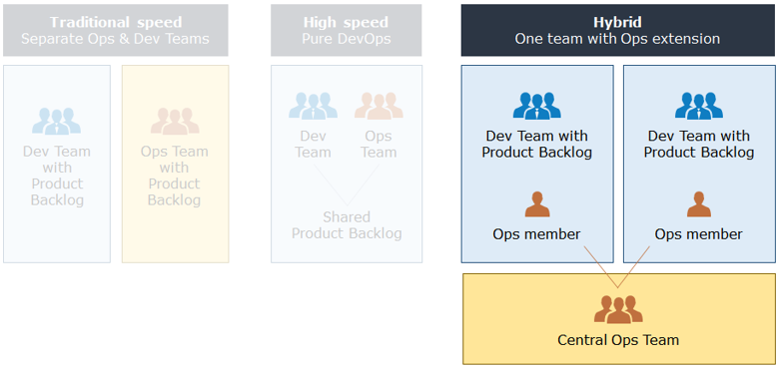

When a pure DevOps team cannot be constructed, a model closer to the pure devOps team can be constructed.

**Salient Features**

* A horizontal Ops team forms a backbone for all development teams
* It provides 24X7 support and performs the tasks which have larger impact on IT  e.g. patch deployment
* Few Ops team members can become part of Dev team and perform tasks which are application specific.
* Ops team members can become part of Dev team
* Ops representative will focus on all the Ops activities which are this team/application specific while all centralized Ops activities will be taken by horizontal Ops team

When speed is increased, deployments are faster. Then teams realize that support service levels start dropping. That is when teams understand the importance of collaboration between development and ops teams.

# **Team structure model 3: Pure DevOps**​​​​​​​

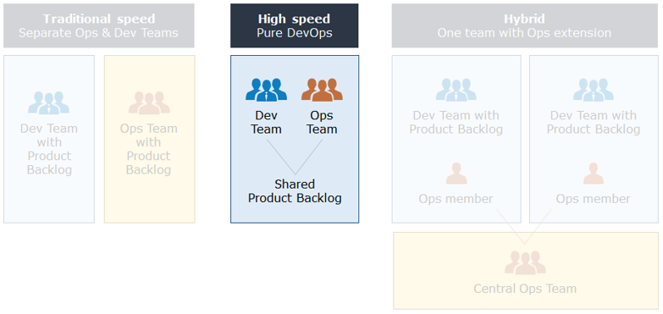

The teams may be merged although DevOps skill set (end to end skills in a software lifecycle) may not be readily available.

**Salient features**

* Embedded team can be created by hiring people with blended skills or cross-training/on the job learning by Dev & Ops teams for each other’s skills
* Team has single backlog with both Dev & Ops tasks
* Each team member is capable of selecting any item & work on it

DevOps involves a change in the culture and the mindset change. The process to be followed plays a major role.

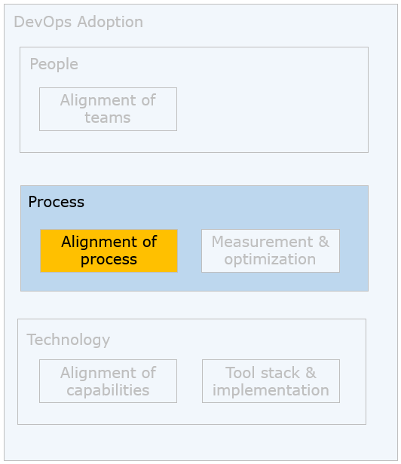

# Process challenges in "Pura Vida"

* Delays due to formal knowledge transfer from Dev to Ops for every release
* Tedious Change Management process requiring lots of approvals
* Complex Release Management with manual checks impacts the operational efficiency

These challenges led to various issues. The coach suggests development and operations teams to follow a unified process.

When teams are merged, which process to follow gains more significance.

# Model 1: Dev and Ops separate

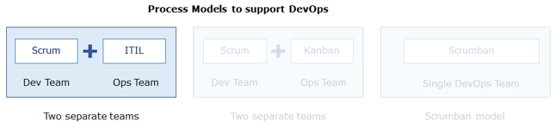

The development team may be following an agile approach say Scrum as shown in the figure. The Ops team may be following another process, here ITIL (Information Technology Infrastructure Library. It is a framework for streamlining maintenance activities).  Here is how the process can be fine-tuned for DevOps adoption.

**Process model**

* Dev in Scrum and Ops in any iterative model
* Governance team (Program Manager) for conflict resolution
* Few team members cross-participate in daily standups

**Limitations**

* Frequent conflicts and less appreciation for each other’s work
* Cross skilling of talents is not possible

**Model 2: Dev and Ops separate but following similar process**

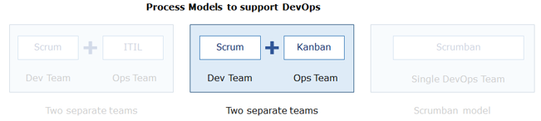

The development and operations team may be following Agile approach say Scrum(by the development ream) and Kanban(by the operations team). Here is how the process can be fine-tuned for DevOps adoption.

**Process model**

* One group does Scrum and the other Kanban as ONE team
* Two different product backlogs (PB), but single PO
* Dev team works on user stories and Ops works on high priority Kanban PB
* Any inter-dependent work items are prioritized by PO to resolve dependencies on time. Daily standup by both teams

**Limitations**

* Cross-skilling of talents is limited

**Model 3: Unified process**

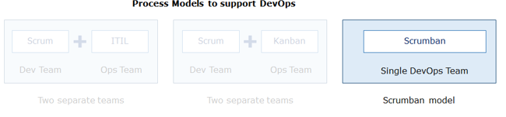

When there is a unified DevOps team, they can follow a unified process like Scrumban as shown in the figure.

**Process model**

* Single PO with one PB
* Based on history, planned vs. unplanned effort considered across
* Team works on the prioritized user stories
* High priority is set for unplanned high severity incident,a team member having expertise in that takes up and resolves
* Cross skilling of talents is possible

Development team at "Pura vida" follows Scrum and operations team adopts ITIL. The team starts with the first model and then move towards a unified process at "Pura Vida" for reasons stated below.

**Reasons**

* The development and operations teams have been separate at "Pura Vida". The team structure is optimized with this arrangement currently and hence it is difficult to have a unified process immediately.
* Over time, as the groups start to become cross-skilled, a unified process can be adopted.

**Implementation of CICD with Java and open source stack done**

Here is the table which consists of the tools suggested by the coach for the "Pura Vida" team and the reasons for the choice are mentioned.

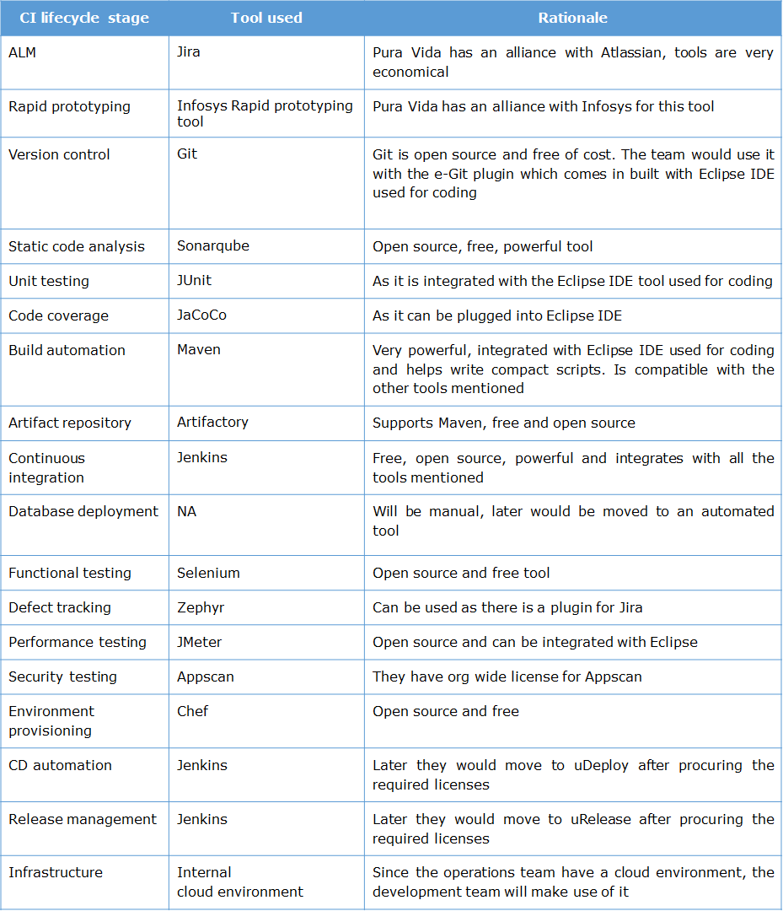

The team now sets out to implement this CICD pipeline using the tools mentioned in the table. Here are the steps suggested.

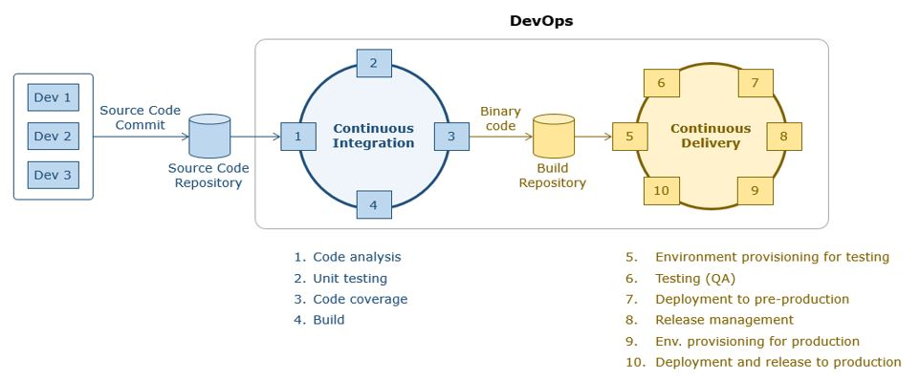

Let us look at each of the steps one by one.Version control using source code repository

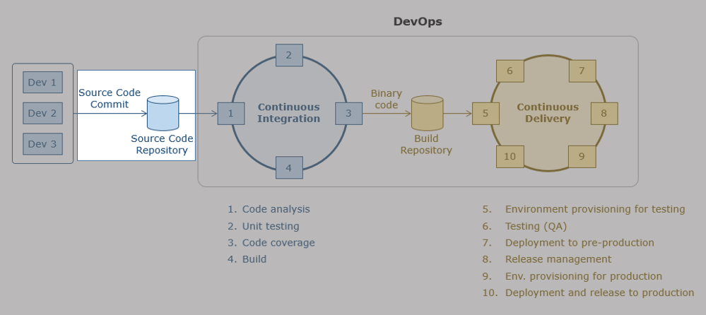



The "Pura Vida" team has the following challenges:

They are presently using a centralized version control system and hence the developers need to be connected to the central server all the time to fetch the code and check-in

1. Since teams are distributed, they need a tool which can support this.
2. There is no track of local changes in the central server and development team is finding difficulty in reconciliation to local changes
3. Branching is very complex and tedious in the existing version control system
4. The code base is increasing in size and the team needs a robust version control system that can handle this size

The coach suggests a distributed version control system which will help mitigate the mentioned challenges. Let us understand the version control activities using a distributed version control system like Git.

# Version control of source code

**Need**

Version control systems are a category of software tools that help a software team manage changes to source code over time. In a continuous integration and deployment pipeline setup, software developers working in teams are continually writing new source code and changing existing source code. Version control helps track every individual change by each contributor and helping prevent concurrent work from conflicting.

**What is a version control system?**

Version control systems are a category of software tools that help a software team manage changes to source code over time. It helps in tracking and reconciliation of code to earlier versions of code written by the team. Here is the basic vocabulary and their description:

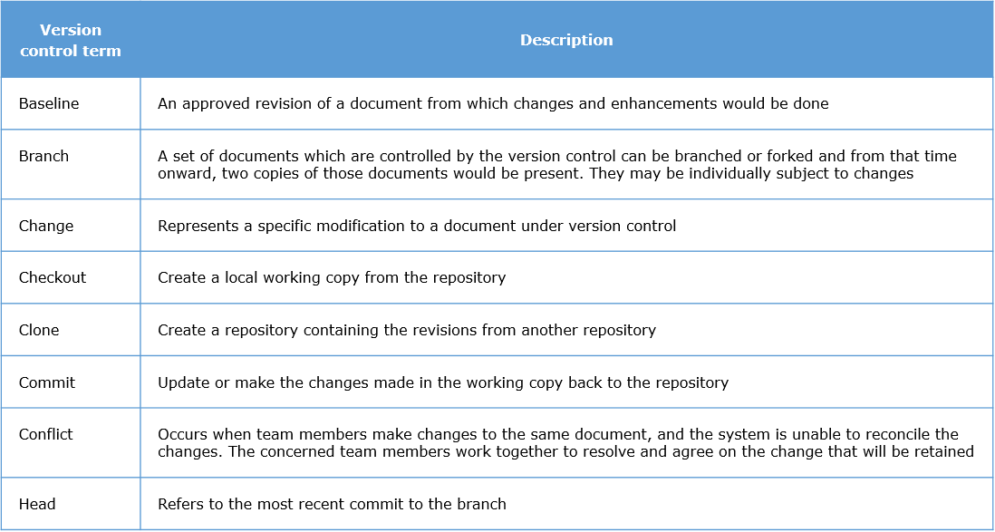

**Git features**

* Open source distributed version control system
* Git Clone is a full-fledged repository
* Version control possible even when not on a network
* Branching is a very inexpensive operation
* Has strong support for non-linear development
* Fully distributed
* Able to handle large projects like the Linux kernel efficiently (speed and data size)

Other distributed systems include Mercurial, BitKeeper, Darcs, Bazaar, Perforce, IBM Rational clearcase, Visual Studio Team foundation Server

* Here are the advantages of a distributed version control system over a centralized version control system
* Each machine is a clone of the server hence developers can work offline too and multiple copies of the code are available as backups
* Local changes are also traced
* Changes made in one part of the software can be incompatible with those made by another developer working at the same time. This problem called conflicts should be discovered and solved in an orderly manner without blocking the work of the rest of the team. Git allows pushing of the code only when conflicts are resolved.

**Git workflow**

Here is how developers work with Git.

1. There is a central trunk which contains the integrated code/test cases of the team which will be used for release.
2. The snapshot of changes for an item is stored in the form of a database of snapshots in a compressed format
3. There may be several branches created for the different teams/team members to work before merging with the central trunk.
4. A development team member clones from the respective branch to the local machine(via clone command). This creates a local git repository in the local machine. The area where changes/ new code development will be done is called the working directory which is not tracked by the version control tool.
5. The development team member makes changes to the working directory till it is ready for commit.
6. The development team member commits the changes done(via commit command) which makes the changes to the local git repository(repository database).This is called staging and can happen several times during the course of development
7. When the team member has a collection of changes ready or as per process laid out, they push the changes to the branch shared by the team(via merge and  push command). Conflicts may arise as the code is shared, in which case the conflicts are resolved and then pushed(via conflict resolution tool).
8. Before starting the next iteration of changes, the development team members fetches the latest version of the code from the branch(via fetch or pull command), merges the changes (via merge command) and repeats the steps 4,5,6 and 7.

This is shown in the figure below.

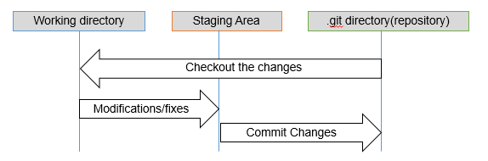

**Common commands in Git**

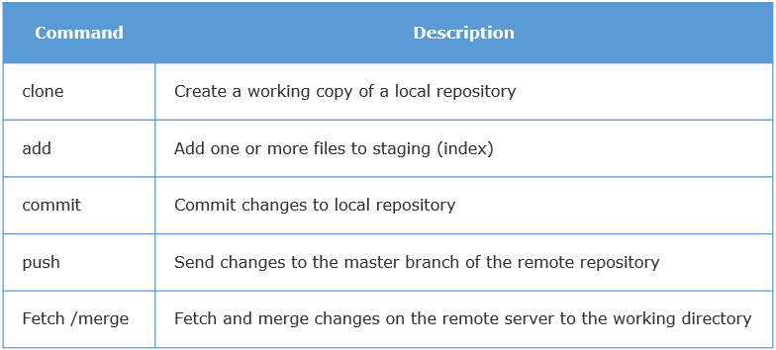

**Practical tips**

* Commit often,push once
* Commit early and often
* Have a process and workflow for the team with commit and push frequencies clearly defined
* Create adequate number of branches – not too many nor too less
* Write useful commit messages
* Commit code which is good quality, tested and follows the definition of done defined
* Do not overwrite commit history

**Demonstration**

Please refer to the next section for the demonstration of the usage of Git commands using the e-git plugin of Eclipse.

The development team at "Pura Vida" will have their challenges mitigated with Git for the following reasons :

* Since it is a DVCS, multiple teams can work in parallel and can work offline on the local changes
* Git can handle huge files due to the compression logic followed in storing the change snapshots
* Staging ensures that local changes are tracked and the history shows the entire list of transactions done
* **Static code analysis**

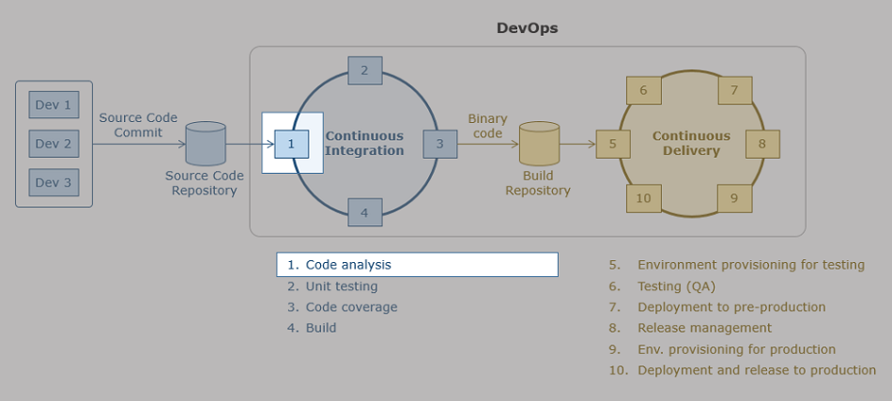

The "Pura Vida" team is facing the following challenges:

* Faster deployments are being done but the quality of code has taken a backseat
* Several issues are reported and the team is doing a lot of rework
* It is increasingly becoming difficult to bring in changes to the design and code

The coach suggests the usage of a code analysis tool (static and dynamic) to ensure that developers check in only quality code which ensure which will help mitigate the mentioned challenges. Let us understand the static code analysis, how it helps ensure quality of code with the help of a static analysis tool like Sonarqube.

# Analysis of source code for quality

**Need**

In the name of fast deployment, code quality should not be compromised. This will have long lasting effects on speed and will bring the productivity to zero. Hence only quality code needs to be pushed to the version control system. This applies to all code – source code, test code, automated scripts etc.

What is static and dynamic code analysis?

Analyzing the code without executing it is known as static code analysis. If it is executed and analyzed for performance is called dynamic code analysis. This helps detects issues like coding standard violation, design principles violation, redundant code which are referred as Technical Debt. If such technical debt is not repaid then it can accumulate, making it harder to make changes in the code at later time.

The development team needs to fix the issues to ensure the technical debt is removed. This is usually performed after coding, compilation and build of source code. CheckStyle, FindBugs, Sonar Qube, PMD are examples of static code analysis.

**Technical debt**

* Is a metaphor developed by Ward Cunningham (similar to financial debt)
* Is incurred by doing development quick and dirty
* Would need extra effort to fix the “dirty” parts in future (similar to interest payments)
* Team can choose to continue putting in extra effort due to the dirty pieces or refactor the code for better design and clean code
* Teams need to remove technical debt over time
* Spending time on refactoring in every sprint
* Improvement in definition of done to allow clean coding
* Usage of quality analyzer tools for checking quality of code
* Factoring time in release and sprint planning for the debt

**Sonarqube features**

Sonarqube is a web based open source tool to manage code quality. It has the following features -

Can check the source code for -

* standard architecture and design principles
  + comments
  + coding rules
  + code complexity
  + duplication in code
* Covers many languages like Java, C,C++
* Has rules, thresholds and alerts can be configured online

**Working of sonarqube**

1. Sonarqube has a list of built-in rules for different languages
2. Rules can be configured as per needs called a profile. Sonarqube has a feature which allows the users to create custom quality profiles on various parameters like defects, code smells, issues etc. Default profile is called Sonarway. Customized profiles can be created and attached to projects by activating required set of rules
3. There are three ways to execute sonarqube
   * Sonar runner (command line)
   * Build script
   * Sonar Lint (plugin to Eclipse)
4. When these profiles are applied to a project, analysis is performed and a dashboard is created
5. The dashboard provides the following details:
   * Code demographics – no. of lines of code, files etc
   * Bugs in code
   * Code smells
   * Code coverage details
   * Duplications in code
   * Technical debt
   * Ratings based on bugs, vulnerabilities and code smells.
6. Quality gates can be applied to ensure that code that does not pass the quality conditions do not move forward to the next stage.

**Calculation of technical debt:**

**Technical debt = Total rework effort in minutes / Total original effort**

Let us understand the formula.

Total rework effort in minutes:

* Each rule is associated with rework effort. If the rule is violated it adds to the rework effort.

Total original effort:

* The original number of lines of code is multiplied with original effort. Sonar considers the original effort as 30 minutes for each line of code to flow through the entire SDLC

The equation provides a percentage which is graded from A to E as a SQALE rating. D and E indicates that code quality is very bad. A and B indicates good quality and C indicates deterioration of code.SQALE is a methodology that was developed by inspearit and then open sourced. Yes, the SonarQube implementation of SQALE is based solely on rules and issues.

**Practical tips**

* Create profiles with increasing number of rules so that teams are not overwhelmed with too many rules in the beginning
* A mix of tools can be used to check quality
* It is important for the teams to fix issues at the earliest and improve the quality
* Issues can be resolved based on priority. The categories of issues can be seen in sonarqube dashboard

The development team at "Pura Vida" will have their challenges mitigated with Sonarqube for the following reasons :

* Code quality will be ensured from design and clean coding perspectives which will go a long way in ensuring that code is maintainable and able to adapt to changes quickly
* This will go a long way in ensuring code quality with speed

# **Unit testing and code coverage**

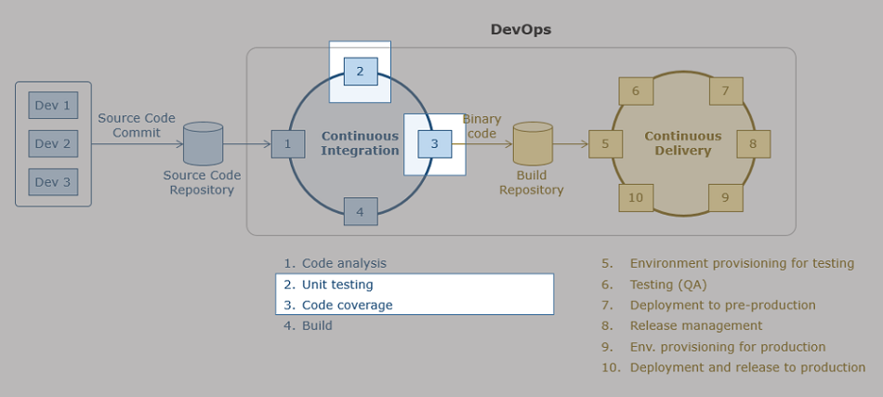.

# Automated unit testing and code coverage

**Need**

Automated unit testing is used to ensure repeatability of tests and bring speed to unit testing process. Code coverage ensures the quality of test cases. This is required to ensure that bugs are detected faster and eliminate human errors.

**What is automated unit testing and code coverage?**

Test automation is the use of special software (separate from the software being tested) to control the execution of tests and the comparison of actual outcomes with predicted outcomes. Automated code coverage ensures -

* Provides quantitative measurement of testing effort
* Indicates redundancy in test cases
* Increased code coverage may lead to early defect detection
* Points to untested areas of code
* Code coverage does not imply that the code is bug free, it means that the code is completely tested (if tests are flaky code coverage cannot help)

**Popular tools for unit testing**

* JUnit
* NUnit
* MSTest

**Popular tools for code coverage**

* Cobertura
* Emma
* JaCoCo

**JUnit features**

* Is an open source Java testing framework used to write and run repeatable tests
* Is an instance of the xUnit architecture for unit testing frameworks
* Features-
  + Assertions for testing expected results
  + Test fixtures for sharing common test data
  + Test suites for easily organizing and running tests
  + Graphical and textual test runners

**Working of Junit test cases**

JUnit is an open source Java testing framework used to write and run repeatable automated test cases. It is the Java version of xUnit architecture for unit and regression testing frameworks written by Erich Gamma and Kent Beck. Here are the common terms used -

* Annotation to identify a test method
* Assertions for verifying expected results
* Test fixtures for sharing common test data
* Test suites for easily organizing and running tests
* Graphical and textual test runners

**JUnit benefits**

* Simple and takes less time to learn for a Java Programmer as no additional knowledge is required
* Can be run automatically and require no manual intervention
* Easy to integrate with any IDEs like Eclipse and Net Beans and also, build tools Ant and Maven
* Makes it possible for the software developer to easily correct bugs as they are found
* Helps the programmer to always be ready with working version of defect free code

**Test suite workflow**

* JUnit runs a suite of tests and reports results.For each test in the test suite:
  + Calls setup().This method should create any object that you may need for testing
  + Calls tearDown().This method should remove any objects you created
* JUnit calls one test method.This method may comprise multiple tests. i.e, it may make multiple calls to the method you are testing.
* Each test method checks a condition (assertion) and returns back to the test runner whether the test failed or succeeded.
* The test runner uses the result to report to the user. The report indicates the tests which passed(green), tests which failed(red) and overall status.

**Code coverage using JaCoCo**

JaCoCo is an open source code coverage tool which can be plugged into Eclipse. JaCoCo is invoked through build scripts.

**JaCoCo features**

* Free Java tool that calculates the percentage of code accessed by tests
* Useful to identify parts of the Java code lacking testing
* Can be called using Ant and Maven scripts

JaCoCo will generate the detailed reports that shows different coverage related parameters like line coverage, method coverage, class coverage and so on. Here are the snapshots of the reports generated by JaCoCo.

​​​​​

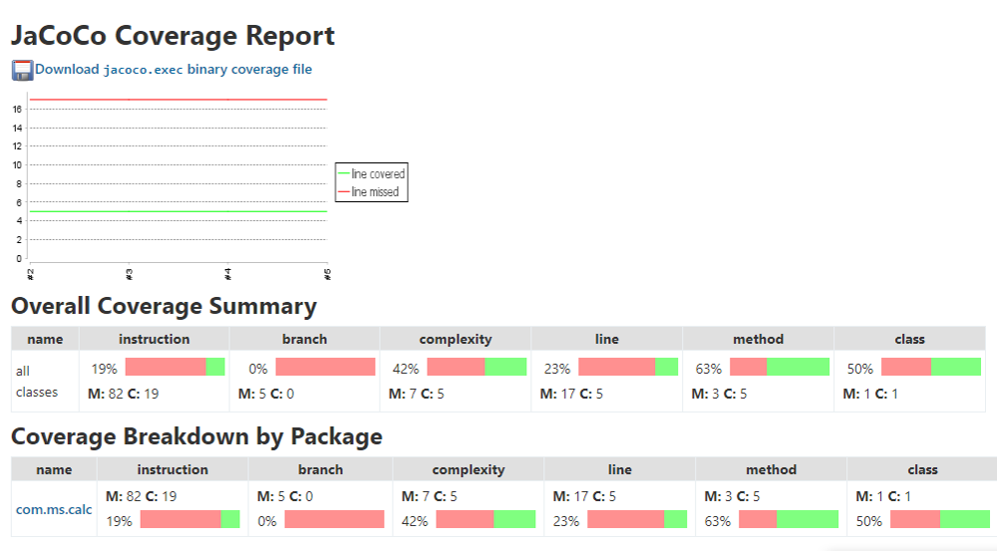

**Practical tips**

* Separate common set up and teardown logic into test support services utilized by the appropriate test cases.
* Test code to be treated on par with production/source code.
* Review of test cases is also mandatory.
* Avoid slow running tests.
* Unit tests are so named because they each test one unit of code.

# Build automation

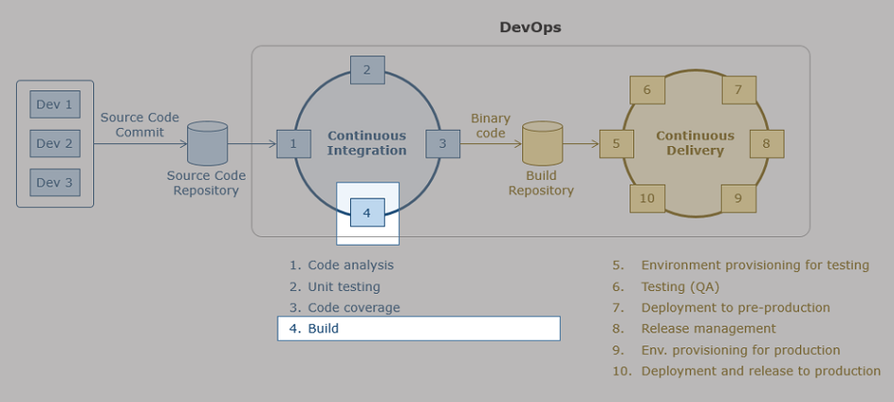

The "Pura vida" team is facing the following challenges:

* The current build process is manual and very cumbersome as the instructions for build are in several pages of a word document
* As the steps in build lifecycle are getting automated and moving towards a quicker frequency of builds, manual builds would be very slow
* A continuous flow of working versions of the application is required by the stakeholders and are constantly asking the development team for it

The coach suggests the usage of a build automation tool to ensure a continuous integration of working versions of the application. Let us understand the build automation using Maven.

# Build automation

**Need**

Developers are paid to invest their effort in solving business problems by developing software programs to build a software system. In the process of building a software system, developers have to do the following technical activities periodically several times in a day/week.

* Getting the latest version of the program files from Configuration Server
* Compiling the programs
* Performing Static analysis on the programs/code to get feedback on design
* Running automated test (Unit/System test cases)
* Collecting Metrics on Code Coverage of each program during Unit Testing
* Packaging the programs into some form of binaries like .war or .jar or .ear files
* Placing the binary file into a central repository from where the SIT or UAT team can pick up for deployment and testing.

All the above steps are a consolidation of Build Process of a software system.

If the above activities have to be done manually by developers, then significant amount of developer’s valuable time will be eaten away on these mundane technical activities. Instead, by automating the above activities, developers can invest the same effort on solving business problems by devising best in class algorithms, designs and programs.

In order to achieve the above automation, we adopt a process called build-automation. Primary goal of Build Automation is to automate manual operations in the build process.

**What is build automation?**

A build automation tool helps in the following –

* Compilation of code
* Testing and integrating the changes
* Packaging the binaries
* Deployment to test server

**Popular tools**

Some of the build tools that are widely used in industry are:

* Apache ANT
* Apache Buildr
* Sbt
* Tup
* Gradle
* Visual build
* Apache Maven
* Grunt
* **Maven features**
* Maven is a software management and comprehension tool based on the concept of Project Object Model (POM) which can manage Project build, Reporting &documentation. In simple terms, Maven is a build automation tool. Maven generates build for us.
* **Workflow of Maven**
* Maven has few built-in lifecycle goals like clean, compile etc. The other user defined targets and project related configurations are specified in the pom.xml in the project. When a build is run, Maven executes a set of goals.
* Maven's local repository is by default located in '.m2' folder within the current user's folder. Maven uses this repository to download required plugins to run the build from the central maven repository or internally in Infosys from the Infy-Nexus repository. For executing the goals mentioned in the pom.xml, if maven doesn’t find the necessary files in the local repository, it will connect to the infy-nexus central repository and download them. Maven uses the target folder to save build data and build reports.

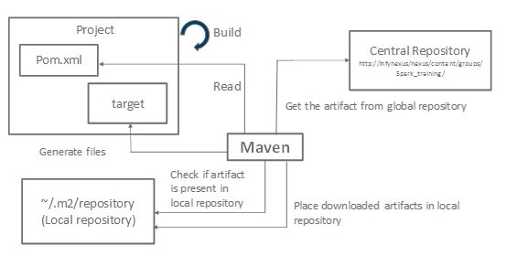

**How to write a build script in Maven?**

* Maven client plug-in should be downloaded into Eclipse IDE
* Create a Maven Project that comes with default POM.xml
* Define the dependencies in POM.xml that specify which external Jar files and Plug-in are required to be downloaded from Maven Central Repository (usually on internet) onto local machine to create project build
* Provide necessary authentication and authorization credentials in ‘config.xml’ available in ‘.m2’ folder
* Specify appropriate Goals (commands) and trigger the execution of POM.xml
* Maven has lifecycle goals to perform the below activities:
  + Clean up the working directories
  + Compile Source Code
  + Copy Resources
  + Compile and Run Tests
  + Package Project
  + Deploy Project

Maven can be considered as a tool that can be used for building and managing any java-based project.

**Maven POM.xml script example**

Explanation for important tags in the below POM.xml are given with ‘->’ symbol.

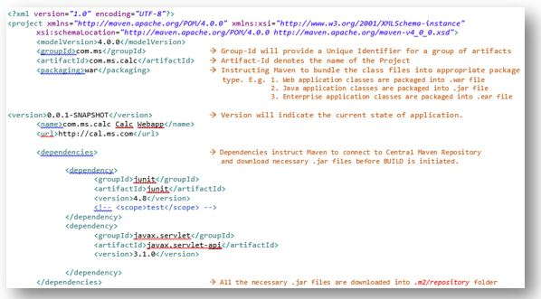



Maven architecture is basically based on assembly of various Plug-Ins thus making Maven having a modular architecture.

Plug-Ins are way in which we can extend the functionality of an application. Based on this philosophy, Maven architecture uses various plug-ins and extends its functionality accordingly thus making its architecture modular. In fact, the Maven compiler in itself is a plug-in inside the Maven system.

**Execution of Maven script**

After all the necessary configurations are done in POM.xml and Config.xml, right click on ‘POM.xml’ and choose ‘Run As -> Maven build…’ and enter one or more of the below mentioned goals:

* clean - This goal is responsible to clean up ‘target’ folder in eclipse before build process is initiated.
* compile- This goal is responsible to compile all the .java files and create .class files
* sonar:Sonar -This goal is responsible to trigger the Static code analyzer tool ‘SonarQube’ that is responsible to generate the static code metrics
* test- This goal is responsible to run the Junit testcases written and kept in the folder ‘src\test\java\ut….’
* cobertura:cobertura -This goal is responsible to consolidate the outcome of the ‘Test’ goal and generate Code Coverage report and make the same available in ‘\site\cobertura\ folder in eclipse.
* war:war - This goal is responsible to create a .war (Web Archive) file
* deploy- This goal is responsible to deploy the .war file at pre-defined server.

**Maven benefits**

Maven is intended to make the day-to-day work of Java developers easier and generally help with the comprehension of any java-based project.

* Maven has many in-built templates and using Maven has multi-fold benefits and some of them are:
* Creates Project Source code template that defines a Project Structure that brings in the following advantages:
* Clear separation of concerns in development
* Discipline in coding
* Import all the necessary libraries that are dependencies to create an application
* Build and package the application by compiling the source code and package the code into a .jar file.

**Practical tips**

* Build every time a change is checked in
* Ensure that the steps of static/dynamic analysis, unit testing, code coverage etc are also included
* If the build is broken, the development team needs to fix it immediately

You can see the demonstration of usage of Maven for orchestration of build lifecycle activities in the subsequent section

The development team at "Pura Vida" will have their challenges mitigated with Maven for the following reasons :

* Build automation will ensure a quick and continuous integration of valuable software

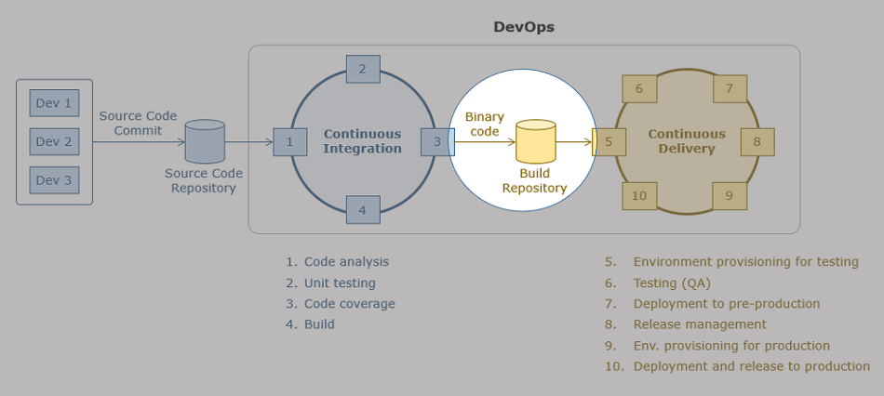

The "Pura Vida" team is foreseeing the following challenges when the entire SDLC will be automated :

Many versions of binary files(ex. .jar,libraries) are involved in the development. Presently the sharing is through a common library folder. They forsee that this approach will not work as there are many people involved

* They also would need an approach to version control the binaries created at the end of the build cycle
* They should have appropriate folder structures to identify Dev tested, QA tested, staged and release stages

The coach suggests the usage of an artifact repository to help this situation.  Let us understand the need for an artifact repository in an automated CICD pipeline with the help of a tool like Artifactory.

# Artifact repository

**Need**

In traditional development-

* Dependencies are managed by using a static list
* It is not a good practice to check-in dependent libraries
* Dependencies are kept as a common library which is used by all developers / tools like Maven download the latest version of the dependent libraries
* When code base and inter-dependencies increase, the version control of the dependencies are not kept track leading to version related and consistency problems

In an enterprise system with CI -

* It becomes difficult to reuse common libraries by the development team members in their builds
* Version control of the dependencies and the build package becomes essential

# **What is an artifact repository?**

This is a software repository for binary artifacts and their corresponding metadata which is akin to a software version control system for source code. This is a way of versioning code binary artifacts, for ex. jars, wars, ears, fully fledged applications, libraries or a collections of libraries that are packaged. This is illustrated in the diagram below:

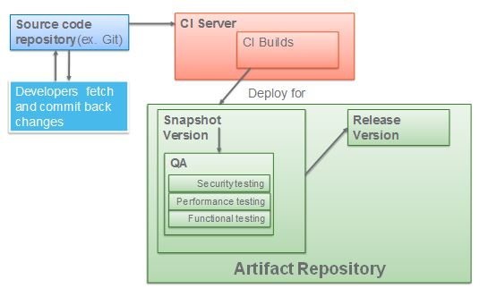

An artifact repository has the following features -

* Dependencies (libraries) are version controlled
* Dependencies can be shared
* Stores information about
* User who triggered the build
* Modules which were built
  + Source control(branches) that were used
  + Dependencies used
  + Environment variables
  + Packages installed

**Popular tools**

Tools include-

* Artifactory
* Nexus

**Benefits of using an artifact repository**

* The right version of the build is used for QA and the completely tested version goes for release
* Ensures that any changes to source code to meet the quality and testing needs are routed only through the source code repository
* Structures the deployment properly

# Artifactory - Features

Artifactory is an open source tool from JFrog. It has the following features-

* Web driven repository manager from Jfrog
* Has four major modules
  + Home: general information, user details, time and version
  + Artifacts: Helps browse repositories in the system
  + Build: Helps view CI server projects
  + Admin: configure users and perform administration and maintenance activities
* Jenkins is configured with Artifactory using the plugin
* Artifactory provides a number of plug-ins to support connectivity with other tools
  + Build tools Gradle,Ivy,Ant,MSBuild
  + Source code version control like SVN, Git,Perforce
  + CI Tools like Jenkins,TFS,Bamboo,TeamCity

**EXERCISE-4**

**Aim:**Configure the web application and Version control using Git using Git commands and version control operations.

**VERSION CONTROL OPERATIONS:**

**1.For initializing empty Git repository.**

The git init command creates a new Git repository. It can be used to convert an existing, unversioned project to a Git repository or initialize a new, empty repository.

**Command:$ git init**

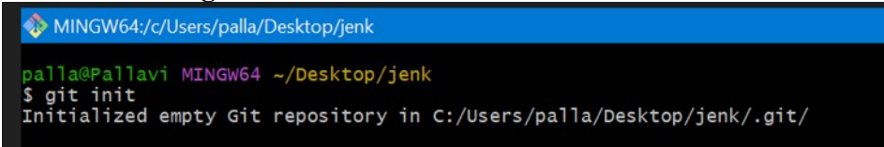

Initialized empty Git repository in C:/Users/palla/Desktop/jenk/.git/.

**2. $ git status**

The git status command displays the state of the working directory and the staging area. It lets you **see** which changes have been staged, which haven't, and which files aren't being tracked by Git.

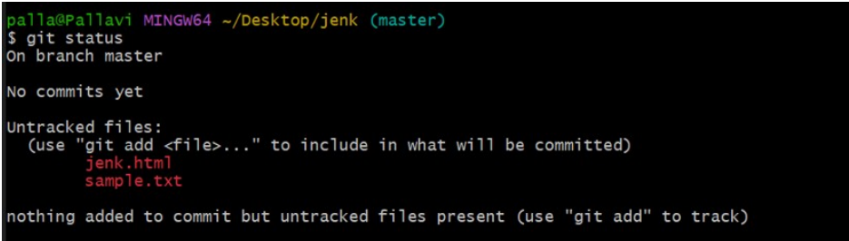

**3. $ git add**

The git add command **adds a change in the working directory to the staging area.**It tells Git that you want to include updates to a particular file in the next commit.

Add using add. Adds all files to the repository.

Now, again check status of files in the repository by giving command

**$git status**

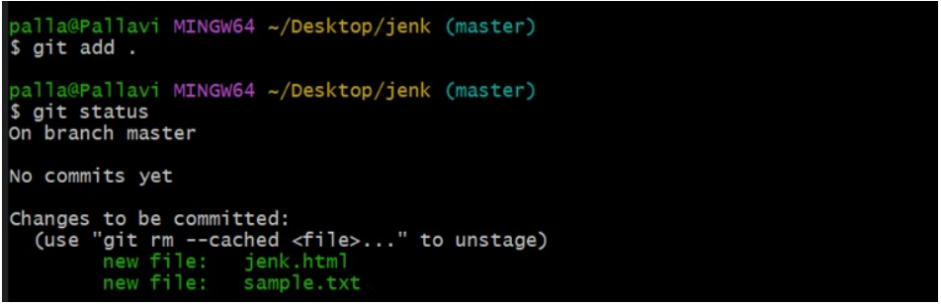

You can now observe ,thecolors of files changed to green from red. This indicates that those files are uploaded to the repository.

**4.$ git commit -m "modify"**

The git commit command **captures a snapshot of the project's currently staged changes.**

After commiting it gives message **“modify”.**

1. **Create a repository in the github account and copy the link of the repository and let s connect the folder with the repository in the github web account.**

**You then able to see the message as modified.**

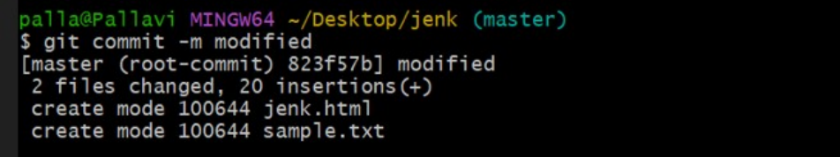

Modes converted into create mode.

1. Now you can be able to change the origin to the repository.

The git remote command **lets you create, view, and delete connections to other repositories**. Remote connections are more like bookmarks rather than direct links into other repositories.

**$ git remote new origin** [**https://github.com/PallaviAlanka/jenk.git**](https://github.com/PallaviAlanka/jenk.git)

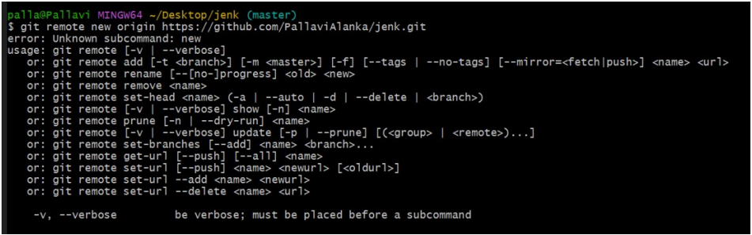

**-> adding new origin.**



1. Now lets push the new file into the repository.

**$git push -u origin master**

The git push command is used to upload local repository content to a remote repository. Pushing is how you transfer commits from your local repository to a remote repo.

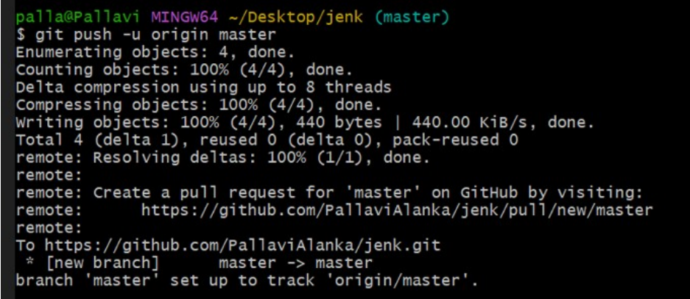

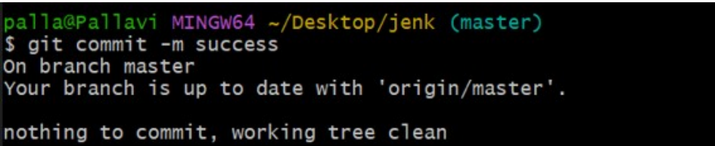

**GitHub Account Creation:**

Steps to create account in github:

**Step-1:**

Go to https://github.com/join in a web browser.You can use any web browser on your computer, phone, or tablet to join.

**Step-2:**

The following screen appears.

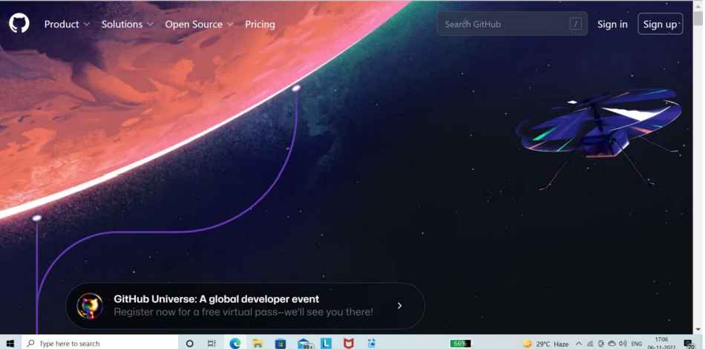

click on sign up.

**Step-3:**

Then it asks for email, Username and Password. Give the valid details carefully.

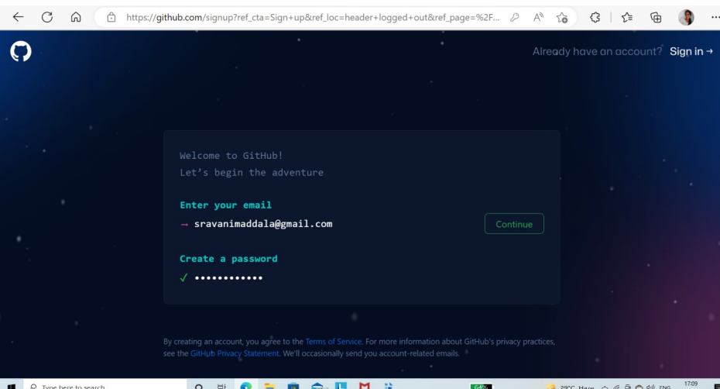

**Step-4:**

After giving all necessary details and reviewing the Terms and Conditions, click on create.

Then it asks to verify your account. Check your email and verify your account.

The account will be created successfully.

**Creating repository:**

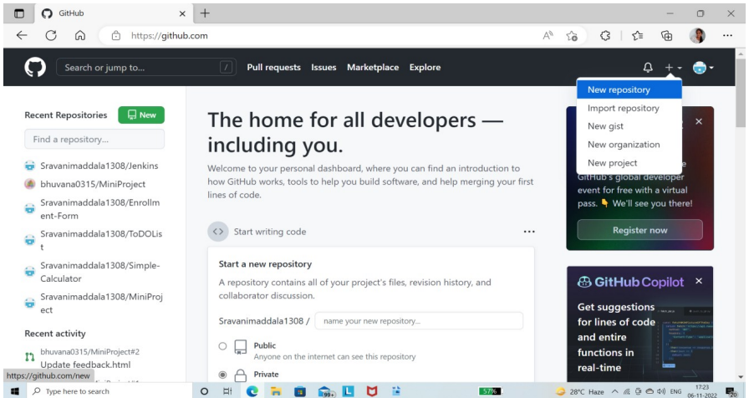

Click on New Repository.

Give a name to your repository and click on “Create repository” at the end of the page.

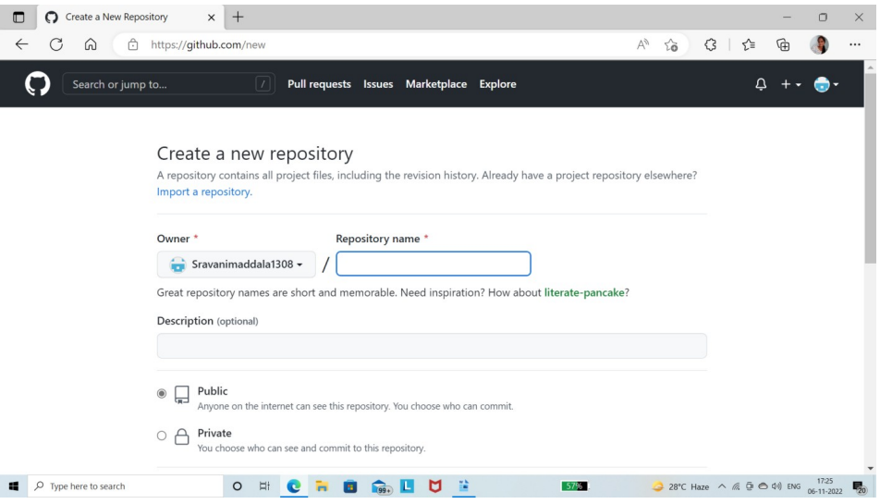

“Click on uploading an existing file.”

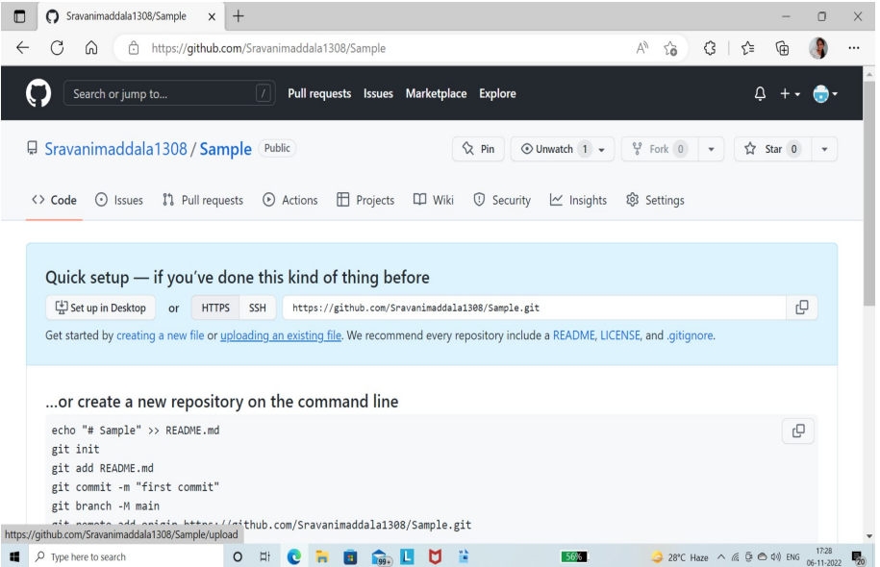

Drag the files that you want to upload and click on “commit changes”.

**In Jenkins:**

1.Open Jenkins Dashboard and create a job.

2.Once the job is successfully created click on it. On the left menu click on “Configure”.

3.Copy your code URL from github as follows

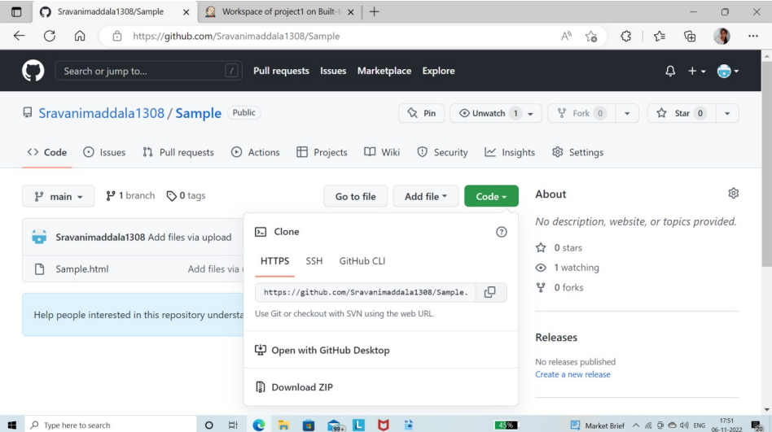

4. Now paste the URL under the Source Code Management.

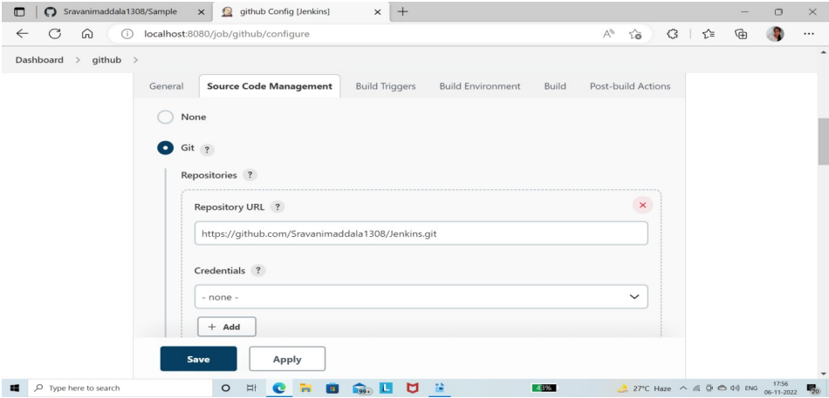

If the branch in the github is Main then give “main” under Branch specifier in SCM.

5.Click on Apply and then on Save.

6.Click on “Build Now” to schedule the build.

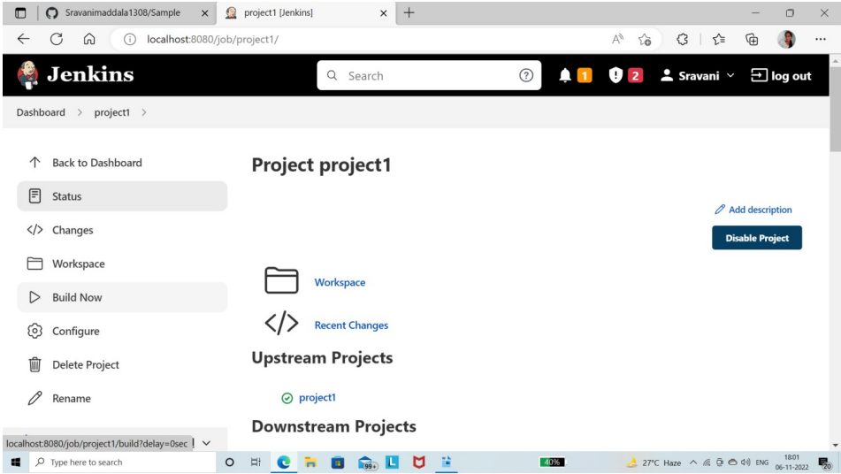

7.After the build has finished successfully, click on Workspace. Then the following screen appears.

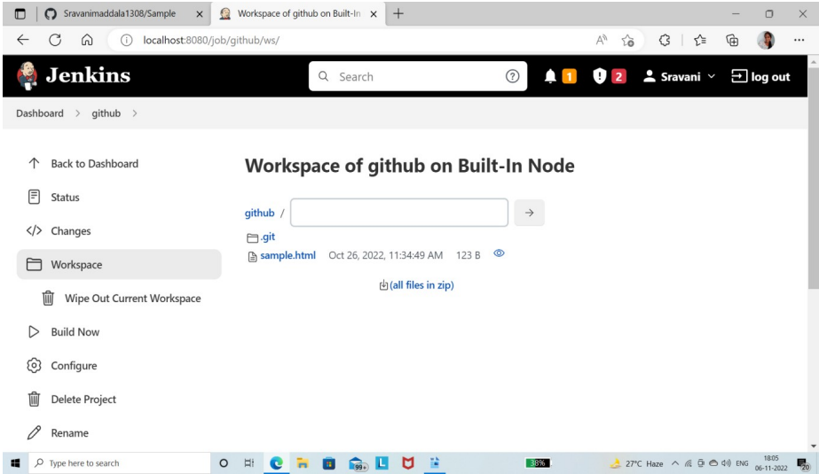

8.Now click on the file that appears there to see the output. In our case click on the “sample.html”.

The output is as follows.

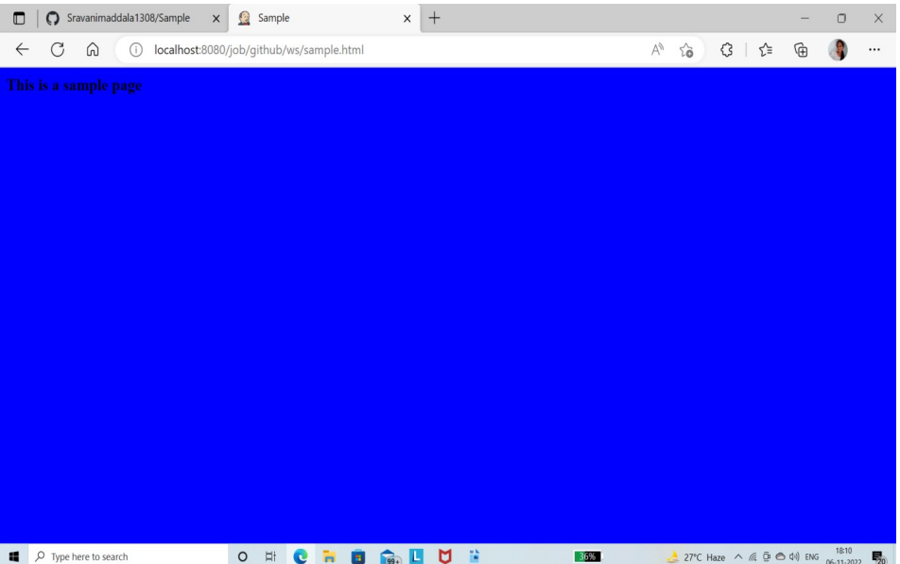

The output is based on the code that you given in the uploaded file

**EXERCISE-5**

**AIM:**Installation of SonaQube and SonarScanner and Configure a static code analyzer which will perform static analysis of the web application code and identify the coding practices that are not appropriate. Configure the profiles and dashboard of the static code analysis tool.

**SONARQUBE INSTALLATION**

###### **WHAT IS A SONARQUBE?**

SonarQube is an open source platform developed by SonarSource for continuous inspection of code quality. It is written in JAVA and supports 20+ programming languages.

###### **FEATURES:**

1. Not just tells what is wrong, also aids you to rectify via Quality Management tool.
2. Covers a greater stretch as far as definition of Quality is concerned (as proudly flaunt by its developers – Seven Axes of Quality), as compared to its competitors, whom major emphasis is on bugs & complexity.
3. Its focus is not only just constraint to potential bugs or code conventions, but also extends to span coding standards, duplications, test coverage, unit testing, code complexity, API documentation, architecture, comments, bugs along with providing details in a dashboard is cherry on the top.
4. It provides metrics, tracking of which can help you to take right decision.
5. It provides various features to support Continuous Inspection practice, viz. Quality Gates, Focus on leak, highlighting hotspots, branch analysis, analyze pull requests, visualizing the history of project.

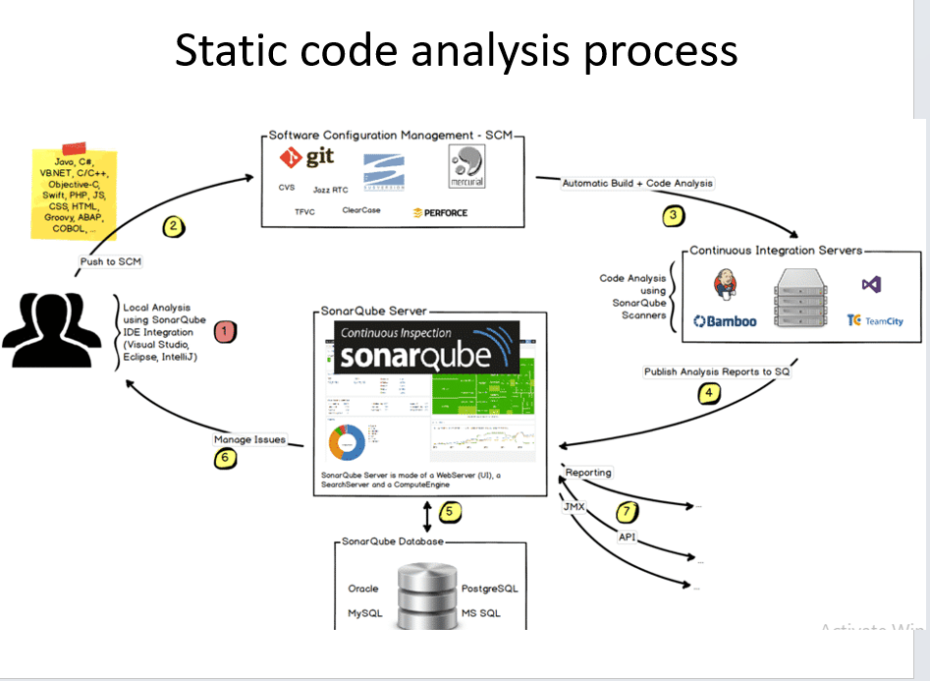

**SonarQube Installation steps:**

**Step 1:**

Download the SonarQube software from **”** [**https://www.sonarqube.org/success-**](https://www.sonarqube.org/success-)**download-community-edition”**

**Step 2:**

Extract the Zip file to the specific location

**Step 3:**

Now open command prompt and change the directory to sonarqube bin upto windows 64 bit installer

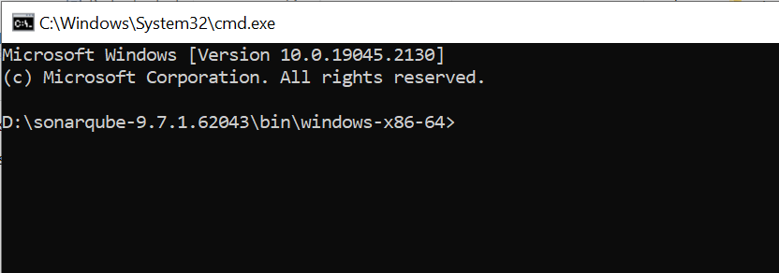

**Step 4:**

Now type the command “**StartSonar.bat”** and now the SonarQube server will be started

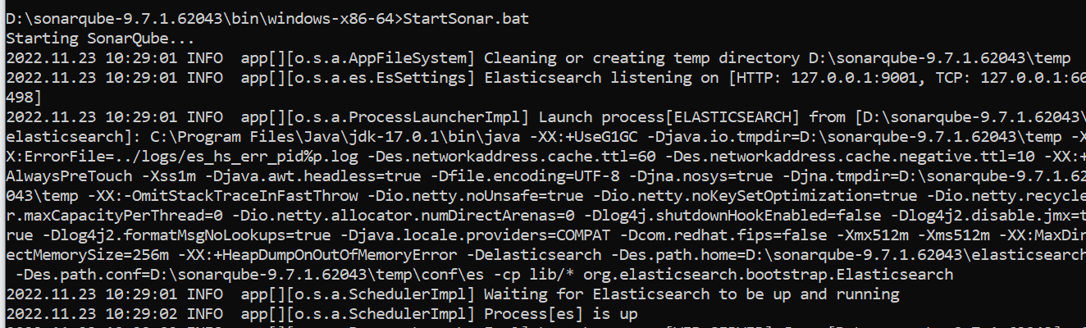

**Step 5:**

Now opensonarqube web server in browser by opening the following link “<http://localhost:9000>”

The screen appear as follows:

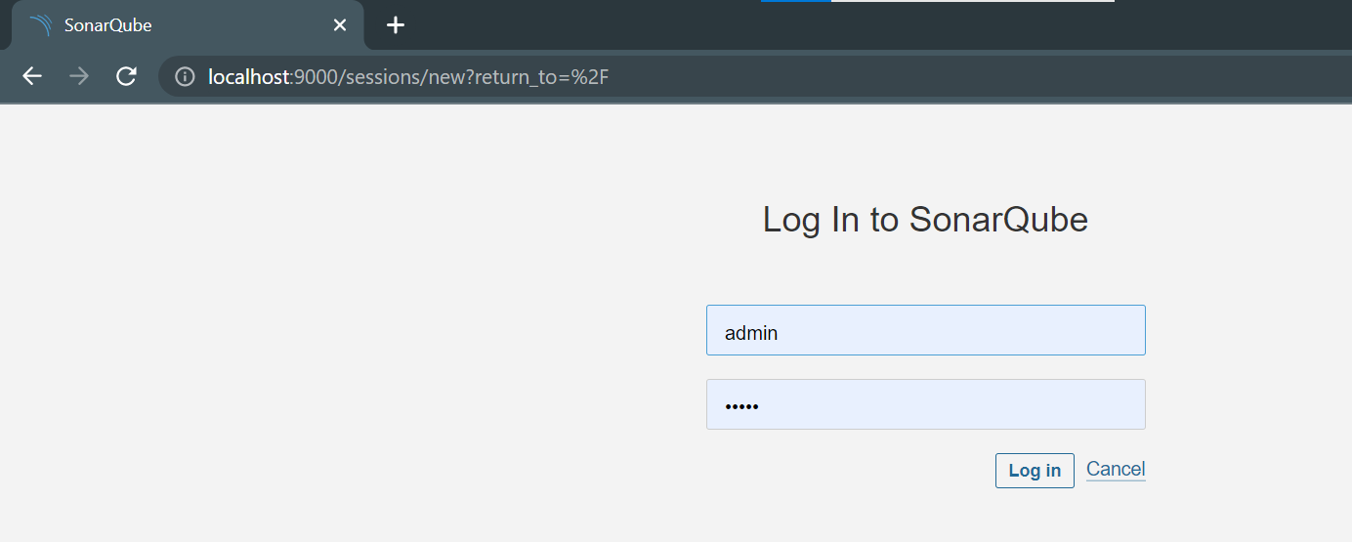

**Step 6:**

Initially login as **admin** and the password will also be **admin**.Later it asks for update password.

**Step 7:**

Now the SonarQbue dashboard will be opened .In dashboard click on create project mannually.Then one screen will appear ,it asks for project name and project key so

Specify them.

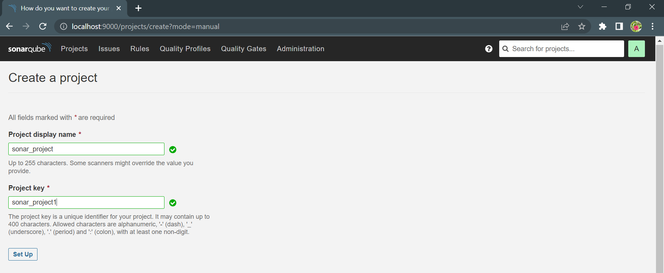

**Step 8:**

Then click on setup , select locally tab as shown in below figure.

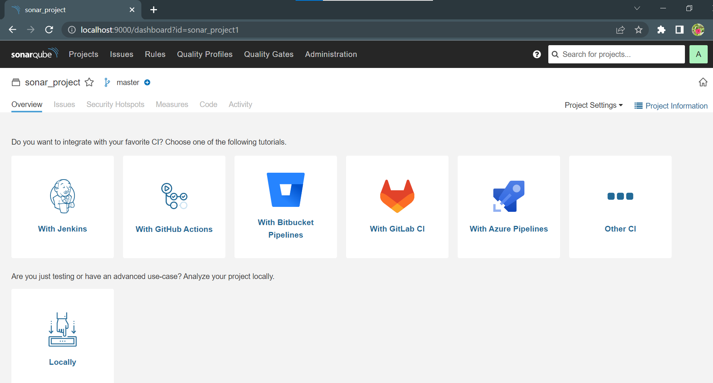

**Step 9:**

After clicking on locally block the screen appears as below and provide a token then set expires days and click on **“generate”** key

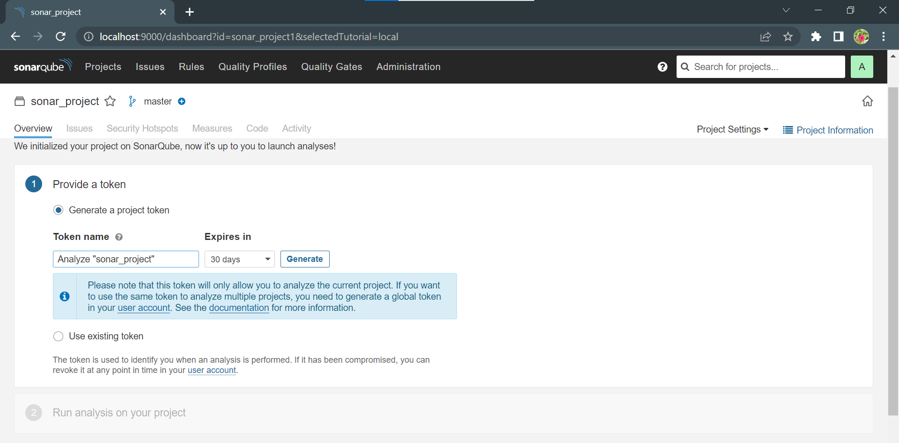

**Step 10:**

The project name,project key and secret key are generated and **save** it at specific location for futher use.

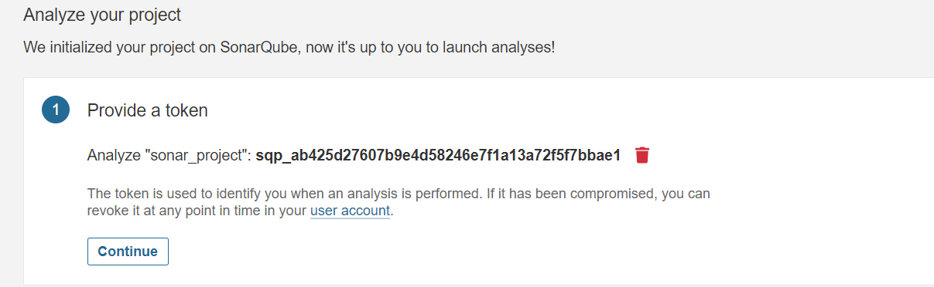

**Step 11:**

Click on continue ,then one screen will appear and select the options as given below.

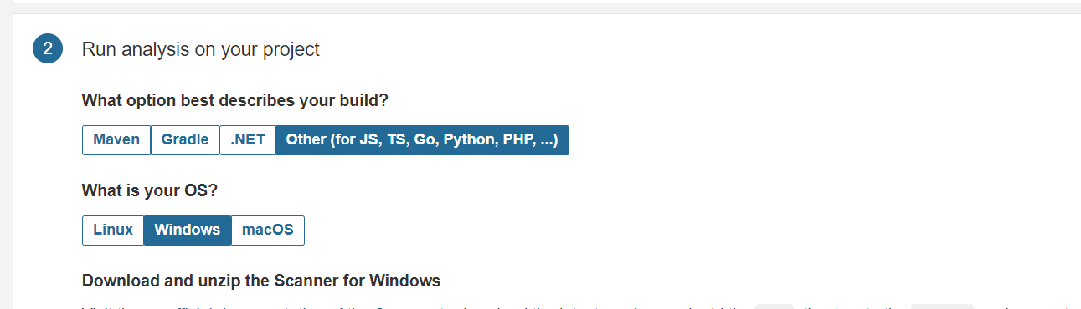

The sonarqube installed successfully and the project with token also created.To view the result we have to install **sonarQube-Scanner**

**SONAR SCANNER INSTALLATION**

SonarScanner is a separate client type application that in connection with the SonarQube server will run project analysis and then send the results to the SonarQube server to process it. SonarScanner can handle most programming languages supported by SonarQube except C# and VB. It is usually located on continuous integration agents (workers) or in separate docker images depending on your project flow.

**FEATURES:**

It can provide information regarding:

* duplicated code
* coding standards
* unit tests
* code coverage
* code complexity
* comments

**Step 1:**

Download the sonar scanner from this link “<https://docs.sonarqube.org/latest/analysis/scan/sonarscanner/>”

The screen will be appear as follows:

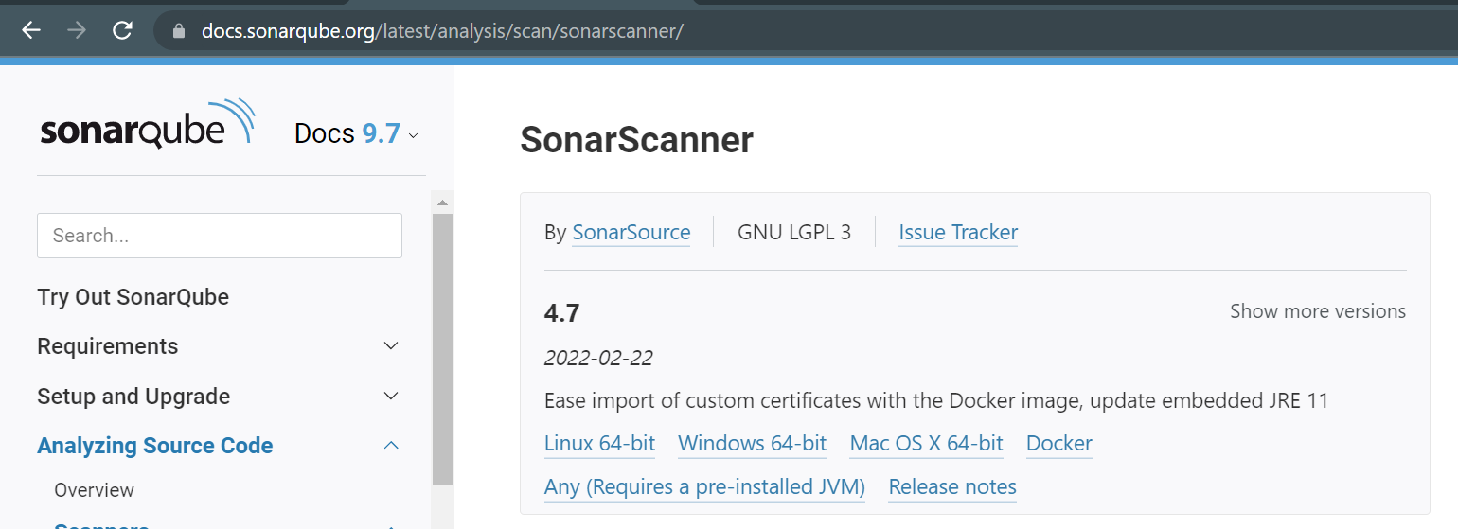

Click on “**windows 64-bit”** and **.exe** file is downloaded

**Step 2:**

Now Extract scanner to destination drive from .exe file and install it.

**Step 3:**

Now set path in system environment variables upto bin and click on **“OK”** as shown in below

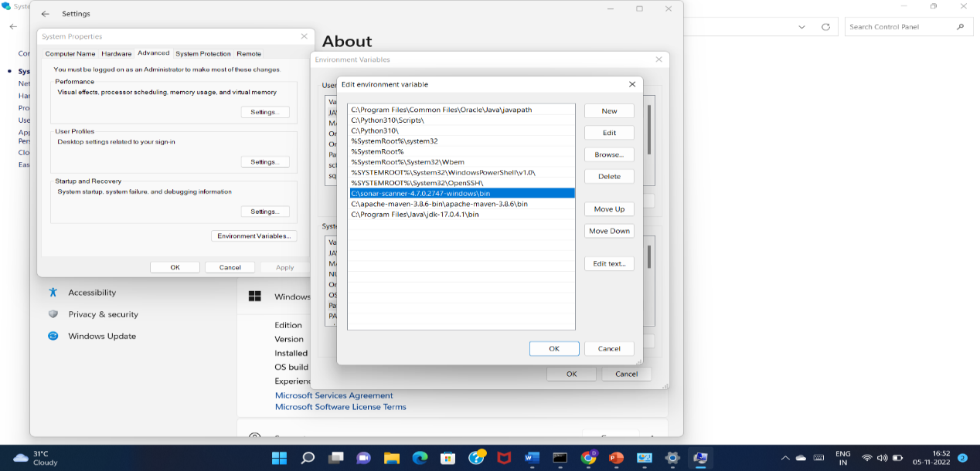

**Step 4:**

Now download a project folder from “<https://github.com/SonarSource/sonar-scanning-examples>”

**Step 5:**

Extract the downloaded file and from that only takesonarQube-scanner project folder and keep at destination path

**Step 6:**

sonarQube-scanner project folder has “[sonar-project.properties](https://github.com/SonarSource/sonar-scanning-examples/blob/master/sonarqube-scanner/sonar-project.properties)” file and append following content.

Give the project name and generated token in sonar-project.properties file

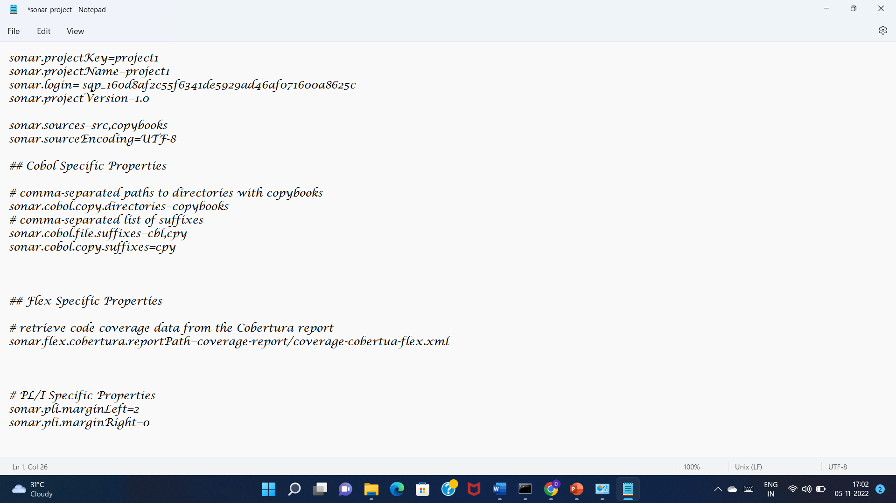

**Procedure of Static Code Analysis:**

Now open the command prompt and change the directory to sonarQube-scanner project folder and execute the command **“sonar-scanner.bat”**

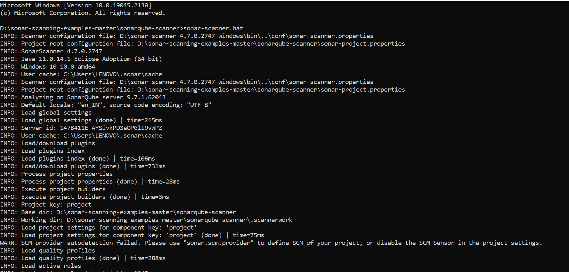

The project code is successfully analysed and the result is shared to the SonarQube dashboard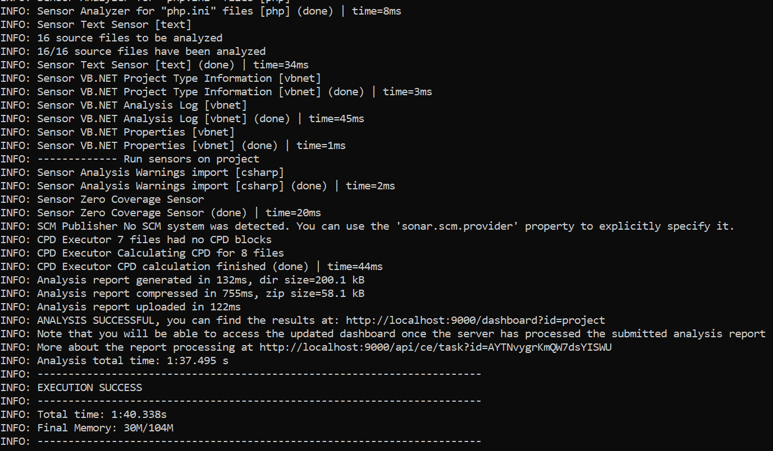

Now open the static code analysis report in the SonarQube server dashboard.It will show the parameters like

* No of bugs
* Vulnerabilities
* Code smell
* Duplicate lines and so on….

All these can be observed in the below figure

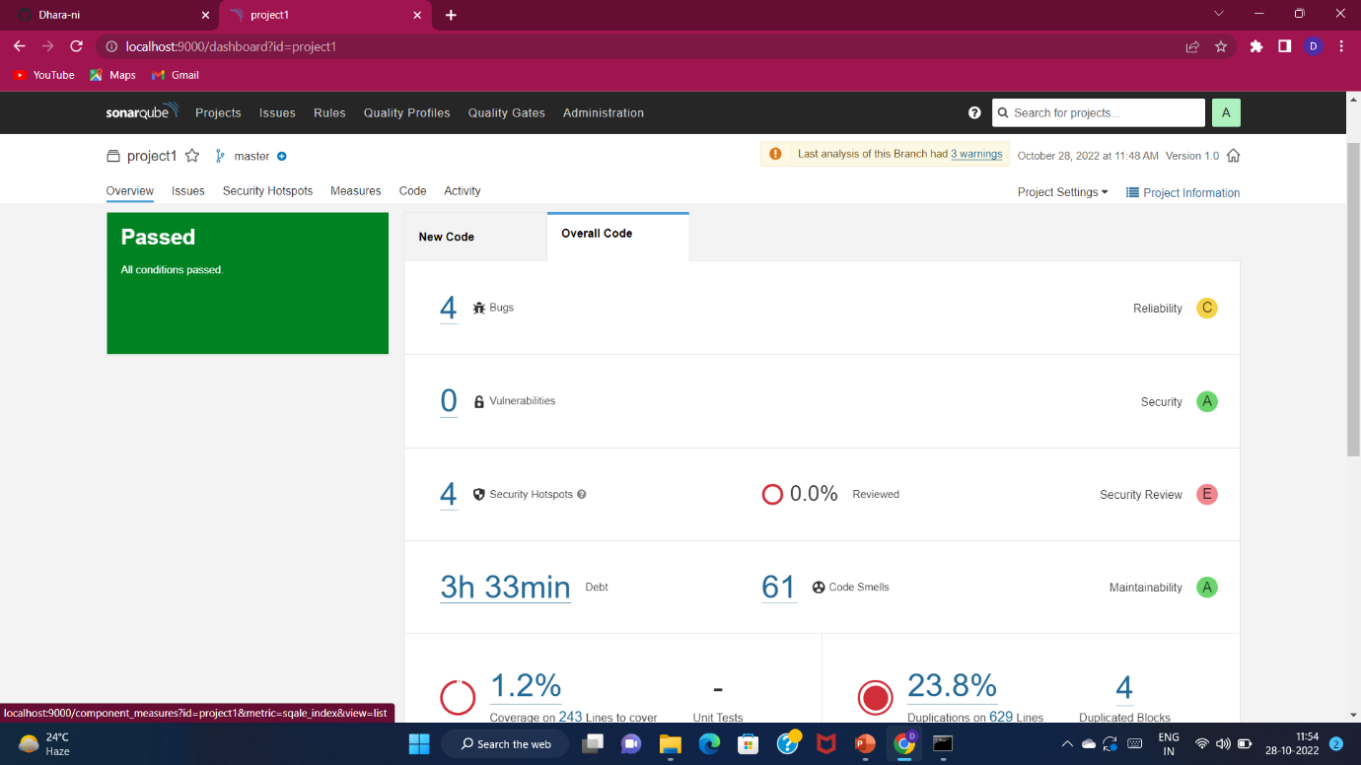

After this,static analysis code is successfully run in the localhost.

**EXERCISE-6**

**Aim:** Write a build script to build the application using a build automation tool like Maven. Create a folder structure that will run the build script and invoke the various software development build stages. This script should invoke the static analysis tool and unit test cases and deploy the application to a web application server like Tomcat.

**What is Maven?**

Maven is a project management and comprehension tool that provides developers a complete build lifecycle framework. Development team can automate the project's build infrastructure in no time.

In case of multiple development teams environment, Maven can set-up the way to work as per standards in a very short time. As most of the project setups are simple and reusable, Maven makes life of developer easy while creating reports, checks, build and testing automation setups. Maven provides developers ways to manage the following –

•Builds

•Documentation

•Reporting

•Dependencies

•SCMs

•Releases

•Distribution

•Mailing list

**What is TomCat?**

It is an open-source Java servlet container that implements many Java Enterprise Specs such as the Websites API, Java-Server Pages and last but not least, the Java Servlet. The complete name of Tomcat is "Apache Tomcat" it was developed in an open, participatory environment and released in 1998 for the very first time. It began as the reference implementation for the very first Java-Server Pages and the Java Servlet API. However, it no longer works as the reference implementation for both of these technologies, but it is considered as the first choice among the users even after that. It is still one of the most widely used java-sever due to several capabilities such as good extensibility, proven core engine, and well-test and durable. Here we used the term "servlet" many times, so what is java servlet; it is a kind of software that enables the webserver to handle the dynamic(java-based) content using the Http protocols.

**Installation of TomCat server:**

1.Open any web Browser and search for Tomcat 8 download. GO to the first link that appears on the webpage. Or click on the below link to download TomCat Server

**32-bit/64-bit Windows Service Installer (pgp, sha512)**

2.Once it has downloaded, double click on the .exe file and click on Yes then Next->i agree -> next. When the following window appears give the port number as 4040 and username as root and password as root and then click on Next.

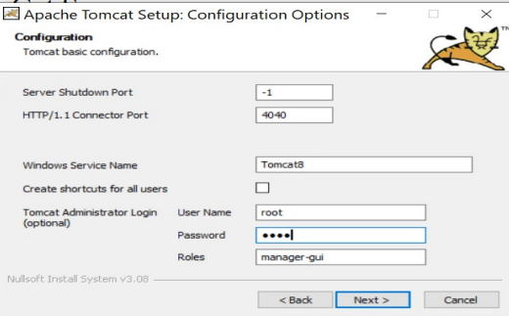

After successdully installed go to any web browser and in the search bar give **localhost:4040** and click **enter**.

**In GitHub:**

1.Login to your GitHub account and create a New repository named as **java-hello-world-webapp**.

prior to this download the file java-hello-world-webapp from your mail and extract it.

2. Now upload the above extracted files to your new repository and commit changes.

3.copy the link as shown below:

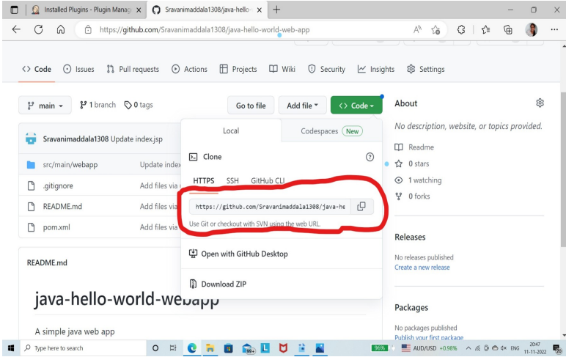

**Now in Jenkins**

**Follow the below given steps carefully:**

1.Open Jenkins Dashboard

2.In the left click on **Manage Jenkins** and click on **Global configureTools**

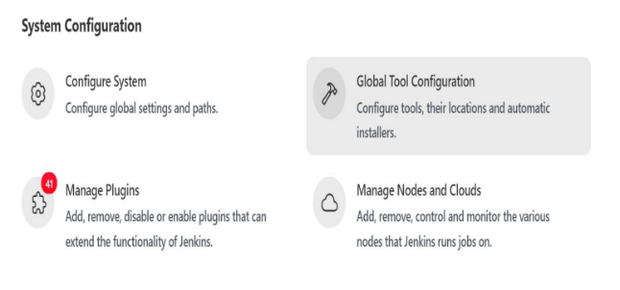3.Now Scroll down and under **jdk installations** click on **add** and fill the details as shown in the below picture.

**Note** that the path specified here is the path where you have installed Java in your system.

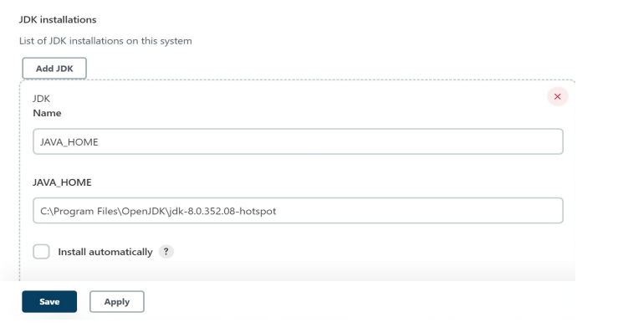

4.Now go to the bottom of the page and under Maven click on add. The path specified here is the location of Maven where you have installed in your system.

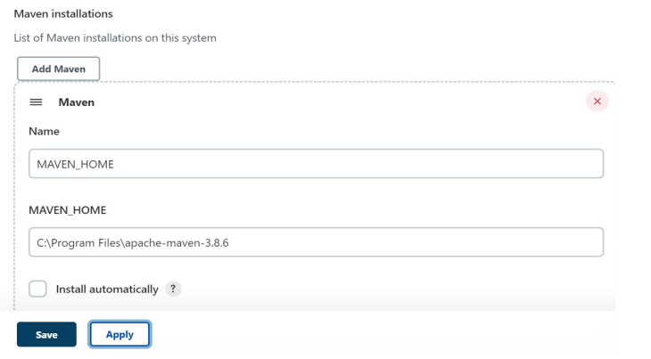

5.Now click on Apply and then click on save.

6.Now go to **plugin Manager(click on Manage Jenkins->Manage plugins).**

7.click on Available and search for **“deploy to container”** and click on **install without restart**. Also search for **Maven Integration** and **install**.

8. create a new job named **“Maven-webapp_development”** and select **Freestyle project** while you are creating the job.

9.under SCM select **Git** and in the repository Url give the above copied link. under credentials click on add-->Jenkins and give the details as follows

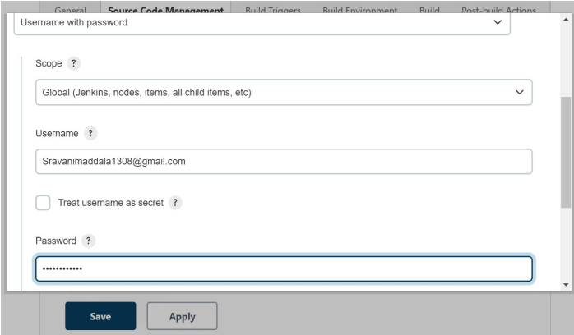

Give the username and password that you have used for logging to GitHub.Scroll down and click on “add”.

10.After the credentials successfully, select the one that is created above then the screen looks as follows

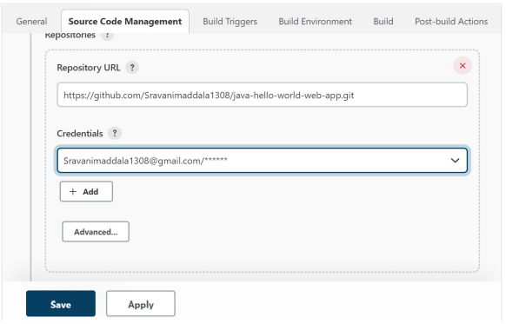

11. Specify the branch that the code in your GitHub has(main or master)

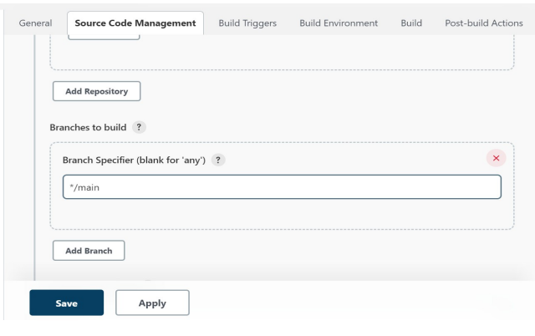

12.Under Build, click on **Add Build step** and **select invoke toplevel Maven targets** and specify the details as shown

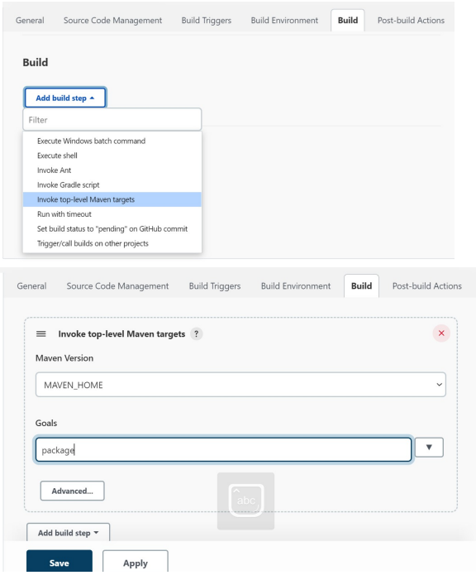

12.under **Post-build Actions** click on **Add container** and select **TomCat 8x remote** and give the details as follows

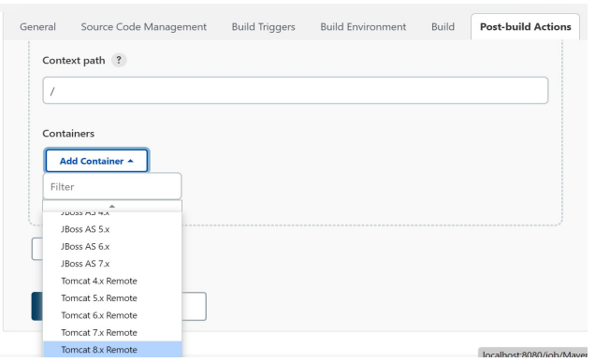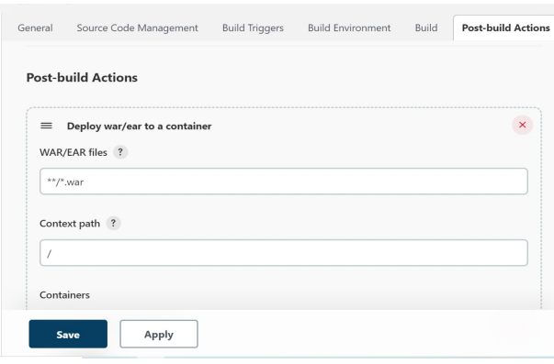

13.Under credentials click on Add-->Jenkins and give the username and password as root.Click on Add.Now select the above added credential from the dropdown displayed.

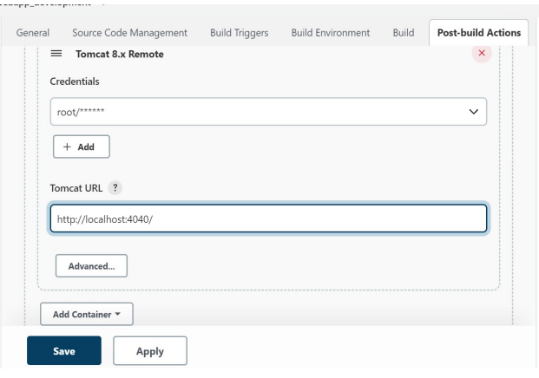

Click on Apply and save.

Now go to C:\Program Files\Apache Software Foundation\Tomcat 8.5\ conf in them open the file **tomcat-users** with notepad and insert the following line just above the last line

<user username=”root” password=”root” roles=”manager-scripts”

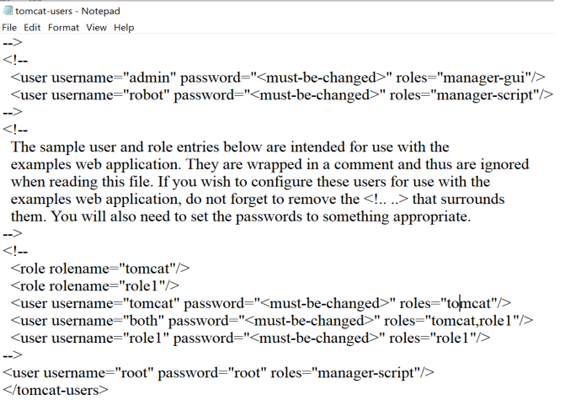

save the file.

Now click on “Build Now”

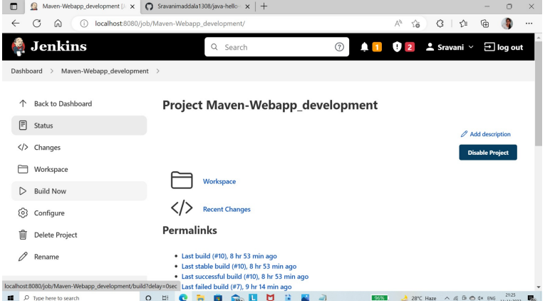

After the build has completed successfully open any web browser and search **localhost:4040** you will see the output of the HTML file as follows.

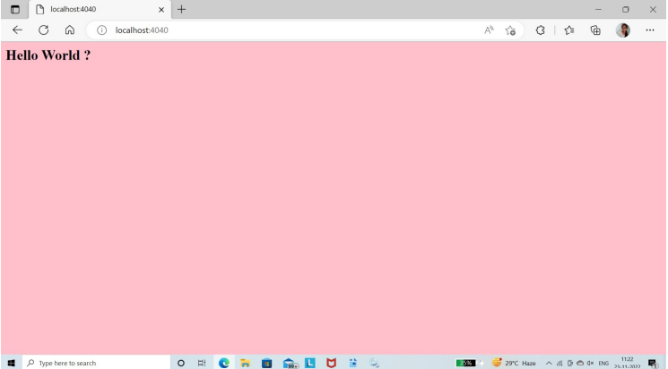

**Implementing java program using Maven**

**Maven Repository**

A **maven repository** is a directory of packaged JAR file with pom.xml file. Maven searches for dependencies in the repositories. There are 3 types of maven repository:

1. Local Repository
2. Central Repository
3. Remote Repository

Maven searches for the dependencies in the following order:

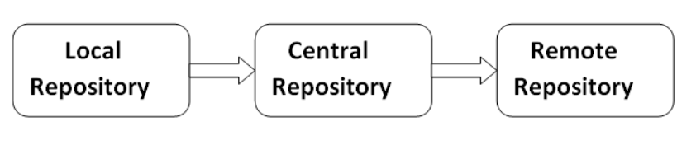**Local repository** then **Central repository** then **Remote repository**.

If dependency is not found in these repositories, maven stops processing and throws an error.

## **Maven Local Repository**

Maven **local repository** is located in your local system. It is created by the maven when you run any maven command.

By default, maven local repository is %USER_HOME%/.m2 directory. For example C:\Users\Amuratha\.m2

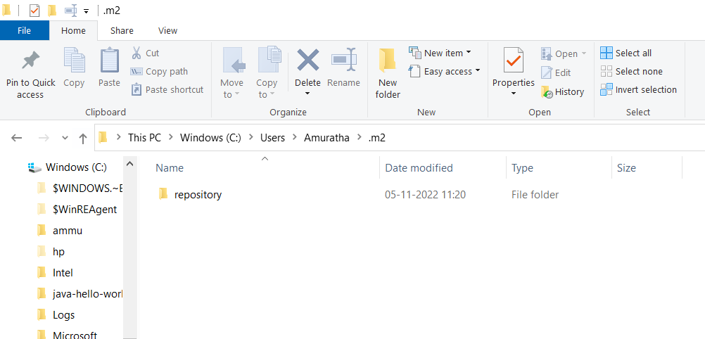

## **STEP 1: Update location of Local Repository**

We can change the location of maven local repository by changing the **settings.xml** file. It is located in **MAVEN_HOME/conf/settings.xml**, for example: **E:\apache-maven-3.1.1\conf\settings.xml**.

Let's see the default code of settings.xml file.

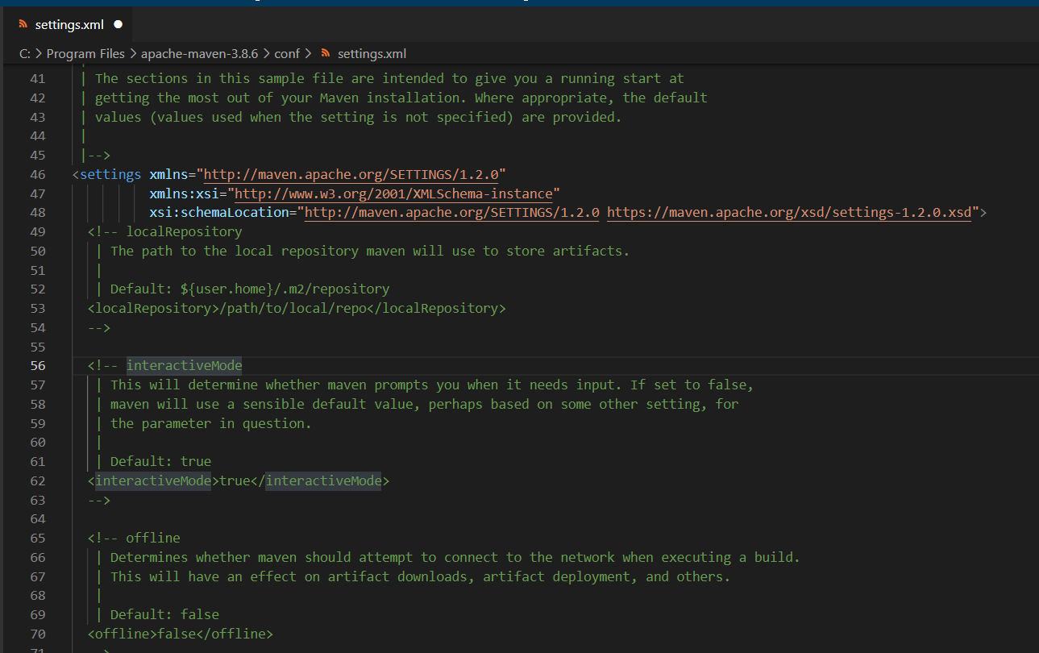

Now change the path to local repository. After changing the path of local repository, it will look like this:

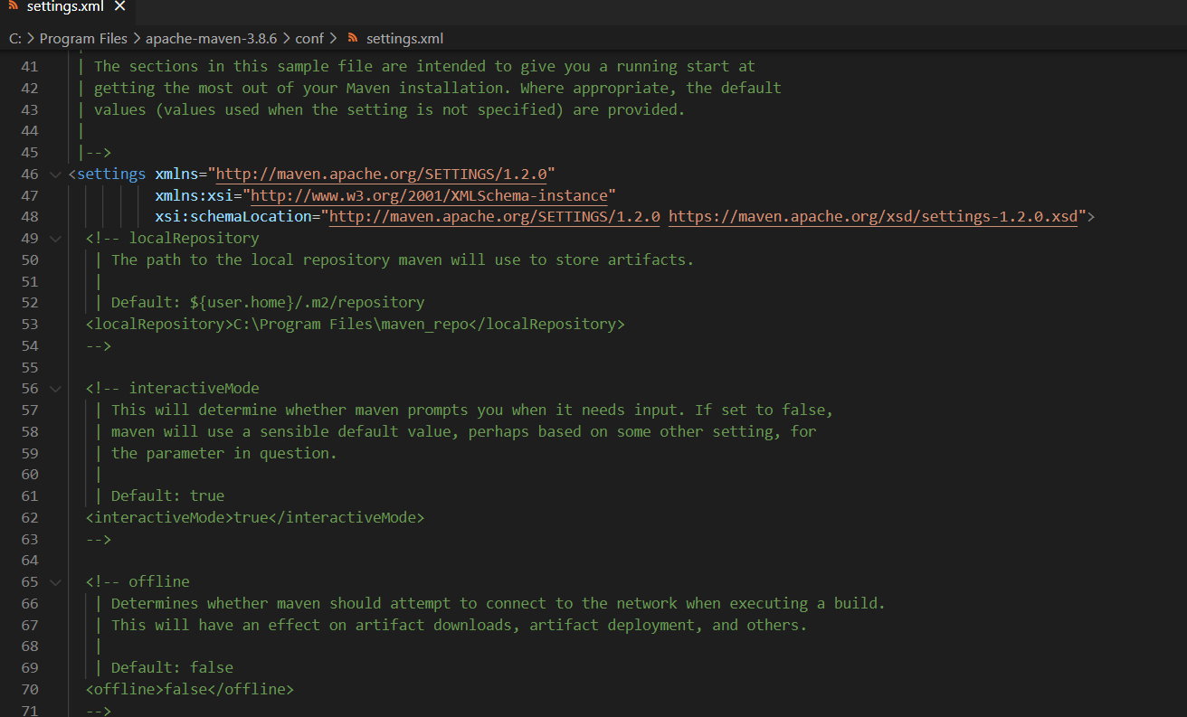

As you can see, now the path of local repository is C:\Program Files\maven_repo

# Maven Example

**STEP2: Creating a simple java project using maven**

To create a simple java project using maven, you need to open command prompt and run the **archetype: generate** command of mvn tool.

The **syntax** to generate the project architecture is given below:



The **example** to generate the project architecture is given below:



#### **Output**

Now it will **generate following code in the command prompt**:

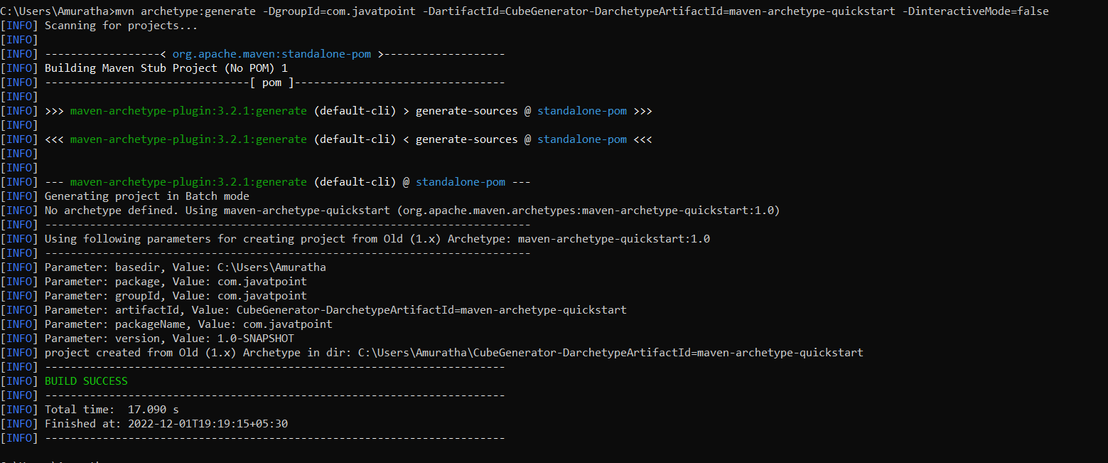

#### **Generated Directory Structure**

Now go to the current directory from where you have executed the mvn command. For example: **C:\Users\Amuratha\CubeGenerator**. You will see that a simple java project is created that has the following directory:

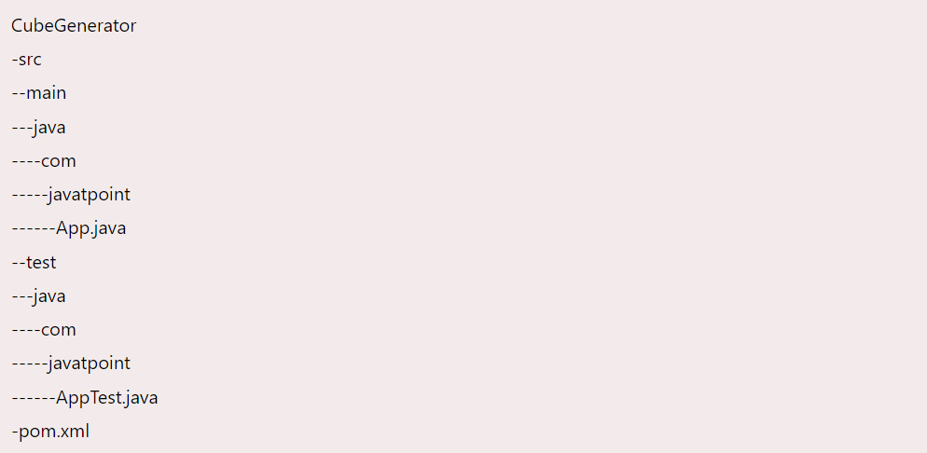

As you can see, there are created 3 files pom.xml, App.java and AppTest.java. Let's have a quick look at these files:

#### **1) Automatically Generated pom.xml file**

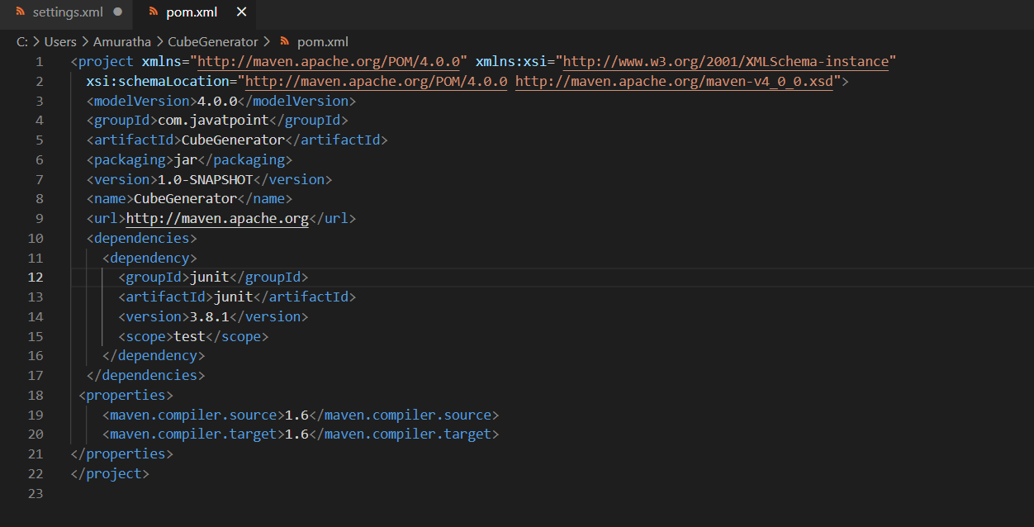

#### **2) Automatically Generated App.java file**

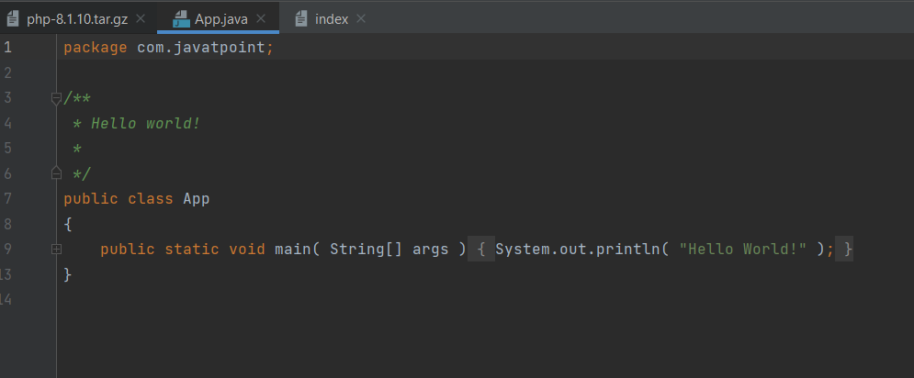

**3) Automatically Generated AppTest.java file**

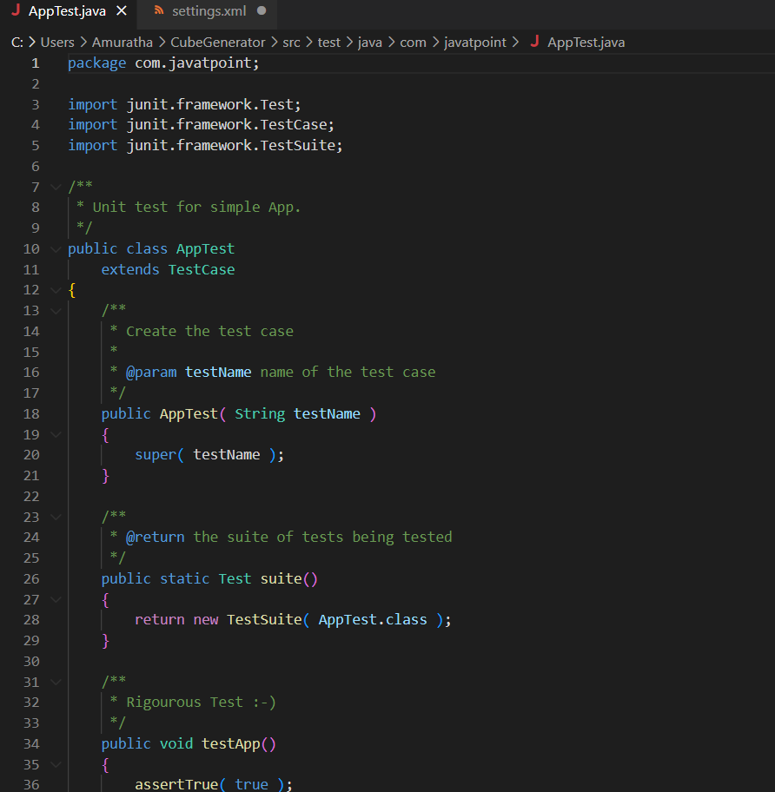

## **STEP 3: Compile the Maven Java Project**

To compile the project, go to the project directory,

for example: **C:\Users\Amuratha\CubeGenerator** and write the following command on the command prompt:



Now, you will see a lot of execution on the command prompt.

Output:

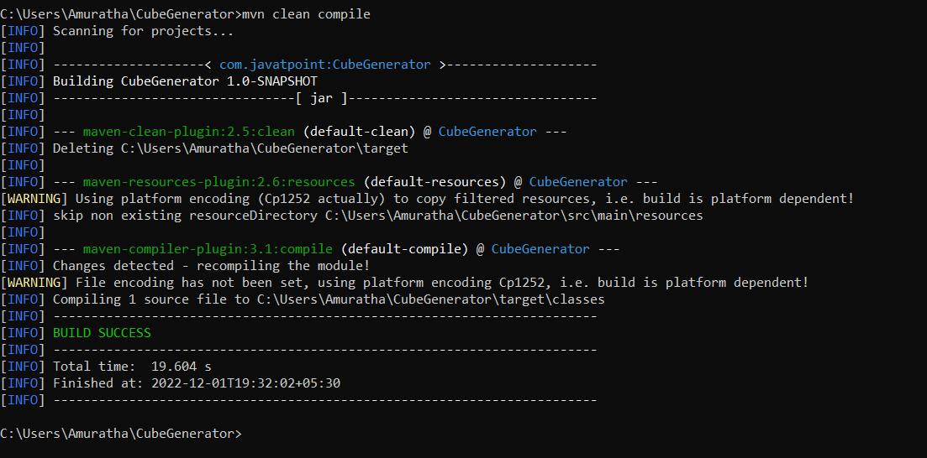

If you check your project directory, **target directory** is created that contains the class files.

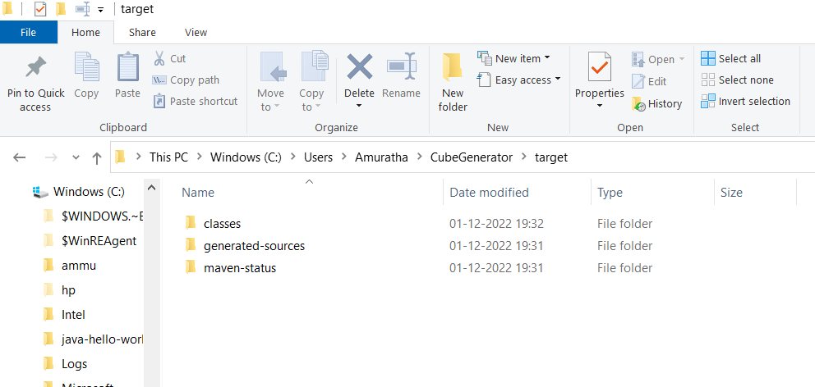

## **STEP 4: Run the Maven Java Project**

To run the project, go to the project directory\target\classes,

for example:C:\Users\Amuratha\CubeGenerator\target\classes and write the following command on the command prompt



Now, you will see the output on the command prompt:

## **Output of the maven example:**

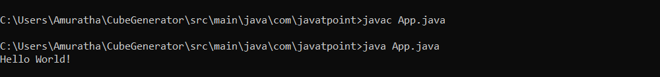

**EXERCISE-7**

**Module Name:** Implementation of CICD with Java and open source stack Configure the Jenkins tool with the required paths, path variables, users and pipeline views.

**What is Jenkins and why we use it?**

Jenkins is an open-source automation tool written in Java with plugins built for Continuous Integration purposes. Jenkins is used to build and test your software projects continuously making it easier for developers to integrate changes to the project, and making it easier for users to obtain a fresh build. It also allows you to continuously deliver your software by integrating with a large number of testing and deployment technologies.

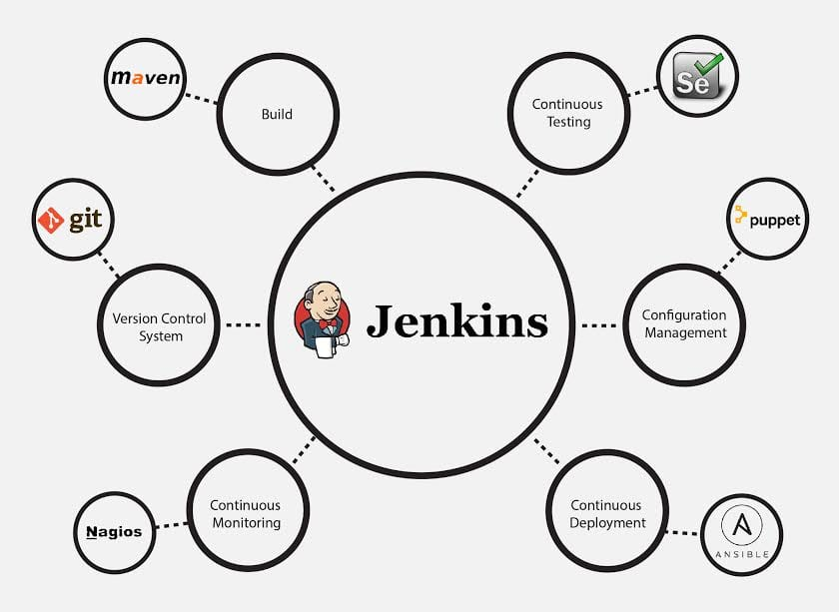

### **Advantages of Jenkins include:**

* It is an open-source tool with great community support.
* It is easy to install.
* It has 1000+ plugins to ease your work. If a plugin does not exist, you can code it and share it with the community.
* It is free of cost.
* It is built with Java and hence, it is portable to all the major platforms

**Installation of Jenkins**

**Step 1: Setup wizard**

On opening the Windows Installer, an Installation Setup Wizard appears, Click Next on the Setup Wizard to start your installation.

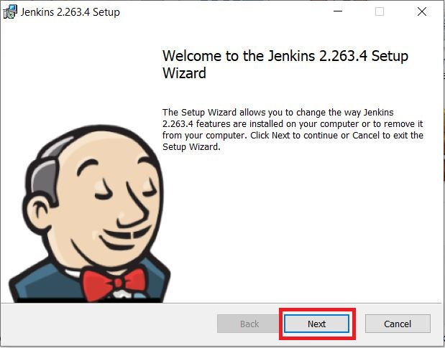

**Step 2: Select destination folder**

Select the destination folder to store your Jenkins Installation and click **Next** to continue.

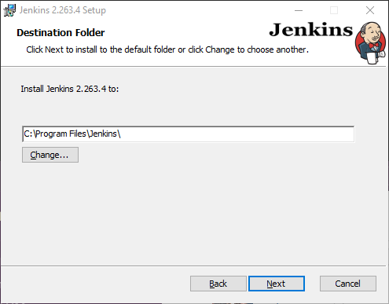

**Step 3: Service logon credentials**

When Installing Jenkins, it is recommended to install and run Jenkins as an independent windows service using a local or domain user as it is much safer than running Jenkins using Local System (Windows equivalent of root) which will grant Jenkins full access to your machine and services.

To run Jenkins service using a local or domain user, specify the domain user name and password with which you want to run Jenkins, click on Test Credentials to test your domain credentials and click on Next.

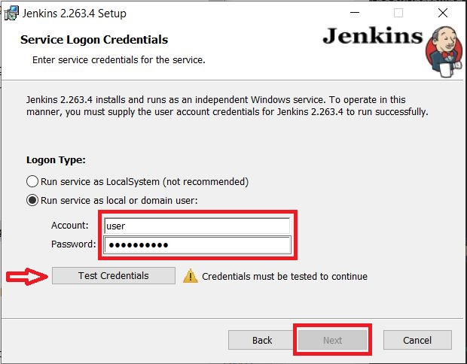

**Step 4: Port selection**

Specify the port on which Jenkins will be running, **Test Port** button to validate whether the specified port if free on your machine or not. Consequently, if the port is free, it will show a green tick mark as shown below, then click on **Next**.

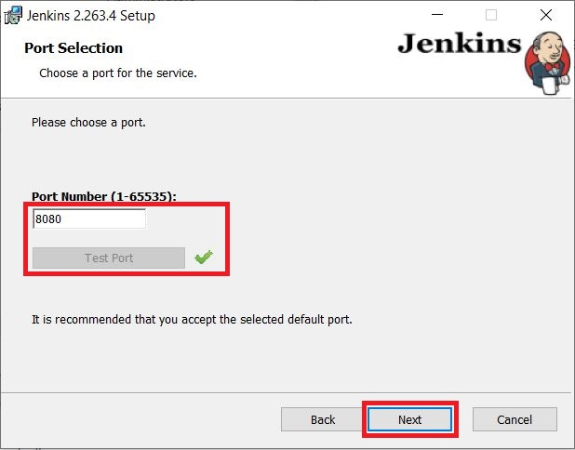

**Step 5: Select Java home directory**

The installation process checks for Java on your machine and prefills the dialog with the Java home directory. If the needed Java version is not installed on your machine, you will be prompted to install it.

Once your Java home directory has been selected, click on **Next** to continue.

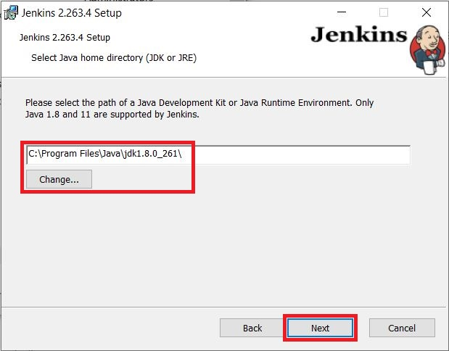

**Step 6: Custom setup**

Select other services that need to be installed with Jenkins and click on **Next**.

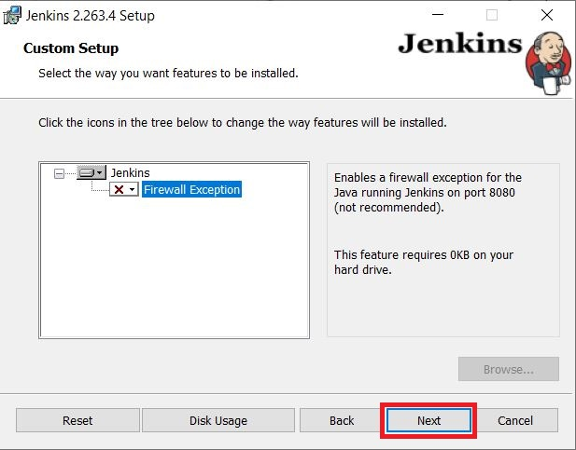

**Step 7: Install Jenkins**

Click on the **Install** button to start the installation of Jenkins.

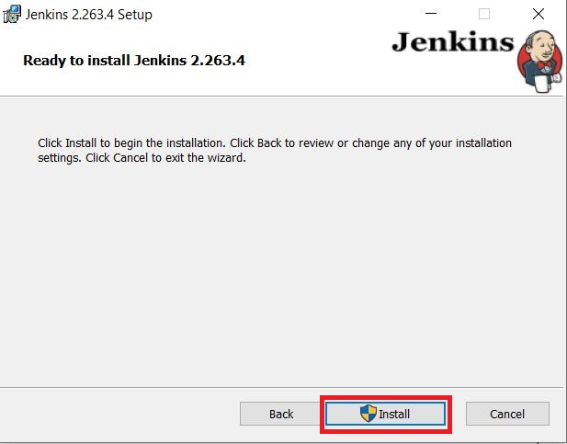

Additionally, clicking on the **Install** button will show the progress bar of installation, as shown below:

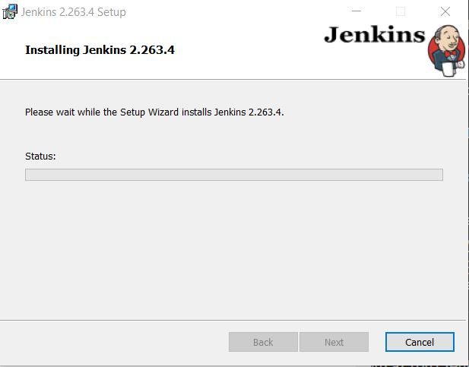

**Step 8: Finish Jenkins installation**

Once the installation completes, click on **Finish** to complete the installation.

Jenkins will be installed as a **Windows Service**. You can validate this by browsing the **services** section, as shown below:

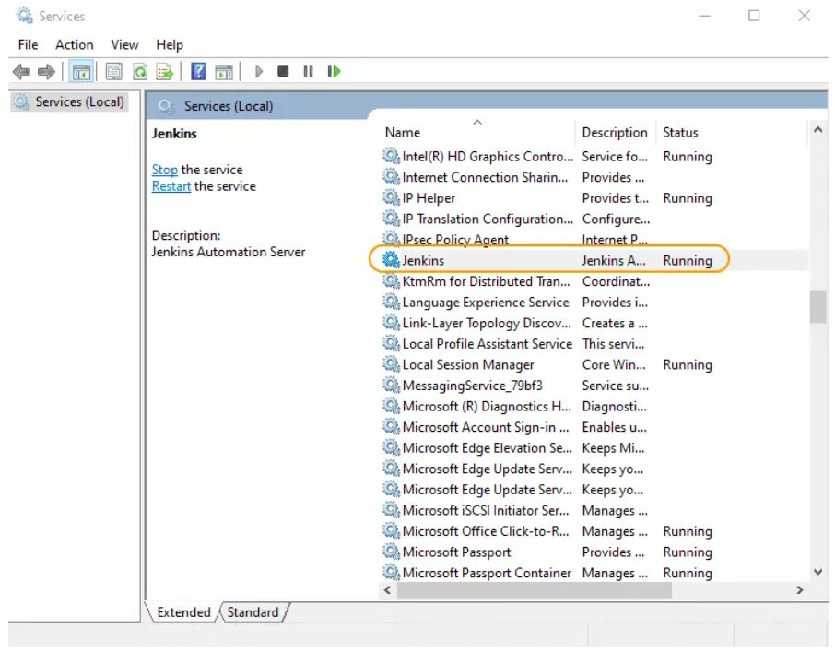

**Login to Jenkins**

To create a Jenkins freestyle job, log on to your Jenkins dashboard by visiting your Jenkins installation path. Usually, it will be hosted on localhost at http://localhost:8080 If you have installed Jenkins in another path, use the appropriate URL to access your dashboard as shown in the below Jenkins job creation example.

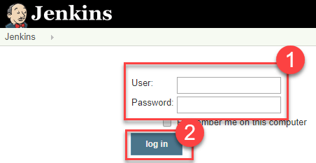

**After Installation the dashboard looks like this:**

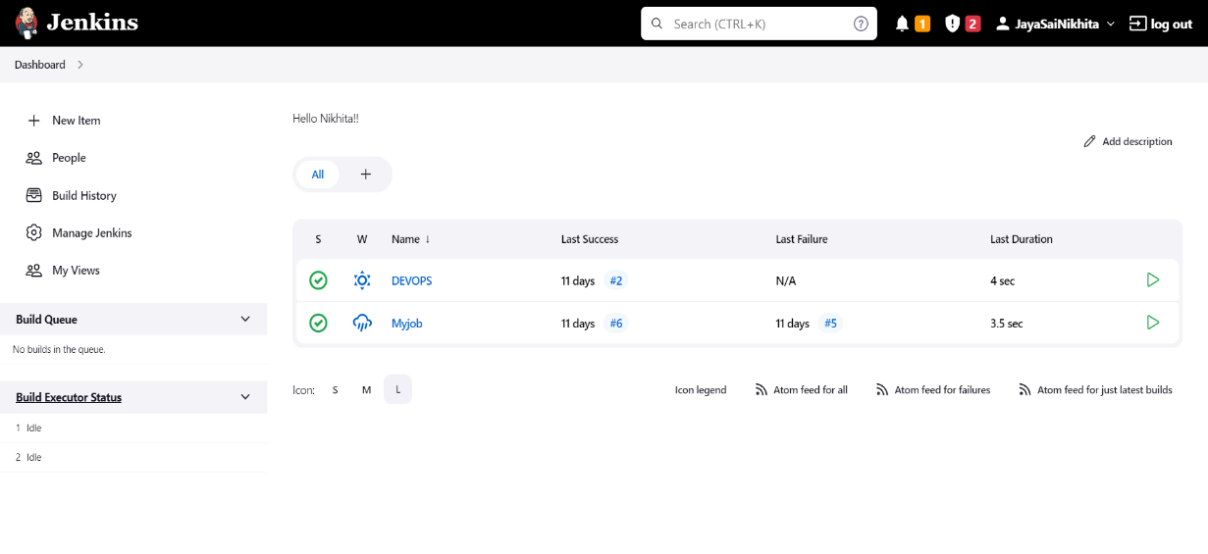

**Exploring the options in Jenkins:**

* **NEW ITEM:**

Click on “**New Item**” at the top left-hand side of your dashboard

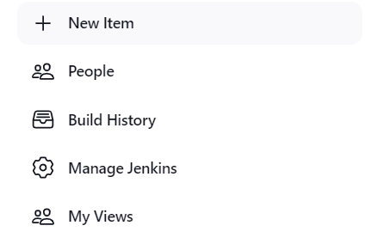

**Enter Item details**

In the next screen,

1. Enter the name of the item you want to create. We shall use the “Hello world” for this demo.
2. Select Freestyle project
3. Click Okay

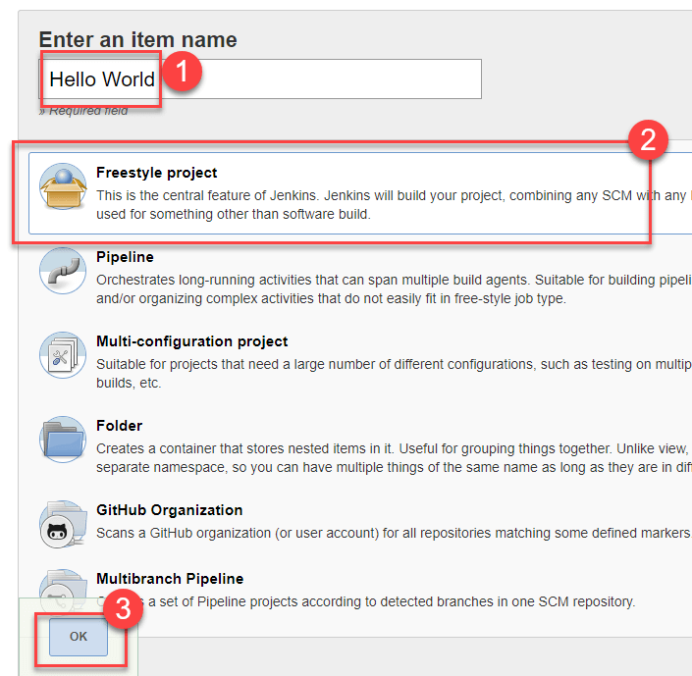

**Enter Project details**

Enter the details of the project you want to test.

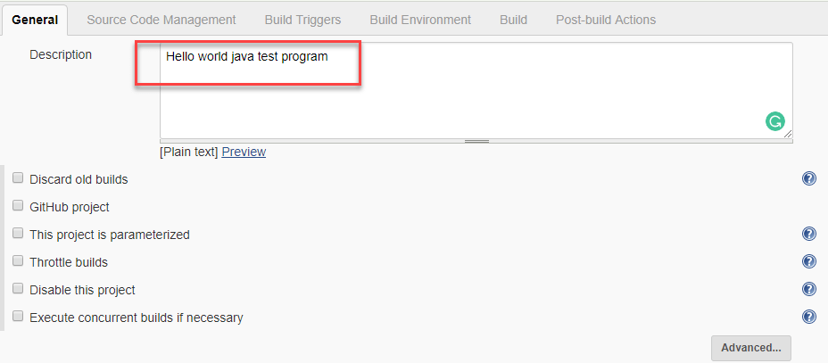

**Enter repository URL**

Under Source Code Management, Enter your repository URL. We have a test repository located at <https://github.com/kriru/firstJava.git>

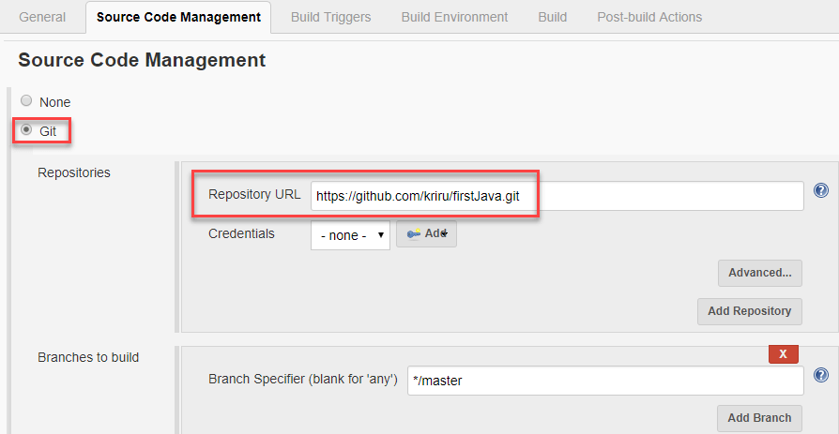

It is also possible for you to use a local repository.

If your GitHub repository is private, Jenkins will first validate your login credentials with GitHub and only then pull the source code from your GitHub repository.

**Tweak the settings**

Now that you have provided all the details, it’s time to build the code. Tweak the settings under the **build** section to build the code at the time you want. You can even schedule the build to happen periodically, at set times.

Under **build**,

1. Click on “**Add build step**”

2. Click on “**Execute Windows batch command**” and add the commands you want to execute during the build process.

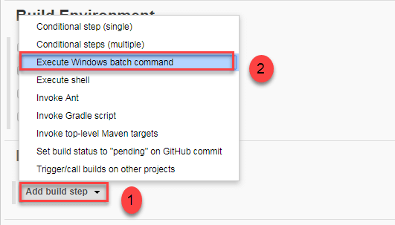

Here, I have added the java commands to compile the java code.

I have added the following windows commands:

javac HelloWorld.java

java HelloWorld

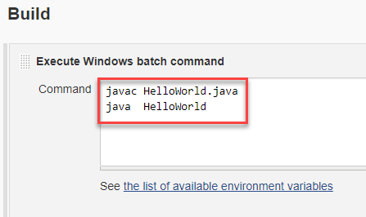

**Save the project**

When you have entered all the data,

1. Click **Apply**
2. **Save**the project.

**Build Source code**

Now, in the main screen, Click the **Build Now**button on the left-hand side to build the source code.

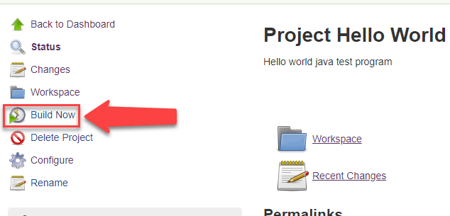

**Check the status**

After clicking on **Build now,**you can see the status of the build you run under **Build History**.

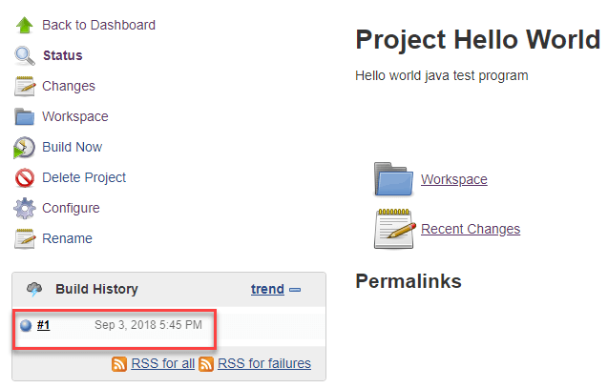

**See the console output**

Click on the **build number**andthenClick on **console output**to see the status of the build you run. It should show you a success message, provided you have followed the setup properly as shown in the below Jenkins create new job example.

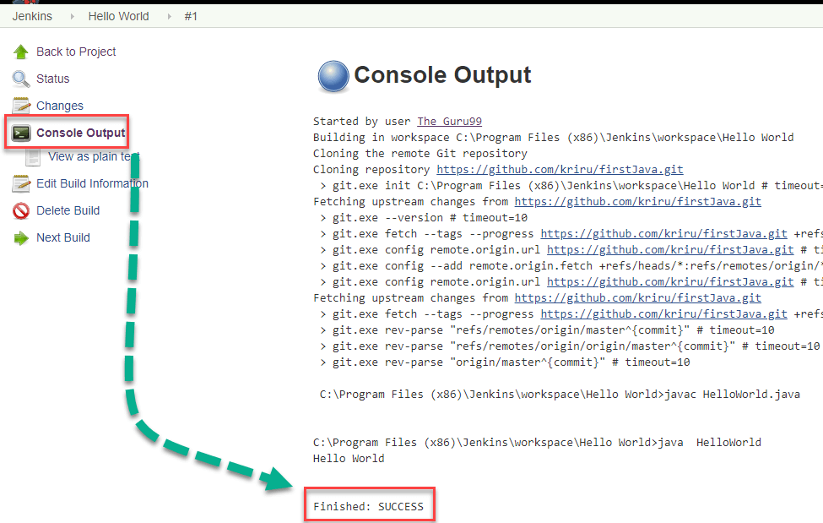

* **PEOPLE**

Includes all known “users”, including login identities which the current security realm can enumerate, as well as people mentioned in commit messages in recorded changelogs.

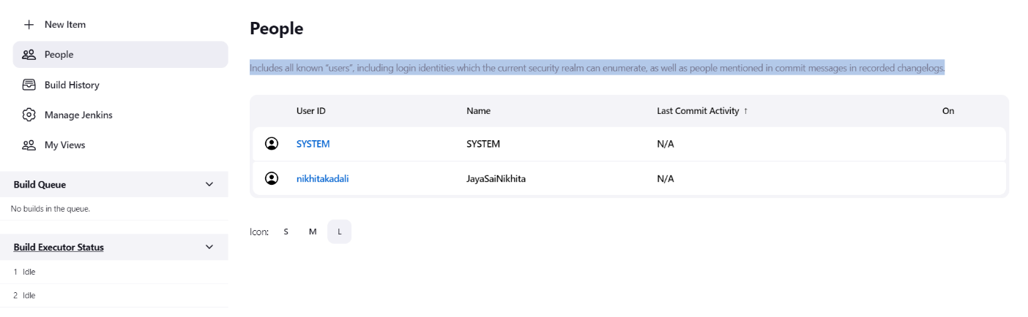

* **Build History**

To view the Build History, perform the following steps:

1. Navigate to the Jenkins dashboard and select Build History.

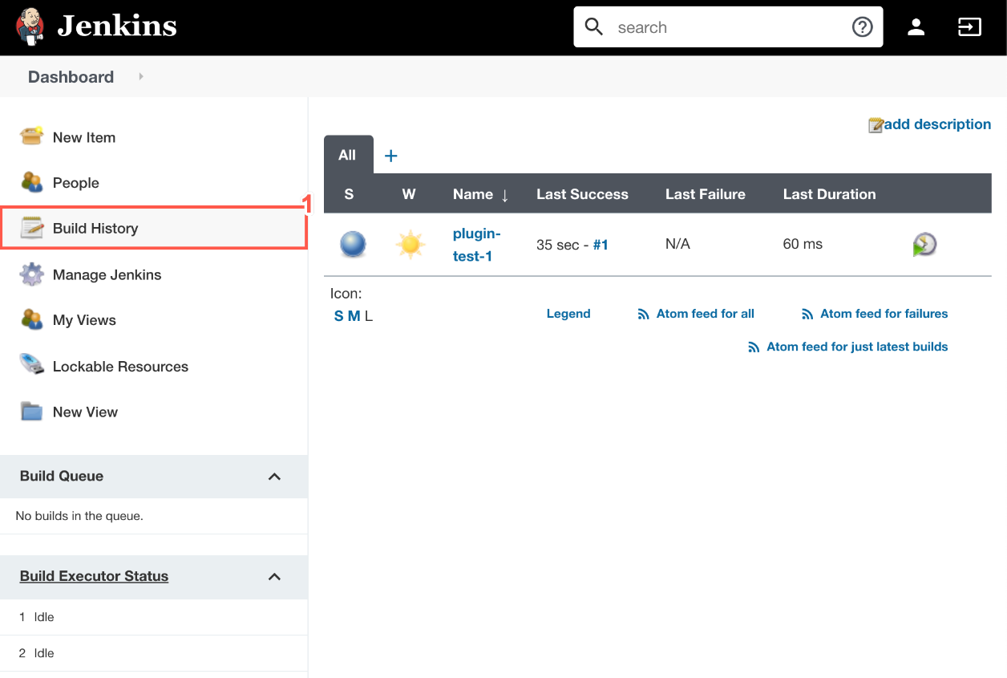

1. This timeline displays your build history.

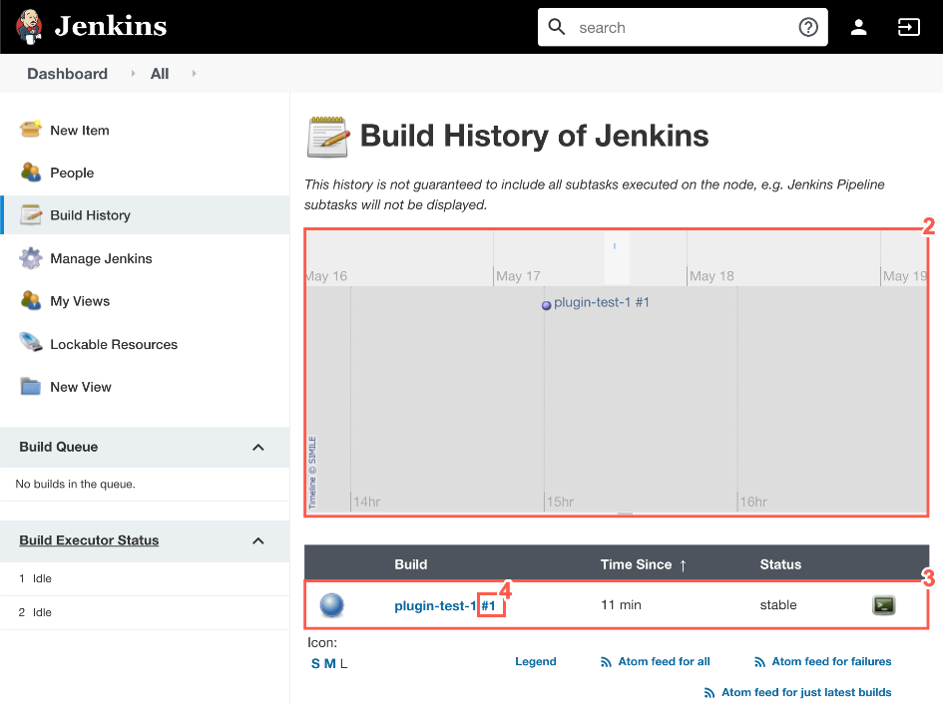

1. This table displays a list of your past builds, time since build and the status of each build.
2. From the list, select the build number to view the build details. From this page you can view the Console Output
3. To view the Console Output from the build details page, select Console Output.

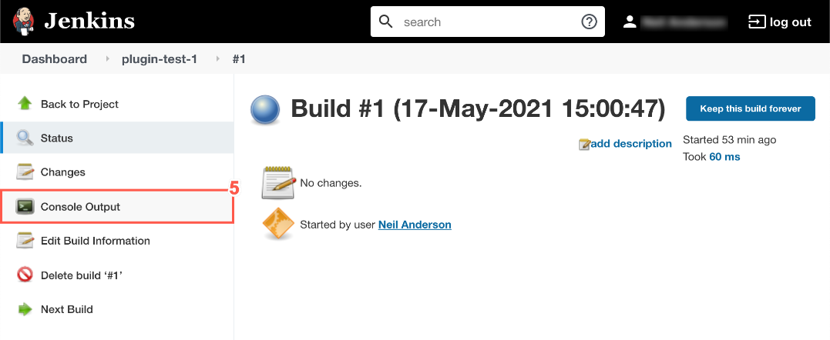

1. The Console Output displays which user started the build, the location of the build and the build status.

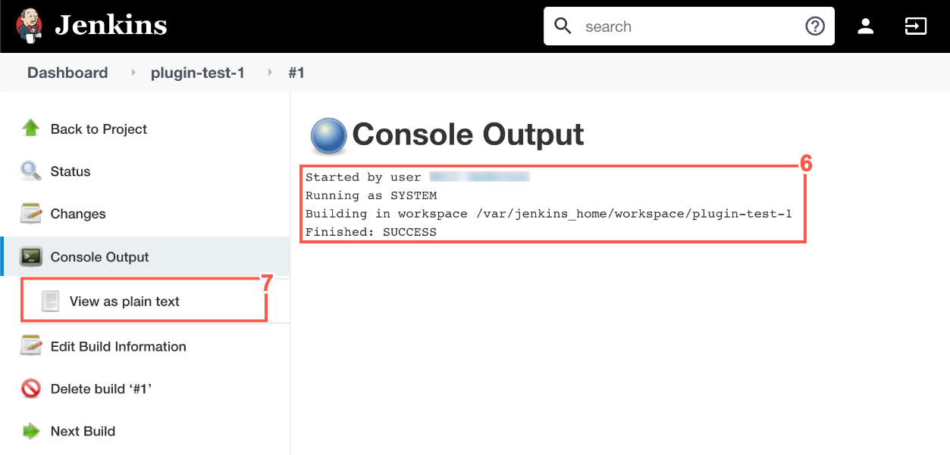

1. Optionally, select View as plain text to view the complete Console Output as a plain text page.

* **Manage Jenkins**

To manage Jenkins, click on the ‘Manage Jenkins’ option from the left hand menu side.

So one can get the various configuration options for Jenkins by clicking the ‘Manage Jenkins’ option from the left hand menu side.

You will then be presented with the following screen −

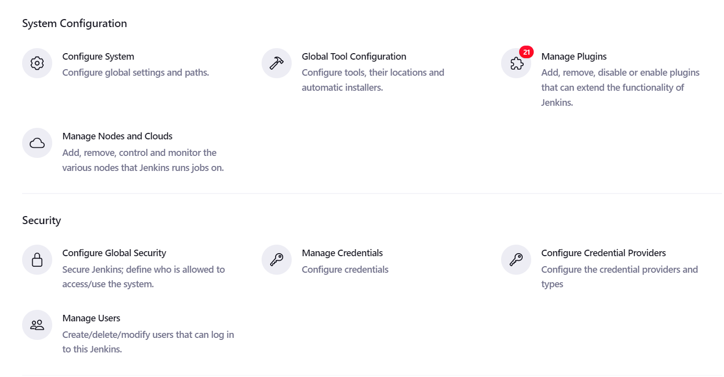

Some of the management options are as follows −

## Configure System

This is where one can manage paths to the various tools to use in builds, such as the JDKs, the versions of Ant and Maven, as well as security options, email servers, and other system-wide configuration details. When plugins are installed. Jenkins will add the required configuration fields dynamically after the plugins are installed.

## Reload Configuration from Disk

Jenkins stores all its system and build job configuration details as XML files which is stored in the Jenkins home directory. Here also all of the build history is stored. If you are migrating build jobs from one Jenkins instance to another, or archiving old build jobs, you will need to add or remove the corresponding build job directories to Jenkins’s builds directory. You don’t need to take Jenkins offline to do this—you can simply use the “Reload Configuration from Disk” option to reload the Jenkins system and build job configurations directly.

## Manage Plugin

Here one can install a wide variety of third-party plugins right from different Source code management tools such as Git, Mercurial or ClearCase, to code quality and code coverage metrics reporting. Plugins can be installed, updated and removed through the Manage Plugins screen.

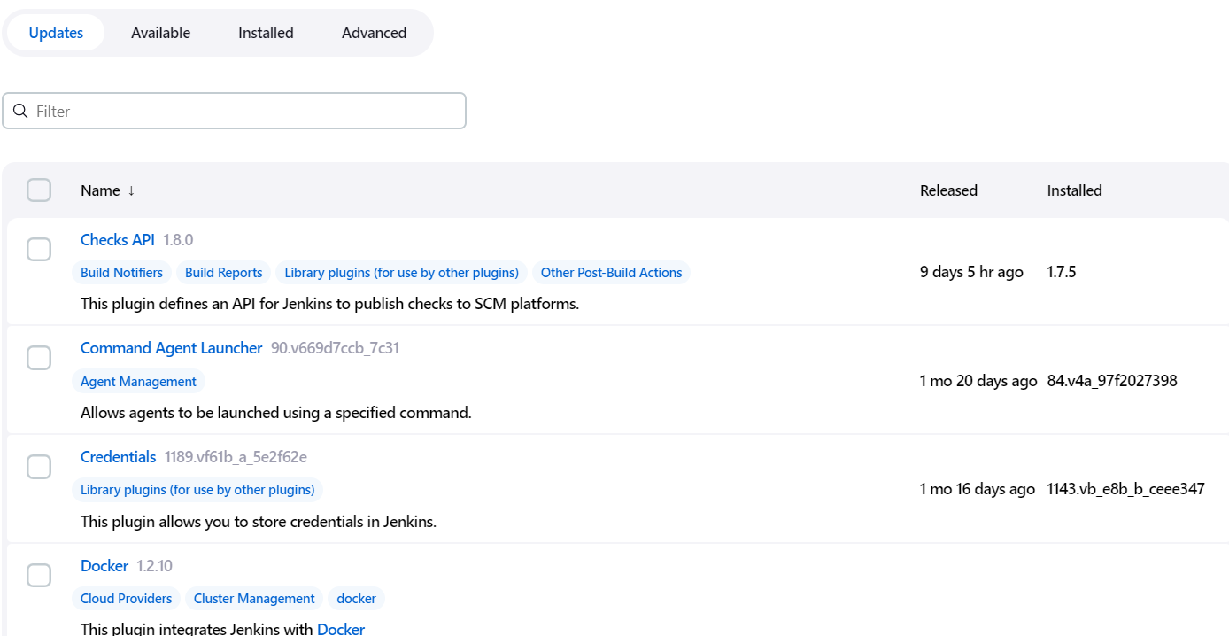

## System Information

This screen displays a list of all the current Java system properties and system environment variables. Here one can check exactly what version of Java Jenkins is running in, what user it is running under, and so forth.

The following screenshot shows some of the name-value information available in this section.

### System Log

The System Log screen is a convenient way to view the Jenkins log files in real time. Again, the main use of this screen is for troubleshooting.

### Load Statistics

This pages displays graphical data on how busy the Jenkins instance is in terms of the number of concurrent builds and the length of the build queue which gives an idea of how long your builds need to wait before being executed. These statistics can give a good idea of whether extra capacity or extra build nodes is required from an infrastructure perspective.

### Script Console

This screen lets you run Groovy scripts on the server. It is useful for advanced troubleshooting since it requires a strong knowledge of the internal Jenkins architecture.

### Manage nodes

Jenkins is capable of handling parallel and distributed builds. In this screen, you can configure how many builds you want. Jenkins runs simultaneously, and, if you are using distributed builds, set up build nodes. A build node is another machine that Jenkins can use to execute its builds.

### Prepare for Shutdown

If there is a need to shut down Jenkins, or the server Jenkins is running on, it is best not to do so when a build is being executed. To shut down Jenkins cleanly, you can use the Prepare for Shutdown link, which prevents any new builds from being started. Eventually, when all of the current builds have finished, one will be able to shut down Jenkins cleanly.

* **My Views**

Views in Jenkins allow us to organize jobs and content into tabbed categories, which are displayed on the main dashboard. As a Jenkins instance expands, it is logical to create associated views for appropriate groups and categories.

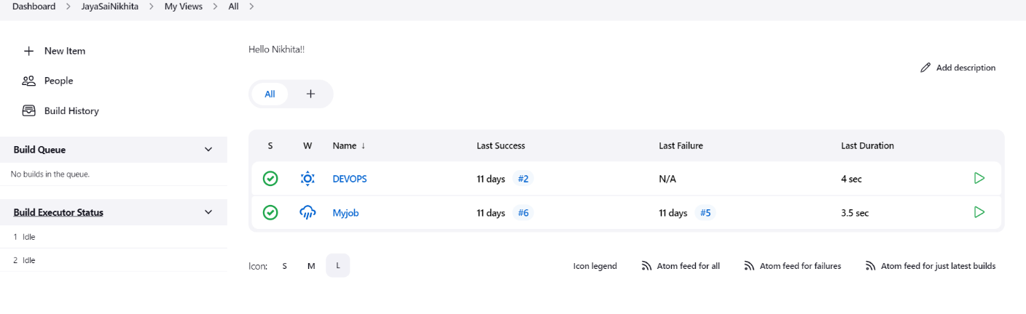

* Jenkins pipeline is implemented as a code which allows multiple users to edit and execute the pipeline process.
* Pipelines are robust. So if your server undergoes an unforeseen restart, the pipeline will be automatically resumed.
* You can pause the pipeline process and make it wait to resume until there is an input from the user.
* Jenkins Pipelines support big projects. You can run multiple jobs, and even use pipelines in a loop.

## **Jenkins Pipeline Concepts**

|  |  |
| --- | --- |
| **Term** | **Description** |
| Pipeline | The pipeline is a set of instructions given in the form of code for continuous delivery and consists of instructions needed for the entire build process. With pipeline, you can build, test, and deliver the application. |
| Node | The machine on which Jenkins runs is called a node. A node block is mainly used in scripted pipeline syntax. |
| ssStage | A stage block contains a series of steps in a pipeline. That is, the build, test, and deploy processes all come together in a stage. Generally, a stage block is used to visualize the Jenkins pipeline process. |
| Step | A step is nothing but a single task that executes a specific process at a defined time. A pipeline involves a series of steps. |

## Install Build Pipeline Plugin in Jenkins

With the **build pipeline** plugin, you can create a pipeline view of incoming and outgoing jobs, and create triggers which require manual intervention.

Here is how you can install the **build pipeline**plugin in your Jenkins:

**Step 1**) The settings for the plugin can be found under,

**Manage Jenkins > Manage Plugins.**

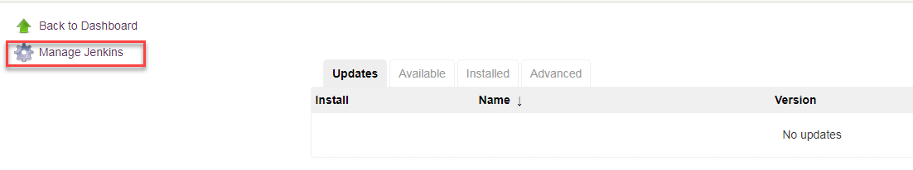

If you have already installed the plugin, it is shown under the installed tab.

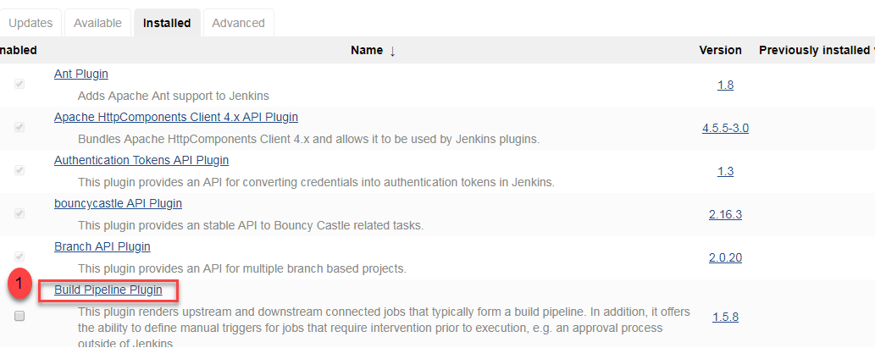

**Step 2**) If you do not have the plugin previously installed,

it shows up under the **Available**tab.

Once you have successfully installed the **build pipeline** plugin in your Jenkins, follow these steps to create your Jenkins pipeline:

## How to Create Jenkins Pipeline

Once you are logged in to your Jenkins dashboard:

**Step 1**) Click on the **“+”**button on the left-hand side of your Jenkins dashboard to create a pipeline.

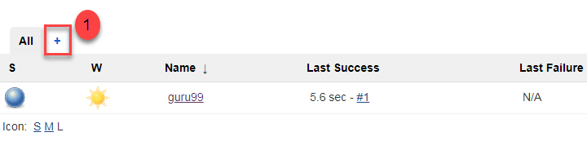

**Step 2**)

1. You will be asked to give a name to the pipeline view. We shall call it “**Guru99 Pipeline**” for the duration of this demo.
2. Select **Build a pipeline view**under **options**
3. Click **ok**

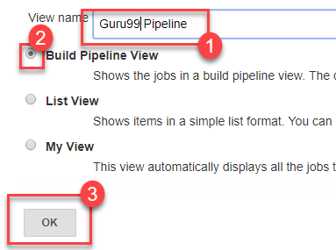

**Step 3**) In the next page, you will be asked for some more details to configure your Jenkins pipeline. Just accept the default settings, and make sure you choose the first job under the settings.

Click on **Apply**and then **OK**.

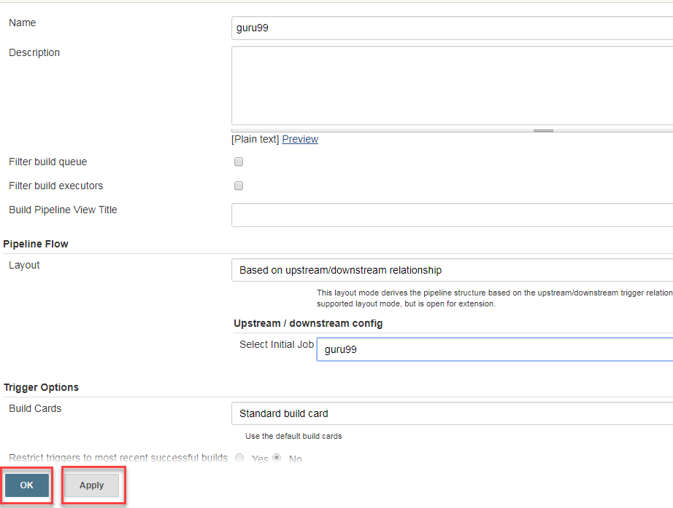

This will show you the sample pipeline view of your item, as given below:

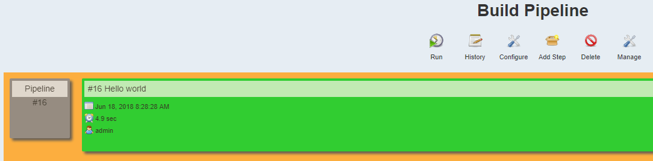

## Running a Pipeline build

**Step 1**) For running a pipeline build, you need to chain your jobs first. For this, go to your first job and click on configure.

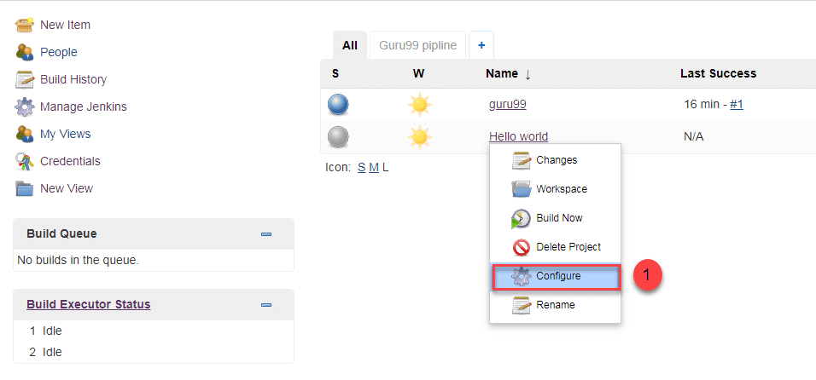

**Step 2**) Now, under **Build Triggers**, check the **Build after other projects are built** option.

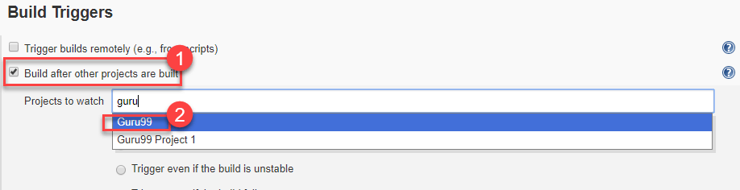

Thus, a chain for all your jobs has been created.

**Step 3**) Install the **Build Pipeline view** plugin if you don’t have it installed already.

**Step 4**) Go to your Jenkins dashboard and create a view by clicking on the “**+**” button. Select the **Build Pipeline View** option and click **OK**.

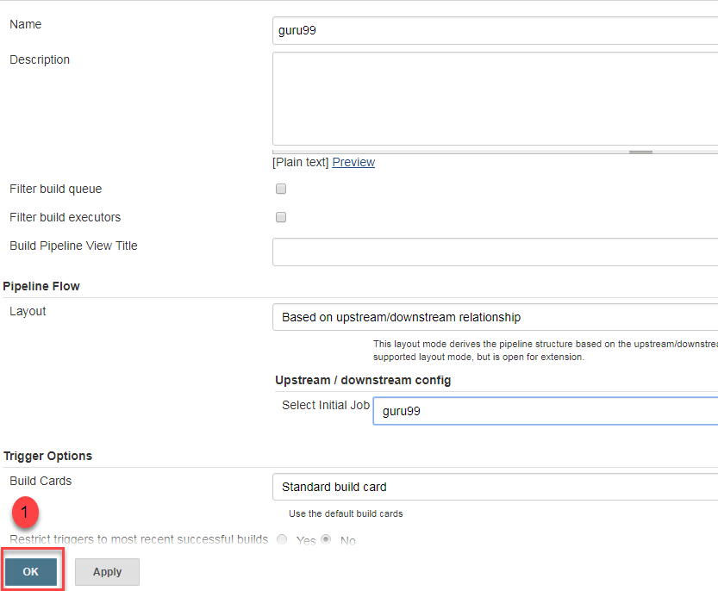

**Step 5**) Under **Pipeline view configuration**, locate **Pipeline Flow**.

Under **Pipeline flow**, select the initial job to run. Now choose the job which has chains to other jobs, as shown in **Step 1** and **Step 2**.

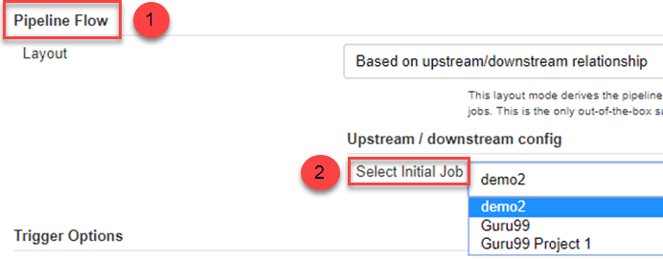

Here we have selected **Guru99 Project 1** as the initial job, chained to other jobs. So, one by one, the jobs will run in the pipeline.

When the Jenkins pipeline is running, you can check its status with the help of Red and Green status symbols. Red means the pipeline has failed, while green indicates success.

In this Jenkins pipeline example, we see that the button is green. Hence, the pipeline is successful.

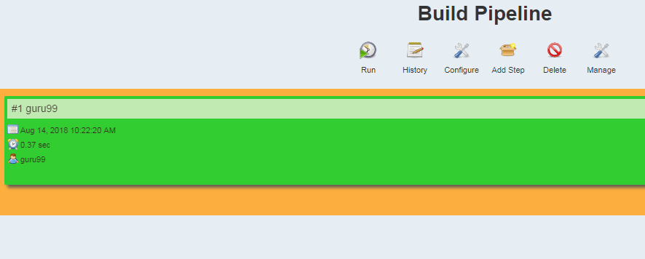

## Running Jenkins pipeline

Click on **Run**to run the Jenkins pipeline. It will look something like this:

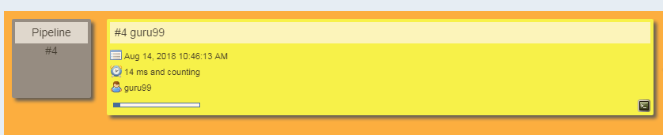

In the Jenkins pipeline script example above, we are demonstrating a simple “helloworld.java” program. But in real time projects, you will be responsible for creating and building complex pipelines in Jenkins. See below for a sample pipeline view.

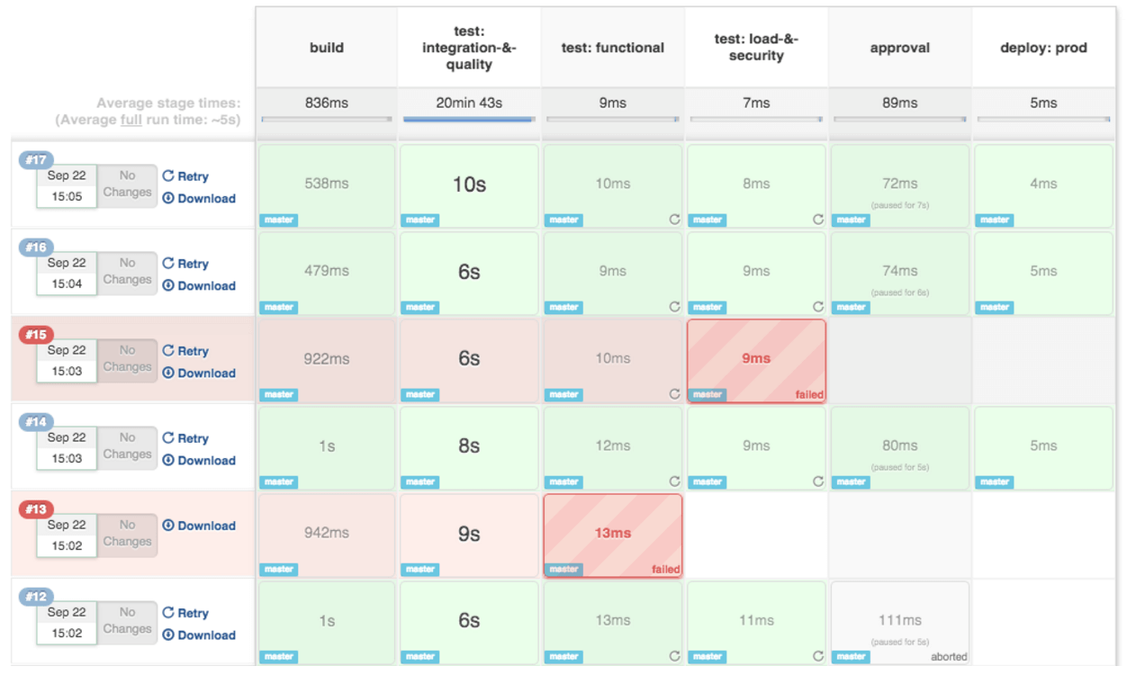

**Best Practices using Jenkins Pipeline:**

* Use the genuine Jenkins Pipeline
* Develop your pipeline as code
* Any non-setup work in your pipeline should occur within a stage block.
* Any material work in a pipeline must be performed within a node block.
* Don’t use input within a node block.
* Never set environment variables with env global variable
* Wrap your inputs in a timeout

**EXERCISE-8**

**Module name:**Implementation of CICD with Java and open-source stack.

**AIM:** Configure the Jenkins pipeline to call the build script jobs and configure to run it whenever there is a change made to an application in the version control system. Make a change to the background colour of the landing page of the web application and check if the configured pipeline runs.

**Creating GitHub repository and uploading files:**

1. Login to your GitHub account. Create if the account doesn’t exist.
2. Click on sign in.

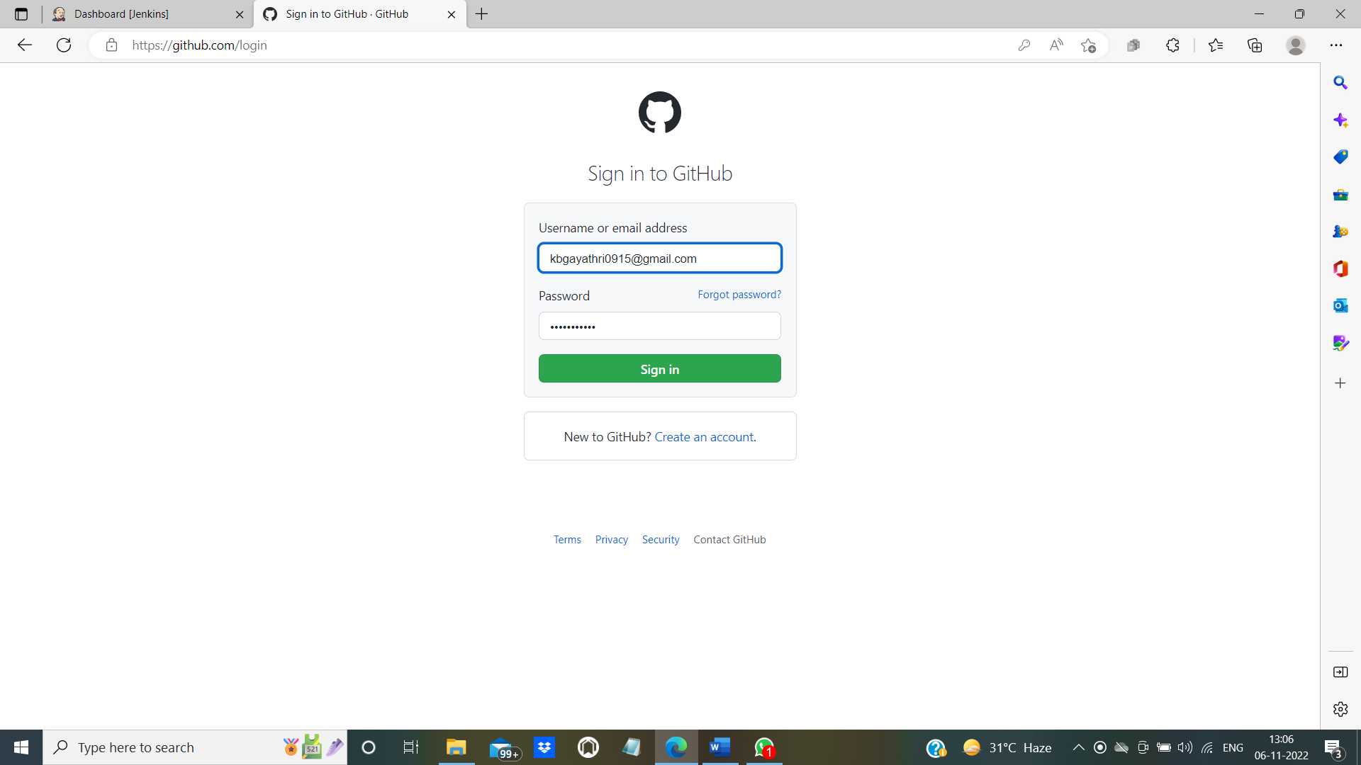

1. The following window will be displayed. You can find recent repositories that are already available in your account. To create a new repository, click on new.

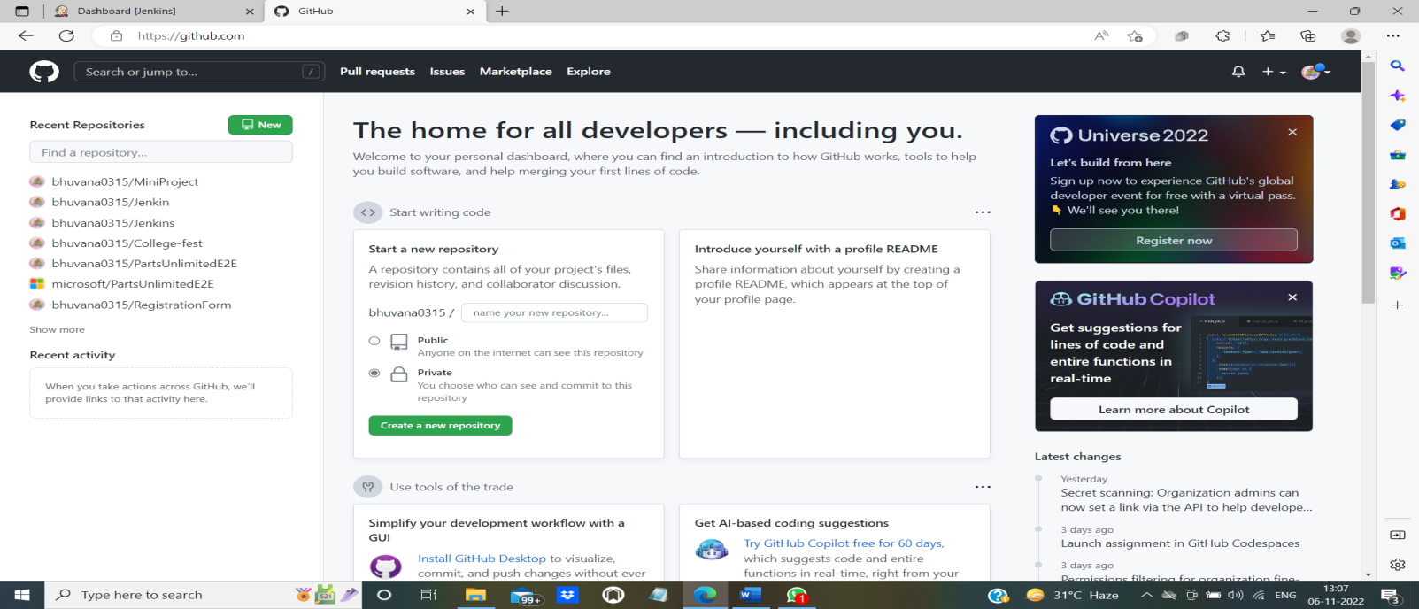

1. Specify a valid name for the repository and click on “Create repository” that can be seen at the bottom of the page.

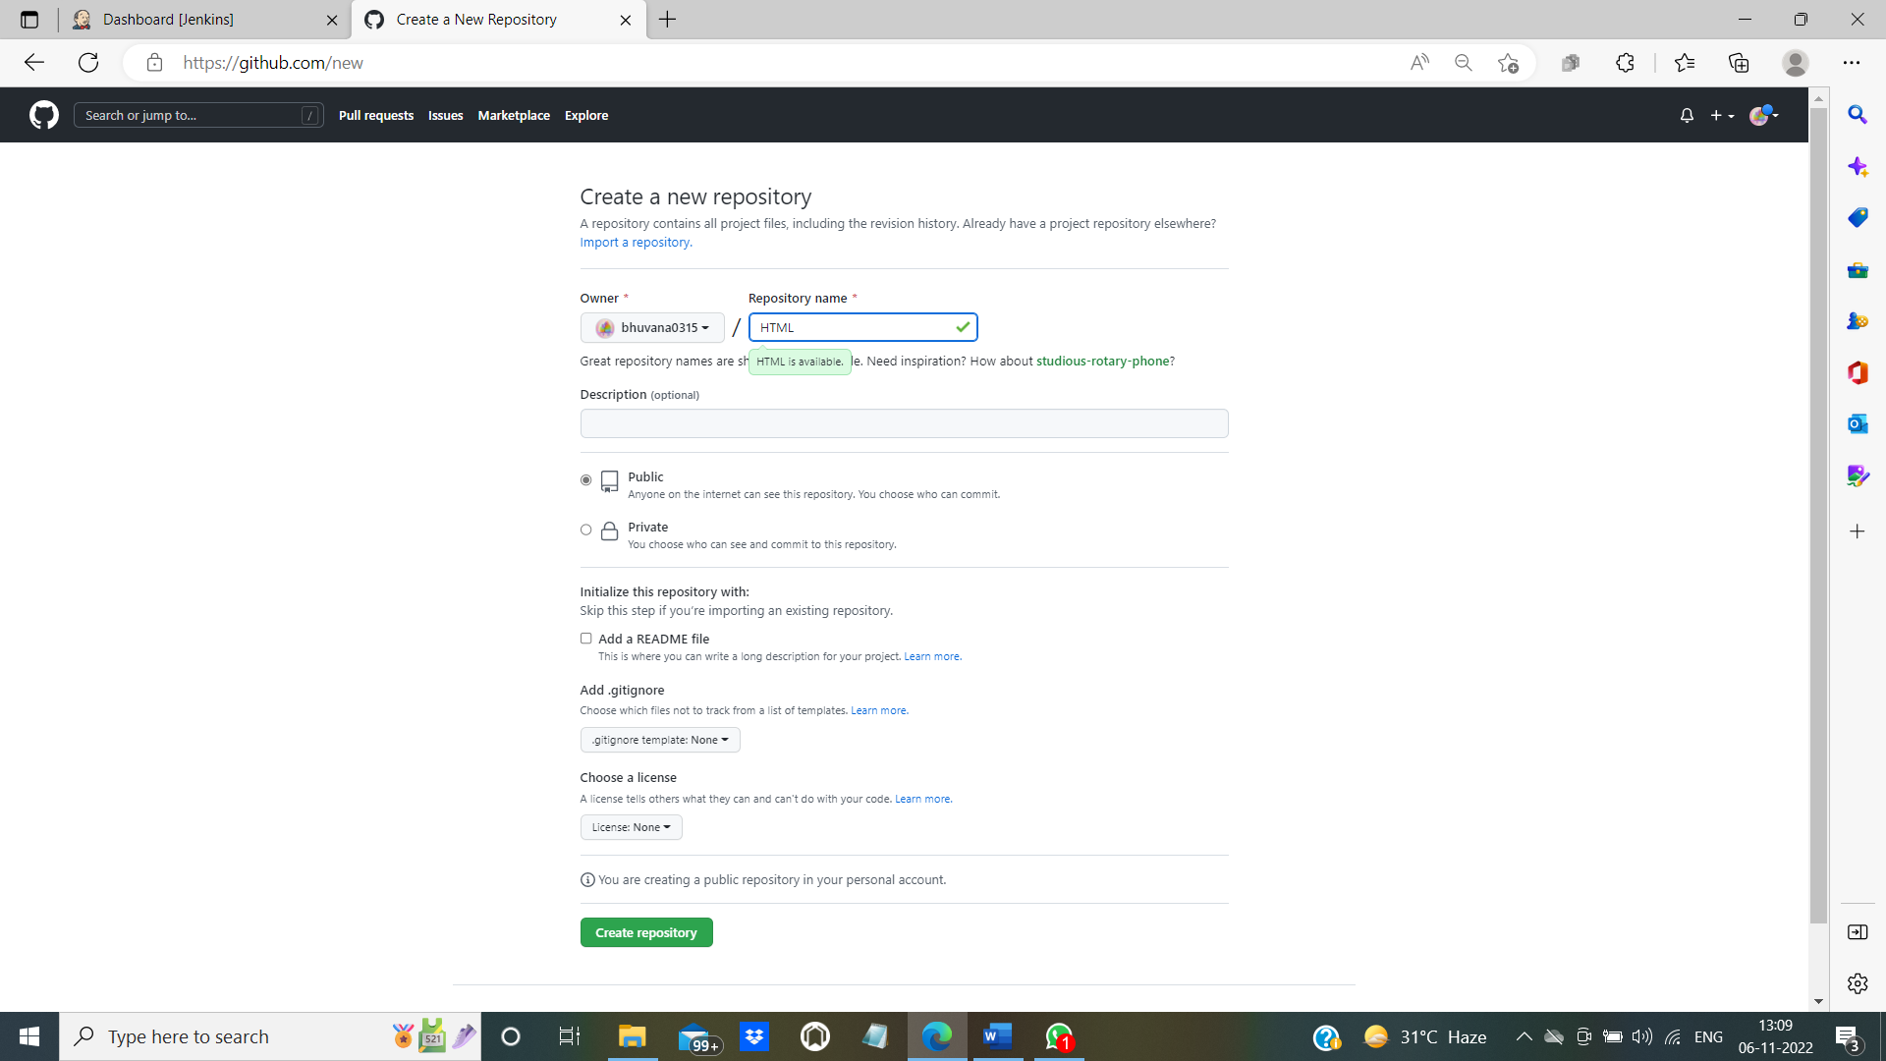

1. Once the repository is created, you will get the following screen where you can create or upload your files.

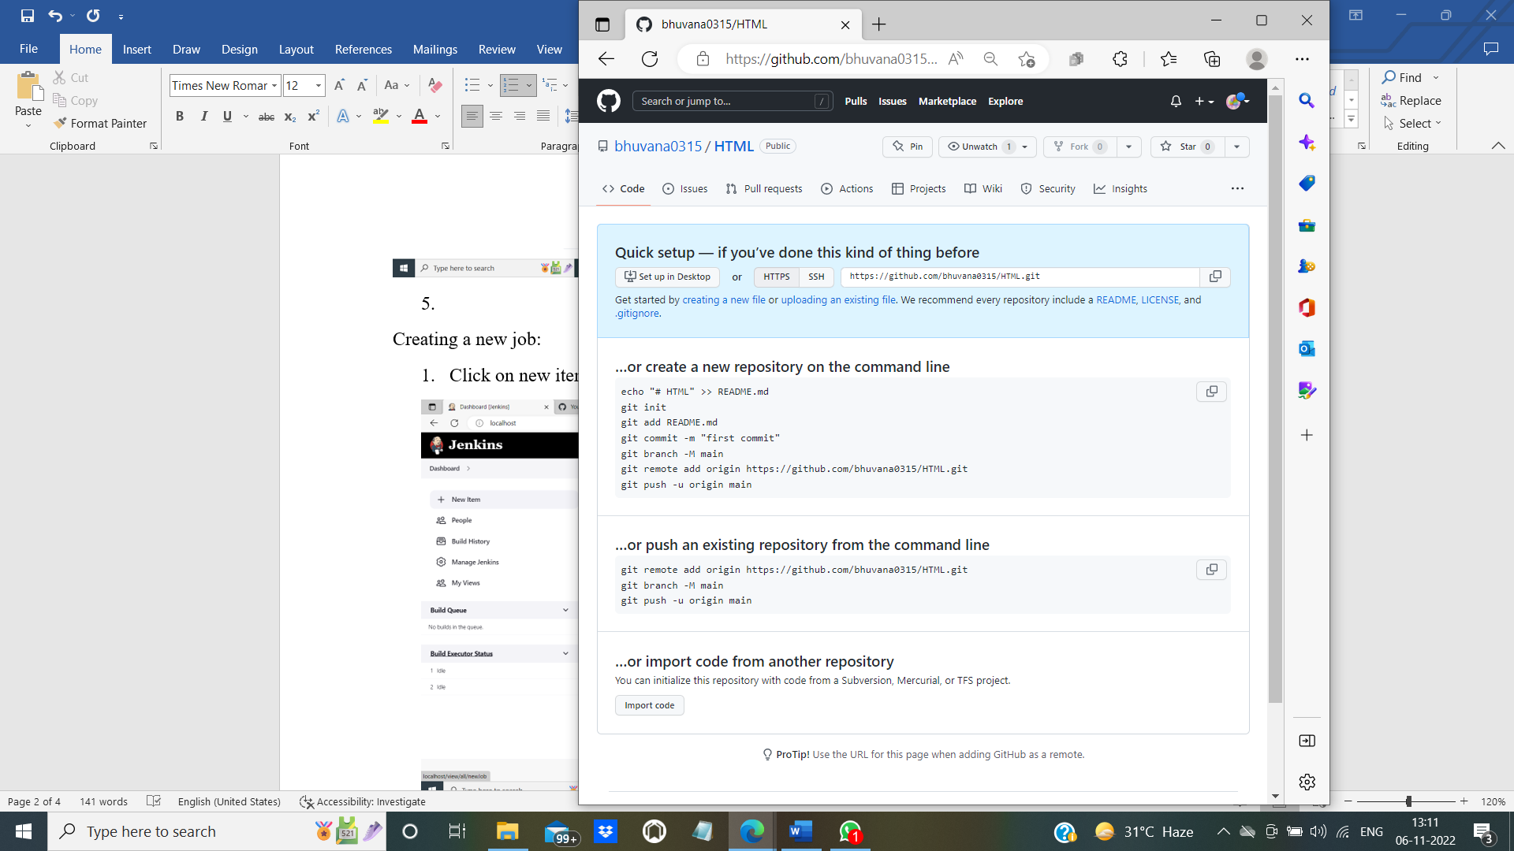

1. Click on creating a new file to create a file. The file name is Sample.html and is created in main branch.

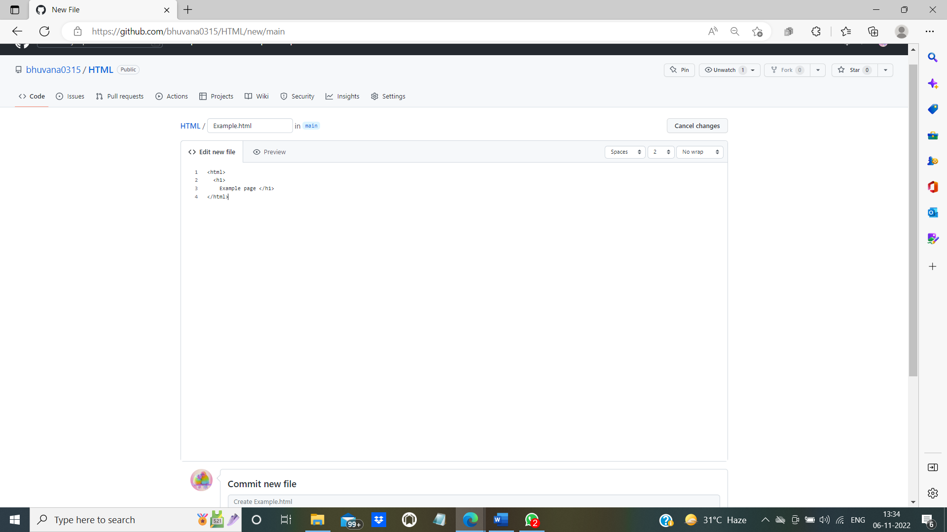

1. At the bottom of the page there is “Commit” option to save the file in the repository.

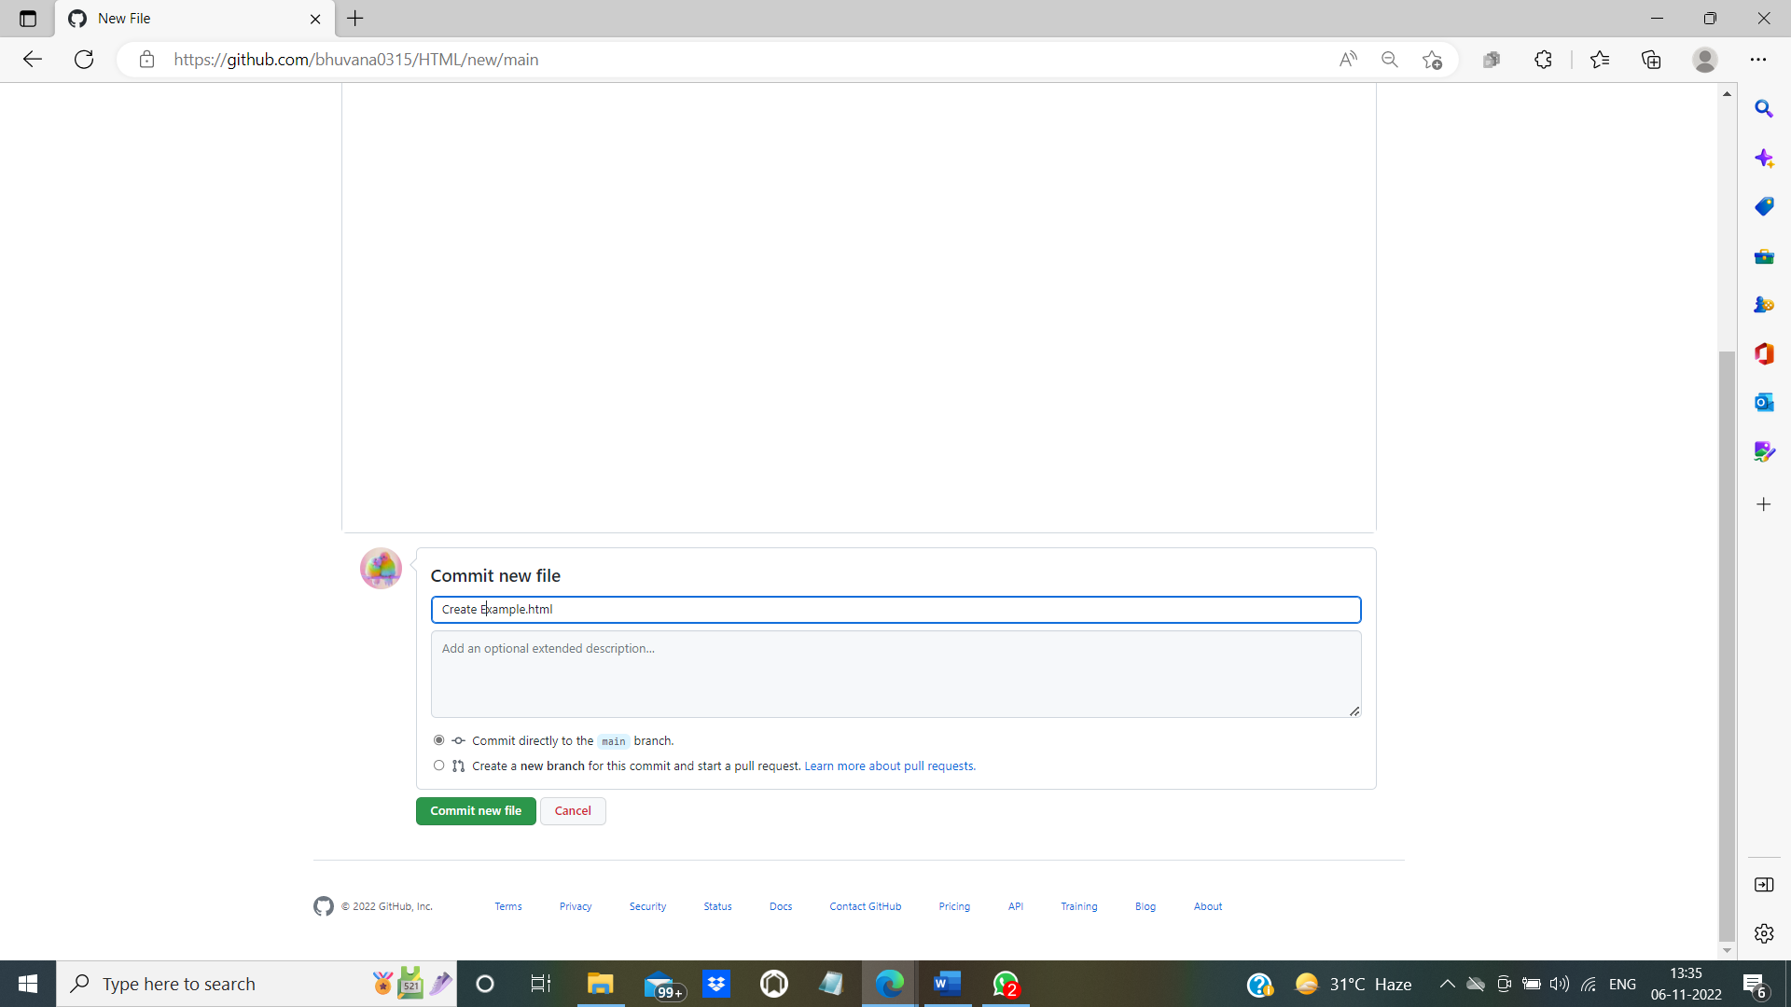

1. Successfully the “Sample.html” file is added to the “HTML”.

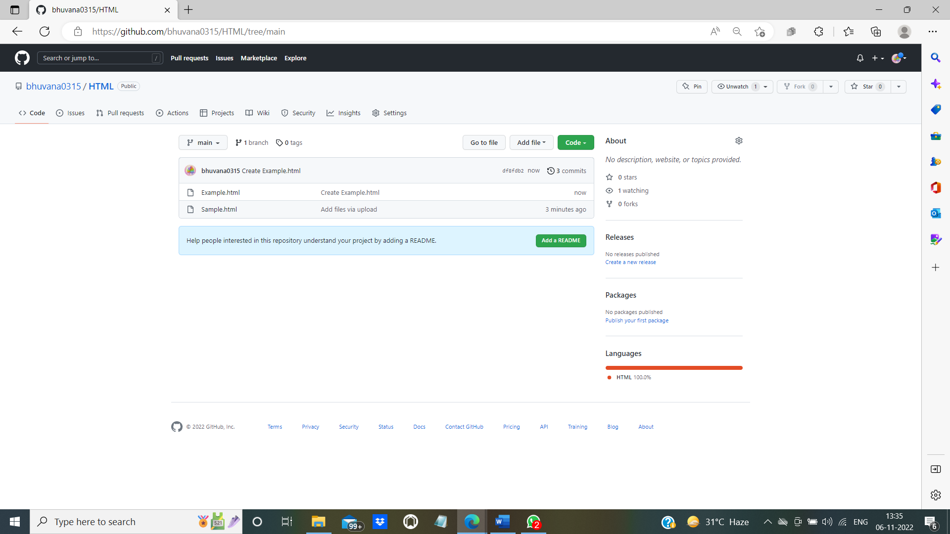

1. You can add new files directly from your device by clicking on “Add file”.
2. Click on “Add file”. You will get options: create a new file , upload files. Click on upload files to upload a file from your device.

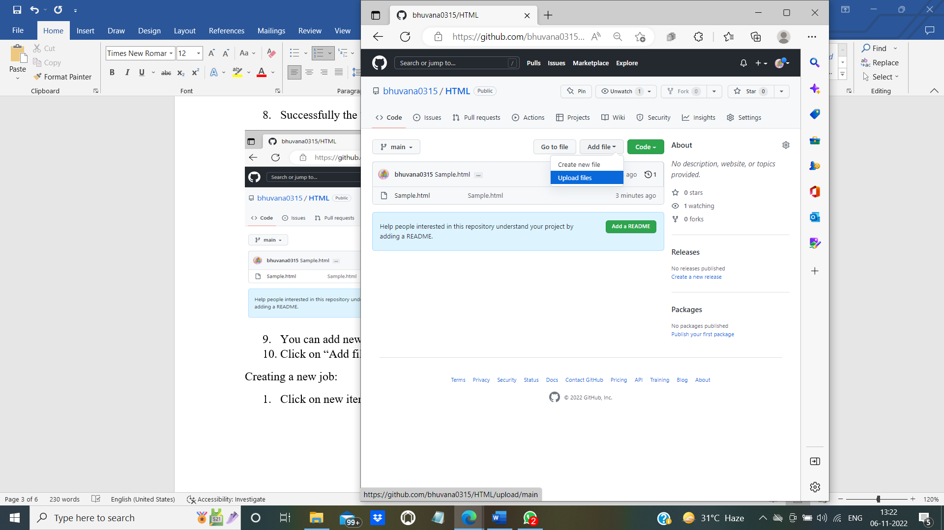

1. On selecting upload file, you will get the following screen. Click on “choose your files” to upload existing files.

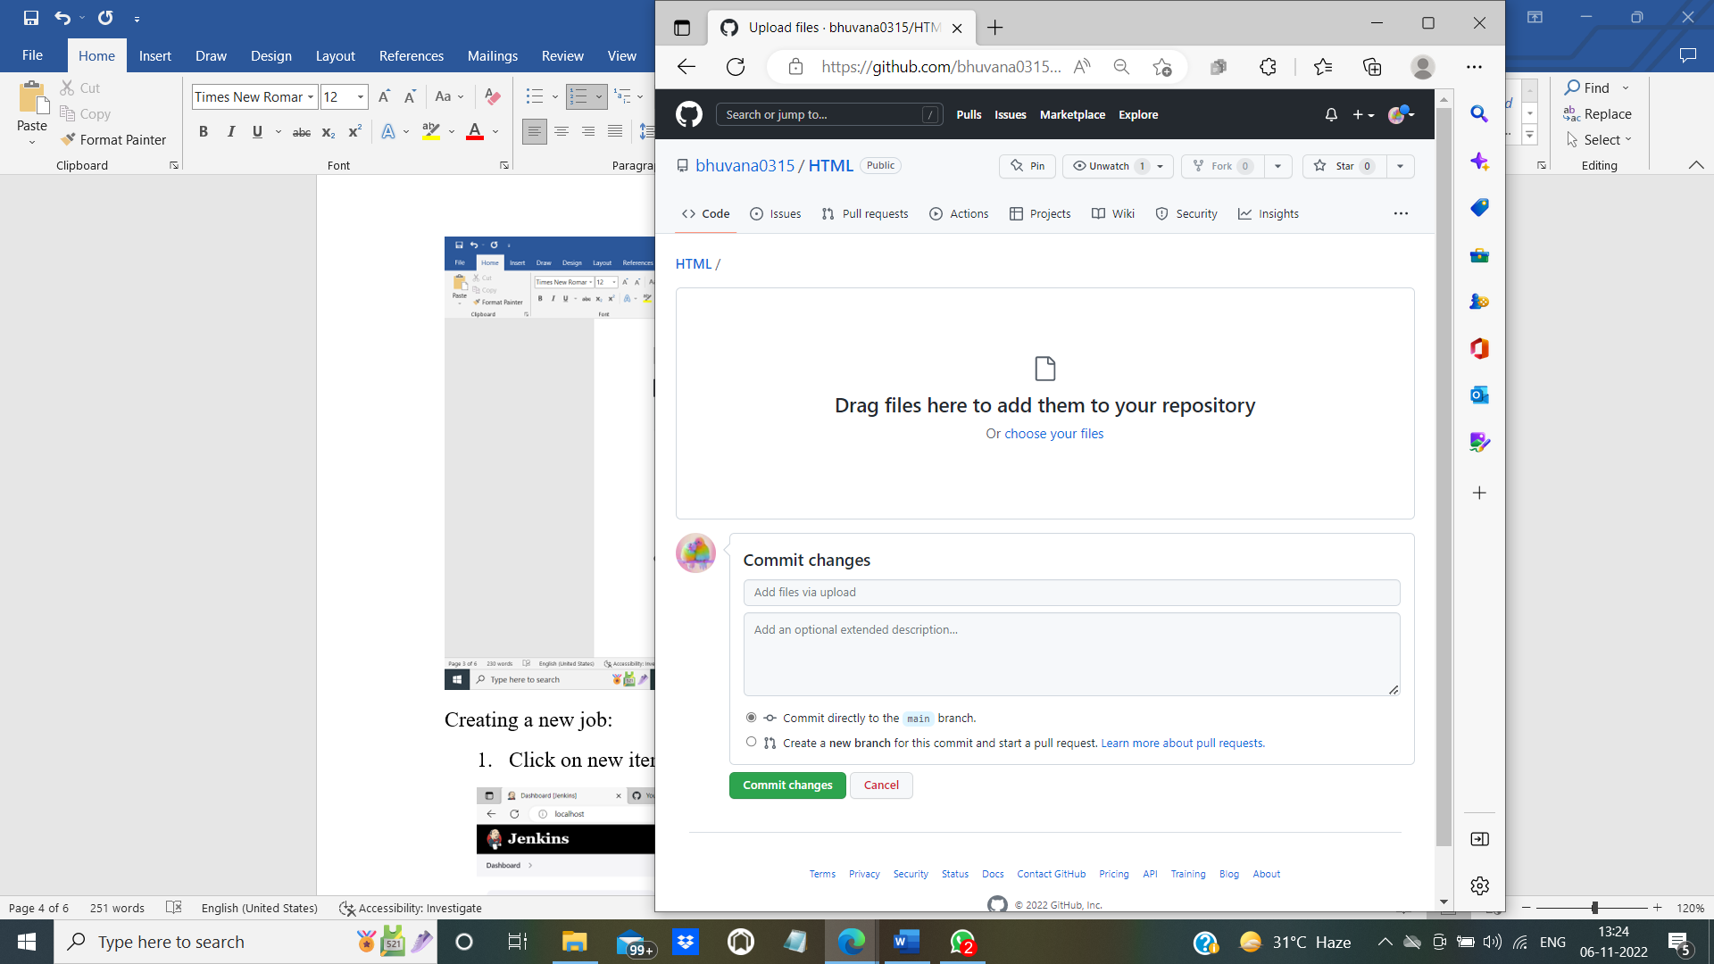

1. Select the file which you want to upload and then click “Open”

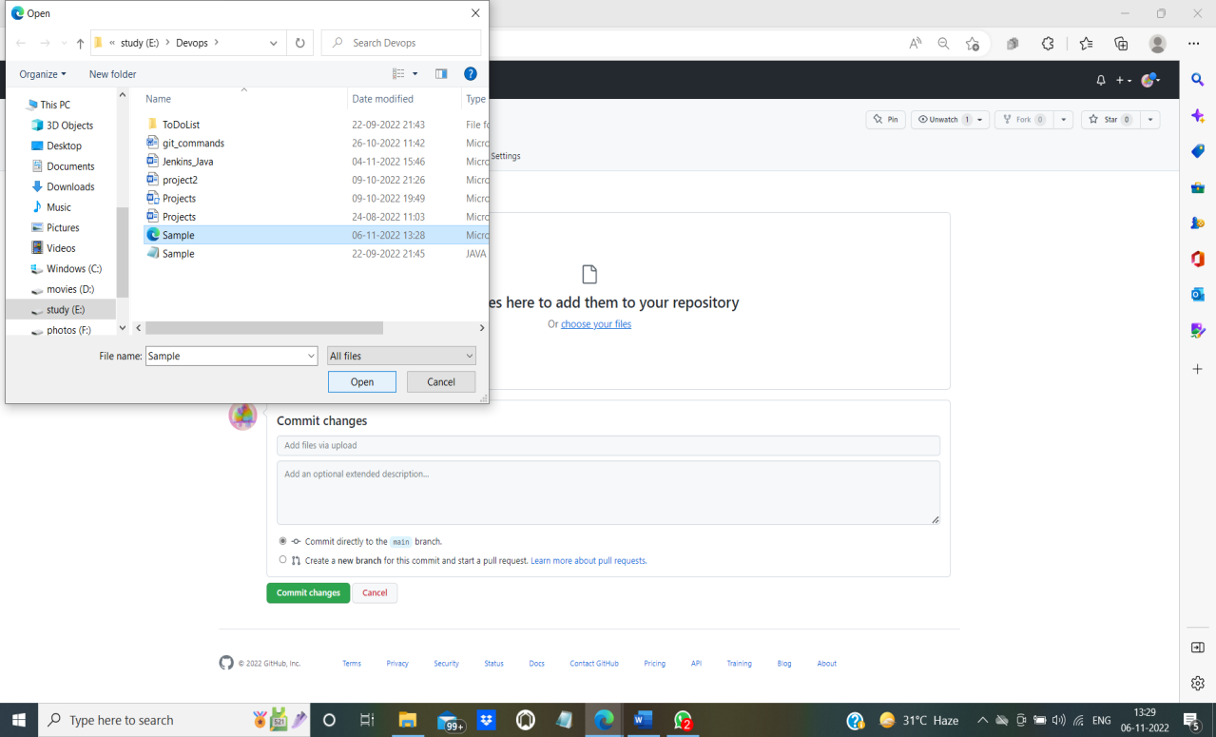

1. The file is uploaded successfully. Click on “commit changes” to upload the file to the repository.

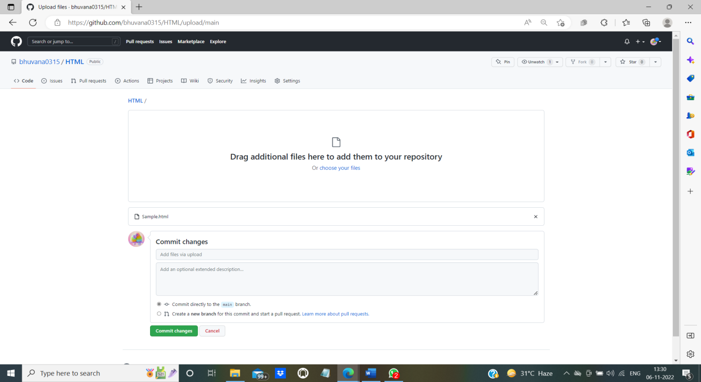

1. Now you can find two files in your repository. You can upload as many files as needed.



----------------------------------------------------------------------------------------------------------------

**Creating a new job in Jenkins:**

1. Click on “new item” that is available under the “Dashboard” at left side.

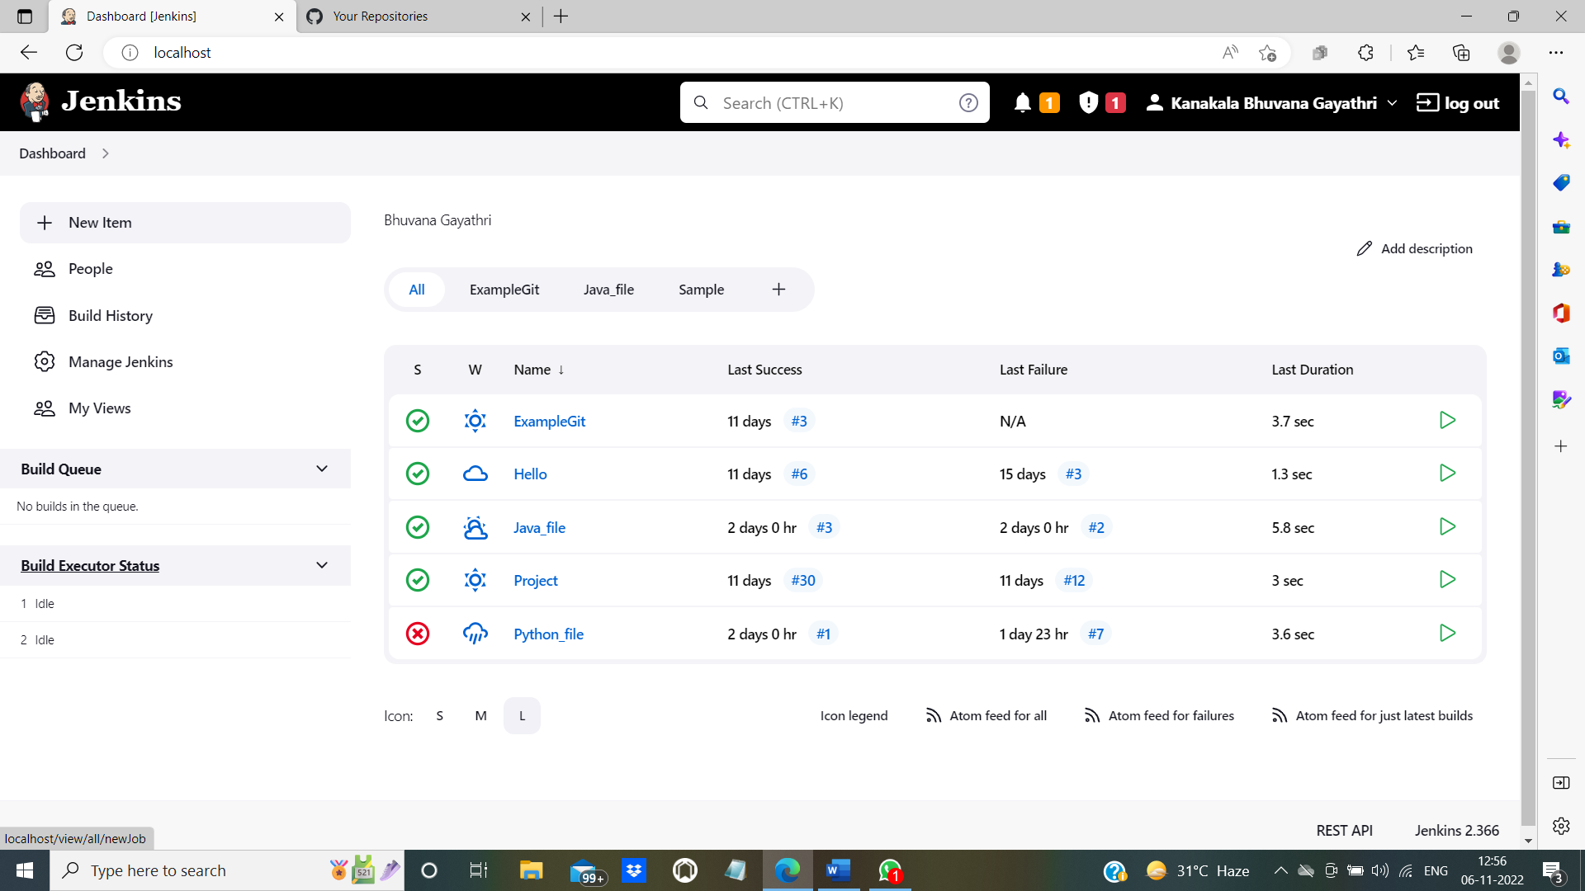

1. The following screen will be displayed.

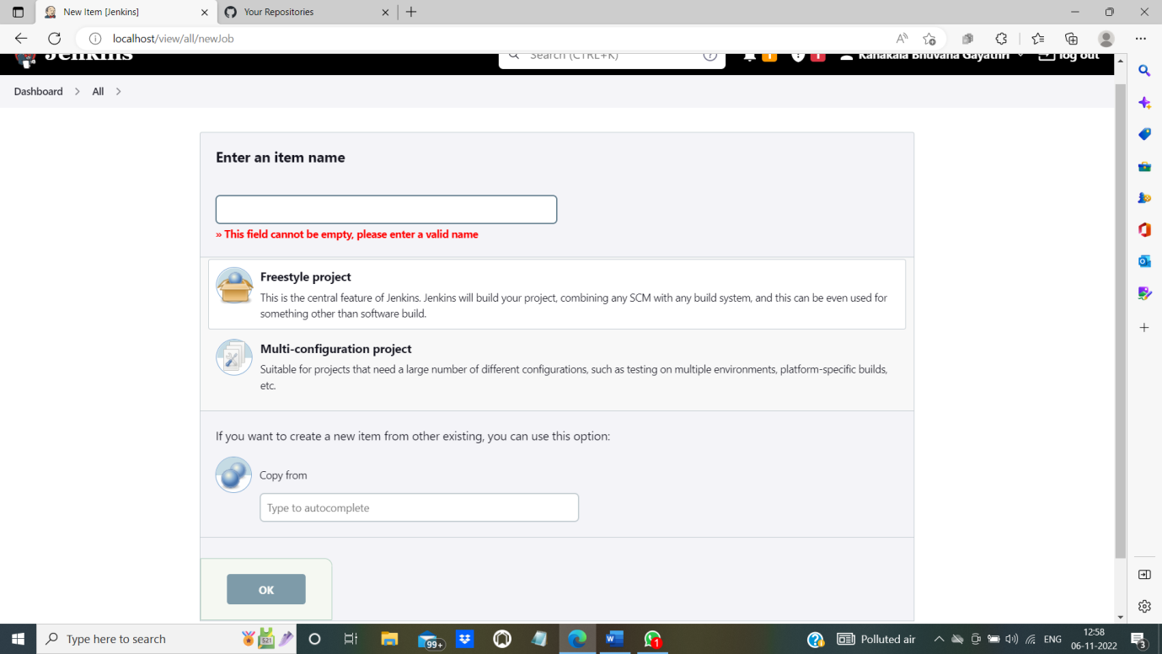

1. Enter an item name of your choice. Then select freestyle project. Finally click on OK.

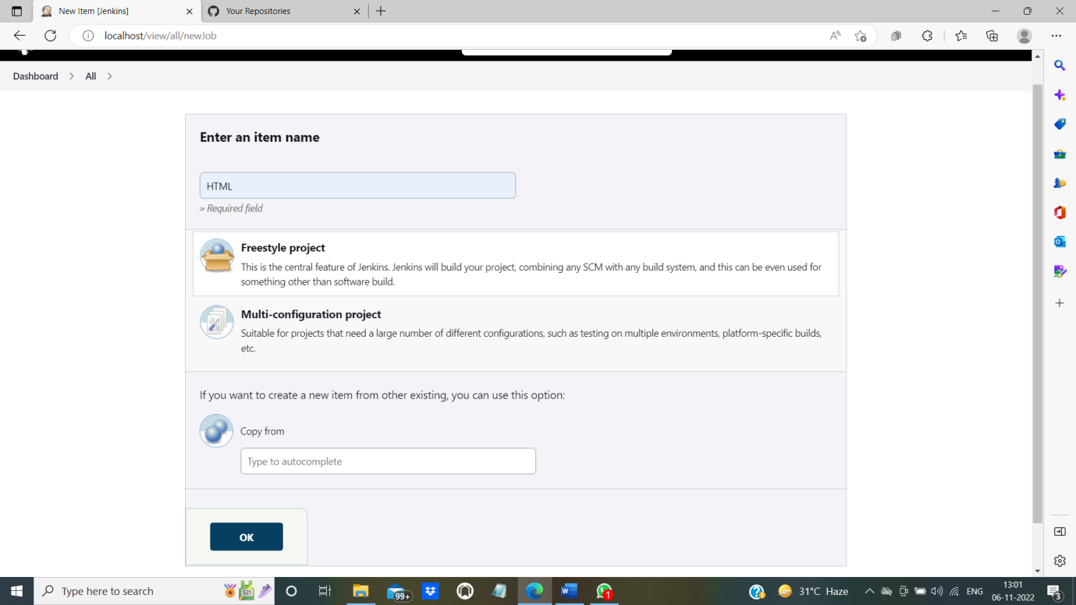

1. On clicking ok you will be directed to configuration page.

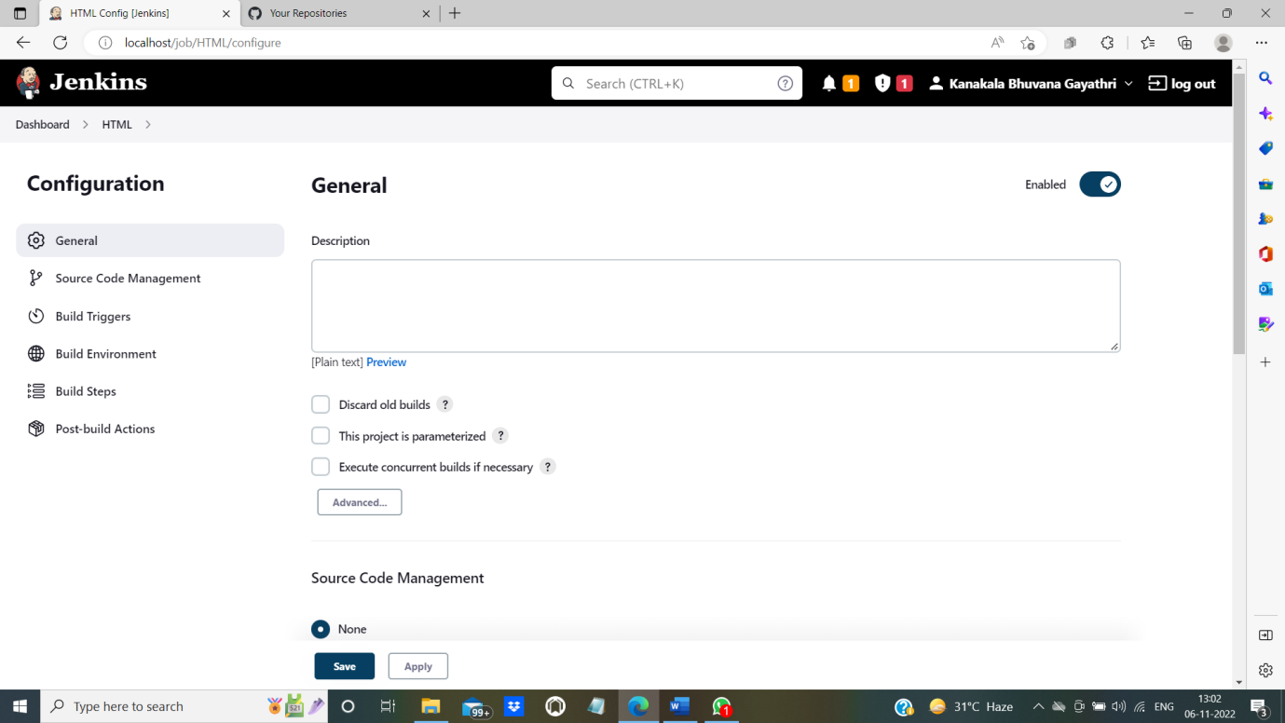

1. You can check whether your job is created or not by clicking on dashboard.

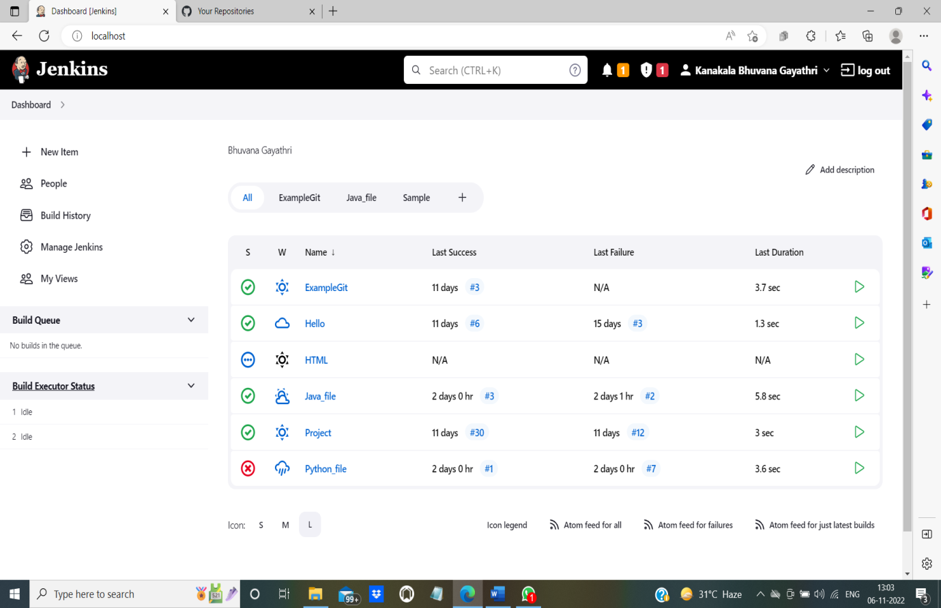

-----------------------------------------------------------------------------------------------

**Configuration in Jenkins:**

1. In configuration there are several categories. They are: General, Source Code Management, Build Triggers, Build Environment, Build Steps, Post-build Actions.

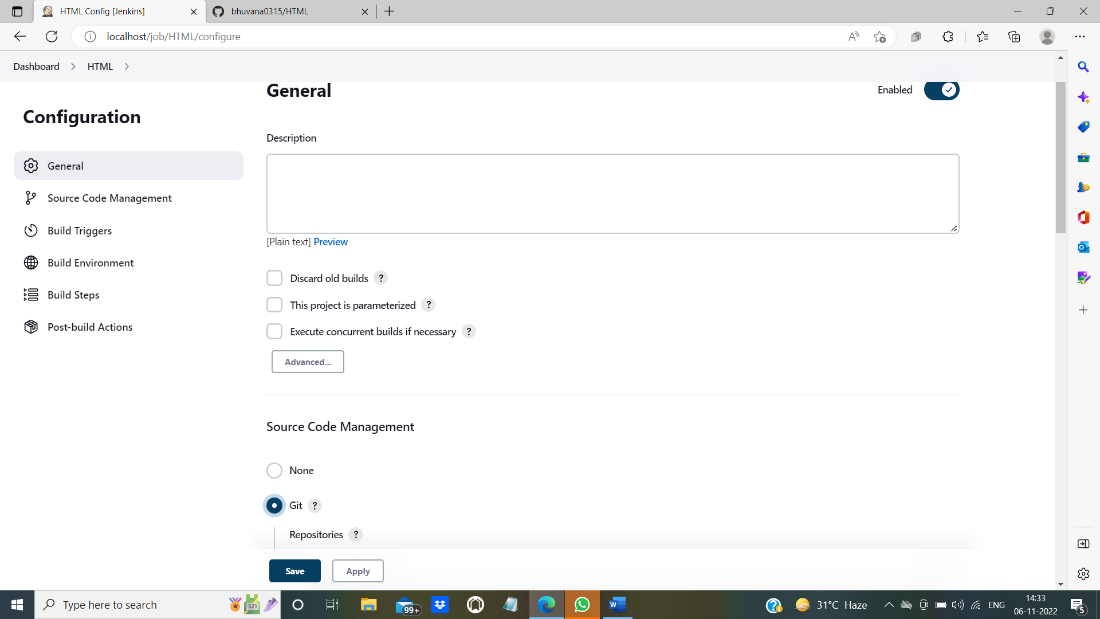

1. Go to “Source Code Management” select “Git”. You will get the following screen.

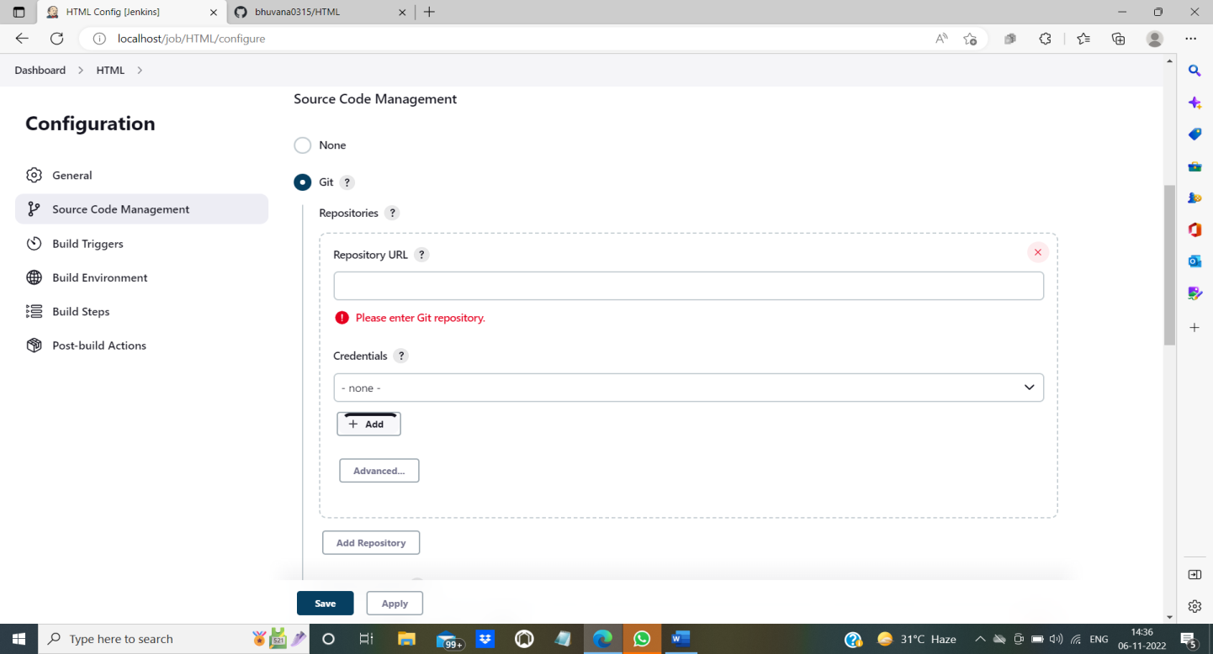

1. Give the repository URL which you have created earlier in GitHub. Copy the URL that is available in Clone menu.

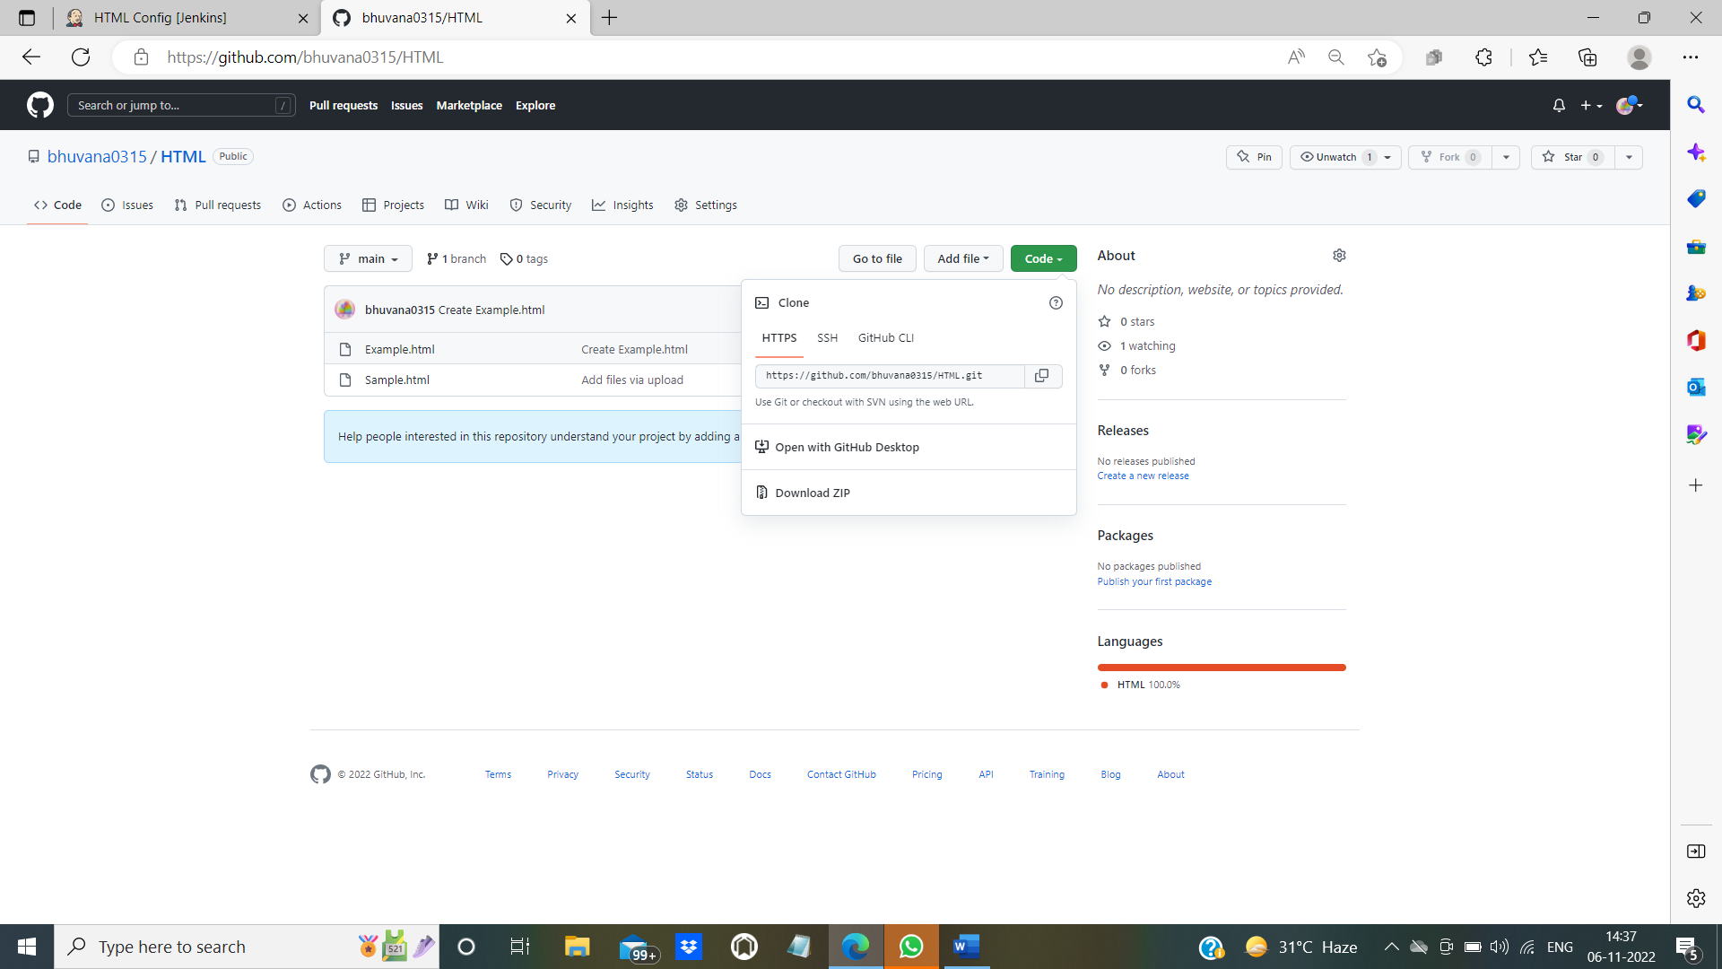

1. Paste the copied URL in Repository URL section.

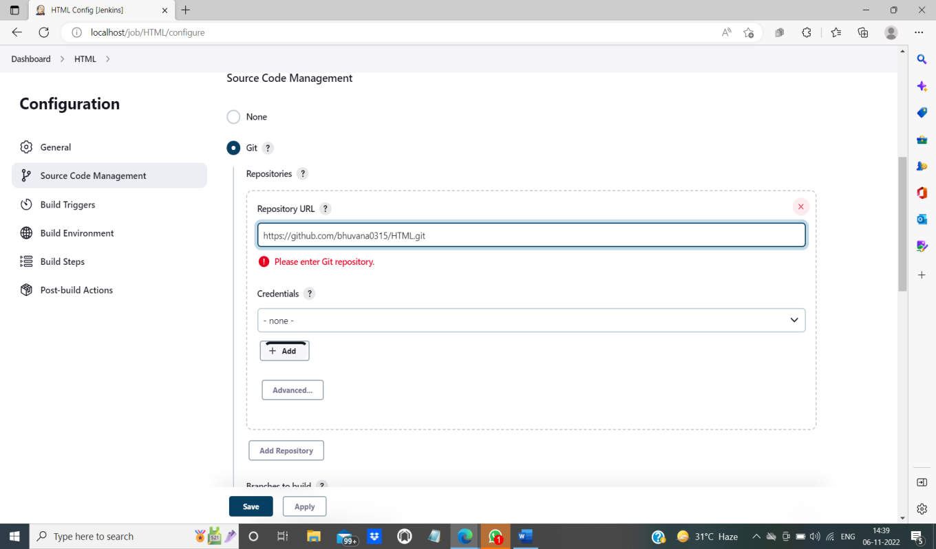

1. Change the branch to “main” because the files in the repository are in “main”. (It can be master also. Check the branch in GitHub before specifying in Jenkins SCM)

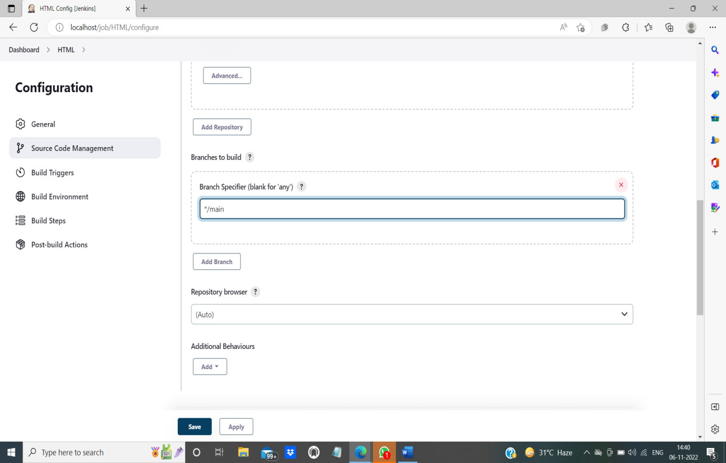

1. Click on Apply and then on Save.

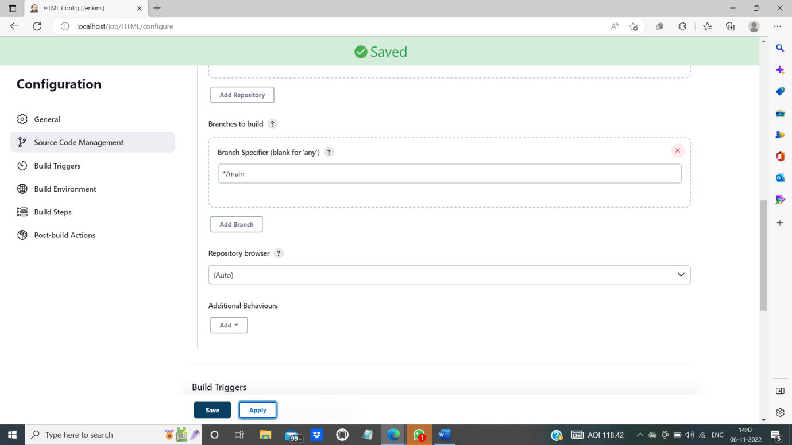

1. Click on “Build Now” to build the project.

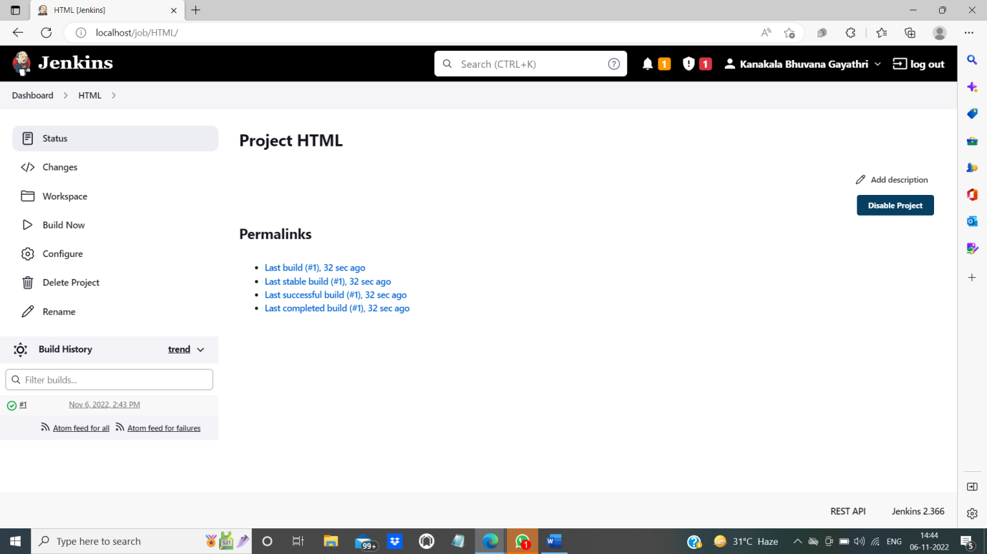

1. Click on “Workspace” to view the files. All the files that are created or uploaded in the repository will be displayed in “Workspace”.

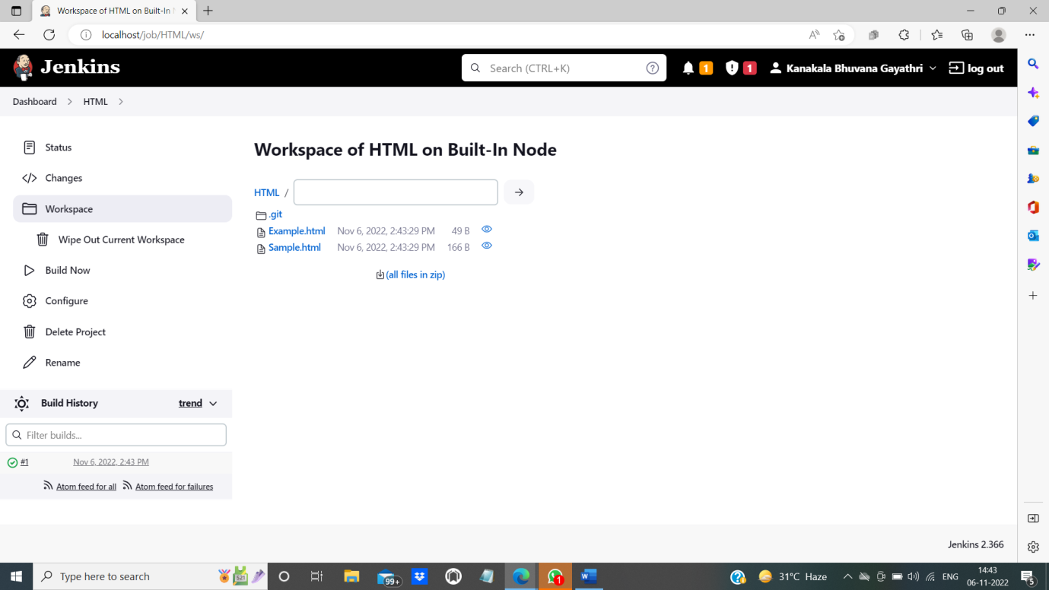

--------------------------------------------------------------------------------------------

**View the file of the repository in Jenkins Project along with the output:**

1. Click on the file “Example.html”. You will get the output as follows:

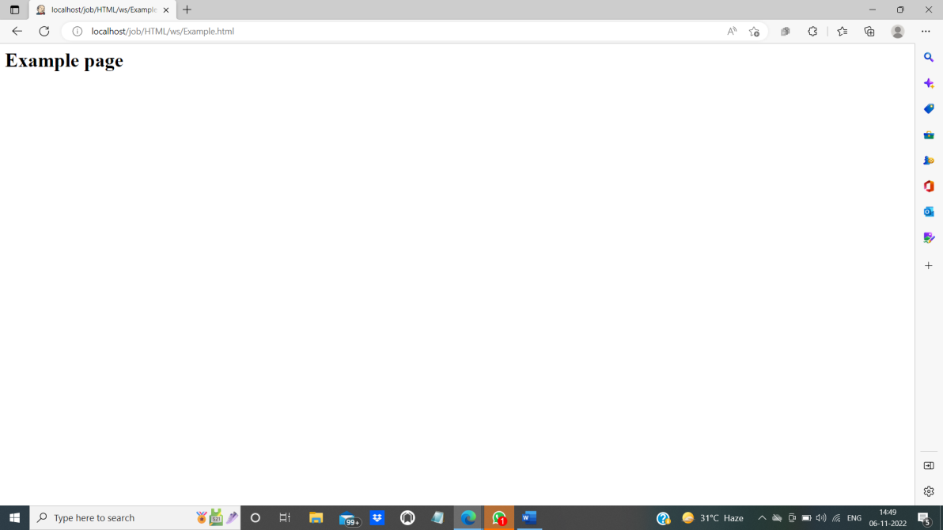

1. Click on eye icon that is available at right side in the same line of the file.

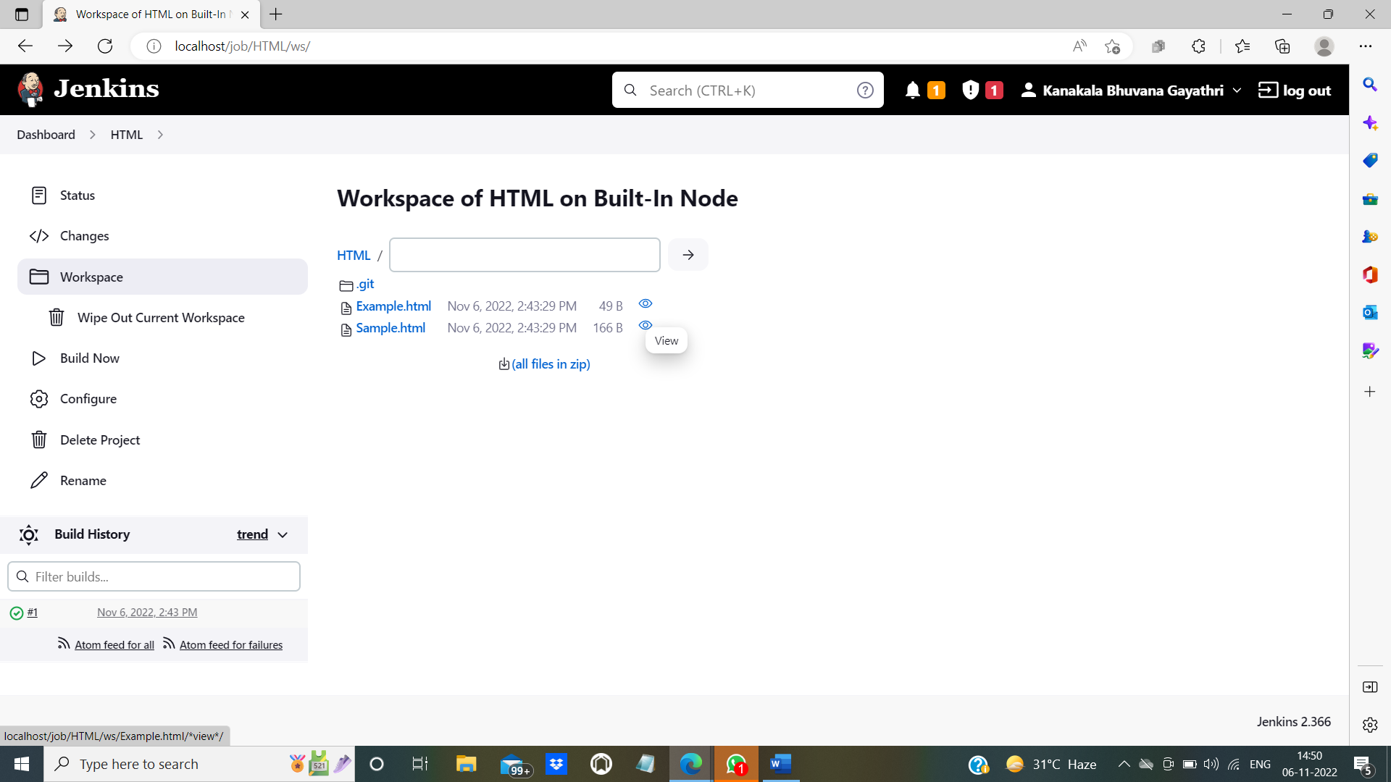

1. On clicking view, you can view the code for the output.

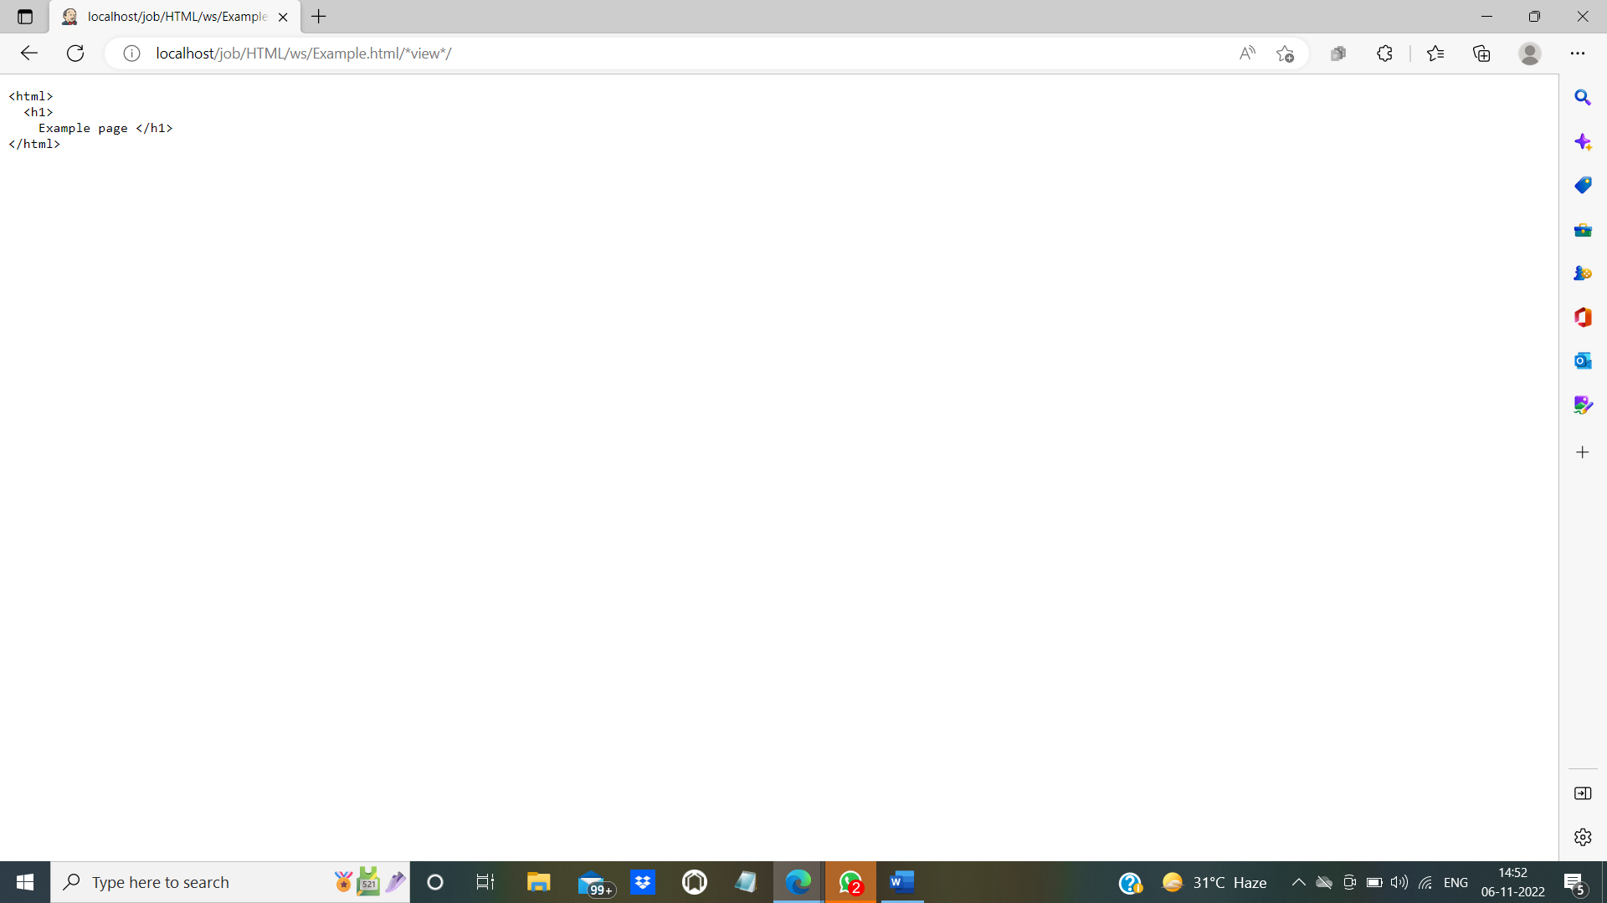

--------------------------------------------------------------------------------------------

**Console output for #1 build:**

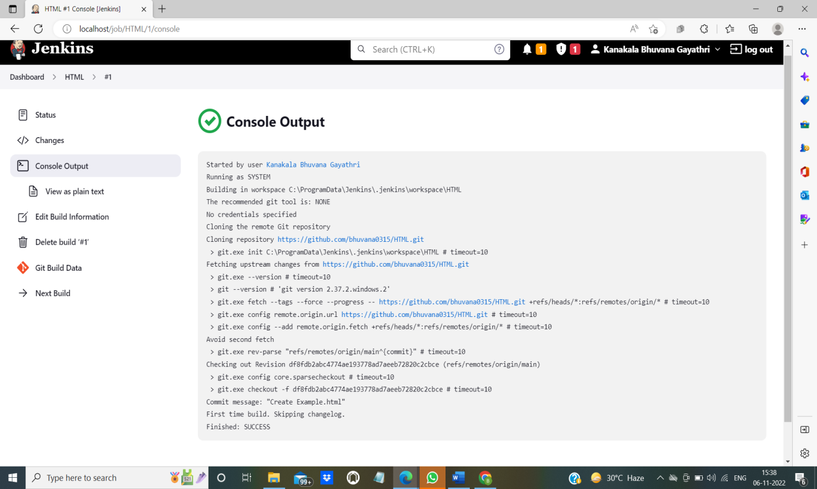

Here we have seen an output for basic html file. Let us see how the output can viewed using HTML publisher in Jenkins.

**Installing HTML publisher in Jenkins:**

1. Click on Dashboard. In dashboard select “Manage Jenkins”. From that select “Manage plugins”.

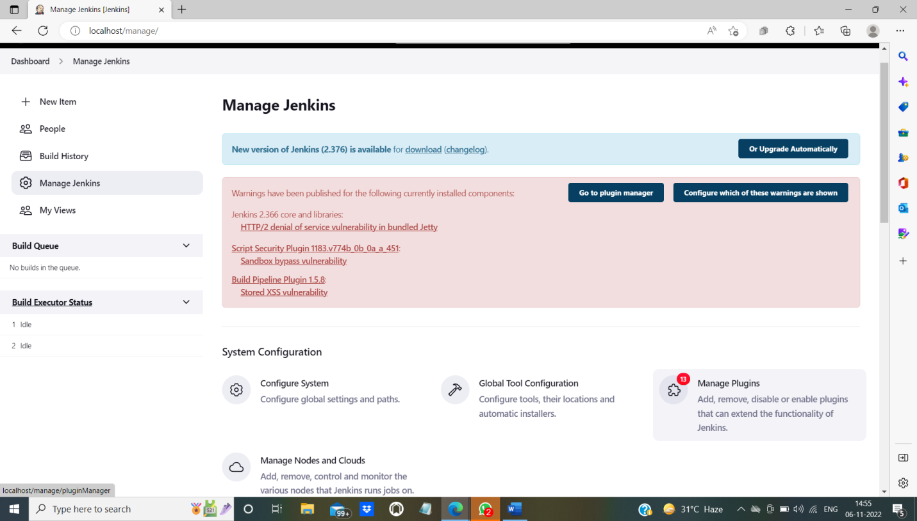

1. Manage plugins will direct you to the following page:

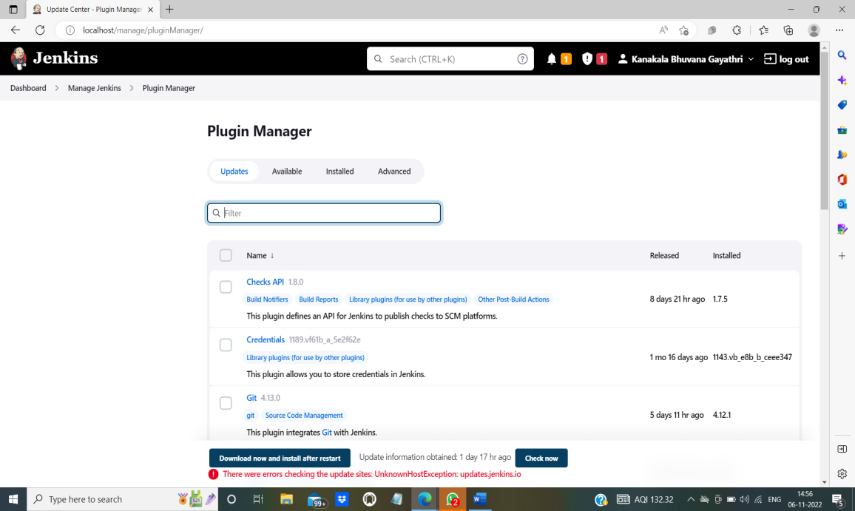

1. Click on “Available” and type “HTML publisher”. You will get the following. Mark the checkbox and click on “Install without restart”.

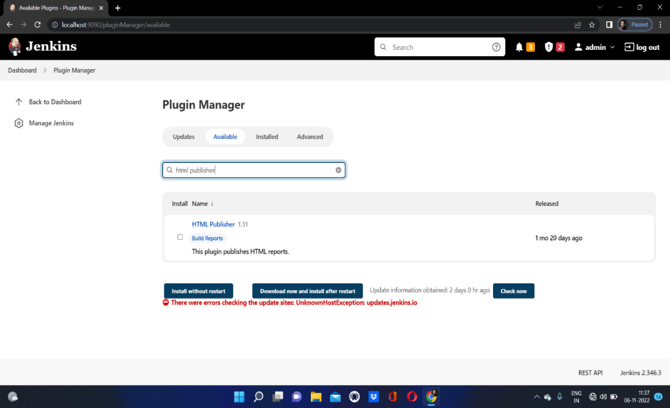

1. The installation process will start and displays the following page.

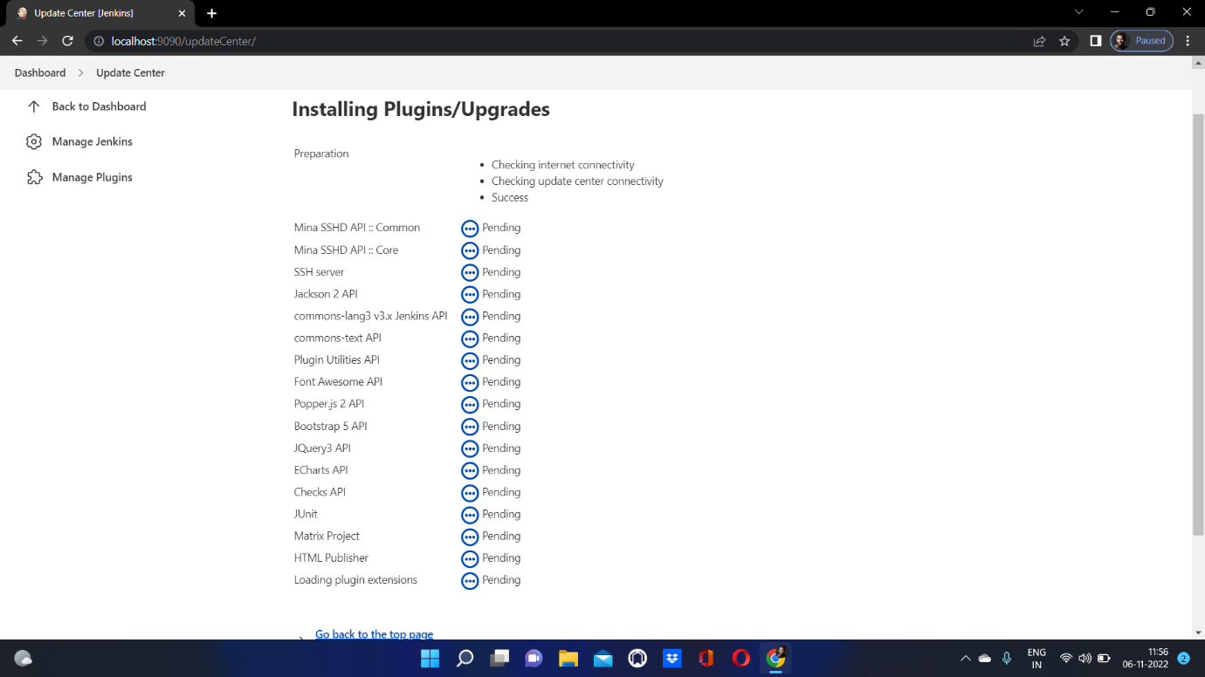

1. To check whether HTML publisher is installed or not. Go to installed and type HTML publisher. If you get the following, then HTML publisher is successfully installed.

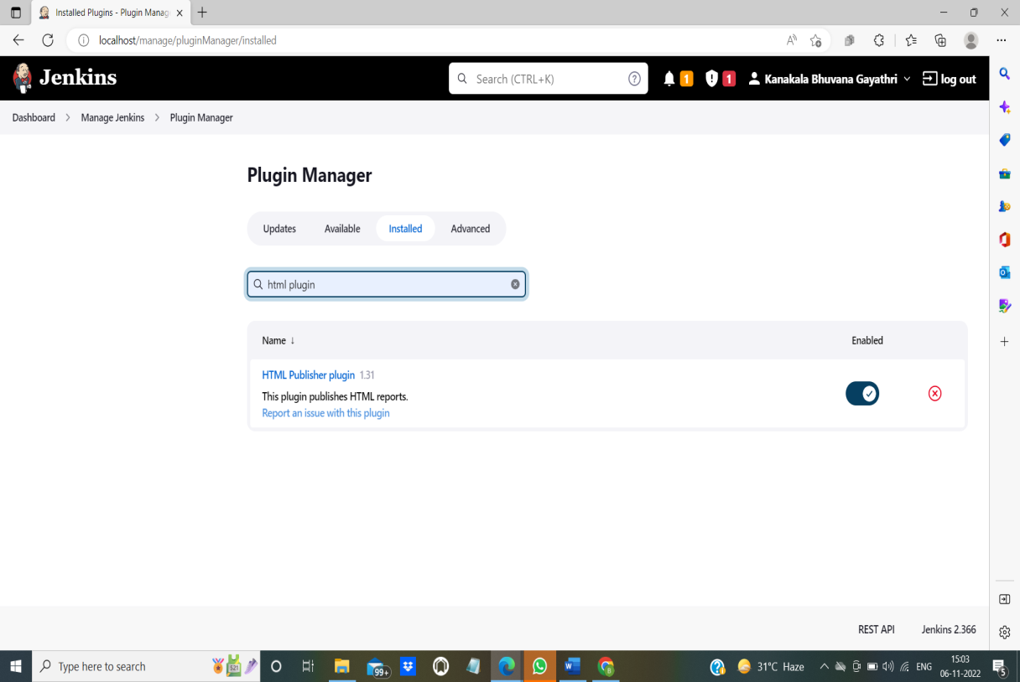

------------------------------------------------------------------------------------------------------------

**Generating HTML reports using HTML publisher:**

1. Click on configure.

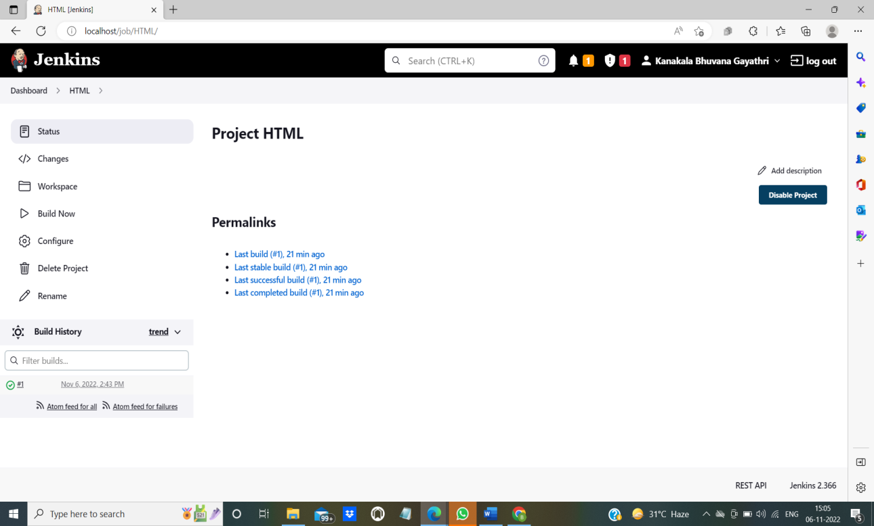

1. On clicking configure, you will get a list of items which are already discussed above. We have already cloned GitHub repository to Jenkins. To apply HTML publisher just follow the below steps.
2. In configure, SCM contains the repository URL, steps for it was discussed above.
3. Now we are supposed to concentrate on “Post-build actions”.

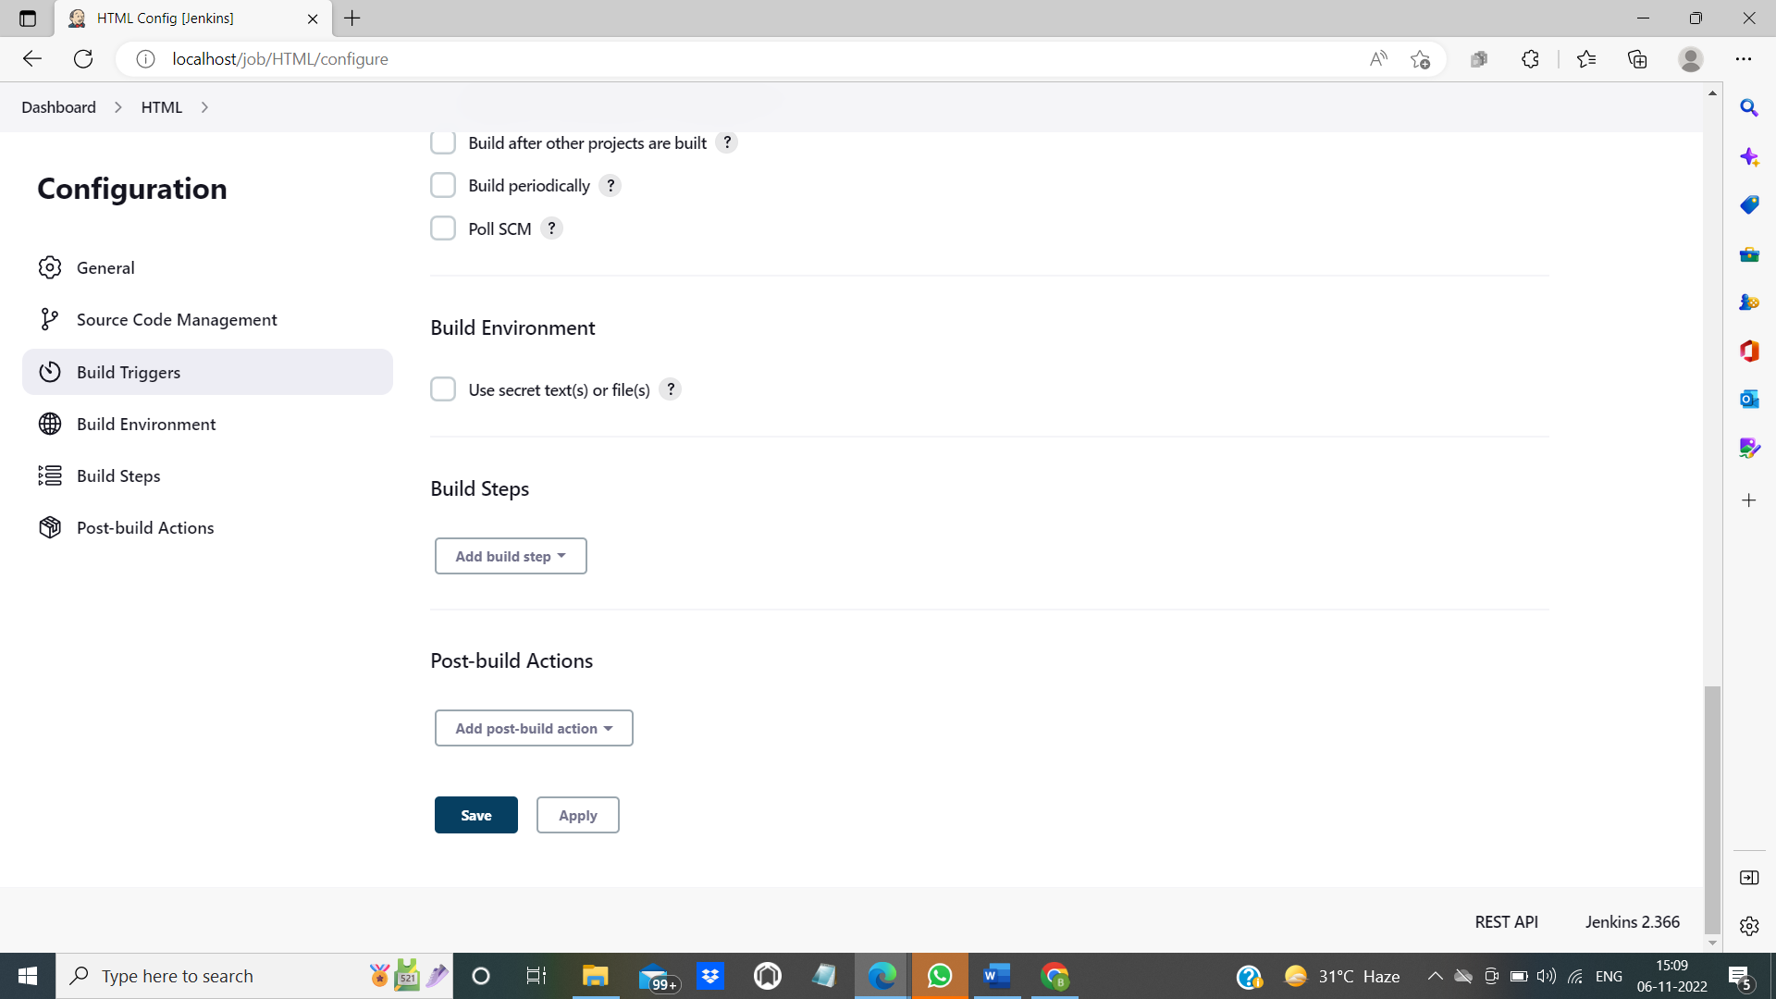

1. From “Add post-build actions” select “publish HTML reports”.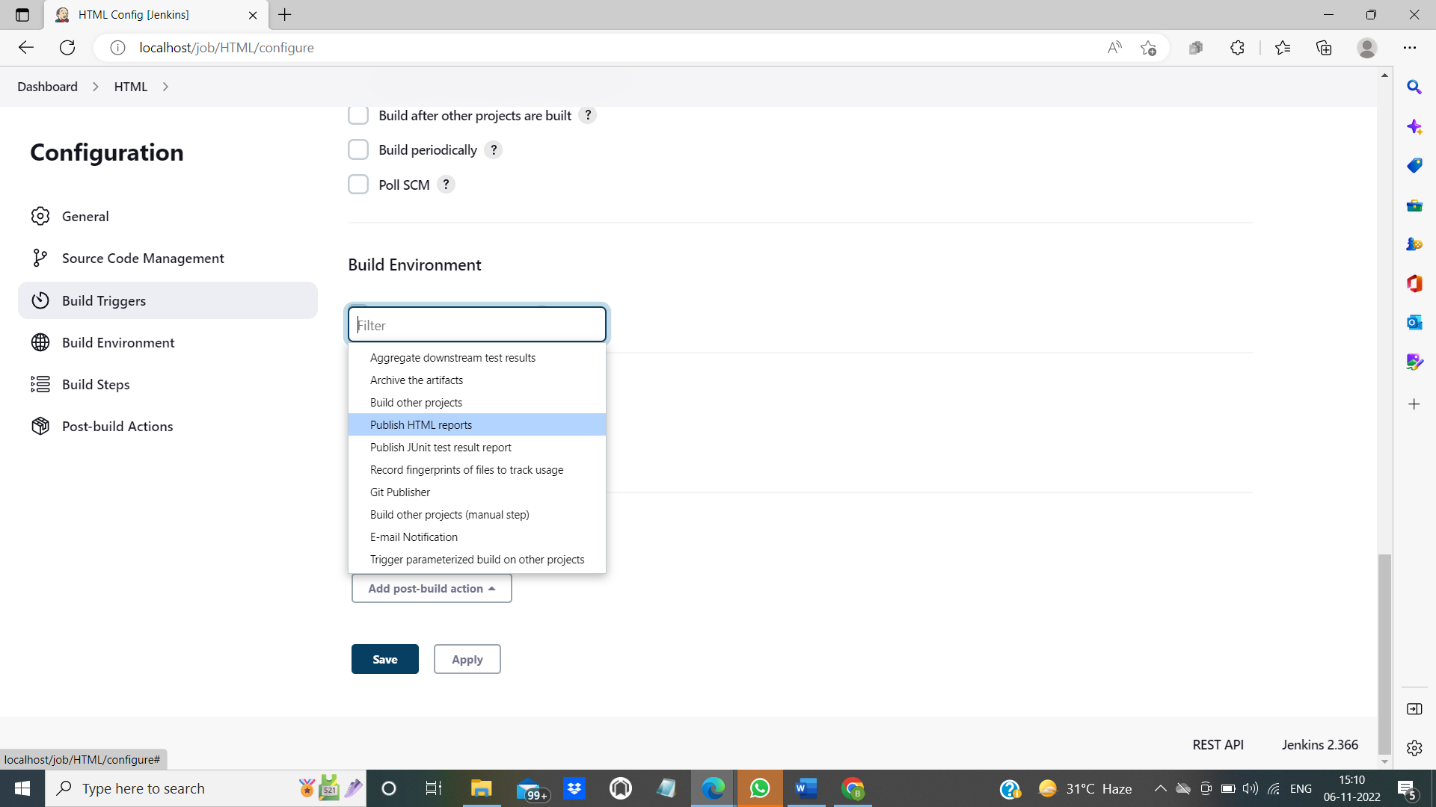
2. On selecting “publish HTML reports”, you will get the following. Click on add.

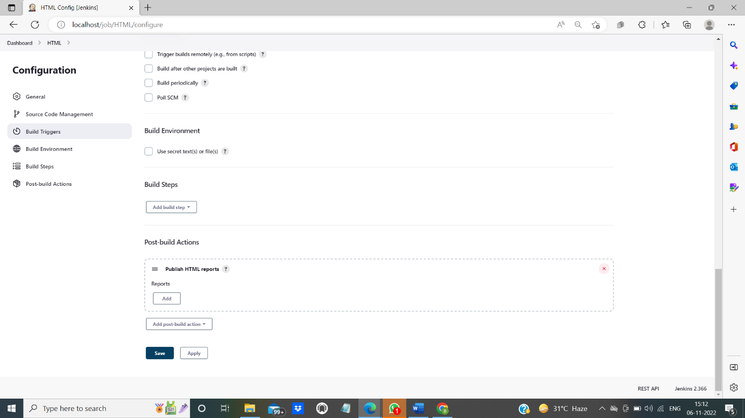

1. On clicking “Add” under reports, you will get the following:

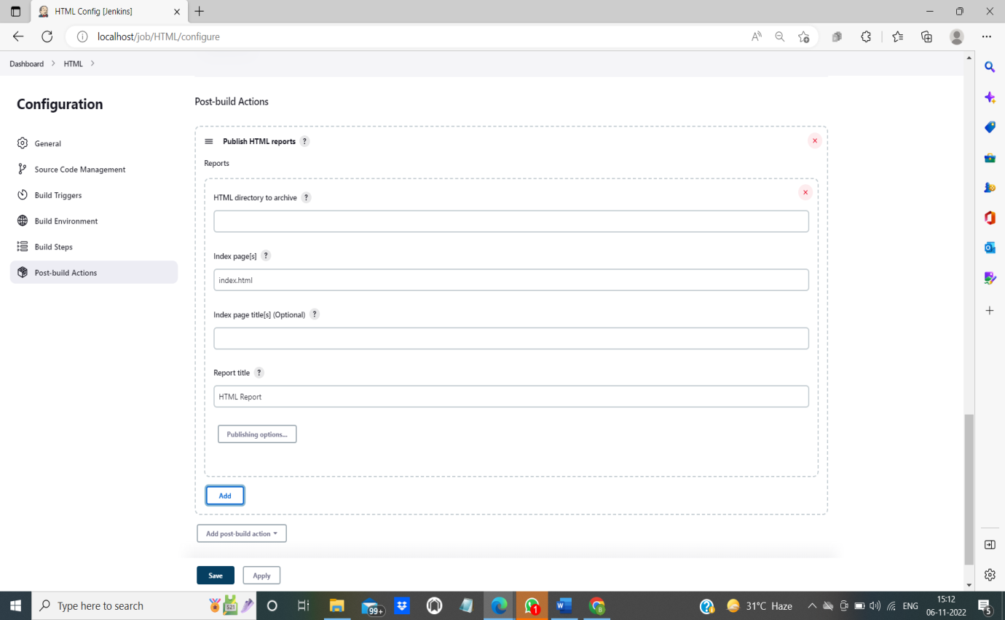

1. Specify the name of the index file. We have created only basic html pages. So choose any html file of your choice. I have chosen “Sample.html”. 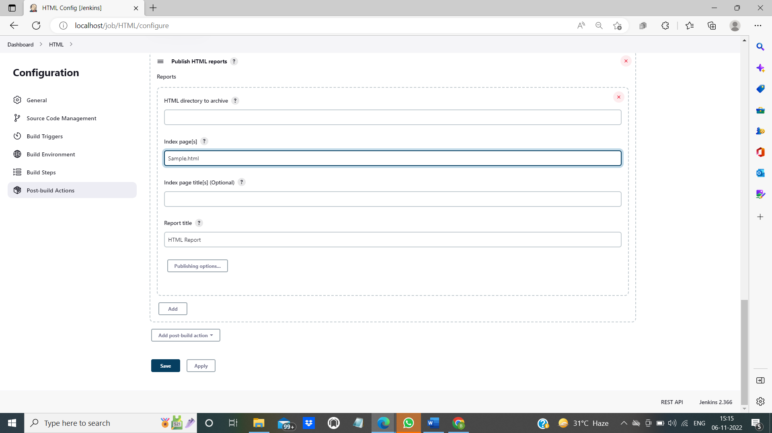
2. Then click on apply and save.

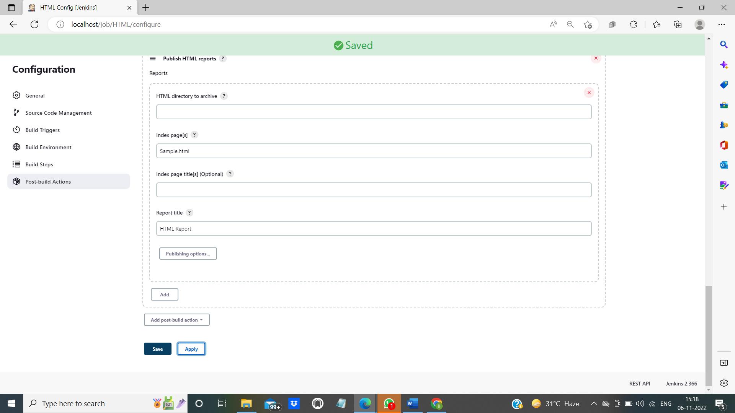

1. After you click on save, it will direct you to your project page. In project page, click on “Build Now”. On clicking “build now”, you can view your “HTML Report”.

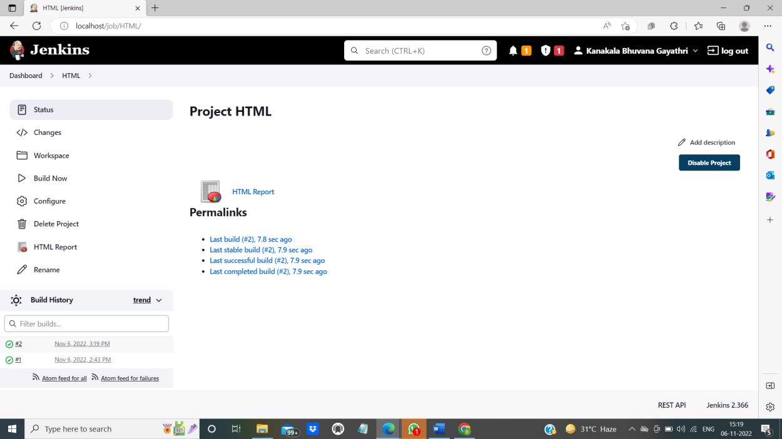10. To see what is there in HTML report, click on it.

1. The following output will be displayed.

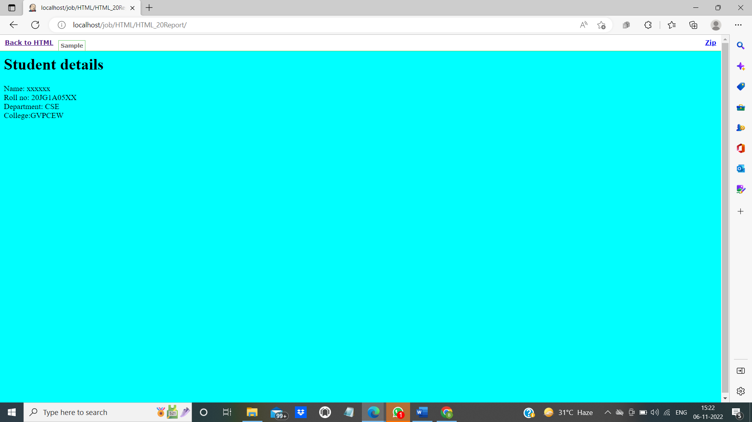

1. Click on “Back to HTML” to go to your project location.

-------------------------------------------------------------------------------------------------

**Console output for #2 build:**

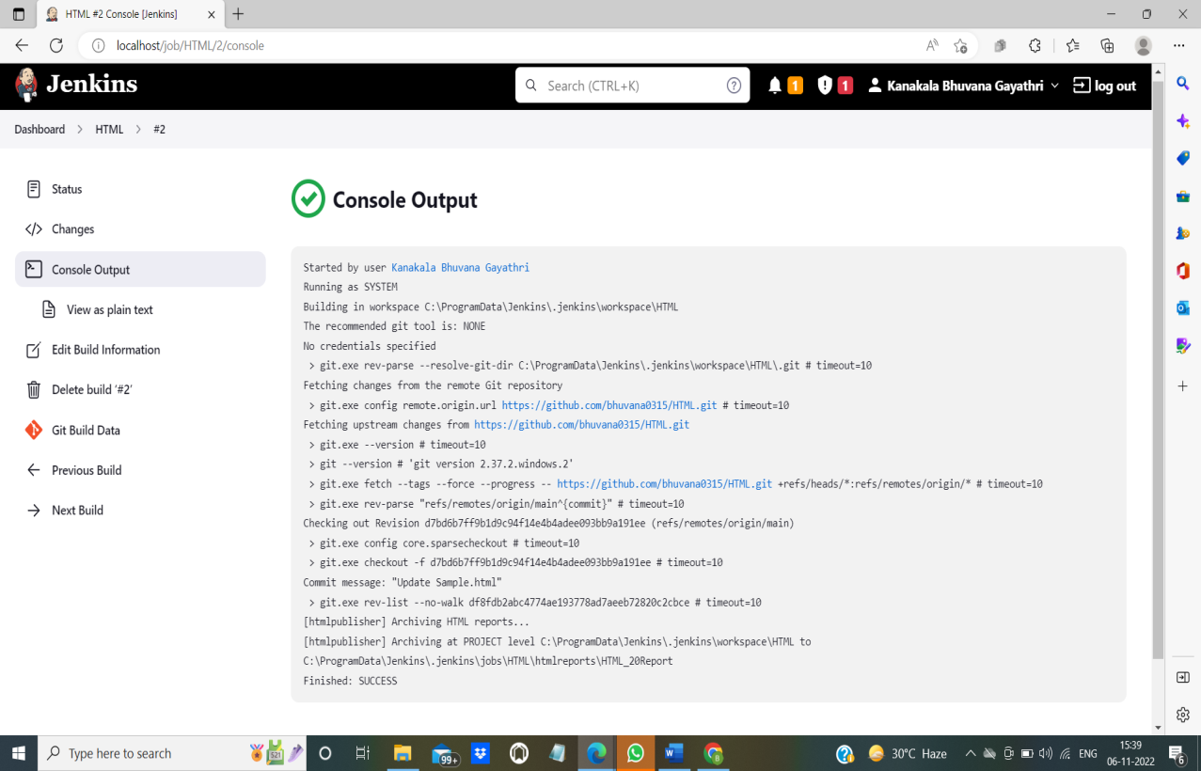

The changes made in GitHub reflects in Jenkins. See how it is possible.

**Steps to edit code in GitHub:**

1. The following is code that is present for the above output in the GitHub for the file named “Sample.html”

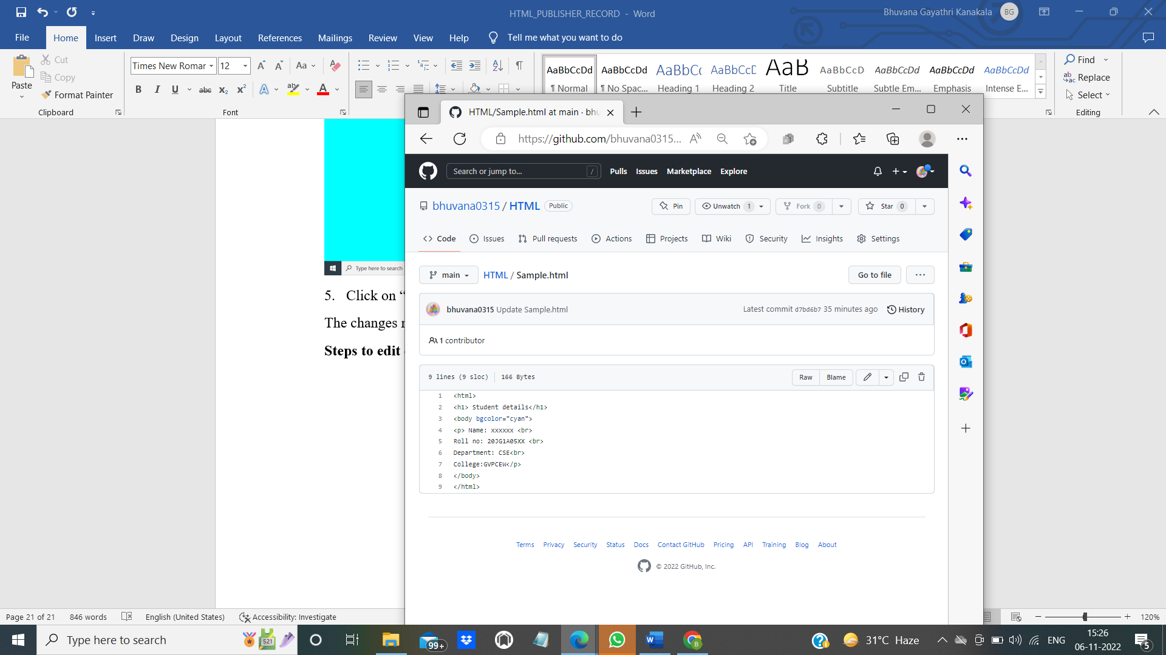

1. Click on the pen icon to edit. Here the body background color and Department are edited.

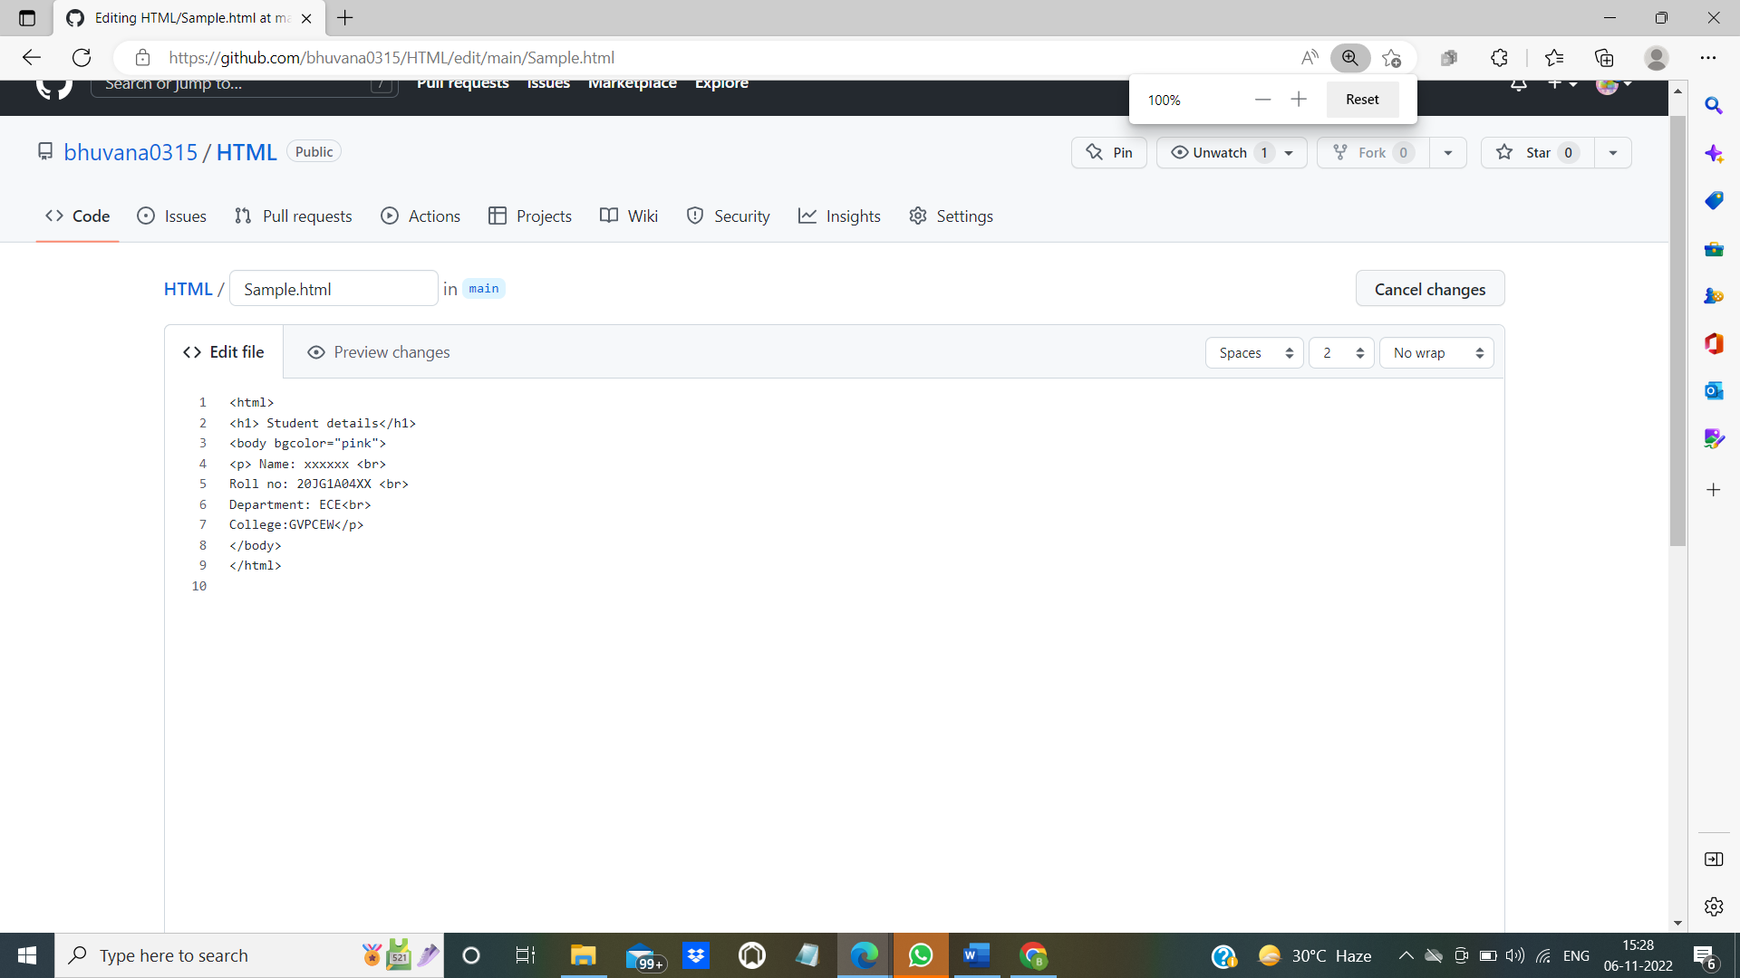

1. Click on commit changes that is available at the bottom of the page.
2. The following is the updated “Sample.html”:

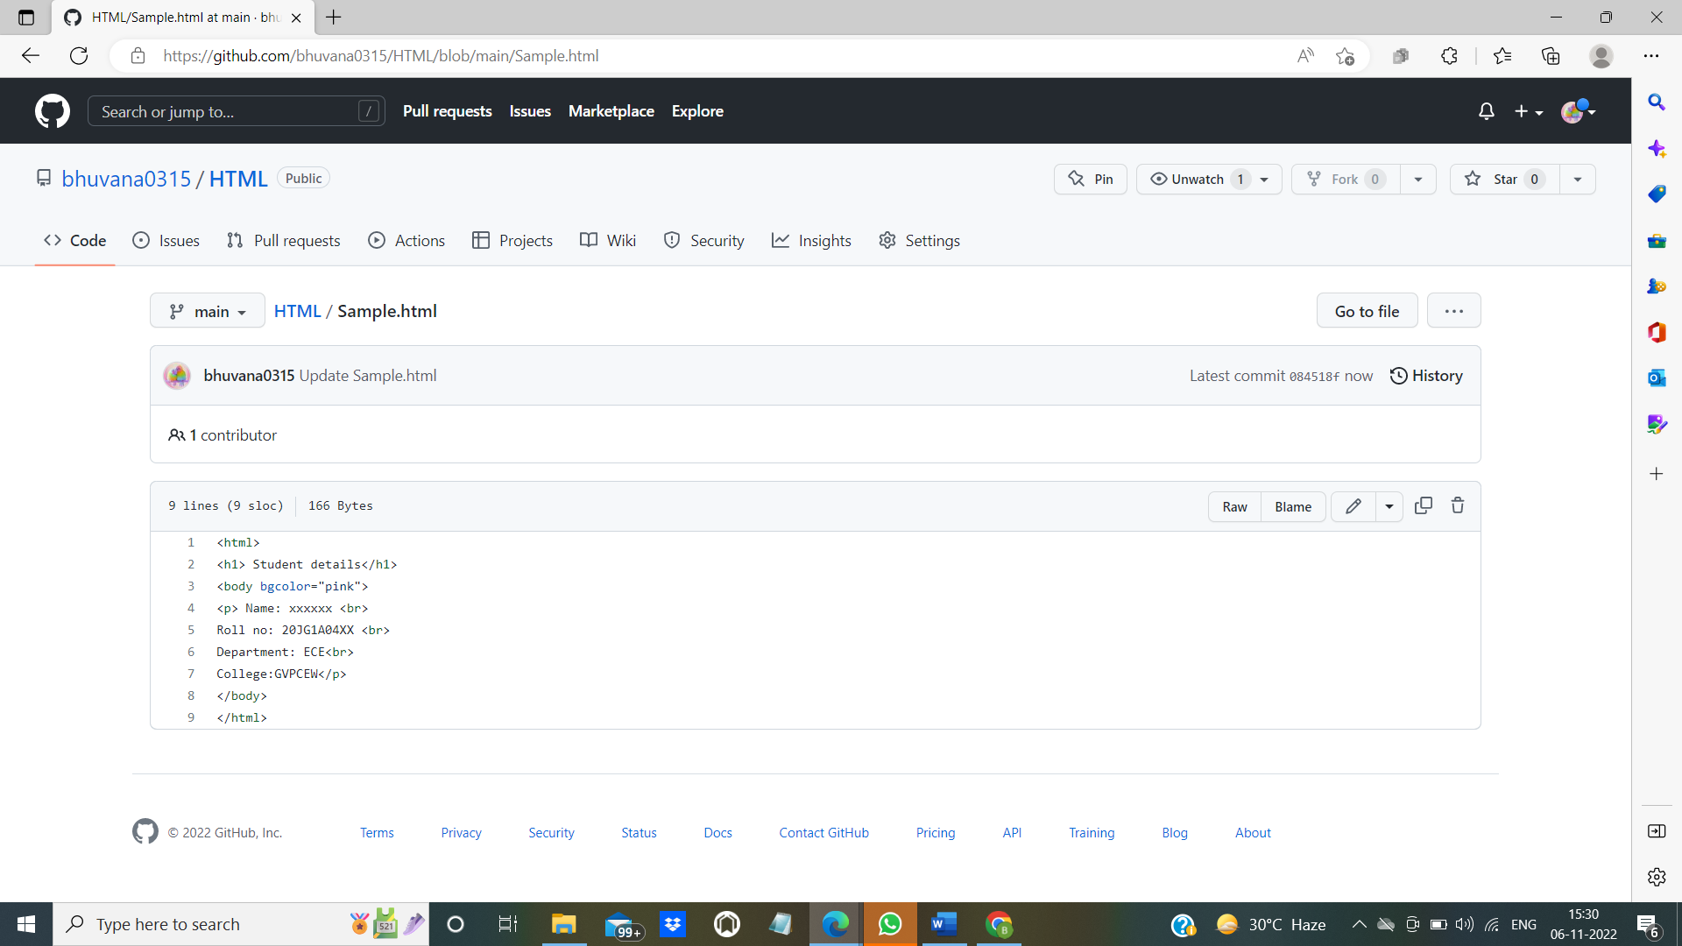

------------------------------------------------------------------------------------

**Steps to view the above changes in Jenkins:**

1. Click on the project that is available in the dashboard. Here our project name is “HTML”. Select the project. Click on the “Build now” option.

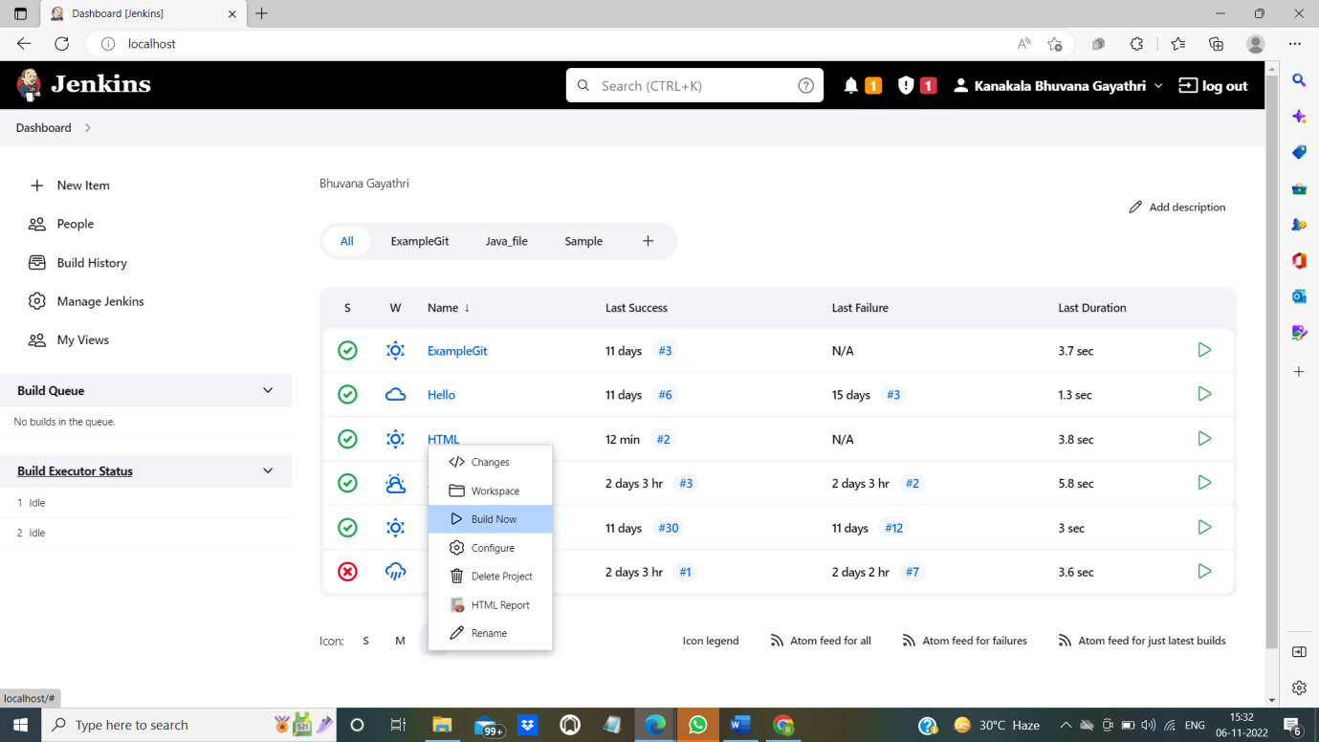

1. On successful build you will get a green tick mark as below.

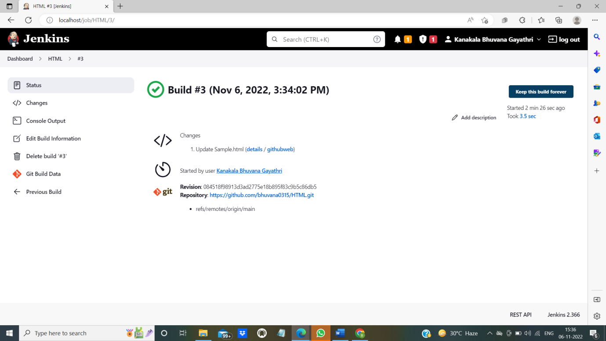

1. Now click on “HTML report” to view the changes.

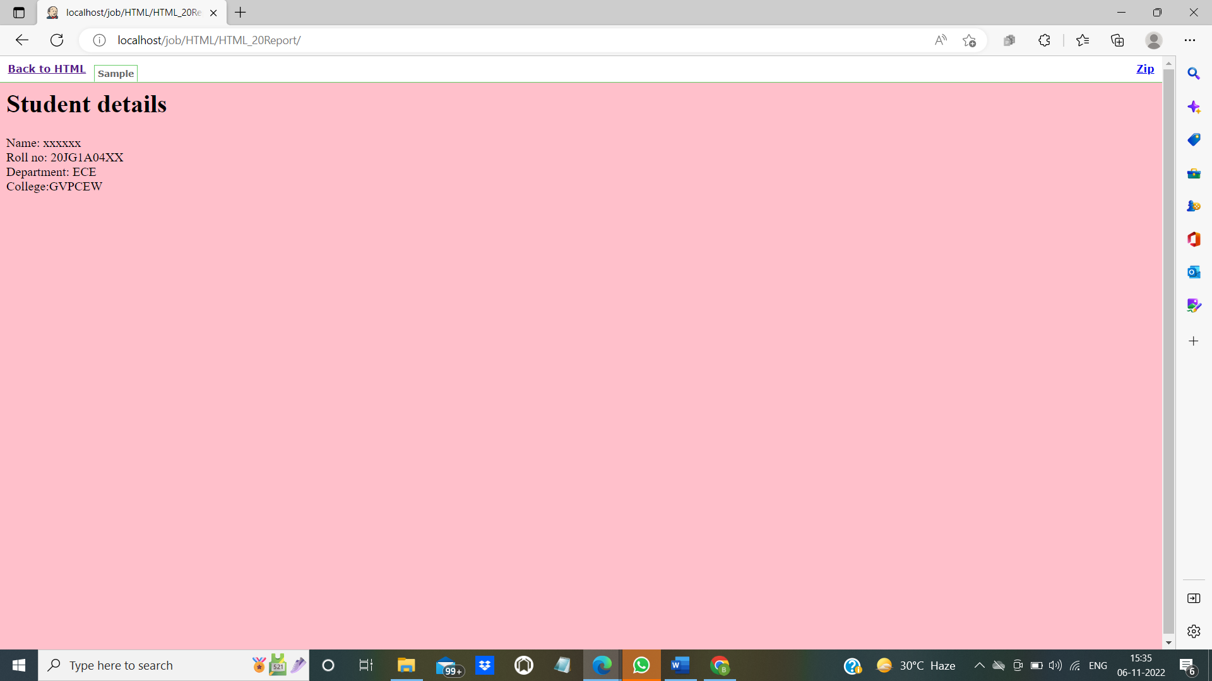

The changes made in GitHub are reflected in Jenkins.

------------------------------------------------------------------------------------------------------------

**Console output for #3 build:**

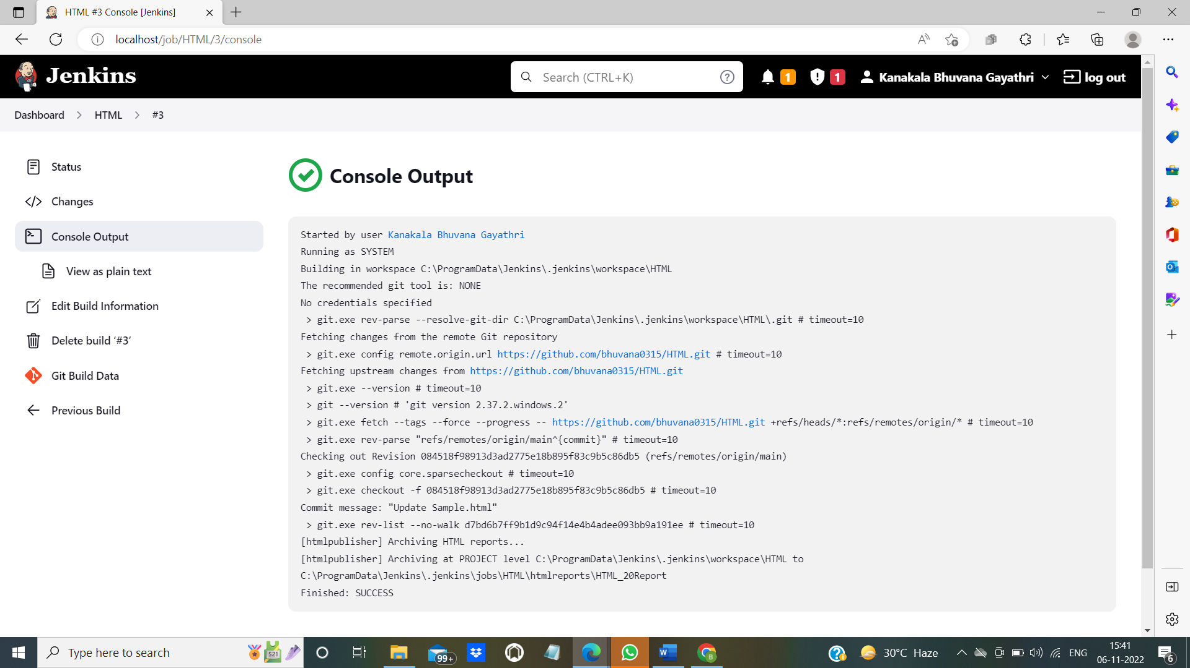

**Installing pipeline plugin:**

1. To install the plugin click on “Manage plugin” which is present under Dashboard.
2. After that switch to “Available” option. Type “Build pipeline plugin”. Then click on “install without restart”.

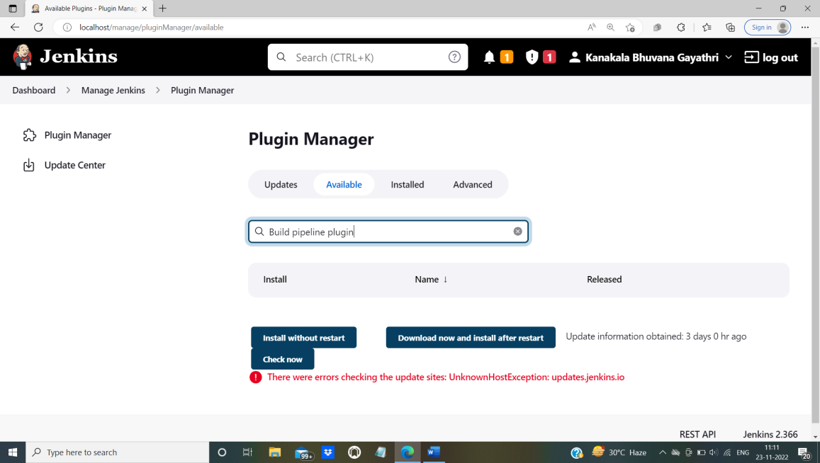

1. Once the plugin is installed. You can see in “Installed”.

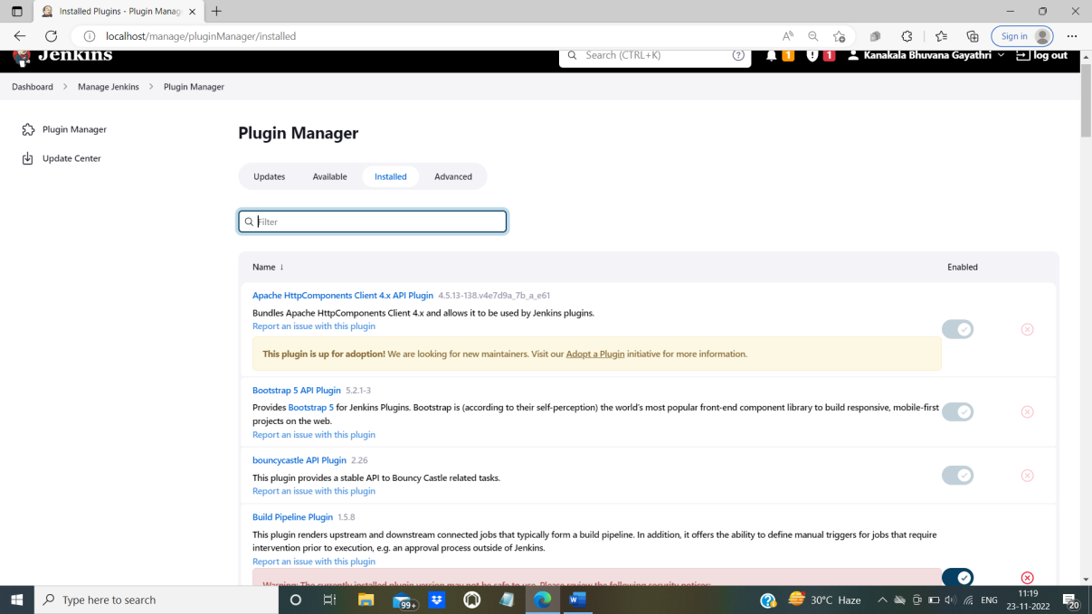

**Creating a pipeline:**

1. To create a pipeline click on the plus symbol which is a new view button.

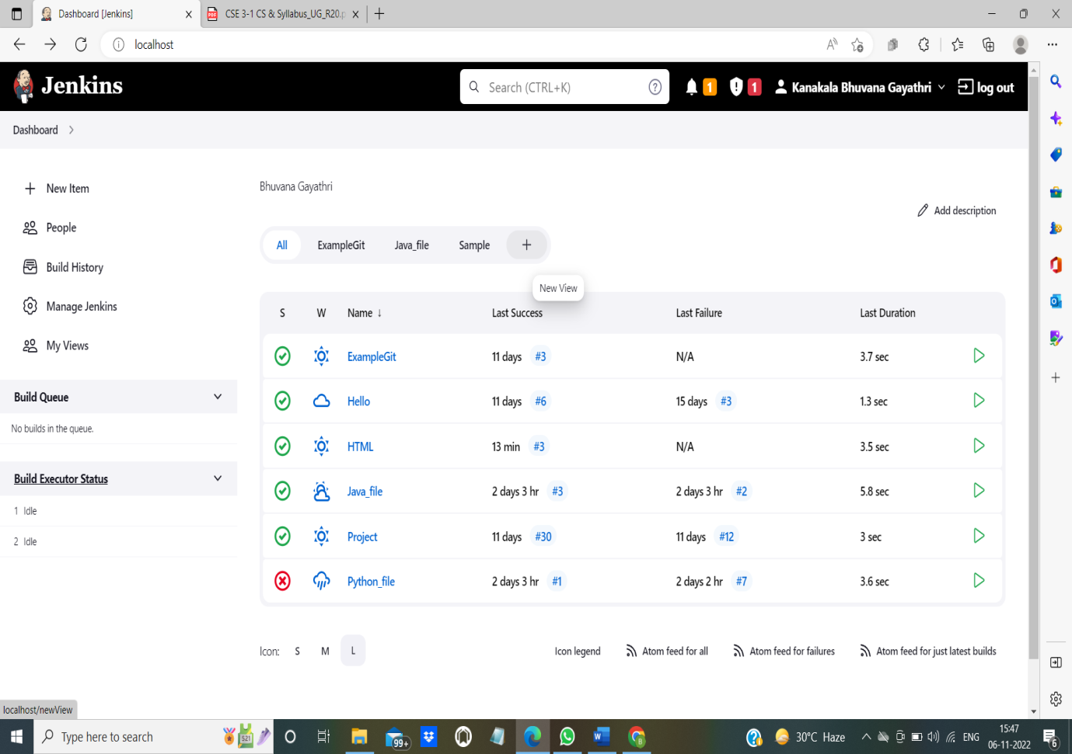

1. On clicking plus you will get the following screen.

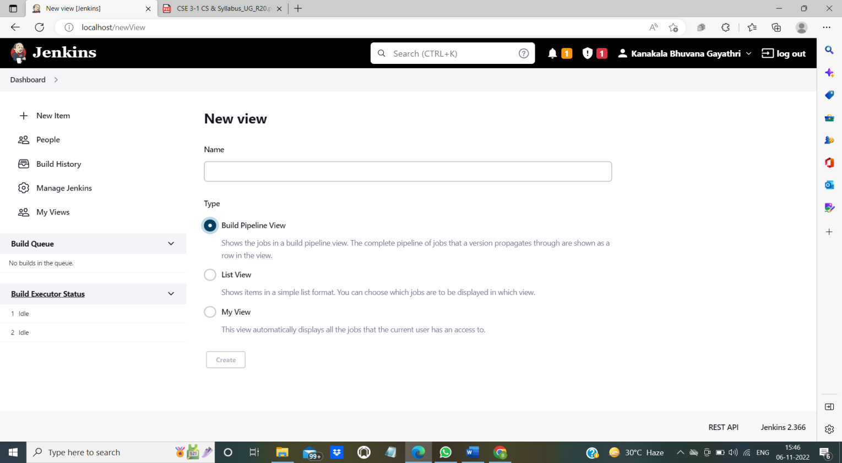

1. Give the name to the pipeline in New View page. Choose build a pipeline view. Then click on “create”.

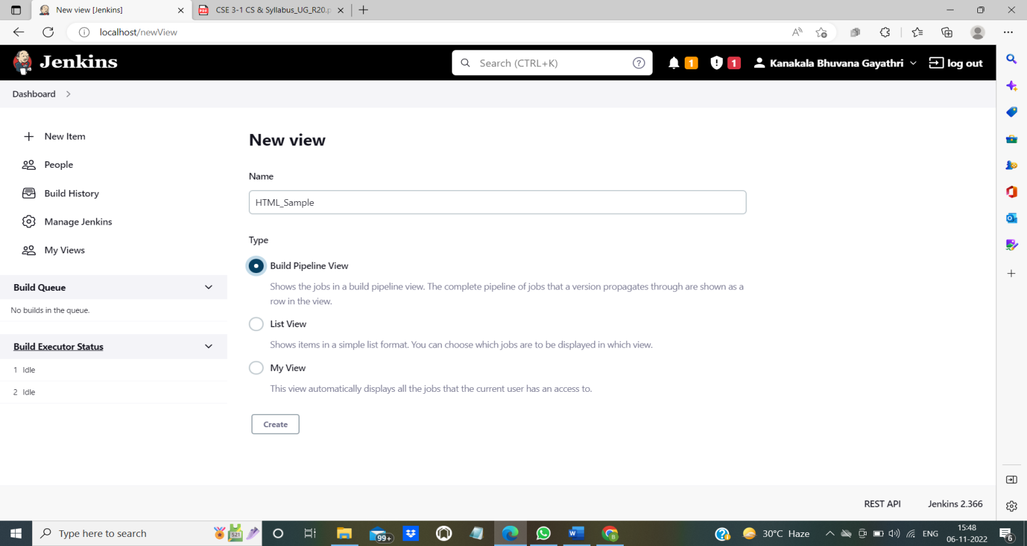

1. On creating pipeline, it will ask you to edit the view and displays the following screen.

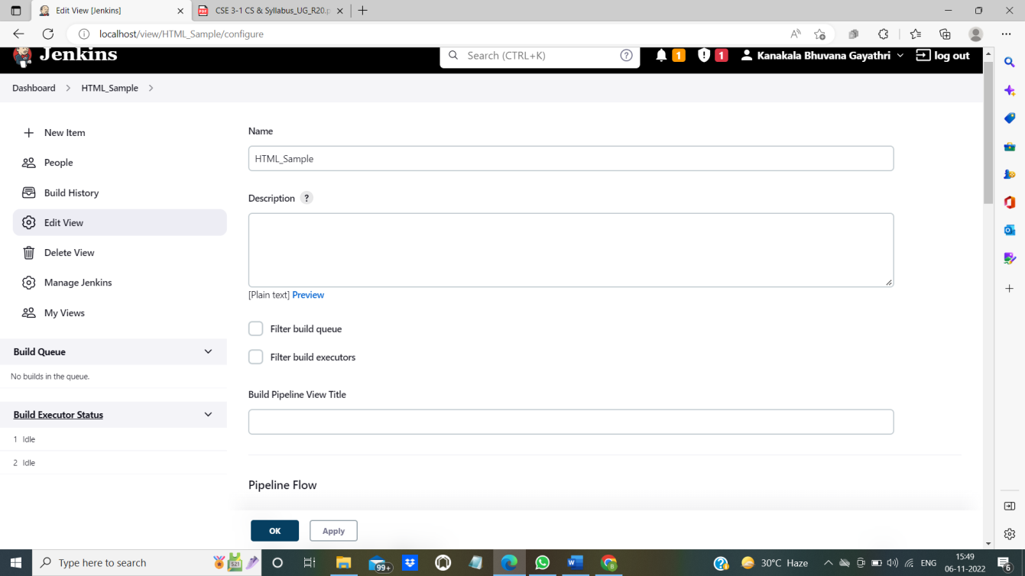

1. Scroll down to see Pipeline flow section. In pipeline flow, under “select initial job”, select the job for which you want to create the pipeline. Here the job/project name is “HTML” (which was created in earlier steps).

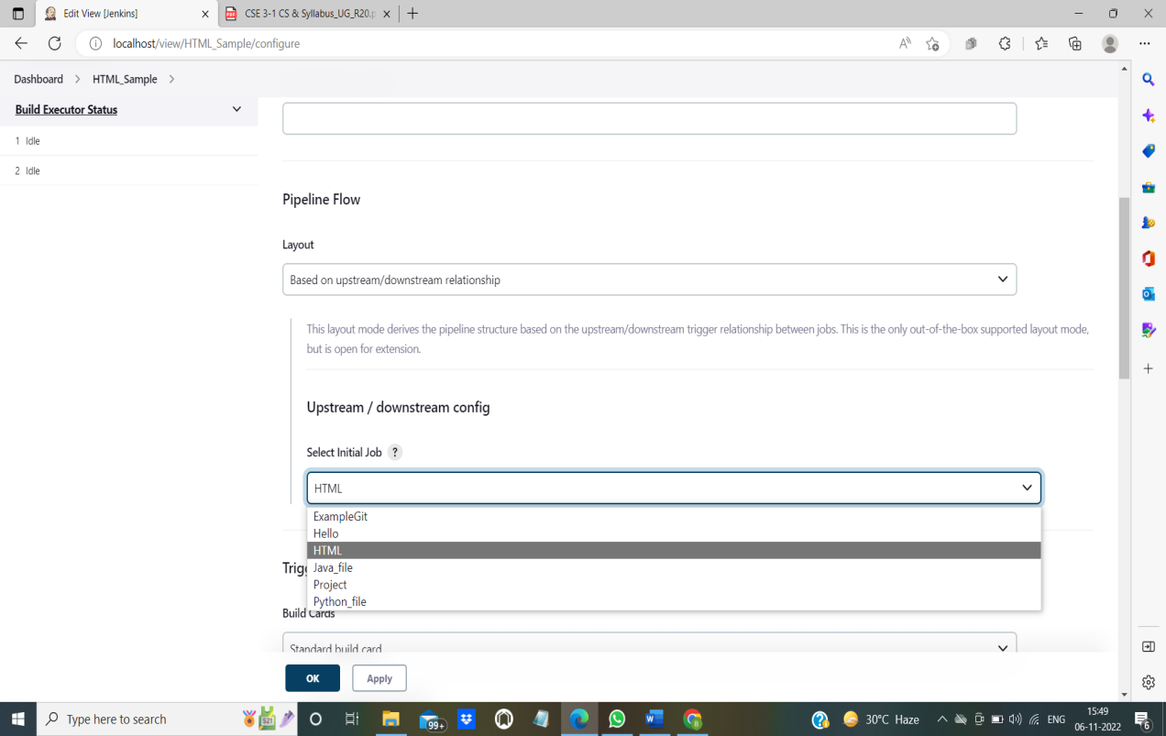

1. Click on apply and ok.

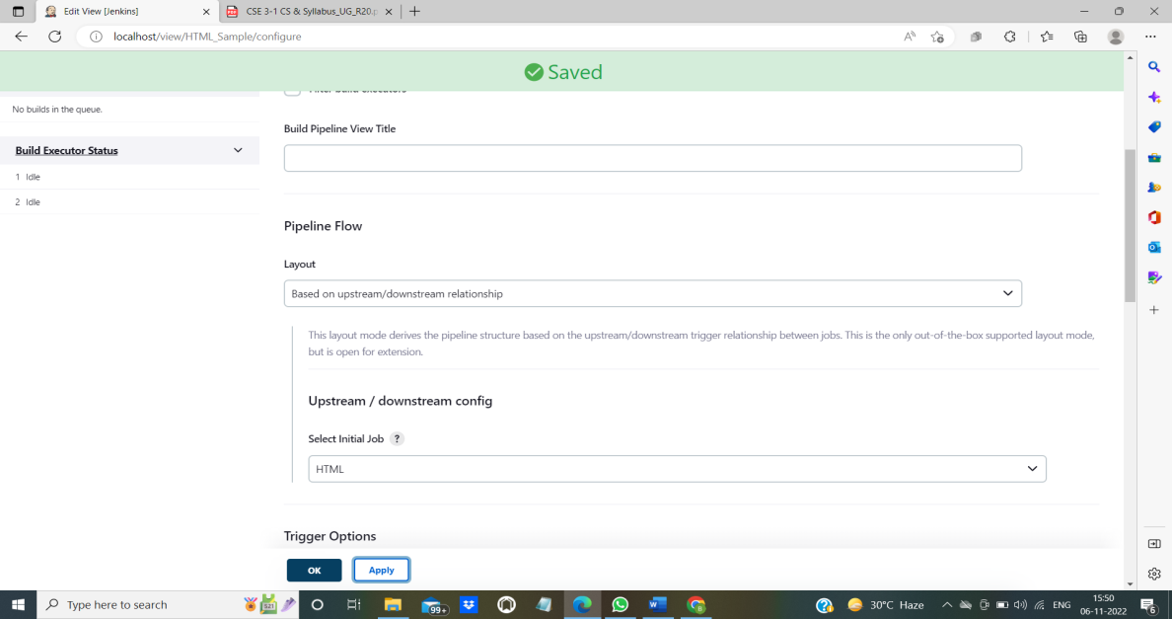

1. If there are no errors, the pipeline will be built successfully. The following will appear:

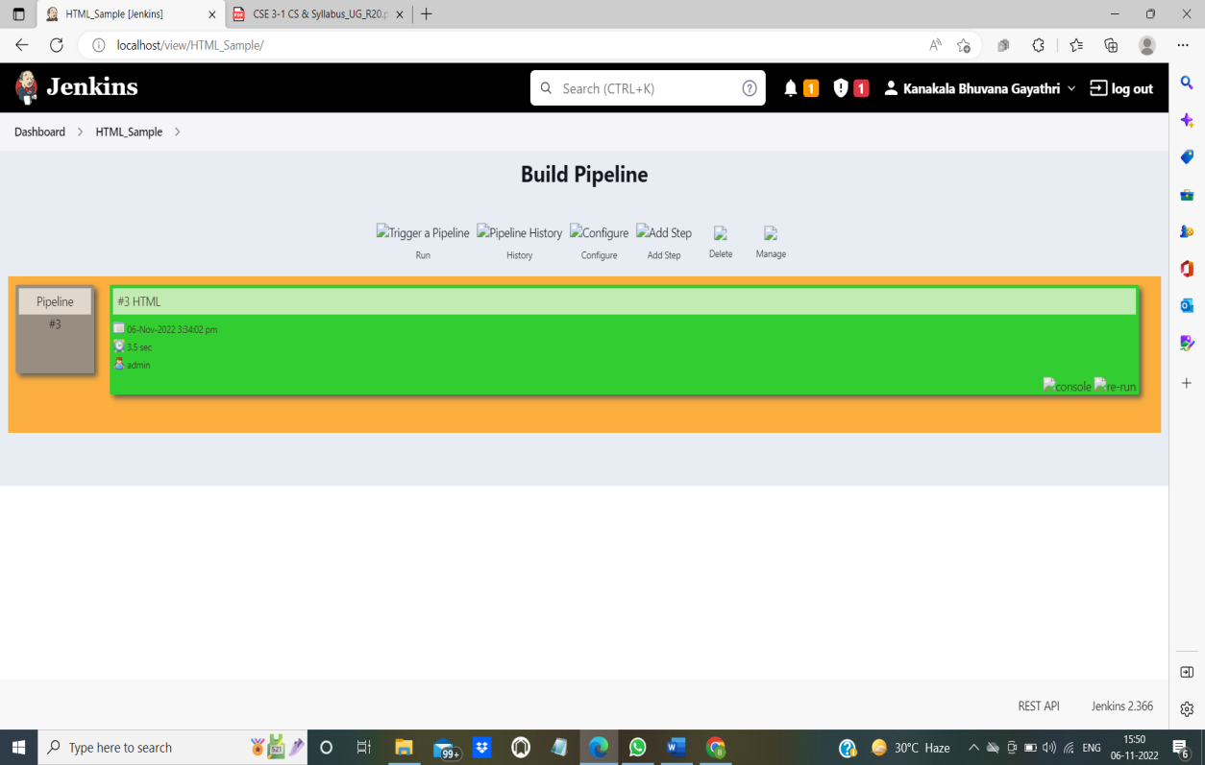

1. Click on Console that is available on the pipeline. The console output will be displayed.

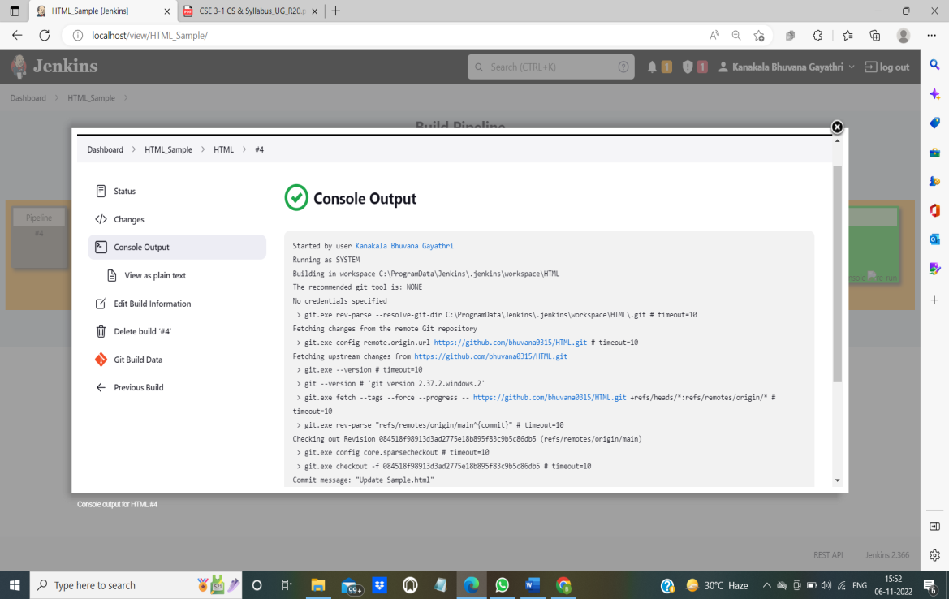

**NOTE: Refer Exercise-4 for more information about Git.**

**EXERCISE-9**

**Aim:**Create a pipeline view of the Jenkins pipeline used in Exercise 8. Configure it with user defined JAVA messages.

**Procedure:**

**Step1:** Select a folder which need to be pushed to Github repository.

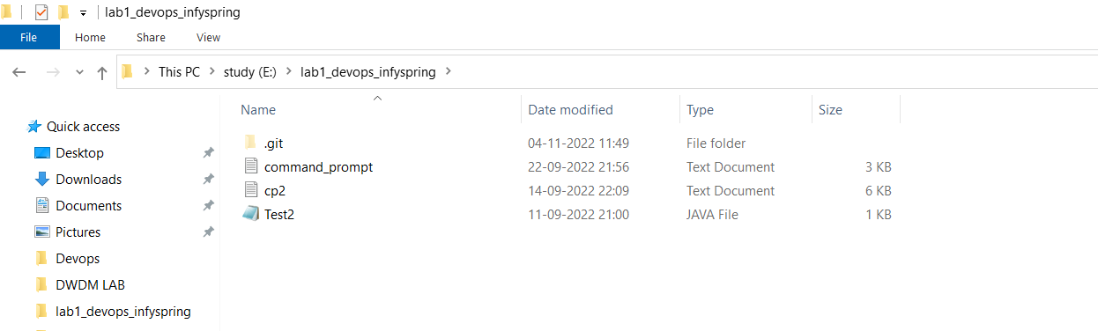

**Step 2:** Follow the following procedure to push the files in desired repository.

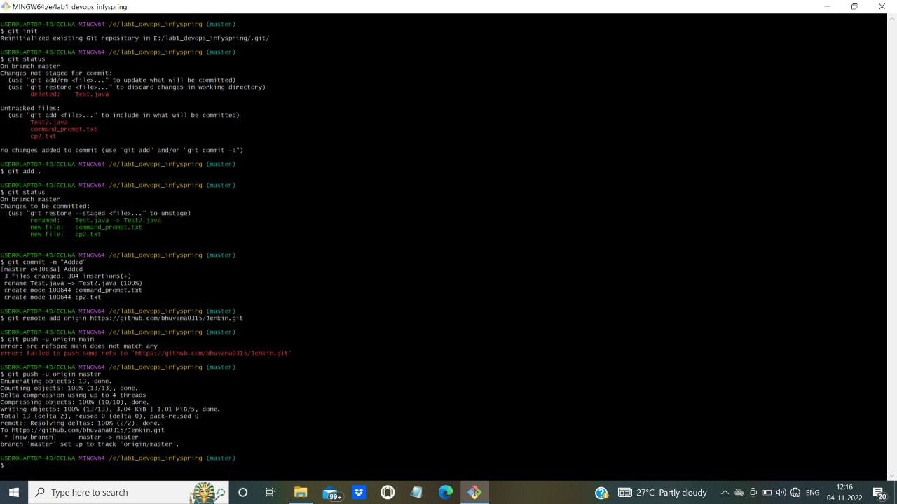

Refer to Exercise-4 for any queries.

**Step 3:** Open Jenkins and create new job by clicking on ‘New Item’.

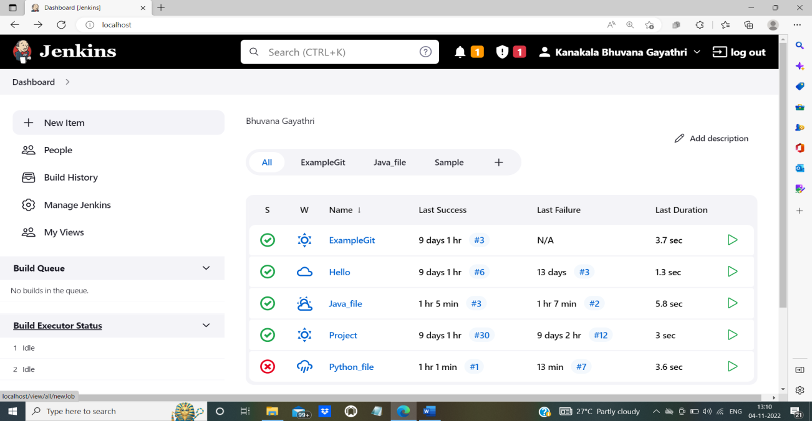

**Step 4:** Give a unique name to job. Select ‘Freestyle project’ and then click on ‘OK’.

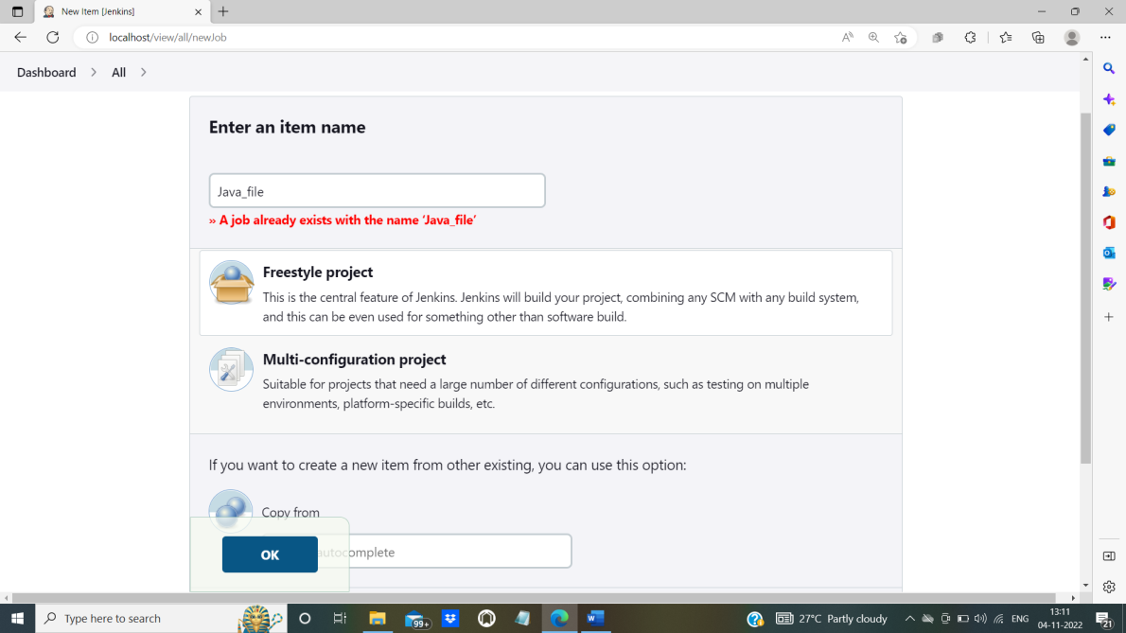

**Step 5:** After clicking ‘OK’, we will be directed to next step where we need to select ‘Git’ and give URL of our repository.

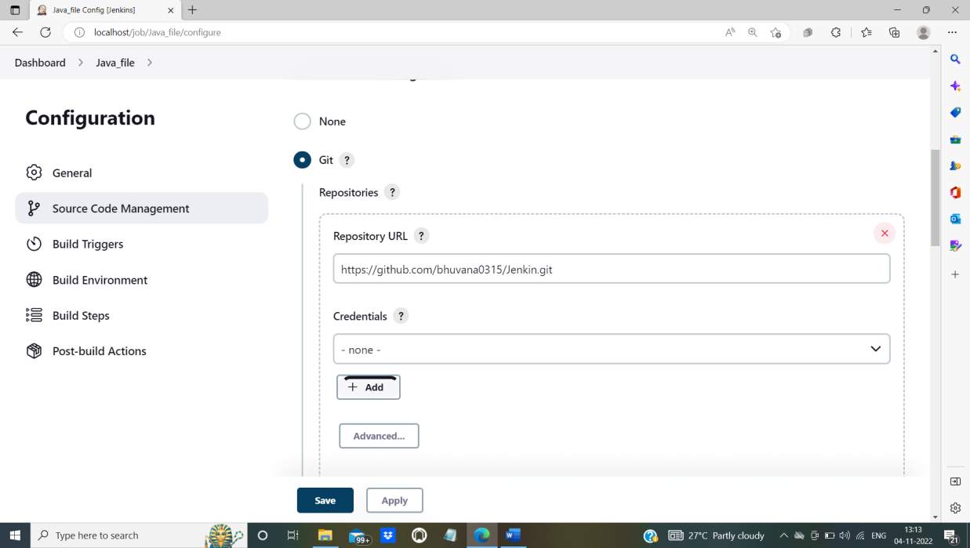

**Step 6:** Set Branch Specifier as ‘*/master’ if we have our file in it(of our mentioned repository). With respect to the repository mention either ‘master’ or main.

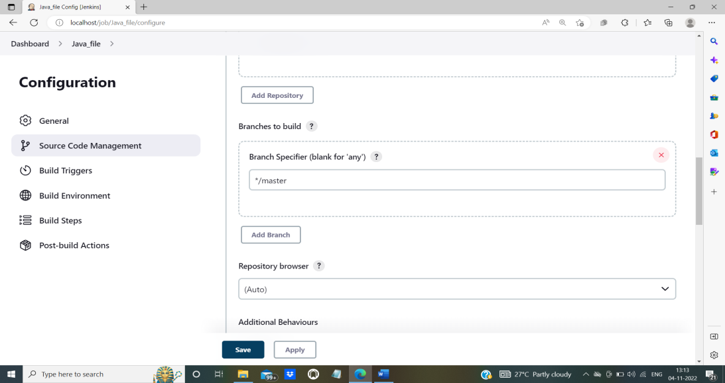

If your codes are present in ‘master’ of Github then set master, otherwise ‘main’.

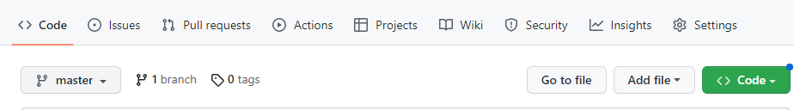

**Step 7:** Open **Build Environment** and give following commands in ‘Execute Windows batch command’.

java <file name>.java

java <file name>

(To execute java file)

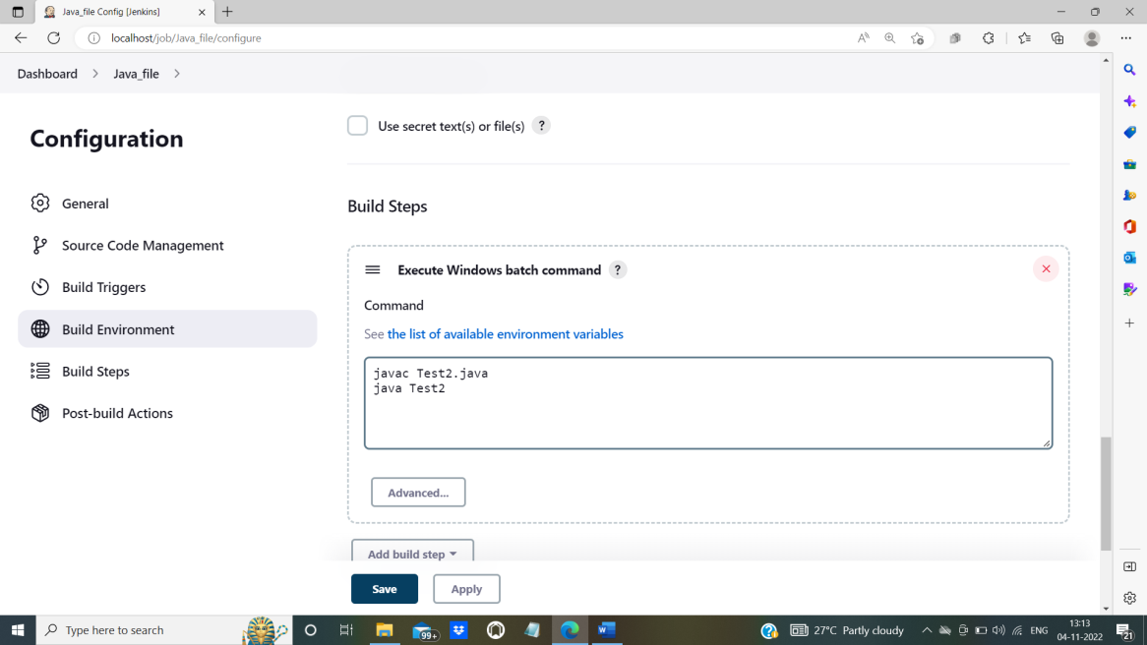

**Step 8:** Click on ‘Apply’ and then ‘Save’ the modification.

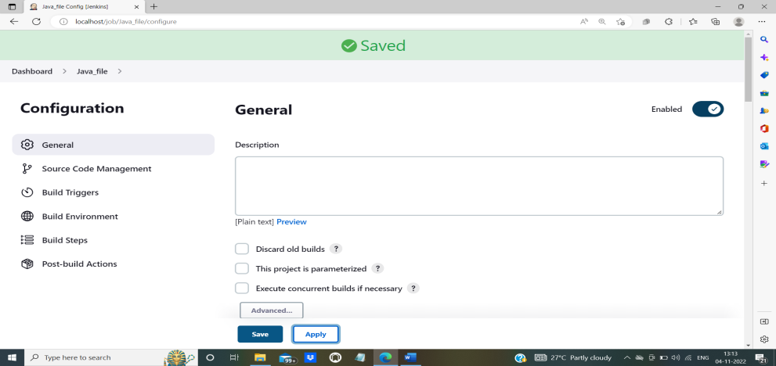

**Step 9:** We can see that our newly created job will be displayed with our previous jobs.

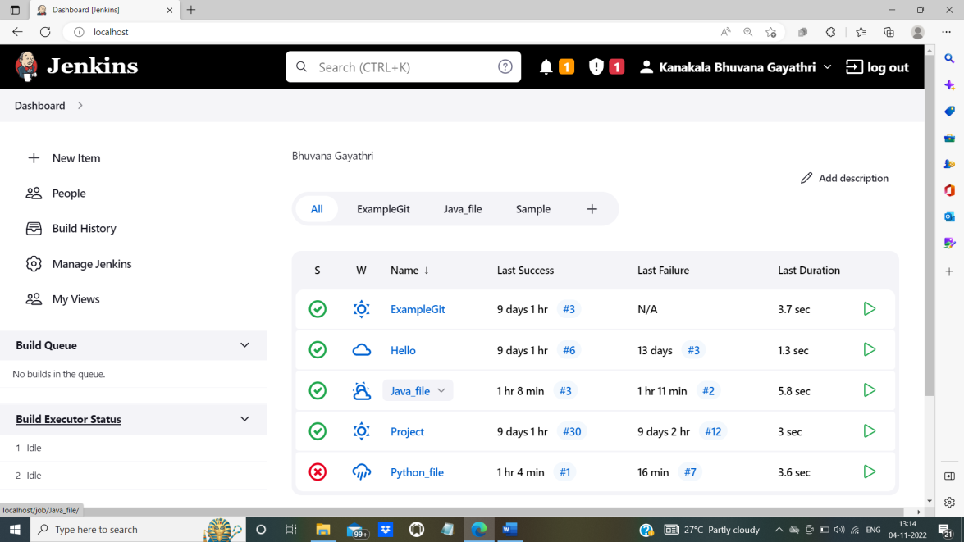

**Step 10:** Select ‘Java_file’ (our newly created job) and click on ‘Build Now’.

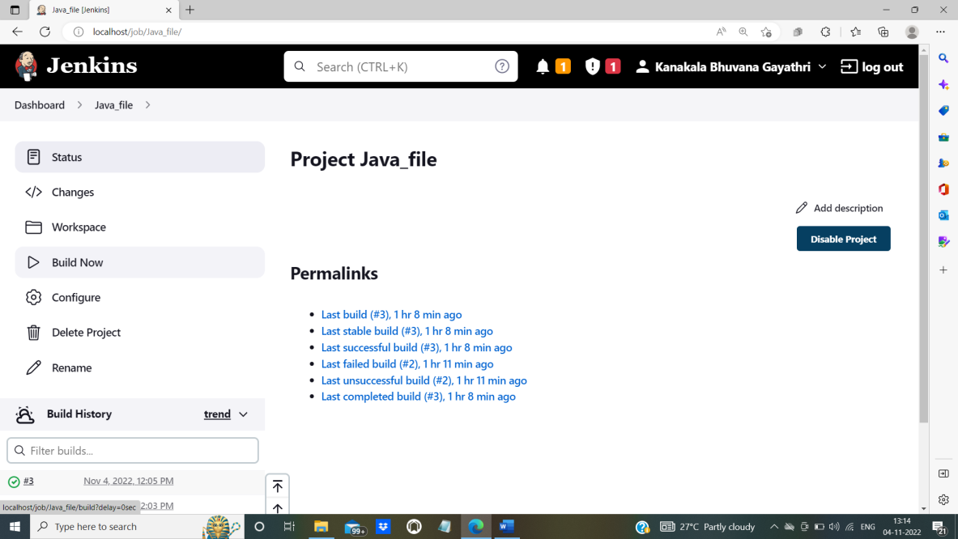

**Step 11**: Following page will be displayed if our build is successful.

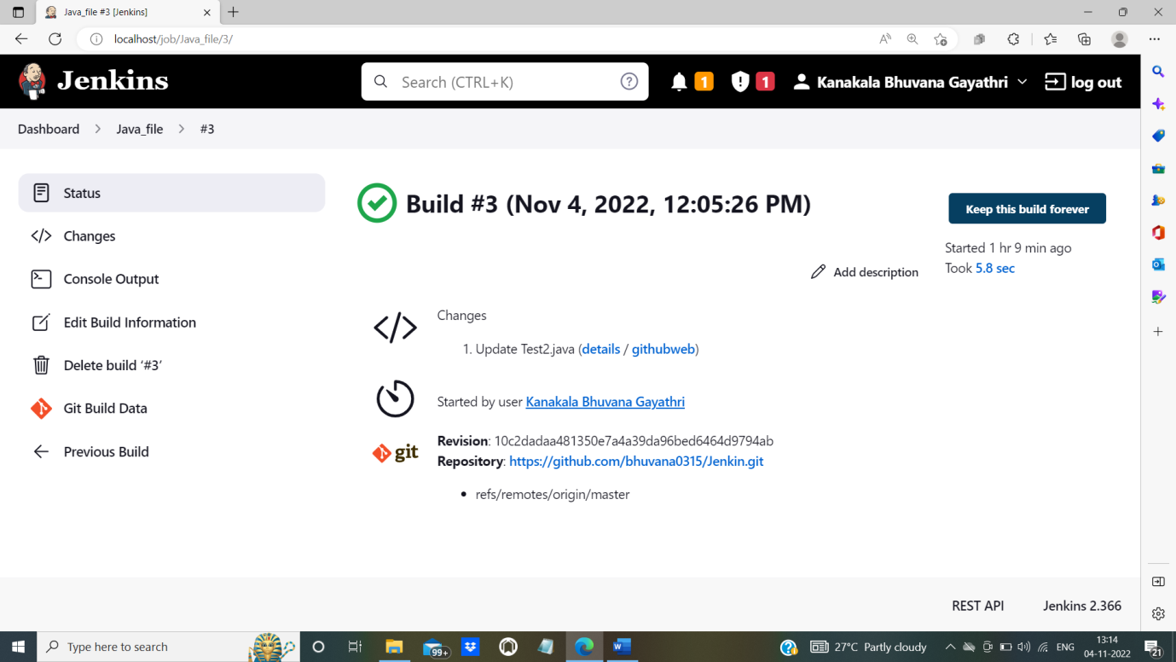

**Step 12:** Click on ‘Console Output’ to check our Java file’s output.

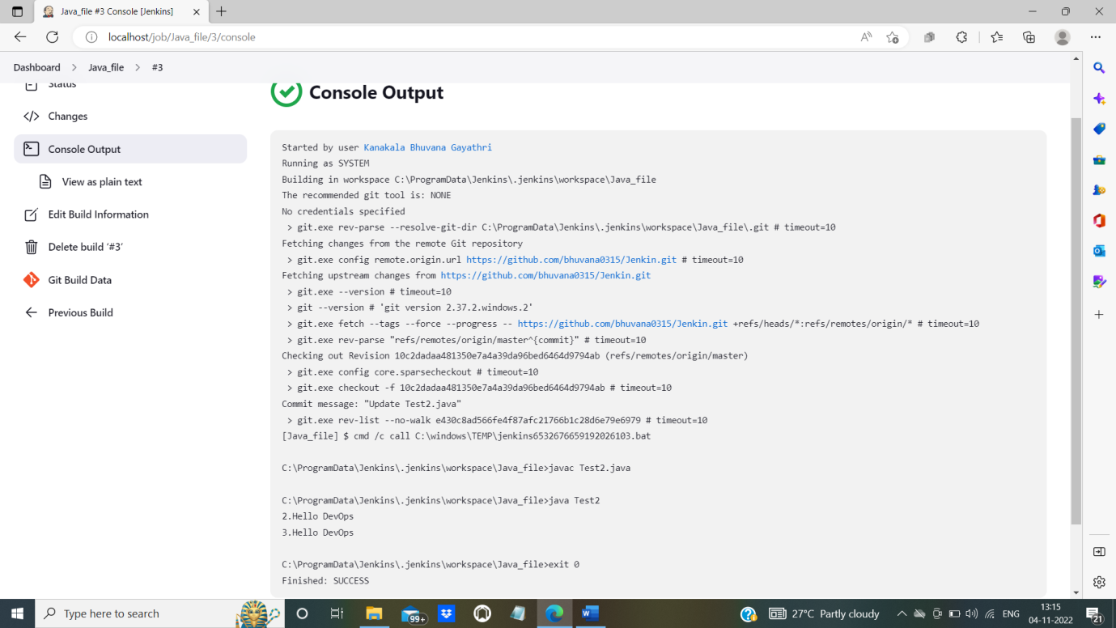

**Using Pipeline**

**Step 13:** Open the Dashboard of Jenkins and click on ‘+’ to create pipeline.

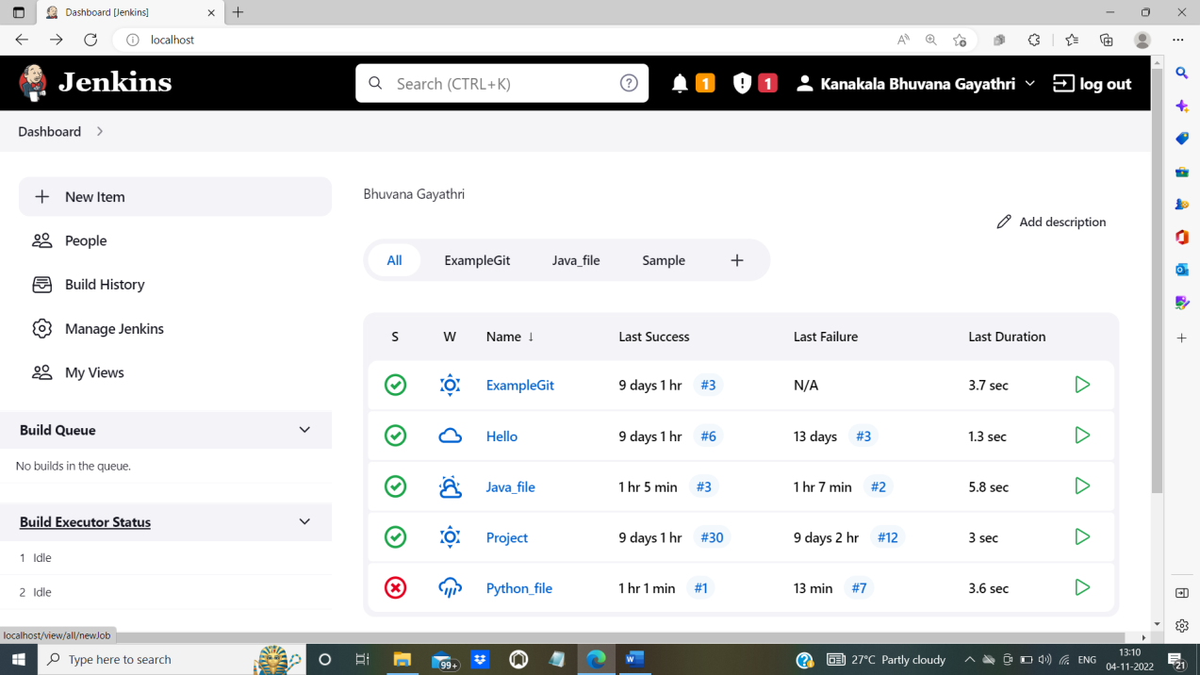

**Step 14:** Give a name to the pipeline and select ‘Build Pipeline View’. Click on ‘create’.

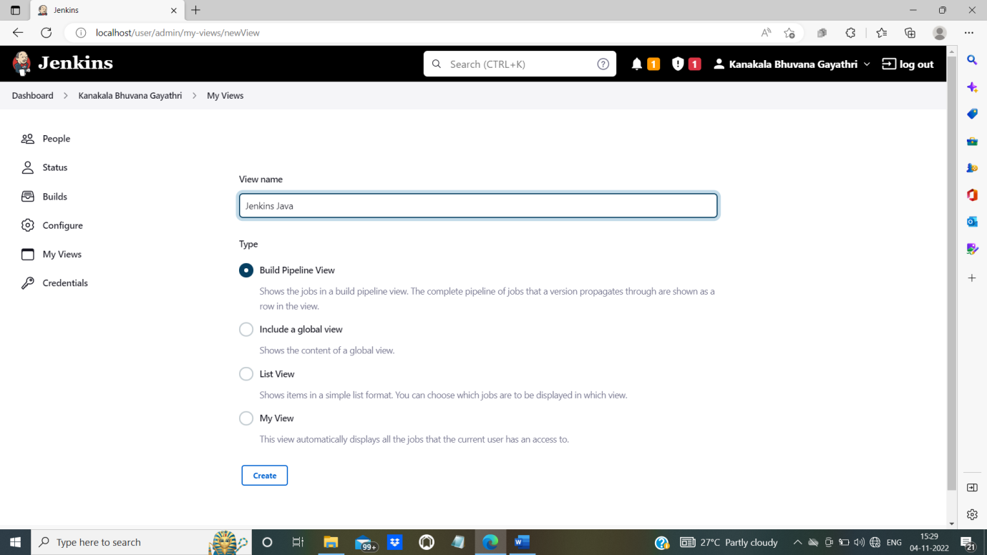

To install Build Pipeline View, go to ‘Manage Jenkins’ and then to ‘Plugin Manager’. Select ‘Available’ and type ‘Build Pipeline View’. Click on ‘Install without restart’.

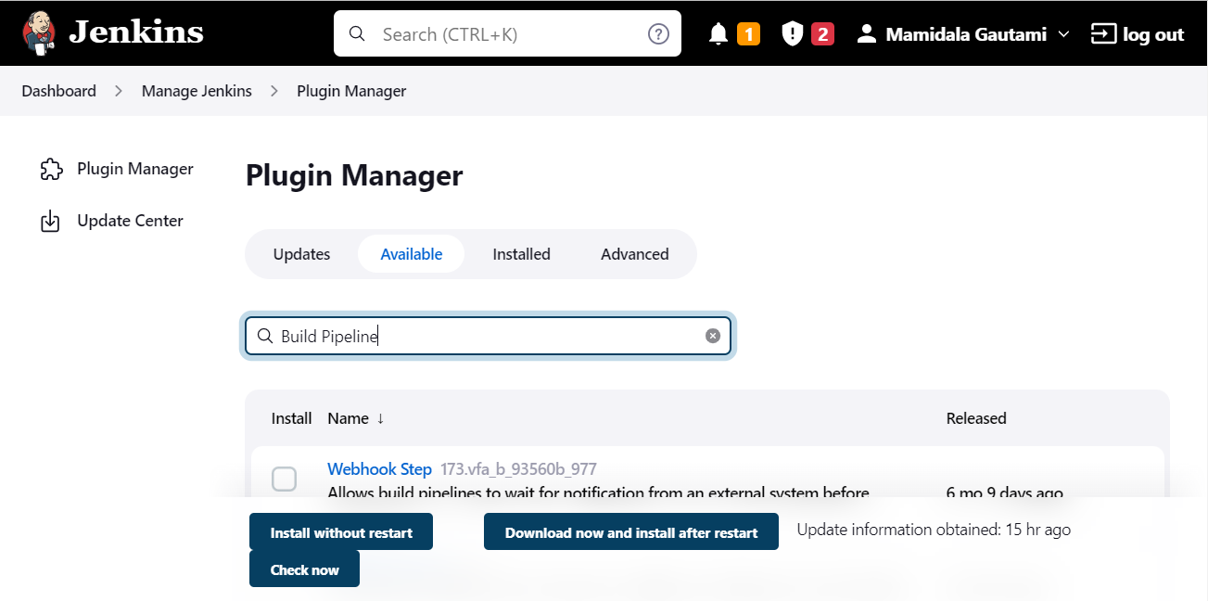

**Step 15:** After creating pipeline, below page will be displayed.

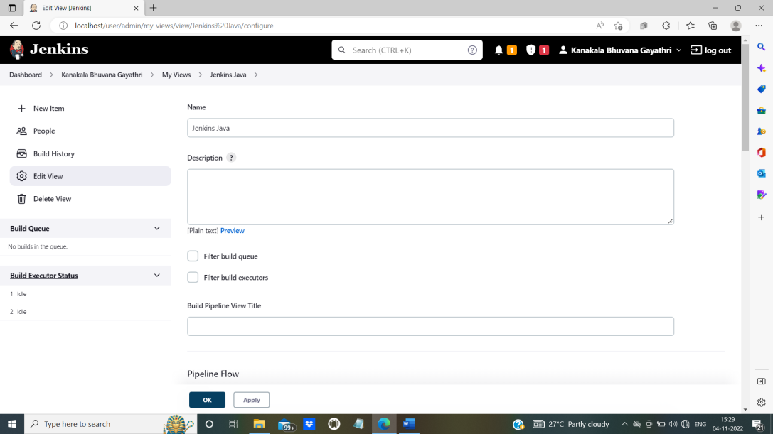

**Step 16:** Select the desired Job in ‘Select Initial Job’ to connect with pipeline (Here it is Java_file). Apply the modifications and click on ‘OK’.

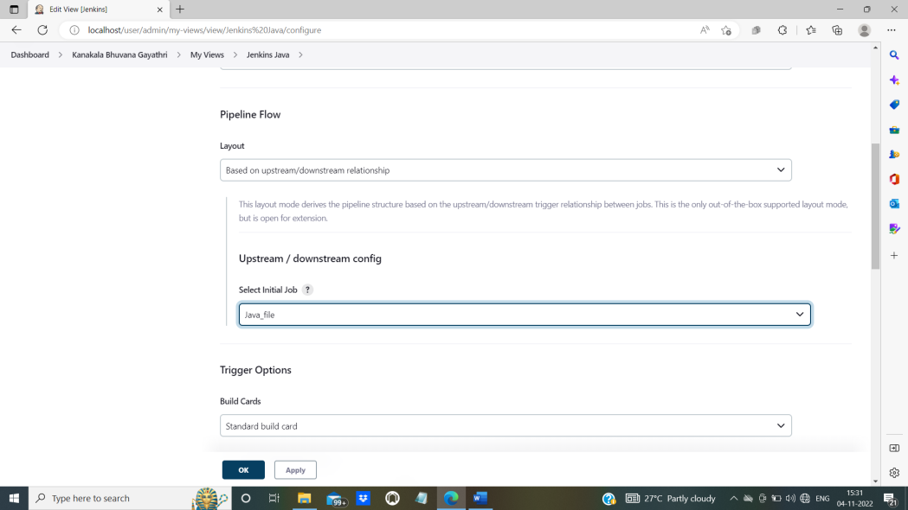

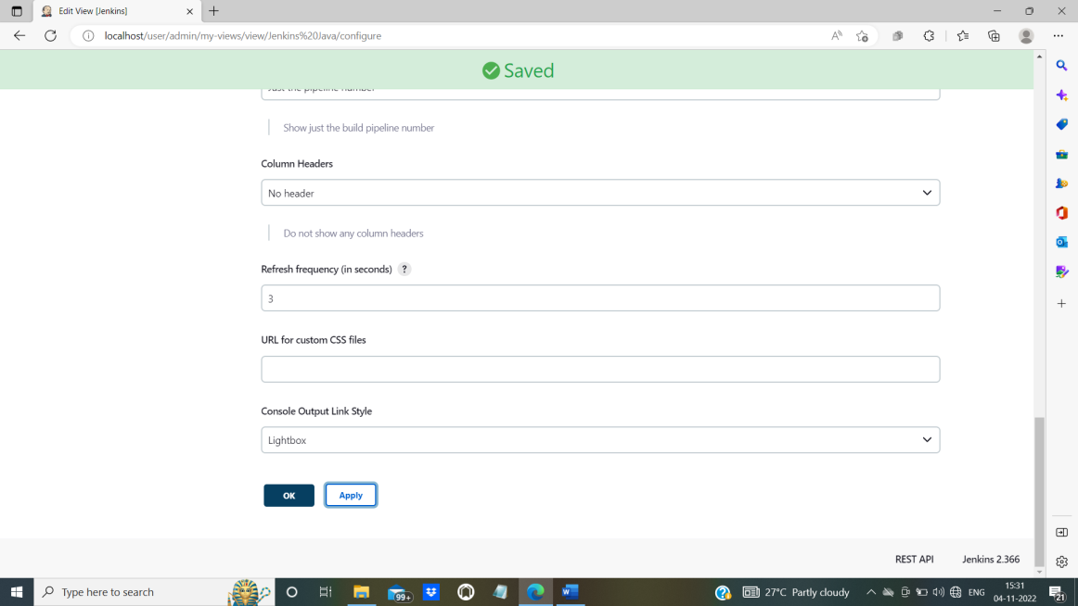

**Step 17:** After applying successfully, following page will be displayed.

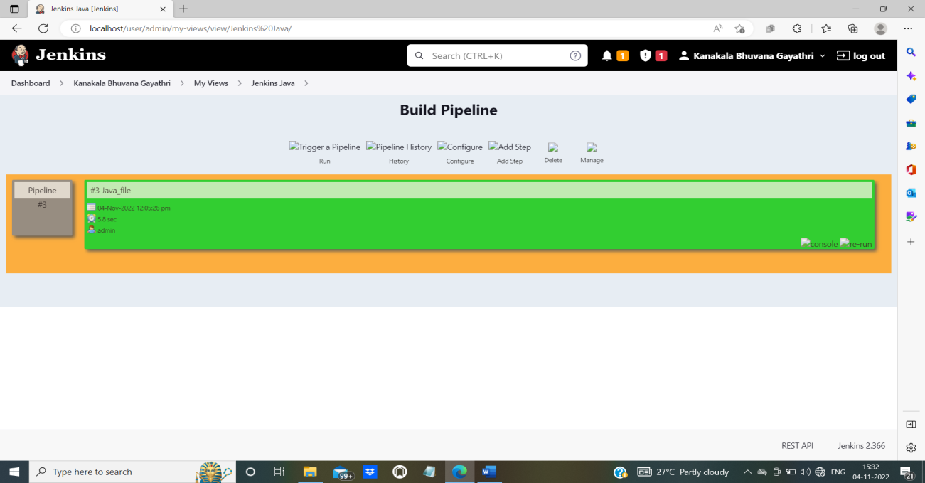

**Step 18**: Click on ‘console’ to view output.

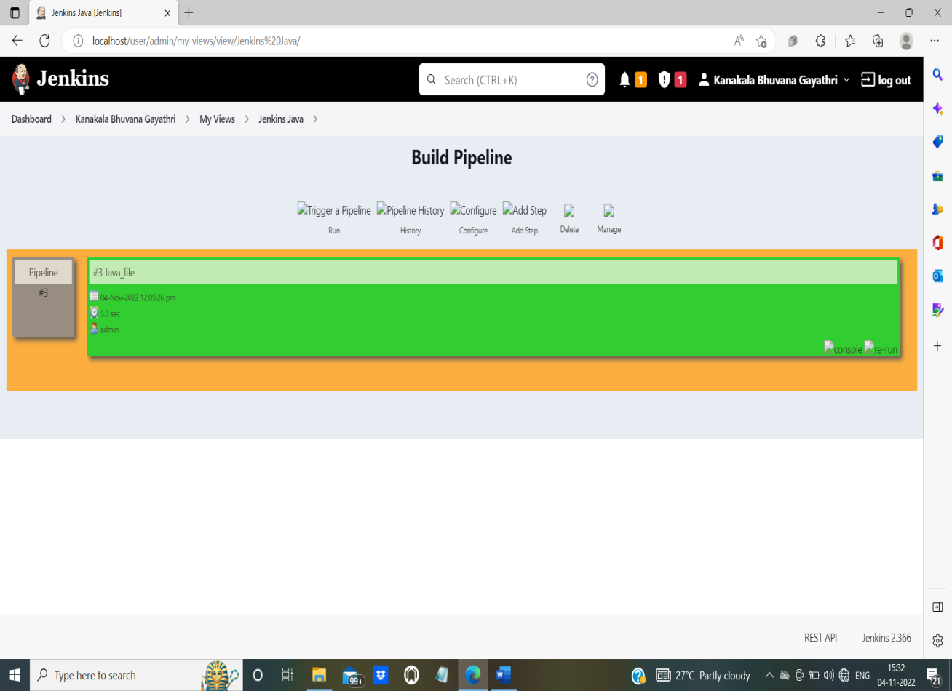

To run the file, we can click on ‘**Run**’ to display Console Output. To modify configurations, we can click ‘**Configure**’.

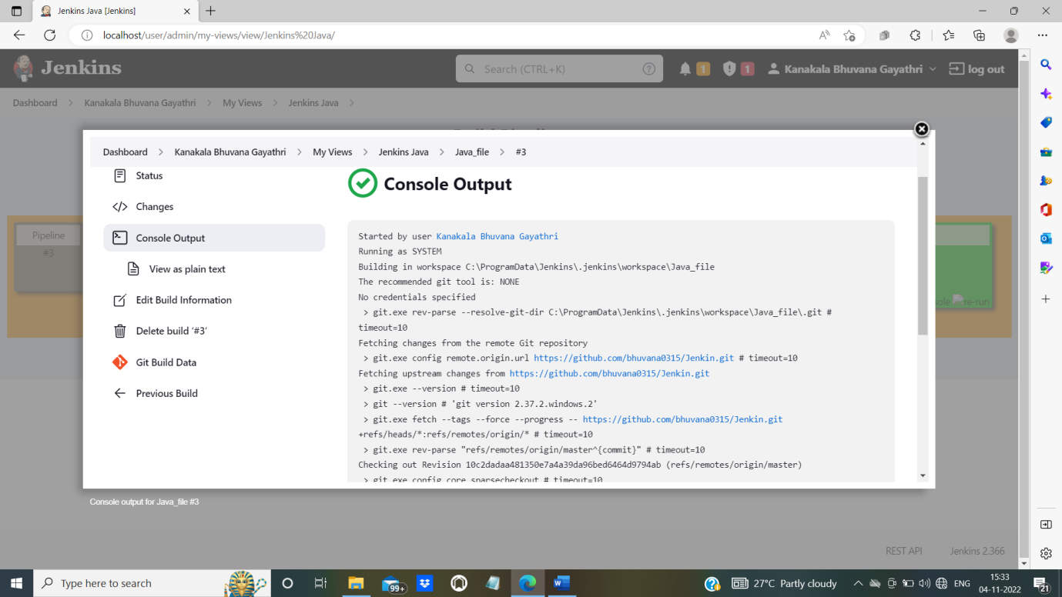

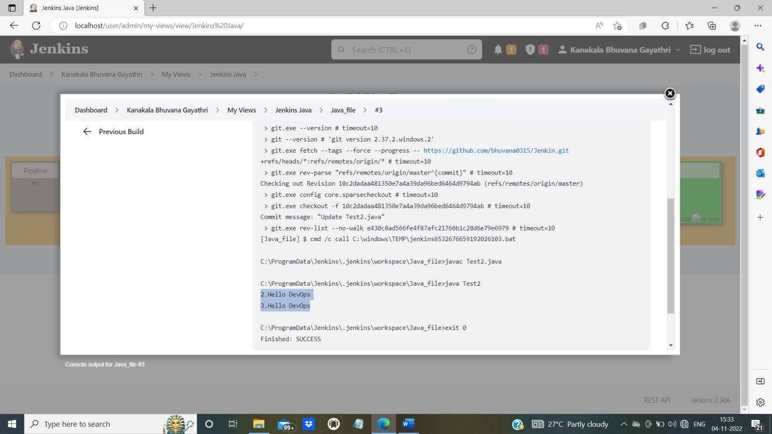

**EXPERIMENT-10**

**AIM:**In the configured Jenkins pipeline created to implement quality gates for static analysis of code.

STEP 1:

The sonarQube and sonarscanner has to be installed in your systems

STEP 2:

Open jenkins localhost [Install the Jenkins Extension for SonarQube via the Jenkins Update Center](https://plugins.jenkins.io/sonar).

STEP 3:

Configure your SonarQube server:

Log into Jenkins as an administrator and go to **Manage Jenkins > Configure System**

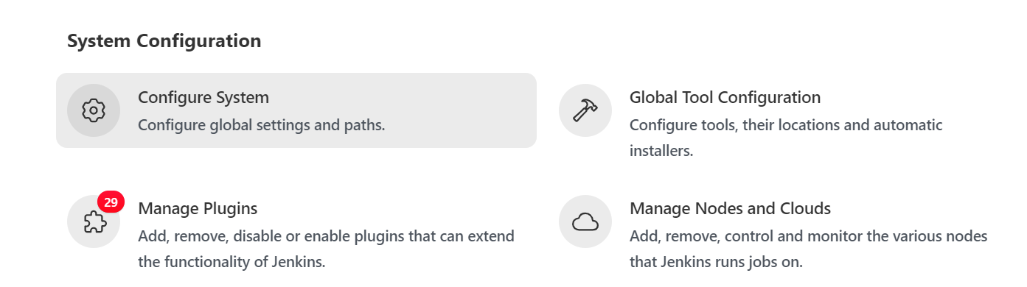

STEP 4:

Scroll down to the SonarQube configuration section, click **Add SonarQube**, and add the values you're prompted for.enter the **name(Any name) ,**  provide localhost where sonarqube is running



The **server** [**authentication token**](https://docs.sonarqube.org/latest/user-guide/user-token/)  click on ‘ADD’ and it should be created as a 'Secret Text' credential as shown in below figure





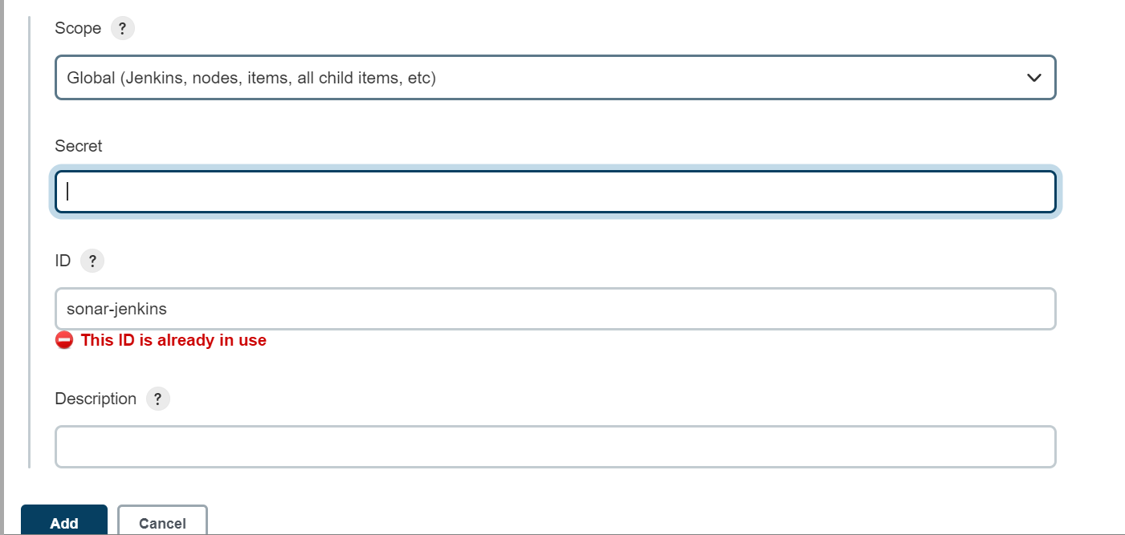

**HOW TO GET SECRET CODE FROM SONARQUBE:**

In secret blank we have to enter the**adminstrator user token** from sonarqube as follows:

1. Open sonarqube localhost and click on **administration** option

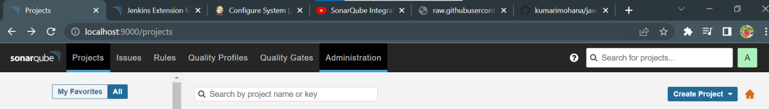

Now click on **security** and select **users** option

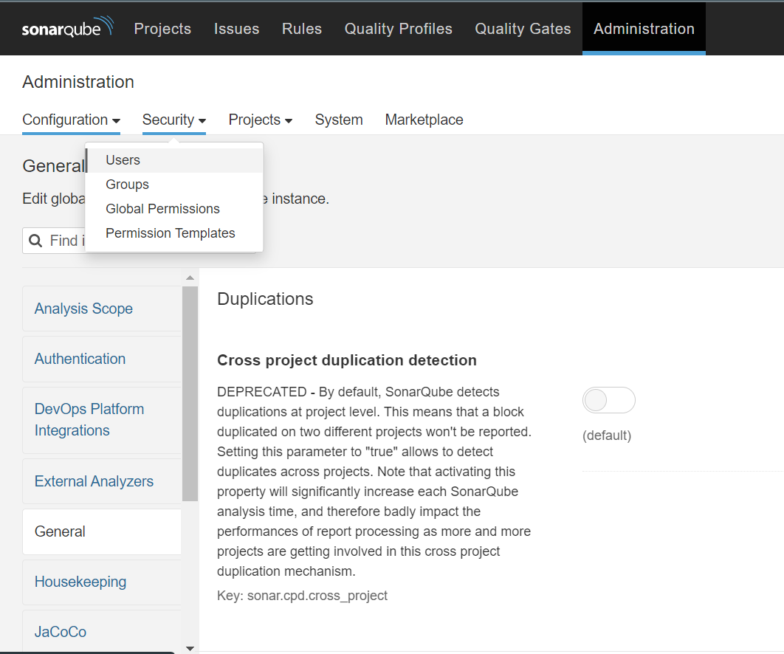

Now click on tokens button as shown below

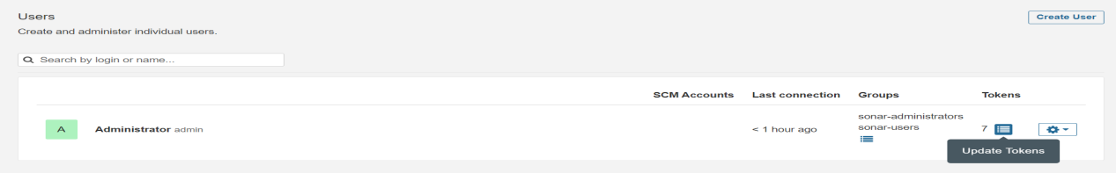

Now enter name of the project and click on **generate** option

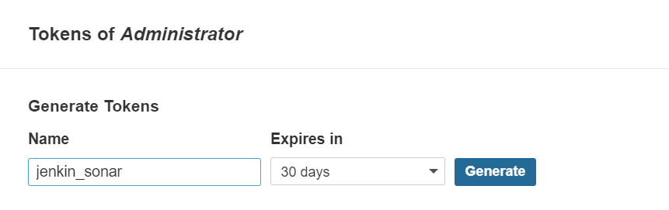

Copy the generated code and paste in the place of secret in jenkins>Add sonarQube



Click on add and add it to the **server authenticaion token** as shown below



STEP 5:

**Global Configuration**  
This step is mandatory if you want to trigger any of your SonarQube analyses with the SonarScanner. You can define as many scanner instances as you wish. Then for each Jenkins job, you will be able to choose which launcher to use to run the SonarQube analysis.

1. Log into Jenkins as an administrator and go to **Manage Jenkins > Global Tool Configuration**
2. Scroll down to the SonarScanner configuration section and click on Add SonarScanner. It is based on the typical Jenkins tool auto-installation. You can either choose to point to an already installed version of SonarScanner (uncheck 'Install automatically') or tell Jenkins to grab the installer from a remote location (check 'Install automatically')

STEP 6:

Log into Jenkins as an administrator and go to **Manage Jenkins>manage plugin and installsonarQube scanner**

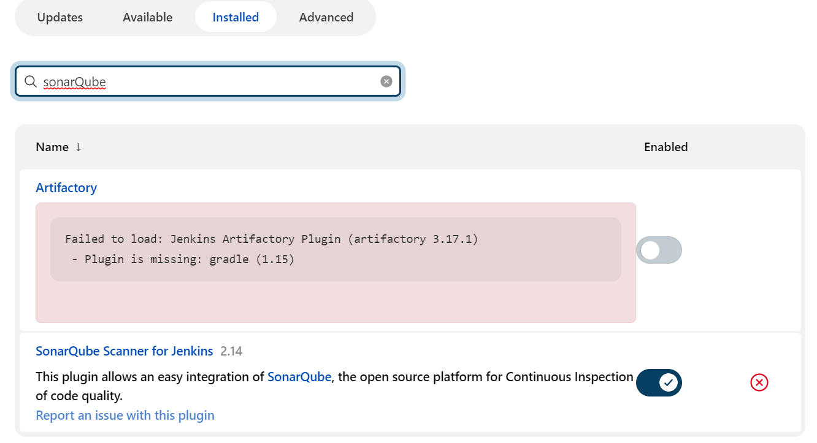

STEP 7:

Create a **PIPELINE JOB**  injenkins and move to pipeline option and select **“pipeline script from SCM”** and provide github code link in **Repository URL** and **credentials** of your github account

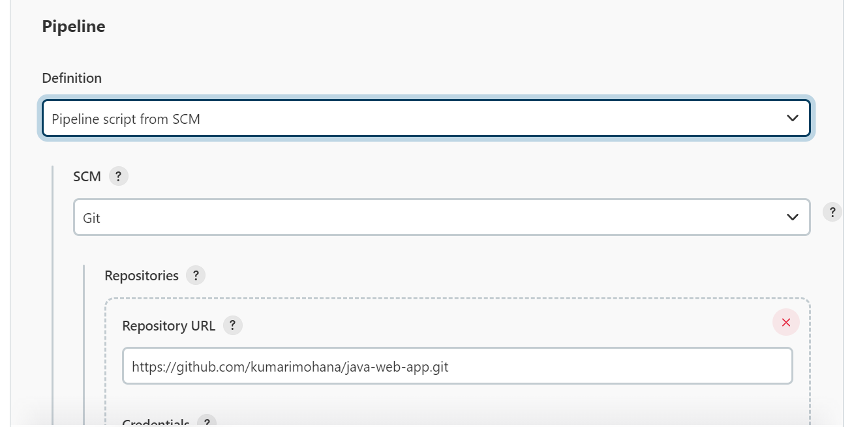

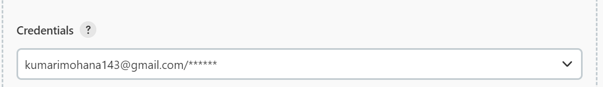

**GITHUB CODE LINK:**https://github.com/kumarimohana/java-web-app.git

STEP 8:

Add name as ‘Jenkinsfile’ in Script path

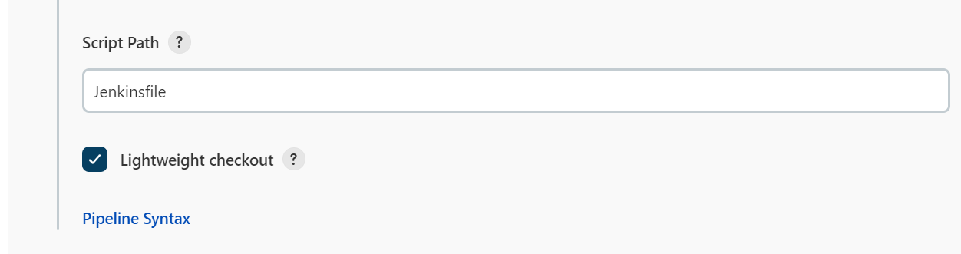

Now click on apply and save it

STEP 9:

Click on Build Now option and the job done successfully

